"Blood tests at home, with just one drop, are as accurate as hospital-grade tests" GIST implements hospital-grade blood testing using next-generation biosensors... Achieving 95% accuracy in blood markers compared to hospital clinical equipment

- Professor Sung Yang's team from the Department of Mechanical and Robotics Engineering has developed a technology capable of high-precision blood testing using only a small amount of blood… An electrochemical-based platform capable of quickly and accurately analyzing health signals and disease indicators in blood

- This platform enables easy, high-sensitivity testing without the need for expensive clinical equipment, promising applications in early diagnosis of cardiovascular disease and personalized healthcare… Published as a cover paper in the international journal 《Analytical Chemistry》



▲ (From left) Ye Sung Lee, a student in the combined master's and doctoral program in the Department of Mechanical and Robotics Engineering, Professor , and Professor Sung Yang

Unlike blood tests that rely on large hospital equipment, a next-generation biosensor technology has been developed that can quickly and precisely identify key blood markers using only small amounts of blood.

The Gwangju Institute of Science and Technology (GIST, President Kichul Lim) announced that a research team led by Professor Sung Yang team from the Department of Mechanical and Robotics Engineering has developed a technology that uses a microfluidic electrochemical impedance sensor (MEIS)* to precisely analyze the morphology and electrical properties of red blood cells simultaneously, and, based on this, calculates key markers comparable to those found in existing clinical blood tests.

* A microfluidic electrochemical impedance sensor (MEIS): A device that measures the electrochemical impedance (electrical resistance and dielectric properties) generated when a small amount of blood or cell suspension flows through a microfluidic channel. This non-destructive, real-time analysis is possible, and multi-frequency measurements enable the precise identification of various biological data, such as changes in red blood cell morphology and the electrical properties of cell membranes and cytoplasm. This technology is attracting attention as a next-generation biosensor technology for blood tests, cell analysis, and early disease diagnosis.

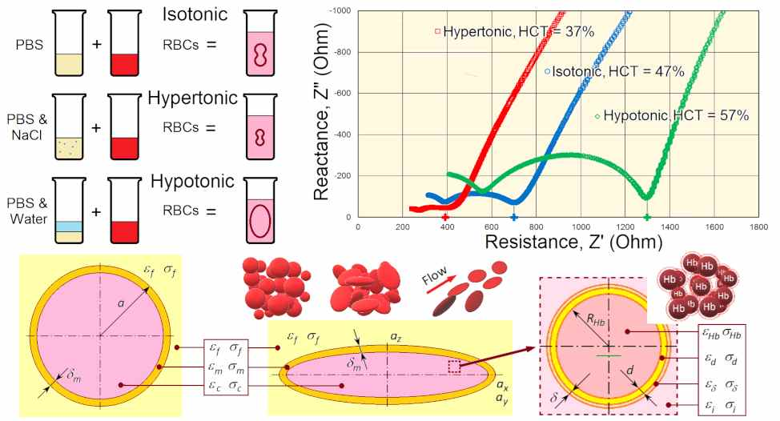

▲ Graphical Abstract. Changes in red blood cell shape according to the water environment in the blood, Nyquist plot (a graphical representation of electrical response) according to osmotic conditions, and theoretical model of the internal and external structure of red blood cells.

This technology enables more accurate analysis than existing sensors. By electrically detecting and reflecting changes in osmotic conditions* during blood flow, it provides stable and reliable results.

* tonicity (osmotic conditions): This refers to the effect on cells of concentration differences between the cell and the external solution. Red blood cells swell in hypotonic solutions, contract in hypertonic solutions, and remain normal in isotonic solutions. In other words, it is a key factor in determining intracellular and extracellular water balance and red blood cell morphology.

Blood tests are essential for the early detection of anemia, infections, and cardiovascular diseases through various indicators such as red blood cell count, hemoglobin concentration, and plasma viscosity. However, existing equipment requires large blood samples, expensive clinical equipment, and skilled personnel, resulting in long analysis times and limitations in performing immediate tests near patients.

To overcome these limitations, microfluidic-based technologies capable of rapidly and accurately analyzing small amounts of blood are attracting attention. Analysis methods utilizing electrical signal changes (impedance analysis) have also garnered attention due to their ability to measure changes in real time without damaging cells.

The research team previously published a study combining electrochemical impedance spectroscopy (EIS) with microfluidic channels that simulate actual blood flow environments to measure the electrical properties of blood and quantitatively analyze the arrangement of red blood cells and the water structure around hemoglobin (hydration structure*). This demonstrated the potential for deriving hematological indices from real blood.

However, previous studies have limited the precision of indices due to insufficiently accounting for changes in red blood cell expansion and contraction under osmotic conditions.

* hemoglobin hydration shell: This refers to the layer of water molecules formed around hemoglobin molecules. This hydration shell plays a crucial role in hemoglobin's stability, maintaining its structure, and performing other functions, including oxygen binding and release. In other words, it is a key element in hemoglobin's normal functioning and maintaining its oxygen-carrying capacity in the blood.

The research team observed how red blood cells change shape and volume under different osmotic environments—for example, swelling due to water absorption or shrinking due to water loss—using optical microscopy and holotomography microscopy*. They then measured the electrical response of blood samples at various frequencies through microfluidic channels equipped with electrodes, allowing them to more precisely capture changes inside and outside the cells.

Based on this data, they calculated the dielectric properties of plasma, red blood cell membranes, and cytoplasm, and proposed a new analytical model that reflects the contraction and expansion of red blood cells due to osmotic pressure changes, as well as the water content surrounding hemoglobin.

* holotomography microscope: This advanced microscopy technology non-invasively reconstructs the three-dimensional structure of cells and tissues by measuring the phase shift that occurs when laser light passes through a sample. It allows for real-time observation of internal cellular structures and morphological changes, including red blood cells, cell membranes, and cytoplasm, without labeling. It is utilized in diverse fields such as cell research, blood analysis, disease diagnosis, and drug response assessment.

* isotonic solution: A solution in which the osmotic pressure inside and outside the cell is equal, preventing cell size change. / Hypertonic solution: A solution in which the osmotic pressure outside the cell is higher than inside, causing water to escape and shrink. / Hypotonic solution: A solution in which the osmotic pressure outside the cell is lower than inside, causing water to enter and swell.

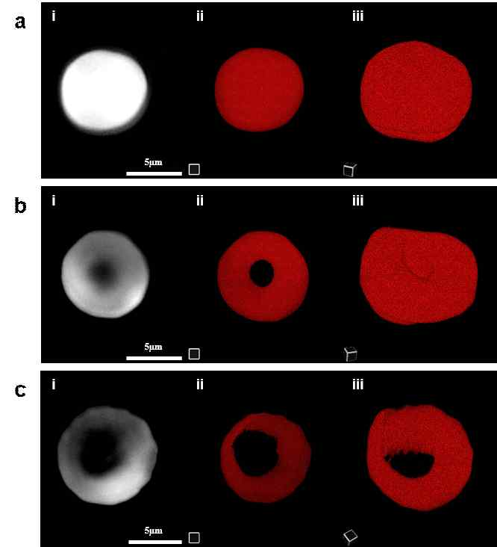

▲ Observing blood cell shape changes according to osmotic conditions using a holotomography microscope. (From top) Images of red blood cells in hypotonic, isotonic, and hypertonic blood.

As a result, the research team succeeded in calculating six major indicators used in clinical blood tests - red blood cell count (RBC), hemoglobin concentration (Hb), hematocrit (HCT)*, mean corpuscular hemoglobin (MCV), mean corpuscular hemoglobin (MCH), and mean corpuscular hemoglobin concentration (MCHC), and showed high accuracy with over 95% agreement with the analysis values ​​of existing clinical equipment.

Furthermore, it demonstrated that it can more precisely reflect a patient's health status by assessing the viscosity of the fluid within plasma and red blood cells. Unlike the existing Coulter Counter* method, which only estimates cell volume at a single frequency, this study presented a new analytical method that comprehensively analyzes and combines electrical signal changes across multiple frequencies to comprehensively interpret the genetic characteristics of blood components.

* hematocrit (HCT): This refers to the proportion of red blood cells in the blood, typically expressed as a percentage of total blood volume. This value is used as a key indicator for diagnosing various diseases, such as anemia and dehydration, and assessing blood status.

* coulter counter: This device calculates cell count and volume by measuring the electrical resistance changes that occur when cells or particles pass through small pores in an electrolyte solution. However, it does not provide detailed information, such as internal cell structure or electrical properties.

Professor Sung Yang stated, "This study is significant in that it has developed a technology that can analyze hematological indicators by reflecting changes in blood moisture. It will simultaneously quantify both morphological changes and electrical properties of blood components, which will serve as an important starting point for the development of real-time blood testing and next-generation point-of-career diagnostic devices."

This research was conducted under the supervision of Professor Sung Yang of the Department of Mechanical and Robotics Engineering at GIST, with Research Professor Alexander Zhbanov and Ye Sung Lee, a combined master's and doctoral student, as co-first authors. It was supported by the Ministry of Science and ICT and the National Research Foundation of Korea's Mid-Career Researcher Support Program.

The results of this research were published online on August 26, 2025, in 《Analytical Chemistry》, an international journal published by the American Chemical Society (ACS), and were selected as the front cover article.

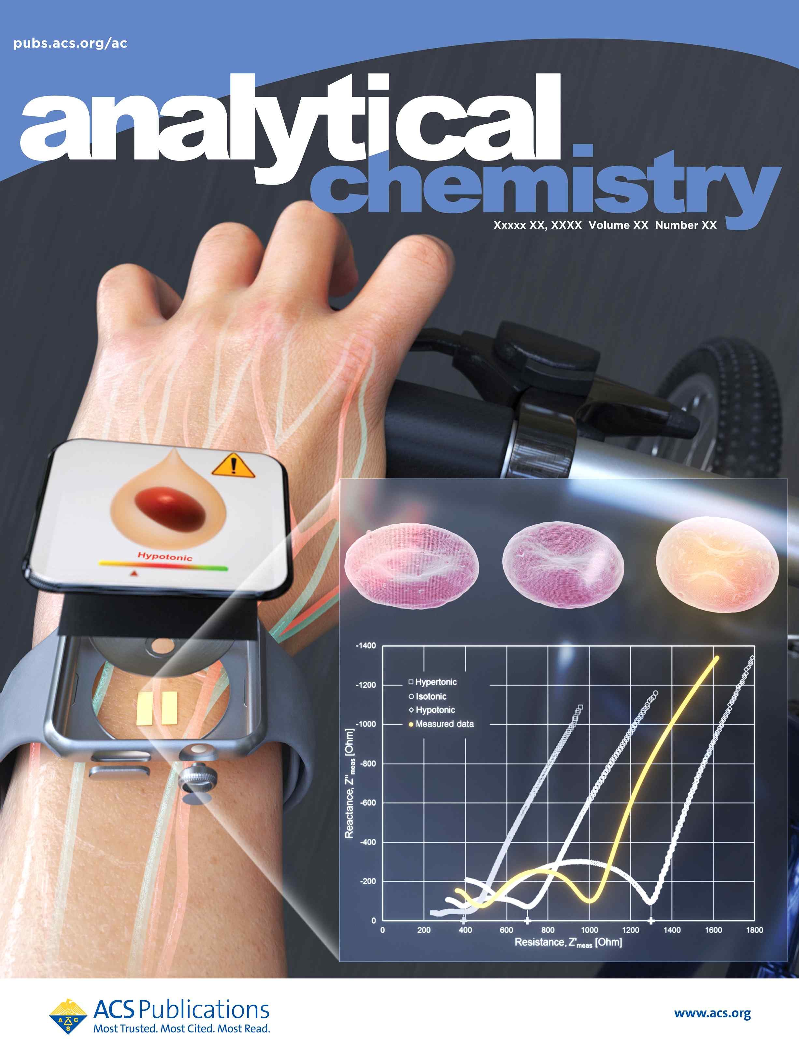

▲ Cover image of the international journal 《Analytical Chemistry》 (to be published).



