GIST and the University of Virginia have developed a precision anticancer drug platform that penetrates deep into tumors and persists in the body

- Professor Inchan Kwon's team from the Department of Materials Science and Engineering presents a next-generation anticancer treatment strategy based on the antibody "Albubody"... This protein fragment, smaller than an antibody, remains in the body over 200 times longer than existing antibodies, effectively attacking cancer cells

- Excellent anticancer effects demonstrated in an animal model of breast cancer overexpressing a specific protein (HER2), confirming its applicability to various cancer targets and drugs... Published in the international academic journal 《Journal of Controlled Release》

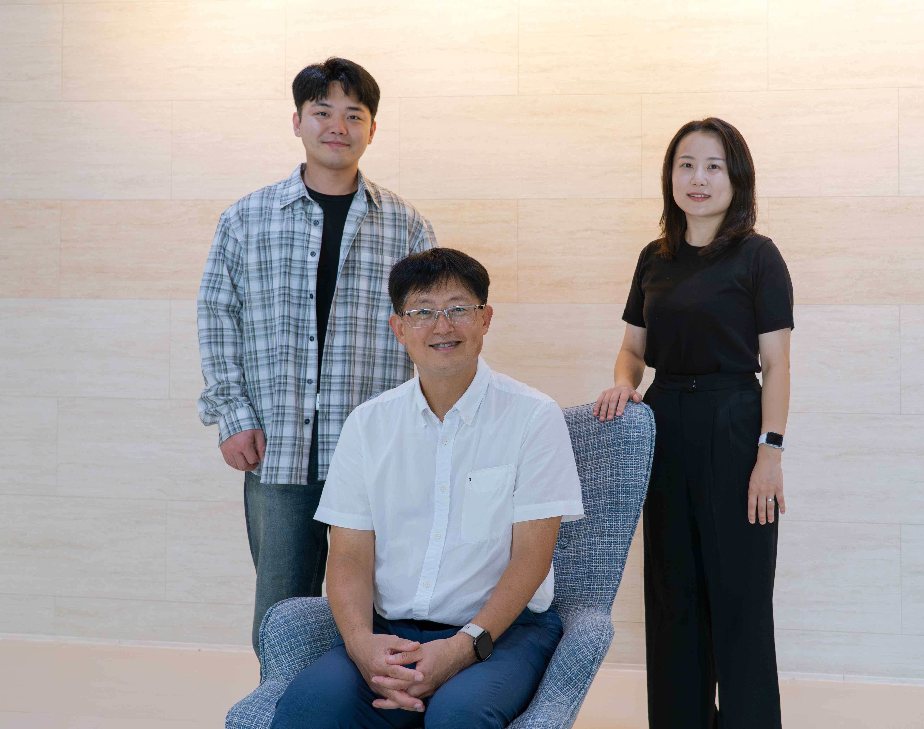

▲ (From left) Dr. Jae Hun Lee, Professor Inchan Kwon, and Ph.D. candidate Na Hyun Kwon of the Department of Materials Science and Engineering

The Gwangju Institute of Science and Technology (GIST, President Kichul Lim) announced that a research team led by Professor Inchan Kwon of the Department of Materials Science and Engineering, in collaboration with researchers at the University of Virginia School of Medicine, has developed "Albubody," a novel anticancer treatment platform that overcomes the limitations of existing antibody-drug conjugates (ADCs).

This achievement holds significant academic and industrial significance as it resolves the short half-life in the body, which is a major obstacle to the development of anticancer drugs based on small antibody fragments.

* antibody: A protein produced by the body's immune system to recognize and eliminate foreign invaders such as bacteria and viruses. It has a Y-shaped structure and possesses high specificity, allowing it to precisely distinguish and bind to specific antigens.

* antibody-drug conjugate (ADC): A targeted therapy that chemically binds a potent anticancer drug to an antibody that recognizes cancer cells. The antibody precisely locates and binds to cancer cells, releasing the drug only there to kill them. It is gaining attention as a "personalized anticancer drug" because it can maximize anticancer effects while minimizing damage to normal cells. Clinical trials and commercialization are currently actively underway for various cancer types.

Antibody-drug conjugates (ADCs) are targeted therapies that selectively and precisely attack cancer cells, minimizing damage to normal cells while maximizing anticancer effects. They are attracting attention as "personalized anticancer agents." To date, 15 drugs have received FDA approval, and over 100 are in clinical trials.

However, most commercially available ADCs are based on large antibodies (IgG*). Their large size makes it difficult to evenly penetrate tumors and their therapeutic effects are unstable.

* immunoglobulin G (IgG): One of the most abundant antibodies in the body, it is widely distributed in blood and body fluids and effectively neutralizes and eliminates pathogens such as bacteria and viruses. However, its large size limits its penetration into tumors.

In contrast, scFv fragments (scFvs)* are small and can penetrate deep into cancer tissues. However, their short half-life in the blood of only about an hour, resulting in rapid clearance from the body, has limited their clinical application.

* antibody fragment (scFv, single-chain variable fragment): A lightweight, simple antibody fragment composed of only the antigen-recognition region of an antibody. It consists of two variable regions (VH and VL) linked by a short peptide. Its small molecular size allows for rapid and even penetration into cancer tissues. However, its short blood half-life limits its rapid clearance from the body. Various studies are underway to address this issue.

To address this issue, the research team developed a novel antibody fragment platform, called "Albubody," that combines the advantages of small antibody fragments (rapid tumor penetration) with those of albumin (long in vivo half-life).

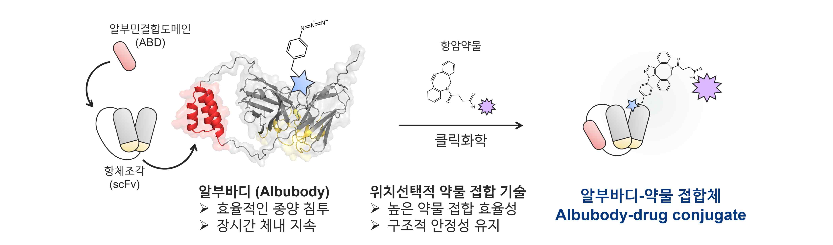

▲ Albubody-drug conjugate. An Albubody is a recombinant antibody fragment fused to an ABD (antibody binding domain) to scFv. It enables efficient tumor penetration and prolonged retention in the body. Using highly efficient and stable site-selective drug conjugation technology, the team synthesized the Albubody-drug conjugate.

Albumbodies are recombinant proteins designed to bind to albumin in the body by inserting an albumin-binding domain (ABD) into an antibody fragment. This allows them to circulate in the blood for a long time by utilizing the body's persistence mechanism of albumin.

In fact, albumbodies have a retention time over 200 times longer in the body than existing antibody fragments and possess superior tumor penetration capabilities compared to the large antibody immunoglobulin G (IgG), demonstrating their potential as a next-generation anticancer drug platform.

* albumin: The most abundant protein in the blood, albumin plays a crucial role in transporting hormones, fatty acids, and drugs within the body and maintaining osmotic pressure. Its large molecular weight and long blood half-life of approximately three weeks allow drugs bound to albumin to circulate longer in the body and to accumulate selectively in tumor tissue.

* albumin-binding domain (ABD): A short protein fragment designed to bind strongly to albumin in the body. When attached to antibodies or drug delivery systems, it allows prolonged circulation in the blood along with albumin. Albumin's long half-life (approximately 3 weeks) and its ability to selectively accumulate in tumor tissues can be utilized to enhance the in vivo stability of antibody fragments or therapeutic proteins and enhance their anticancer efficacy.

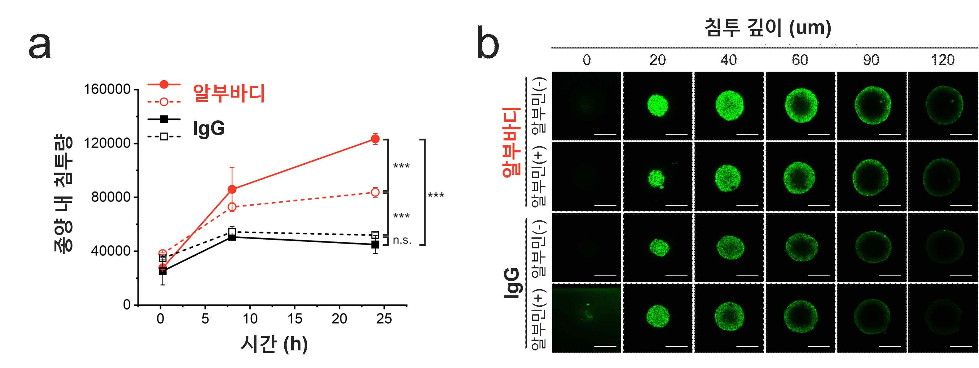

▲ Albumin exhibits superior tumor penetration compared to conventional IgG. In a tumor penetration experiment using 3D tumor spheroids, Albumin demonstrated superior tumor penetration compared to IgG.

The research team applied click chemistry*-based regioselective drug conjugation technology to develop an Albumin-drug conjugate targeting HER2*, a protein receptor overexpressed in breast and gastric cancers that promotes cancer cell growth and metastasis.

This design allowed the drug to bind precisely to a specific site on the antibody fragment, thereby simultaneously enhancing the synthesis efficiency and stability of the antibody-drug conjugate.

In biodistribution experiments, unlike conventional antibody fragments, Albumin accumulated in tumor tissue for a long period of time, demonstrating effective anticancer effects. Furthermore, its safety was confirmed by the absence of toxicity in normal tissues.

* HER2 (Human Epidermal Growth Factor Receptor 2): A receptor tyrosine kinase present on the cell surface, it regulates cell growth and differentiation. In some cancers, such as breast and stomach cancer, gene amplification or protein overexpression occurs, promoting cell growth and metastasis.

* click chemistry: A general term for chemical reactions that rapidly and selectively link different molecules together, as if "clicking" together. It is stable in the biological environment and has few side effects, making it widely used for precisely conjugating drugs to proteins or antibodies.

The synthesized albumin-drug conjugate demonstrated superior in vivo persistence and deep penetration into tumor tissue, demonstrating outstanding anticancer efficacy in a mouse model transplanted with HER2-positive breast cancer cells.

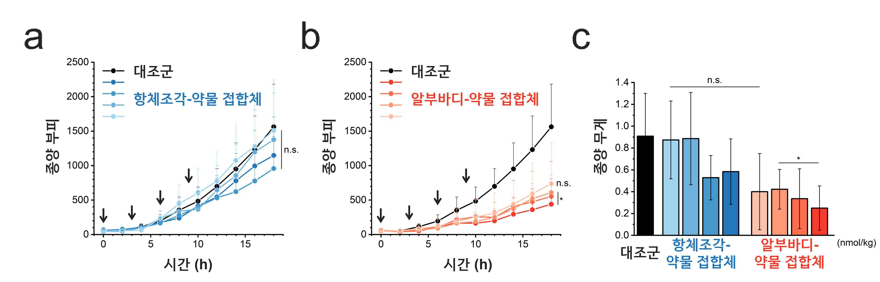

▲ Albumin-drug conjugate demonstrating superior anticancer efficacy compared to existing antibody-drug conjugates. In a breast cancer cell xenograft mouse model, the albumin-drug conjugate demonstrated superior tumor growth inhibition compared to existing antibody-drug conjugates with shorter in vivo persistence.

This technology can be applied to other target antigens and drugs, raising the possibility of developing into a universal anticancer treatment platform.

Professor Inchan Kwon stated, "Overcoming the short half-life, the biggest weakness of antibody-fragment-based anticancer agents, through albumin binding technology is significant. If combined with various anticancer agents and applied clinically, this could lead to more effective and safer cancer treatments."

This research, supervised by Professor Inchan Kwon of the Department of Materials Science and Engineering at GIST and conducted by doctoral students Na Hyun Kwon and Jae Hun Lee, was supported by the Individual Basic Research Program (Mid-Career Researcher) of the Ministry of Science and ICT and the National Research Foundation of Korea. The results were published online in the international academic journal 《Journal of Controlled Release》 on August 22, 2025.



