"Preventing the Shrimp Farming 'Disaster' of Mass Deaths in Ten Days" GIST develops an electrochemical sensor that diagnoses shrimp white spot disease in 15 minutes

- Professor Sung Yang's team from the Department of Mechanical and Robotics Engineering has developed a molecularly imprinted polymer-based electrochemical biosensor that detects white spot virus infection, which causes billions of dollars in annual aquaculture damage, in just 15 minutes without antibodies

- This low-cost, high-efficiency field diagnostic technology with PCR-level accuracy can be applied not only to the early diagnosis of various aquatic viruses but also to food safety and human infectious disease diagnosis... Published in the international journal 《Sensors and Actuators Reports》



▲ (From left) Professor Sung Yang of the Department of Mechanical and Robotic Engineering at GIST, and Dr. Young-Ran Yun

The Gwangju Institute of Science and Technology (GIST, President Kichul Lim) announced that a research team led by Professor Sung Yang of the Department of Mechanical and Robotics Engineering has developed an electrochemical-based biosensor capable of rapidly and accurately diagnosing white spot syndrome virus (WSSV), which has caused significant damage to the shrimp aquaculture industry.

The newly developed sensor is expected to contribute to preventing large-scale damage by enabling real-time detection of virus infection in aquaculture farms and early intervention. Furthermore, the electrochemical sensor platform based on a molecularly imprinted polymer (MIP)* can be used not only for white spot virus detection but also for the early diagnosis of various aquatic viruses and zoonotic diseases.

* molecularly imprinted polymer (MIP): An artificial polymer material engineered to selectively recognize specific molecules. During the fabrication process, MIP interacts with target molecules to form a "molecularly imprinted" structure, enabling accurate detection even if the target molecule is present in the sample. Due to these properties, MIPs are used as artificial receptors to replace natural antibodies or enzymes in various fields such as sensors, separation and purification, and drug delivery.

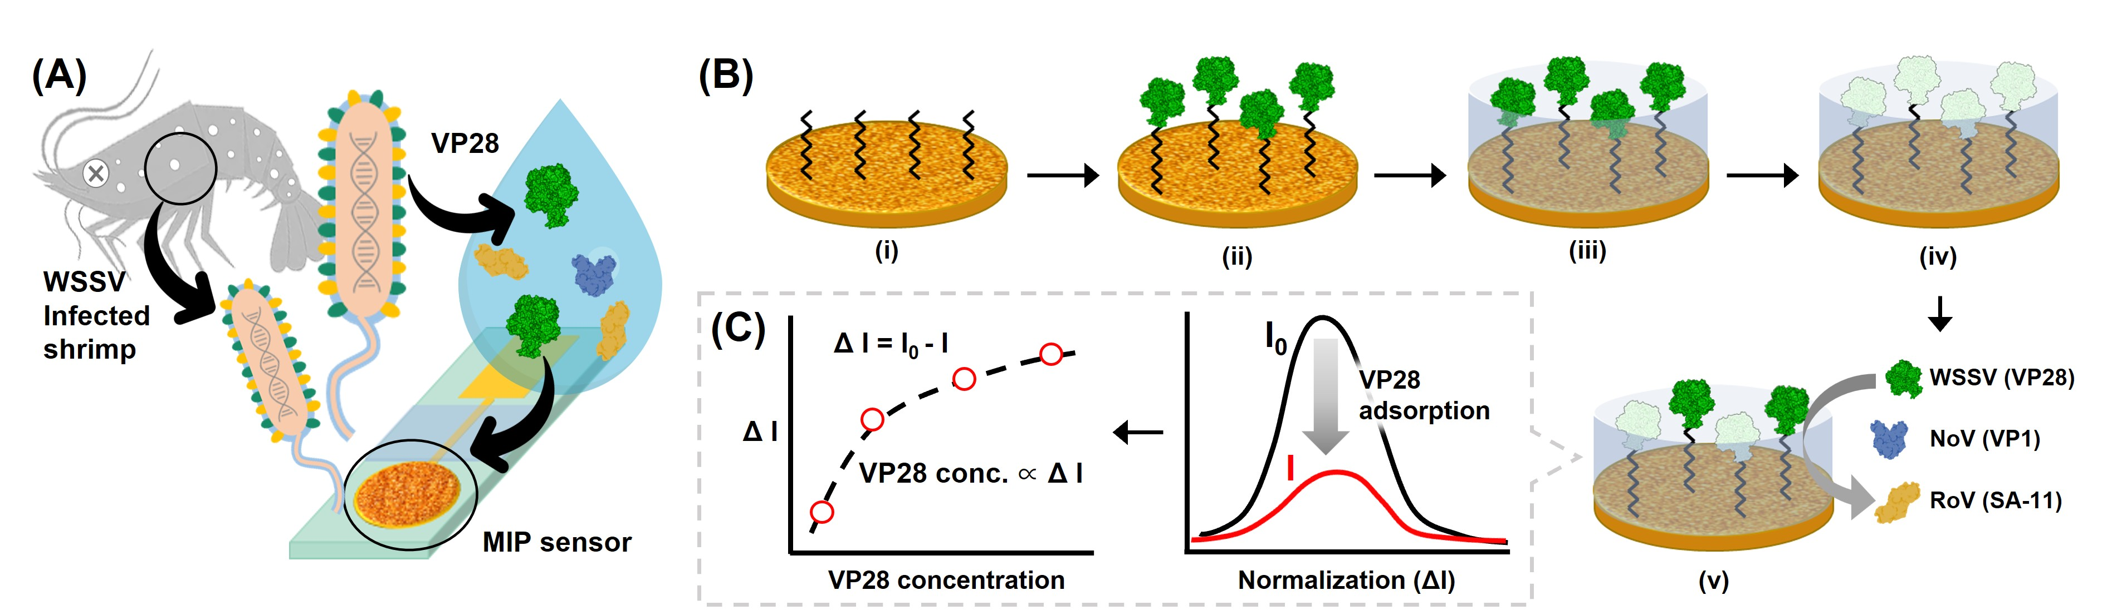

▲ Schematic diagram of the white spot virus (WSSV) detection principle using a molecularly imprinted polymer-based biosensor. (A) To detect the coat protein VP28, a diagnostic indicator for white spot disease, (B) a molecularly imprinted polymer was used on the surface of gold nanoparticles to ensure sensitivity and specificity. (C) The developed sensor quantitatively assessed the coat protein of the white spot virus through electrochemical signal analysis.

White spot syndrome virus (WSSV) infects crustaceans such as shrimp and causes white spot disease*, a lethal virus that can cause mass mortality within just 10 days. It causes billions of dollars in economic losses to the global aquaculture industry every year. Currently, there is no commercially available vaccine, so early identification and isolation of infected individuals is the only way to minimize damage.

Conventional PCR (polymerase chain reaction) tests offer high accuracy, but they require expensive equipment, skilled personnel, and analysis times exceeding several hours, making them difficult to apply in the field. Accordingly, the development of low-cost, high-speed, and highly accurate point-of-care diagnostic technologies has been urgently needed.

* white spot disease (WSD): This disease is caused by the white spot syndrome virus (WSSV), a lethal infection in crustaceans such as shrimp. Infection causes white spots on the outer shell, followed by loss of appetite and decreased activity, which can lead to mass mortality within days. It is a representative aquatic disease that causes significant economic damage to the global farmed shrimp industry. Once infected, the mortality rate can reach 100% within 10 days. Currently, there are no vaccines or treatments, making early diagnosis and rapid isolation key to preventing the spread of the disease.

The research team applied a "molecularly imprinted polymer (MIP)" to the surface of a previously developed gold nanoparticle electrode to establish a novel electrochemical sensor platform capable of precisely recognizing "VP28," the signature protein of the white spot syndrome virus (WSSV).

The polymer used here is made of small molecules called "o-aminophenol" linked together repeatedly. Electrochemically coating this polymer on the electrode surface creates a recognition site that perfectly matches the "VP28" protein. This allows for high accuracy and specificity without the use of expensive biomaterials such as antibodies or enzymes.

Performance evaluation results showed that the sensor achieved a low limit of detection (LoD)* of 7 nanograms per milliliter (ng/mL)*, demonstrating superior sensitivity to existing techniques. Compared to other viral proteins, such as norovirus (NoV) and rotavirus (RoV), it exhibited approximately 4.5 times higher selectivity. The analysis time was also extremely short, under 15 minutes, enabling rapid diagnosis.

Even after reusing the same electrode three or more times, the signal change remained within 13%, confirming its economic feasibility.

Furthermore, the sensor demonstrated accuracy similar to standard PCR tests in actual infected shrimp tissue and farm water samples and maintained stable performance even in high-salinity environments, demonstrating its immediate applicability in aquaculture settings.

* nanograms per milliliter (ng/mL): A unit of concentration representing the amount of a substance contained in 1 milliliter (mL) of a solution in nanograms (ng, one billionth of a gram). It is commonly used in life sciences, medicine, and chemistry.

* limit of detection (LoD): This refers to the lowest concentration at which an analytical method or device can reliably detect a specific substance in a sample. In other words, accurate detection is difficult when the concentration of a substance in a sample is lower than the LoD, and its presence can only be confirmed when it is above the LoD. The LoD is typically calculated through background signal and statistical analysis and is an important criterion for assessing or validating the sensitivity of an analytical method.

* norovirus (NoV) and rotavirus (RoV): Enteroviruses commonly found in marine environments cause gastroenteritis, including vomiting and diarrhea. They are also considered a major cause of water pollution in aquaculture farms.

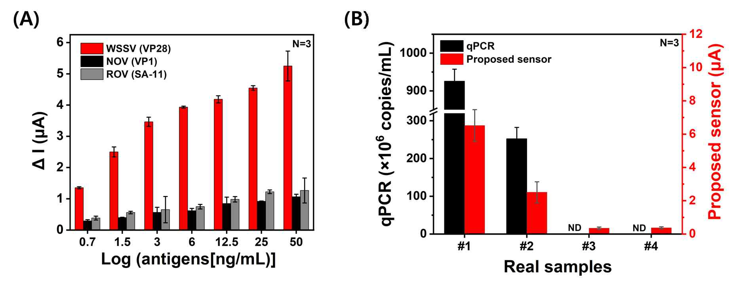

▲ Performance verification of the developed sensor. The developed sensor (A) demonstrated a current signal difference approximately 4.5 times higher than that of NoV and Rotavirus (RoV), and (B) demonstrated virus detection trends similar to standard PCR tests in actual shrimp tissue (#1, 2) and farmed seawater (#3, 4) samples.

Unlike existing immunoassay methods (PCR, ELISA, LFA),* the electrochemical sensor developed by the research team is simple to manufacture, can be mass-produced at low cost, and offers practicality for immediate use in the field. Therefore, it is expected to establish itself as a next-generation field diagnostic platform that simultaneously delivers the high accuracy of PCR and the convenience of rapid testing.

* immunodetection methods (PCR, ELISA, LFA): These are technologies that selectively detect and quantify specific proteins, antigens, antibodies, or genetic material in a living organism. They are appropriately utilized based on sensitivity, specificity, analysis speed, and field applicability, and are widely used in diverse fields such as diagnostics, environmental analysis, and food safety.

Professor Sung Yang stated, "This research has enabled early diagnosis and prevention of infectious diseases in aquaculture settings using a low-cost, high-efficiency field diagnostic platform." He added, "In the future, it can be expanded into a variety of virus diagnostic platforms and applied to fisheries, food safety, and human infectious disease diagnosis."

This research, supervised by Professor Sung Yang of the Department of Mechanical and Robotics Engineering at GIST and conducted by Dr. Young-Ran Yun as first author, was supported by the Ministry of Science and ICT and the National Research Foundation of Korea's Mid-Career Researcher Support Program. The results were published online in the international journal 《Sensors and Actuators Reports》 on August 17, 2025.



