"Even in a zero-gravity space station, the rotational error is only 1.43°" GIST-NASA develop a space robot direction control technology that accurately finds a three-dimensional target point

- Professor Pyojin Kim's team from the Department of Mechanical and Robotics Engineering at GIST, in collaboration with NASA's Ames Research Center, developed a robotic compass technology that maintains orientation even on a space station without any up or down orientation

- "Digital Twin" technology, which virtually replicates the actual space environment, and "absolute attitude" estimation enable precise control... Expected to be used not only in space but also in indoor spaces such as airports, hospitals, and warehouses

- Presented at the "2nd Space Robotics Workshop," held in conjunction with the IEEE International Conference on Space Mission Information Technology and Space Computing (SMC-IT/SCC 2025)

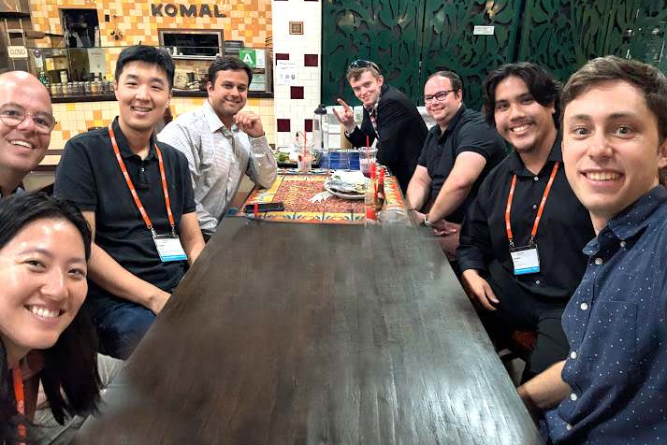

▲ Professor Pyojin Kim's research team from the Department of Mechanical and Robotics Engineering at GIST and a joint research team from NASA's Ames Research Center are taking a commemorative photo after the workshop.

The Gwangju Institute of Science and Technology (GIST, President Kichul Lim) announced that Professor Pyojin Kim's research team in the Department of Mechanical and Robotics Engineering, in collaboration with NASA, has developed a "digital twin*-based visual compass technology" that helps robots navigate stably and without losing direction even in complex environments like the International Space Station (ISS).

This research follows the development of "Astrobeet*," the world's first dataset for ISS indoor autonomous navigation, which Professor Pyojin Kim's team, in collaboration with NASA, built and released in March of this year. Based on this dataset, the team conducted experiments under conditions similar to real-world space environments, demonstrating the accuracy and effectiveness of the technology.

* digital twin: A digital model of a real-world physical system or space (e.g., a space station, a city, a factory, etc.) that is precisely replicated and replicated in a virtual space based on real-time data. This allows for remote monitoring of the status of the actual system and allows for various simulations and predictions in a virtual environment, which is utilized for maintenance, operation optimization, and risk analysis. In the space sector, digital twins are used to simulate the internal environment of a space station, robot movements, and equipment status, contributing to increased mission safety and efficiency.

* Astrobee: An autonomous flying robot developed by NASA for use within the International Space Station (ISS). It freely navigates zero-gravity space, performing missions such as assisting experiments, monitoring equipment, and transporting supplies. Designed in a compact cube shape, Astrobee perceives its environment through built-in sensors and cameras and supports astronauts' tasks through remote control or autonomous navigation. Digital twin technology is also being used to simulate robot behavior in a virtual space and precisely reproduce the conditions inside the ISS.

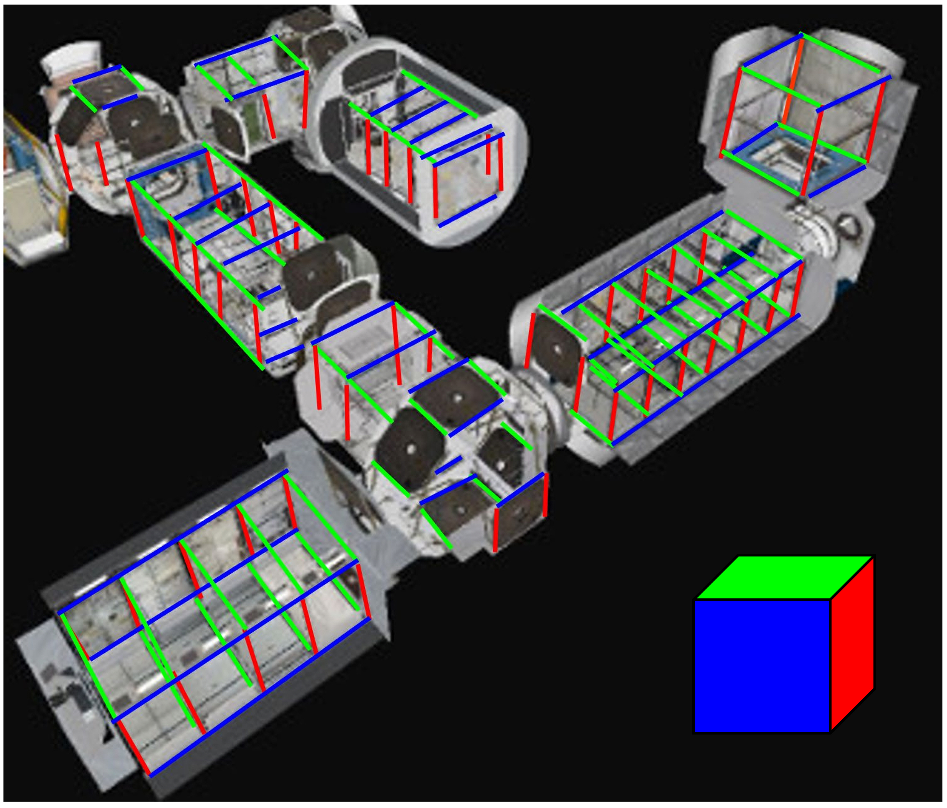
▲ The International Space Station (ISS) is a prime example of a space station that satisfies the Manhattan World (MW) assumption, with the three major vertical directions (orthogonal directions) visualized in red, green, and blue.

The ISS operates in microgravity, with no distinction between up and down, making it difficult for robots to perceive their orientation and navigate.

In particular, the Astrobee robot, operating in zero gravity, frequently rotates freely in place, both forward and backward and left and right. This often leads to failures in orientation recognition using existing visual navigation techniques.

To address this issue, methods leveraging the structural regularity of space, such as the "Manhattan World" model*, are being used, which assumes that building structures are aligned horizontally and vertically.

However, the interior of the ISS is complexly intertwined with facilities and floating objects, making accurate recognition difficult due to the often obscured or blurred structural features such as lines and walls.

* Manhattan World model: A spatial structure model based on the assumption that most buildings and indoor structures are aligned horizontally and vertically, and is widely used in robot position recognition and computer vision.

To overcome these limitations, the research team developed a new technique that uses "digital twin" technology to build a 3D indoor spatial orientation map and utilizes it to accurately determine a space robot's absolute orientation (Drift-Free & Absolute Orientation) without accumulated errors.

The core principle is to compare and verify structural lines detected in actual footage with a digital twin model, eliminating confusing or unnecessary lines and selecting only reliable structures.

* absolute orientation (drift-free & absolute orientation): This refers to the robot's ability to accurately perceive and maintain its own orientation regardless of time or distance traveled. While conventional vision-based navigation can lose its sense of direction due to accumulated errors (drift) over time, absolute orientation estimation techniques can accurately determine orientation without this accumulated error, even without an external reference. This makes them particularly valuable in complex and confined spaces, such as indoors or space, where GPS is unavailable.

By utilizing only these intelligently selected, reliable lines and planes, space robots can reliably and accurately track their orientation in three-dimensional space.

This has secured a core technology that will enable accurate and lightweight autonomous flight not only in space robots but also in complex indoor environments.

The research team demonstrated the superiority of this technology through experiments utilizing the world's first dataset for ISS autonomous flight robots, developed and released through a GIST-NASA joint research project.

The experiment revealed that the "absolute rotation error (ARE)*," a representative indicator of a robot's rotational accuracy, averaged only 1.43°, demonstrating the technology's suitability for precise attitude control, exploration, and operations. Furthermore, the technology's real-time applicability was confirmed with a computational speed of approximately 20 milliseconds (0.02 seconds) per frame.

* absolute rotation error (ARE): This metric quantifies the difference between the predicted and actual rotations in degrees. It is primarily used to evaluate performance in applications such as camera pose estimation, SLAM, and 3D reconstruction. The rotation angle is extracted and calculated from the error matrix obtained by multiplying the actual rotation matrix and the predicted rotation matrix. The closer it is to 0°, the better the two rotations match. Therefore, ARE is used as a key indicator that can evaluate only the rotation accuracy regardless of the position (translation).

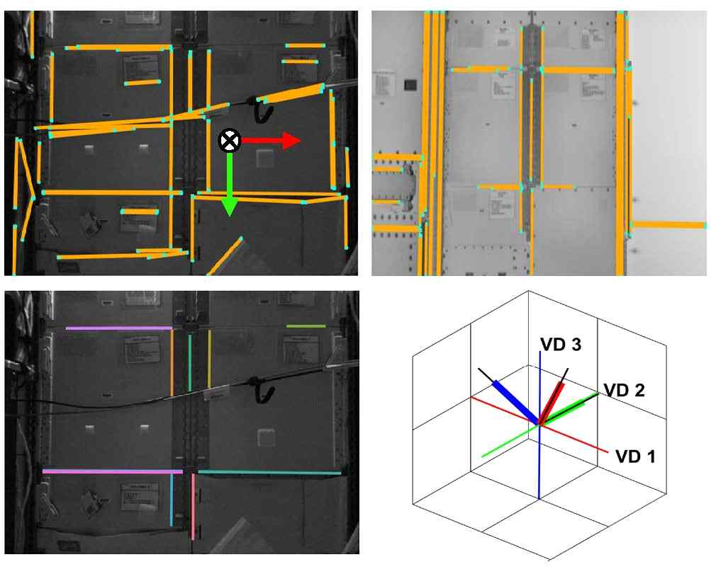

▲ All lines detected in the ISS image (top left) and their corresponding rendered image from a 3D CAD digital twin (top right) reveal a highly complex and cluttered scene. Unreliable features resulting from the clutter are distinguished from structural features aligned to the ISS's Manhattan frame (bottom left), enabling accurate estimation of the camera's orientation without drift (bottom right).

Professor Pyojin Kim stated, "This research demonstrates technology that enables robots to navigate autonomously without losing their bearings, even in extreme environments like the space station." He added, "We anticipate that this digital twin-based technology will enable accurate pathfinding for autonomous robots in complex indoor spaces such as airports, hospitals, and warehouses."

This research, supervised by Professor Pyojin Kim and conducted by doctoral student Jungil Ham of the Department of Mechanical and Robotics Engineering at GIST, was supported by the Ministry of Science and ICT and the National Research Foundation of Korea (NRF)'s Outstanding Young Researcher Program and the GIST International Research Experience Fellowship (IREF). It was conducted in collaboration with NASA's Ames Research Center, one of NASA's key research centers.

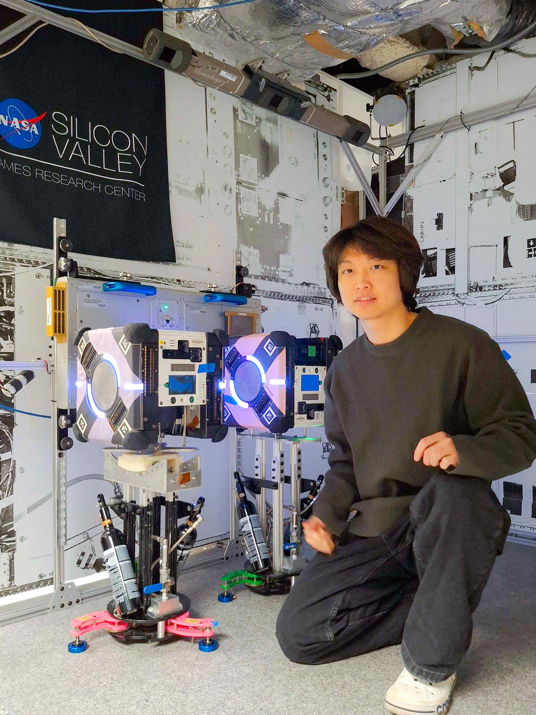

▲ Jungil Ham, a student of the Department of Mechanical and Robotics Engineering at GIST, conducts research at NASA Ames Research Center's Granite Lab (a research facility that simulates the International Space Station environment on Earth and tests space robots).

The research results were announced on Tuesday, July 29th at the 2nd Space Robotics Workshop held at the California Science Center in Los Angeles, USA, in conjunction with the IEEE (Institute of Electrical and Electronics Engineers) International Conference on Space Mission Information Technology and Space Computing (SMC-IT/SCC 2025), a representative academic event in the field of space robotics.



