"There were reasons why greenhouse gases alone couldn't 100% explain the changes." GIST analyzed changes in Arctic sea ice to elucidate the complex interactions among climate factors, revealing new insights into the impact of aerosols.

- An international joint research team led by Professor Jin-Ho Yoon of the Department of Environment and Energy Engineering confirmed that the combined effects of greenhouse gases and aerosols generated by human activities are accelerating sea ice loss in the Chukchi Sea.

- Aerosol-inclusive climate model doubles Arctic climate change predictions... "A response that considers the 'aerosol-atmospheric circulation-ocean heat transport' chain reaction is necessary," the study, published in the international journal 《Communications Earth & Environment》, found.



▲ (From left) Professor Jin-Ho Yoon and doctoral student Yungi Hong of the Department of Environment and Energy Engineering

Aerosols*, such as fine dust and sulfates generated by human activities, have a "cooling effect," reflecting sunlight and cooling the Earth, and are known to be a factor in suppressing global warming.

Consequently, discussions regarding the primary cause of climate change have been limited to greenhouse gases. However, GIST and an international joint research team recently presented a new perspective through climate model experiments: aerosols are not simply coolants; they can act as catalysts, altering atmospheric circulation and accelerating Arctic ice melt.

* aerosol: refers to very small solid or liquid particles suspended in the air. These include fine dust, ultrafine dust, smoke, and fog, and can be generated by natural or anthropogenic factors.

The Gwangju Institute of Science and Technology (GIST, President Kichul Lim) announced that an international joint research team led by Professor Jin-Ho Yoon of the Department of Environment and Energy Engineering discovered through a large-scale ensemble analysis of the Global Earth System Model (CESM2)* that aerosols caused by human activities strengthen the North Pacific high-pressure system, which in turn increases oceanic heat transport through the Bering Strait, ultimately accelerating sea ice loss in the Chukchi Sea.

This study reaffirms the complex interactions of the Earth's climate system, as air pollution caused by industrialization in Asia can impact the Arctic climate on the other side of the globe.

* Global Earth System Model 2 (CESM2): A global climate simulation model developed under the leadership of the U.S. National Center for Atmospheric Research (NCAR). It is used to predict future climate by computerizing the interactions between Earth's components, including the atmosphere, ocean, land, and cryosphere.

* ensemble analysis: Rather than relying on a single climate prediction result, this technique analyzes multiple simulation results (ensembles) with slightly different initial conditions or model settings to determine average values and uncertainties. This allows for more reliable predictions and variability analysis.

The Arctic is warming approximately four times faster than the global average, and the Chukchi Sea, in particular, is the region experiencing the fastest sea ice loss within the Arctic.

In particular, according to a recent analysis by the NSIDC ("Arctic sea ice sets a record low maximum in 2025," March 27, 2025), the maximum Arctic sea ice extent in March 2025 reached its lowest level in 47 years of satellite observations. This indicates that Arctic sea ice loss is accelerating.

* National Snow and Ice Data Center (NSIDC): Located at the University of Colorado, Boulder, NSIDC is a specialized research institute that collects, stores, and analyzes data on the cryosphere, including snow, ice, glaciers, and sea ice, across the Earth, including the Arctic and Antarctic. It utilizes satellite observation data and climate models to provide information on environmental changes in polar regions.

The research team confirmed that the increased fine dust in Asia between 1980 and 2020 intensified the high pressure over the North Pacific, strengthening southerly winds and increasing the inflow of warm ocean water into the Arctic.

This has caused sea temperatures in the Chukchi Sea in the western Arctic to rise and sea ice to melt more quickly.

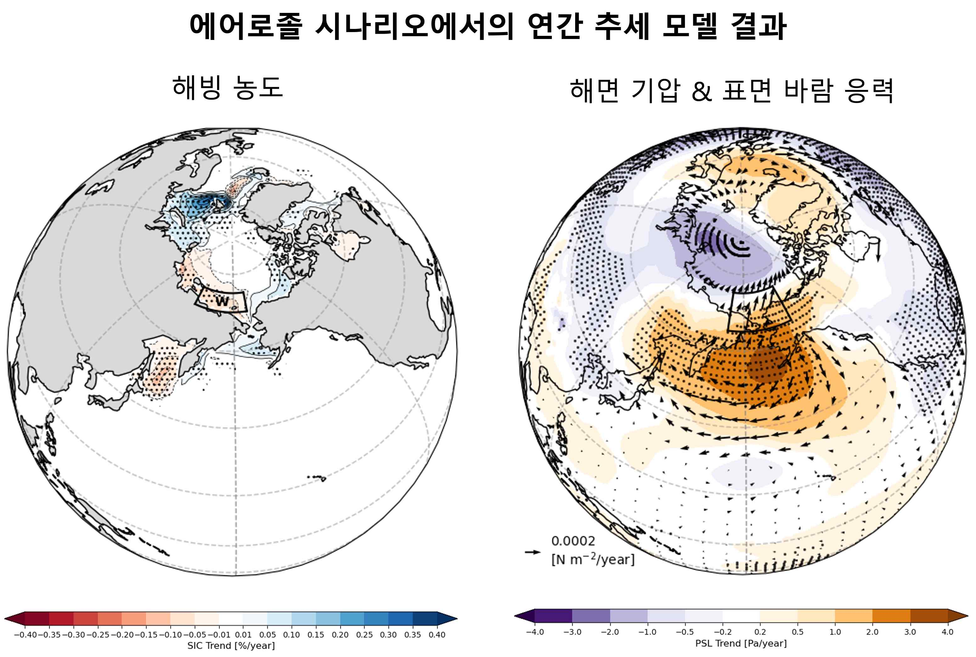

▲ Annual trend maps from CESM2 aerosol simulations from 1980 to 2020. Annual trend maps for (left) sea ice concentration, (right) sea level pressure, and surface wind stress from 1980 to 2020. The shading in the left and right figures represents sea ice concentration and sea level pressure, respectively, while the vector represents surface wind stress. The left and right boxed regions represent the western Chukchi Sea and the Bering Strait, respectively. A significant sea ice decline trend is observed in the western Chukchi Sea region, and a high-pressure anomaly is observed in the North Pacific. These changes in atmospheric circulation enhance oceanic heat transport to the Arctic, contributing to sea ice loss.

The research team conducted three scenario experiments: ▴ greenhouse gases (GHGs) alone, ▴ aerosols alone, and ▴ greenhouse gases and aerosols together.

As a result, Arctic sea ice loss was significantly accelerated when combined with aerosols compared to greenhouse gases alone. This suggests that aerosols do not simply offset the warming effect of greenhouse gases, but rather exhibit a compound effect* that exceeds the simple sum of the two.

In particular, the aerosol-induced North Pacific high pressure intensified southerly winds, increasing the northward transport of heat through the Bering Strait, further accelerating the loss of sea ice in the Chukchi Sea.

* compound effect: A phenomenon in which two or more factors or events occur simultaneously or sequentially, resulting in a much greater impact or damage than a single factor. For example, the simultaneous occurrence of a heatwave and a drought can result in more severe climate damage than either of the two alone.

The research team explained, "In a warmer ocean environment due to greenhouse gases, aerosol-induced atmospheric circulation changes transport more heat to the Arctic, accelerating sea ice loss more than when greenhouse gases act alone."

A model that combined greenhouse gases and aerosols more accurately predicted the actual pattern of Arctic sea ice change than a model that only considered greenhouse gases. In particular, the prediction accuracy was 4.4% higher in the western Chukchi Sea region, explaining more than half (approximately 52%) of the overall sea ice change, providing a much closer approximation to reality than a model that only considered greenhouse gases (approximately 29%).

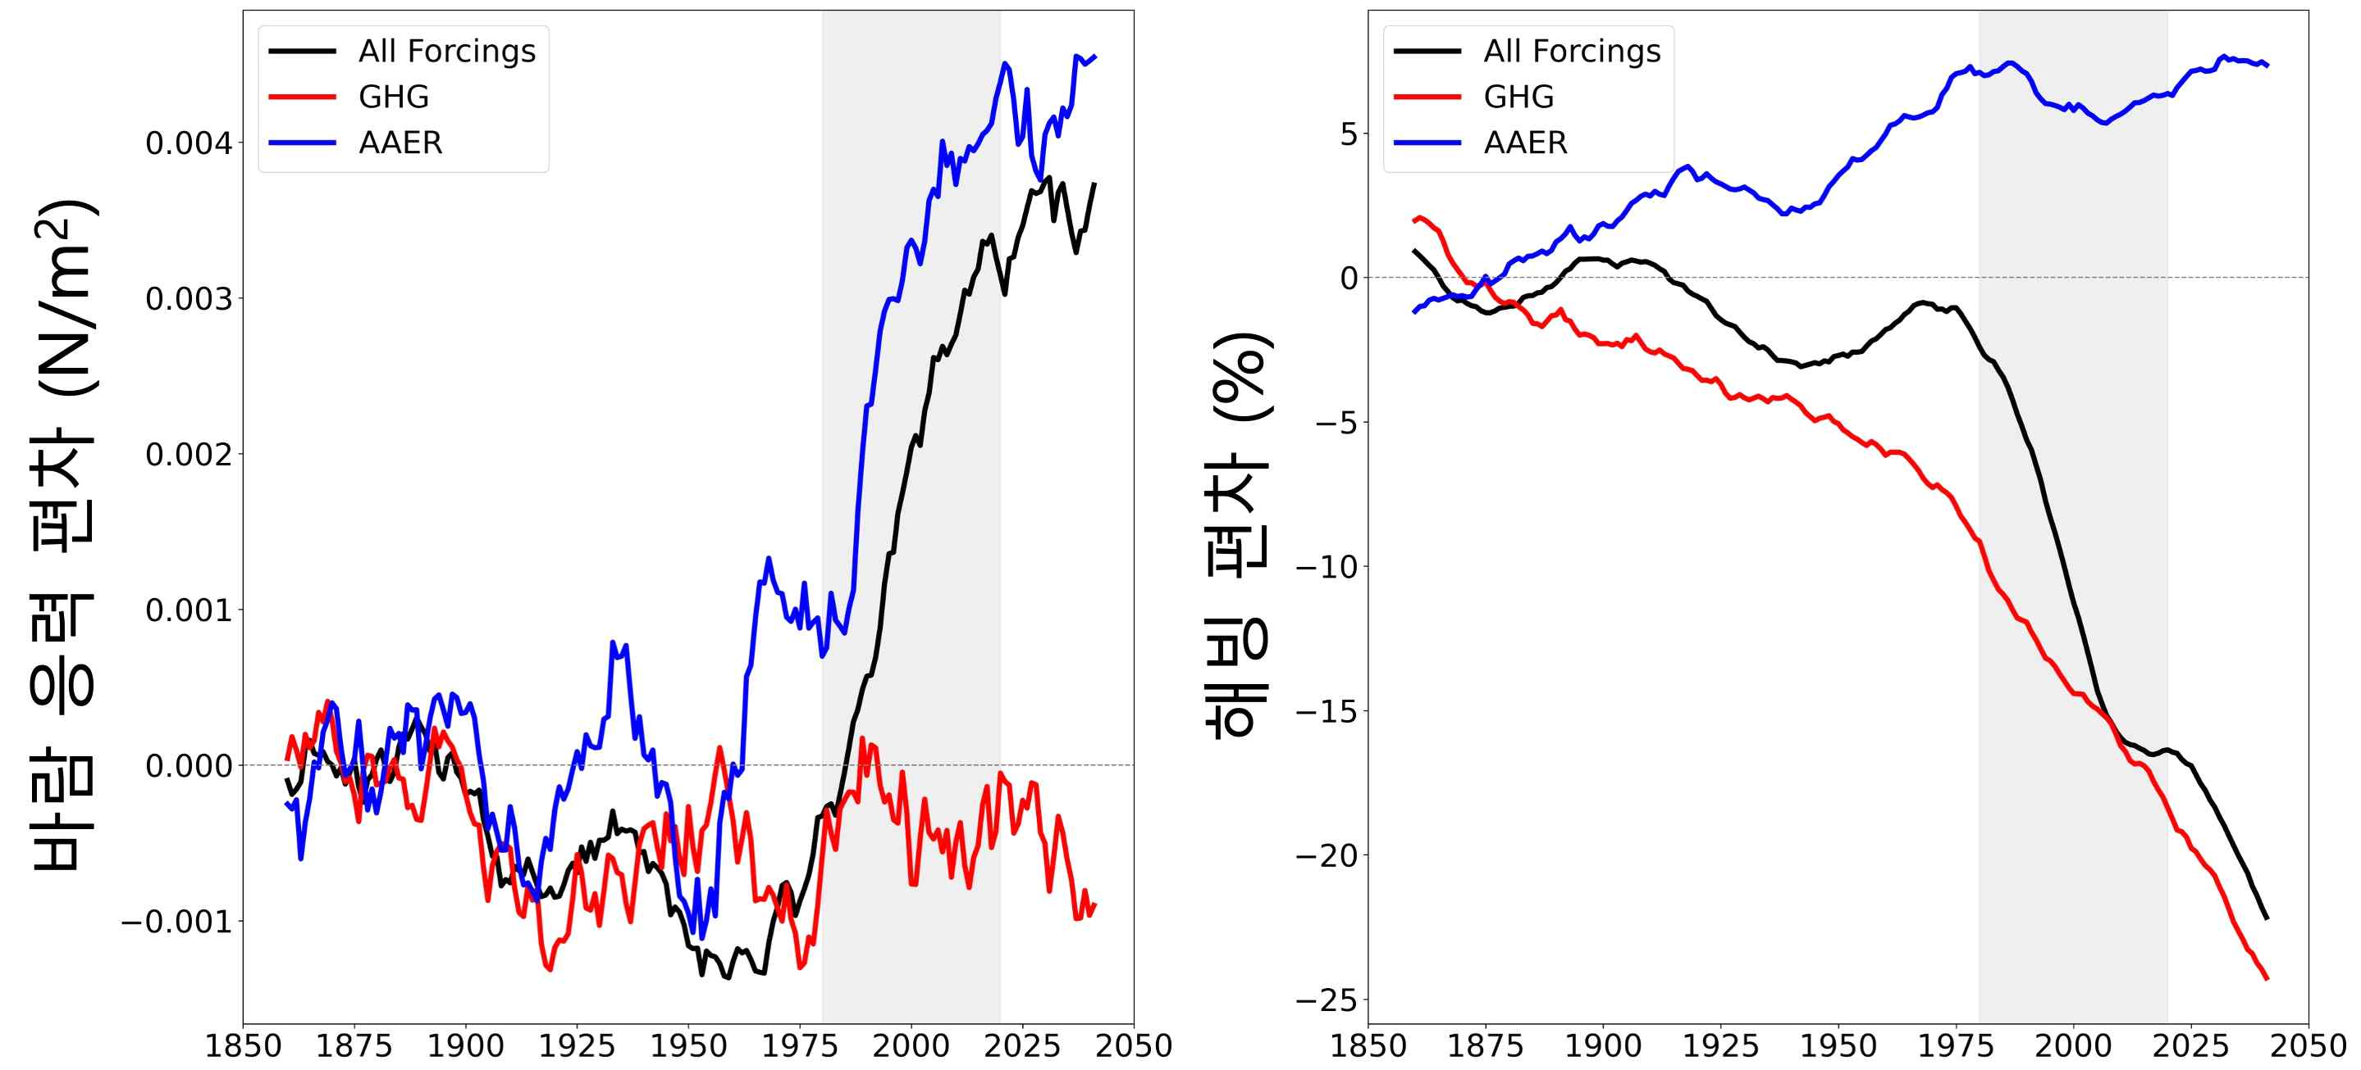

▲ 20-year moving average time series of wind stress and sea ice concentration. Graphs showing wind stress anomalies in the Bering Strait (left) and sea ice anomalies in the western Chukchi Sea (right) from 1850 to 2050. Gray shading represents the period 1980–2020, while black, red, and blue lines represent the CESM2 ALL (all-forcing), GHG (greenhouse gas forcing only), and AAER (aerosol forcing only) simulations, respectively. Over the 1980–2020 period, Arctic winds increase in the aerosol-incorporated simulations, and sea ice decreases more rapidly in the ALL simulations than in the GHG simulations. This indicates a combined effect of GHG and AAER.

This study provides new evidence that aerosols, previously considered solely a "cooling agent," can accelerate sea ice loss. Given the direct and indirect link between air pollution and Arctic climate change, future climate modeling must fully consider the complex interactions among aerosols, atmospheric circulation, and heat transport.

In particular, the fact that increased fine dust emissions due to East Asia's industrialization could impact Arctic sea ice loss suggests the need for international cooperation.

Professor Jin-Ho Yoon stated, "This study demonstrates that human activities can significantly impact the Arctic environment even in indirect ways." He added, "It is crucial to incorporate the indirect effects of aerosols into future climate modeling and international environmental policymaking."

He continued, "While climate change has been explained solely through greenhouse gases, it is urgent to develop prediction models and policies that consider the complex impacts of aerosols."

First author Yungi Hong, a doctoral student scheduled to graduate in August, said, "We have shown that aerosols not only have a cooling effect but can also influence the Arctic climate by inducing changes in atmospheric circulation. This research will make a significant contribution to understanding the complexity of the climate system."

This research, led by Professor Jin-Ho Yoon and doctoral student Yungi Hong of the Department of Environment and Energy Engineering at GIST and jointly conducted with a team led by Professor Simon Wang of Kasetsart University in Thailand, was supported by the National Research Foundation of Korea and the Korea Environmental Industry & Technology Institute.

The results of the research were published online on July 25, 2025, in 《Communications Earth & Environment》, a prominent international journal in the field of meteorology and a sister journal of 《Nature》.



