"Detecting sound with light to see inside the body" GIST and Korea University have developed a clear 3D bioimaging technology without skin contact

- Professor Byeongha Lee's team from the Department of Electrical Engineering and Computer Science at GIST, in collaboration with Professor Wonshik Choi from the Department of Physics at Korea University, successfully developed the world's first ultrasound signal imaging and backpropagation technology, successfully achieving 3D bioimaging.

- Ultrasonic signal generation and detection using only lasers and optical sensors, achieving high-resolution 3D images up to 5 mm deep without contact and achieving 3D imaging 10 times faster (within 1 second) than existing technologies.

- From cerebrovascular and tumor diagnosis to non-destructive testing of semiconductors and nuclear power plants... Published in the international journal 《Photoacoustics》



▲ (Clockwise from top left) Professor Byeongha Lee of GIST, Professor Wonshik Choi of Korea University, Dr. Taeil Yoon of Korea University, Researcher Jeongmyo Im of GIST, Dr. Hakseok Ko of KAIST, and Professor Euiheon Chung of GIST

A Korean research team has succeeded in creating a world-first, high-resolution 3D image of the inside of a living body without direct contact with the skin, combining laser and ultrasound techniques.

This technology is expected to be widely used in medical imaging fields such as cerebrovascular disease, tumor detection, and drug response tracking, as well as in non-destructive testing in industrial settings such as semiconductor and nuclear power plant facilities.

The Gwangju Institute of Science and Technology (GIST, President Kichul Lim) announced that a team led by Professor Byeongha Lee from the Department of Electrical Engineering and Computer Science, in collaboration with Professor Wonshik Choi of the Department of Physics at Korea University, has developed an optical-based, non-contact photoacoustic tomography (PAT)* technology.

This technology is expected to revolutionize medical imaging diagnostics by overcoming existing limitations by enabling high-resolution 3D imaging of the inside of living tissue without the need for ultrasonic sensors to be placed in close contact with the skin.

* photoacoustic tomography (PAT): This technology detects the ultrasound waves (photoacoustic waves) generated by the light-absorbing region when a short laser beam is irradiated onto biological tissue, reconstructing a 3D image of the tissue's interior. This technique combines the high selectivity of light with the deep penetrability of ultrasound, enabling simultaneous, high-resolution observation of deep-body structures and physiological information. It is attracting attention in medical imaging fields such as tumor detection, vascular imaging, and drug response tracking, and holds great potential as a non-invasive, high-precision imaging technique.

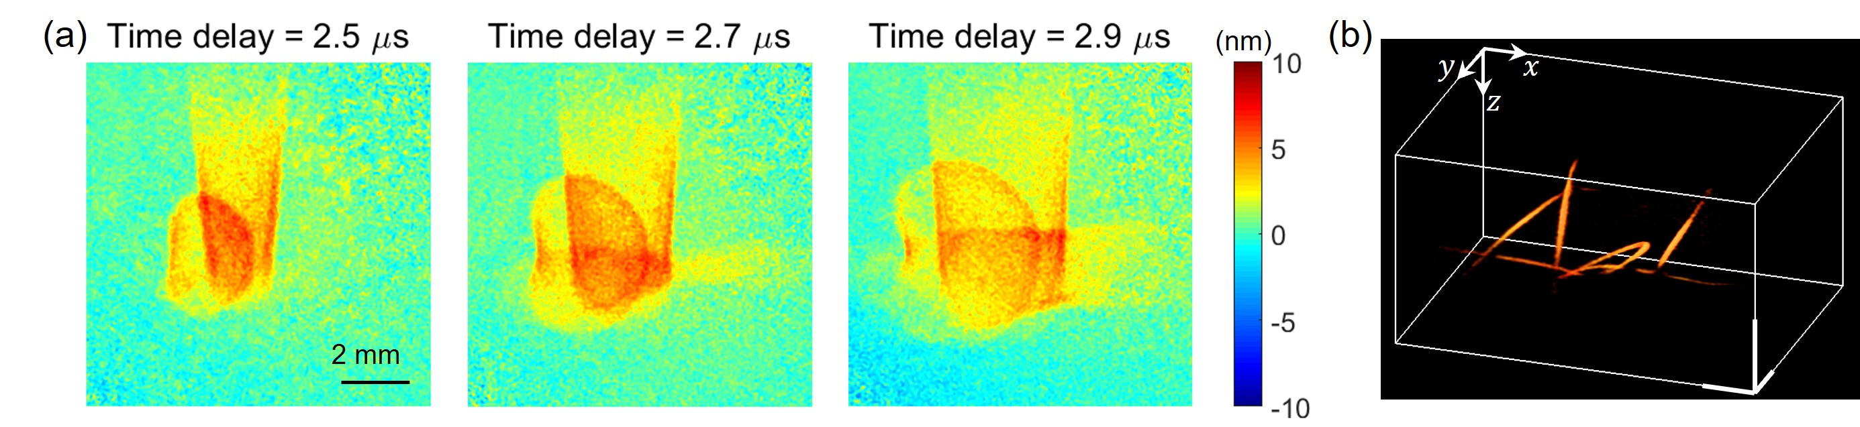

▲ Photoacoustic tomography image of an "AOL"-shaped phantom. (a) Photoacoustic ultrasound ripple image acquired from the sample surface. This image shows the propagation of ultrasound waves generated within the sample over time. (b) 3D image of the object reconstructed using a backpropagation algorithm.

PAT is a technology that detects photoacoustic waves (ultrasound) generated by tissue that absorbs the energy by briefly irradiating it with a laser, thereby reconstructing its internal structure in 3D. Combining the high selectivity of light with the deep penetrating power of ultrasound, it is useful in various fields such as tumor detection and blood vessel observation.

However, existing PAT methods require ultrasound sensors (transducers*) to be placed in close contact with the skin to receive signals. This has limited their application due to the sensor's size and shape, and has resulted in reduced sensitivity and resolution. Furthermore, PAT has been difficult to use in sensitive areas such as burns or the eye.

* ultrasound transducer (UT): A device that converts electrical signals into ultrasound, or vice versa. It serves as a sensor for transmitting and receiving ultrasound in medical imaging. Typically, this type of transducer is used in close contact with the skin for applications such as obstetrics and gynecology diagnostics and cardiac ultrasound. In photoacoustic imaging, it is used to detect photoacoustic waves (ultrasound) generated in tissue.

Accordingly, the research team developed a non-contact photoacoustic imaging system that generates and detects ultrasound signals using only lasers and optical sensors, without using any ultrasound sensors.

The team generated photoacoustic waves in tissue using a laser, then detected the minute ultrasound waves spreading across the surface of the body using digital holography*, recorded them at a video-quality level, and analyzed them to precisely reconstruct the internal vascular structure in three dimensions.

* digital holography: A technology that records light interference phenomena as digital images and interprets them with a computer to precisely visualize the three-dimensional shape or subtle movements of an object. Using coherent light, such as a laser, the interference pattern (hologram) between the light reflected from the object and a reference light is captured with a digital camera. This is then mathematically reconstructed, enabling precise measurement of the object's surface curvature, vibration, and deformation at the nanometer level. In this study, this technique was utilized to simultaneously detect minute ultrasound waves generated on a biological surface over a wide area.

In particular, by simultaneously measuring a large surface area using digital holography, much faster imaging was possible than with conventional point-by-point scanning methods.

Furthermore, a transparent and soft PDMS cover layer* was applied to detect minute surface displacements on the order of a few nanometers (nm). By averaging the "phase" (waveform position) of multiple measured signals, background noise was eliminated and only the actual signal was clearly captured, enhancing sensitivity.

* PDMS cover layer: Made of a transparent and soft polydimethylsiloxane material, applied to biological tissue surfaces, it enables precise ultrasound signal measurement even on irregular and moving surfaces. This layer reduces surface noise and increases signal sensitivity without interfering with light transmission. Its biocompatibility and flexibility contribute to improved measurement accuracy and tissue protection.

However, it is difficult to accurately identify internal structures based solely on the waveforms displayed on the surface. To address this, the research team developed a new algorithm that uses frequency-dependent backpropagation* to return information to the location where the wave originates.

In particular, by applying the single-sheet backpropagation* technique, high-resolution 3D images measuring 158 micrometers (μm) wide and 92 μm long were achieved, reaching a depth of up to 5 mm. A 3D image of a 10×10 mm2 area was processed in less than 1 second, achieving an imaging speed more than 10 times faster than conventional methods.

* backpropagation: A mathematical technique that tracks the internal location of the initial ultrasound wave origin by propagating the ultrasound wave backwards at a specific frequency on the sample surface at a specific time, and reconstructs the structure into a 3D image.

* single-sheet backpropagation: A high-speed backpropagation algorithm that reconstructs the distribution of ultrasound sources within the sample into a 3D image from the 2D ultrasound wavefront information measured on a single sheet of the sample surface.

Using this technology, the research team captured clear 3D images of the thigh blood vessels of a mouse and the chorionic blood vessels of a chicken embryo. They compared these images with actual anatomical images, confirming a high degree of agreement.

In particular, blood vessels beneath opaque layers, such as adipose tissue, were clearly identified, suggesting significant potential for applications in various medical imaging areas, including deep vascular monitoring, tumor detection, and drug response tracking.

* mouse thigh blood vessels and chorionic blood vessels (CAM) of a chicken embryo: The mouse femoral blood vessels are models that allow for precise observation of deep tissues with actual blood flow in vivo. The CAM model, located in a shallow, vascularized layer, is ideal for verifying resolution and sensitivity, both indicators of imaging performance. By using these two models in parallel, the team demonstrated both the accuracy and versatility of the technology.

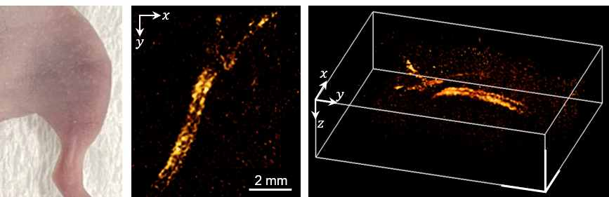

▲ Photoacoustic tomography (PAT) images of a rat thigh. (Left) Photograph of the thigh, (Middle) Reconstructed image from above, (Right) Reconstructed 3D image. Showing the distribution of blood vessels.

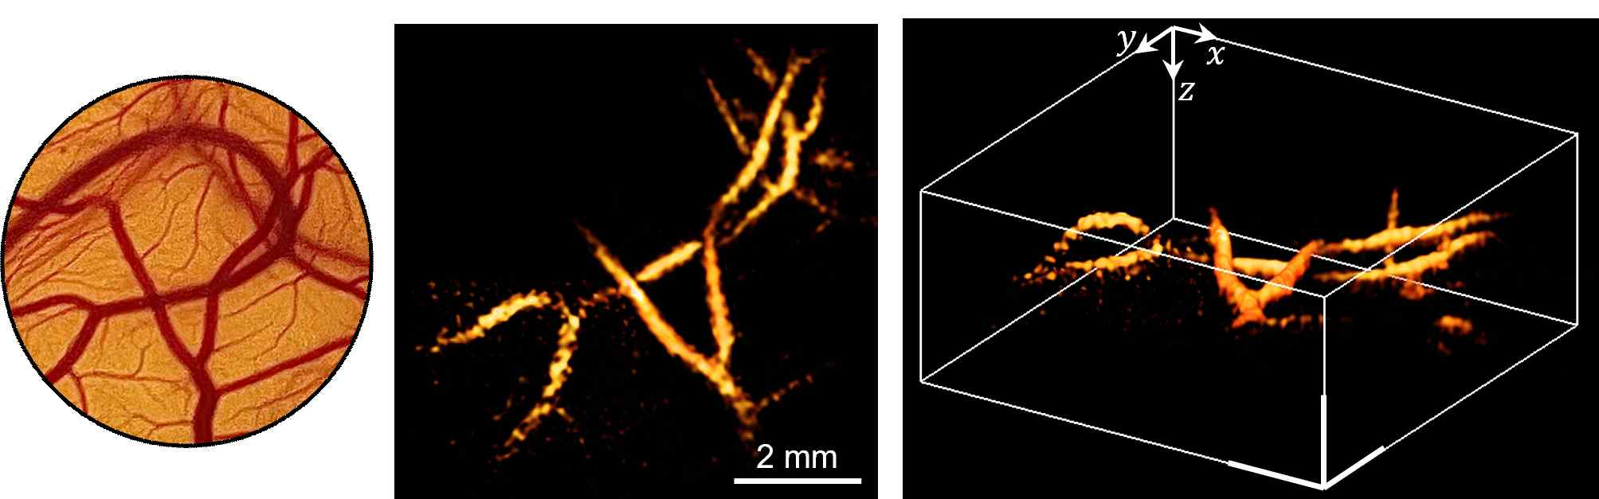

▲ Photoacoustic tomography (PAT) images of a chicken embryo. (Left) Photograph of the embryo, (Middle) Reconstructed image from above, (Right) Reconstructed 3D image. Showing the distribution of blood vessels.

Professor Byeongha Lee of GIST stated, "This research has enabled the world's first technology to rapidly measure ultrasound signals generated within a living body over a wide area using only light, without the need for direct contact with the body. This technology can be widely used in medical imaging, such as cerebrovascular disease and tumor diagnosis, as well as in non-destructive testing across industries, such as semiconductor wafers and nuclear power plants."

Professor Wonshik Choi of Korea University emphasized, "With a new backpropagation algorithm and multi-layer acoustic compensation technology, we have overcome the limitations of existing photoacoustic imaging in terms of resolution and speed. This will open a new paradigm in various fields requiring high-precision, high-speed, and non-invasive 3D imaging."

This research, led by doctoral student Yoon Tae-il under the supervision of Professor Byeongha Lee of the Department of Electrical Engineering and Computer Science at GIST, and involving Dr. Hakseok Ko (KAIST), Researcher Jeongmyo Im (GIST), Professor Euiheon Chung (GIST), and Professor Wonshik Choi (Korea University), was supported by the Ministry of Trade, Industry and Energy, the Ministry of Science and ICT, and the National Research Foundation of Korea. The results were published online in the international journal 《Photoacoustics》 on July 25, 2025.



