GIST and InnoCORE Research Group announce first results, suggesting directions for AI convergence research for early diagnosis of brain disease

- InnoCORE Fellow Postdoctoral Researcher Jun Ho Hwang achieved joint research results under the multi-mentorship of Professor Eunji Lee at GIST and Professor Gianneschi at Northwestern University... Suggests new directions for convergent research in "real-time protein imaging + AI analysis"

- Analysis of protein aggregation phenomena that cause brain diseases through the convergence of real-time transmission electron microscopy images and machine learning-based AI, promising the development of a platform for disease prediction, early diagnosis, and treatment... Published in the international journal 《Matter》
▲ (From left) Dr. Jun Ho Hwang and Professor Eunji Lee of the GIST InnoCORE Research Group, and Professor Nathan C. Gianneschi of Northwestern University in the United States

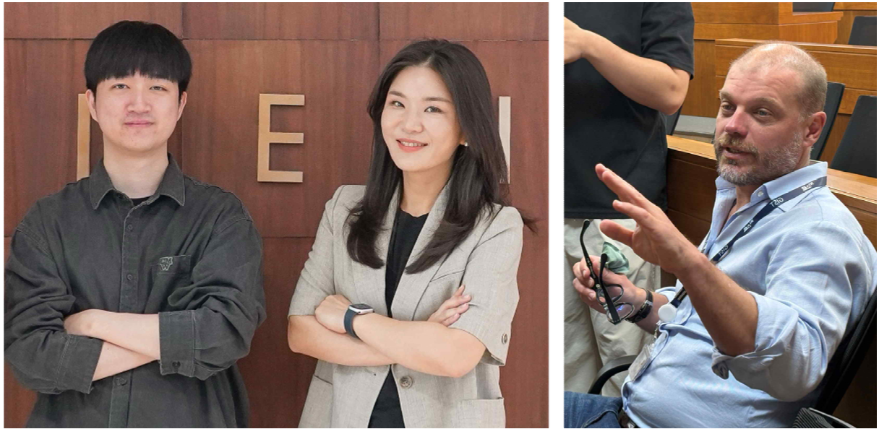
The Gwangju Institute of Science and Technology (GIST, President Kichul Lim) announced that a research team led by Professor Eunji Lee of the Department of Materials Science and Engineering at the GIST-InnoCORE Research Group, in collaboration with researchers from Northwestern University in the United States, has presented research findings suggesting a new direction for the convergence of "real-time protein imaging and AI analysis" for the early diagnosis of degenerative brain diseases such as Alzheimer's disease.

The GIST-InnoCORE Research Group is one of eight research groups under the "InnoCORE Project," a national research talent development program promoted by the Ministry of Science and ICT, and is led by GIST.

The InnoCORE Project involves Korea's four major science and technology research institutes (KAIST, GIST, DGIST, and UNIST) each operating core research groups in the AI convergence field. This program recruits outstanding postdoctoral researchers and supports "multi-mentoring" (where they receive guidance from two or more mentors) and global collaborative research.

The GIST research group's core goal is "AI + Nano Convergence for Early Diagnosis of Brain Disease."

This achievement marks the first example of establishing a convergence research direction from the early stages through the GIST-InnoCORE Research Group's "multi-mentoring system." Dr. Jun Ho Hwang joined the GIST-InnoCORE Research Group as an "InnoCORE Fellow" and developed his research ideas under the guidance of his chief mentor, Professor Eunji Lee, and his international mentor, Professor Nathan C. Gianneschi of Northwestern University.

One of the main causes of degenerative brain diseases is abnormal protein aggregation. The research team focused on the "two-step growth mechanism" reported by Professor De Yoreo's team at the University of Washington, namely, the process by which silk proteins grow from an unstable amorphous cluster phase to a stable crystalline structure.

Understanding this mechanism could allow for control of the "growth direction" of proteins, which could have wide-ranging applications in biodiagnostic technologies and new material design.

In this paper, the research team emphasized the importance of observing protein structural changes using "in-situ TEM"*, beyond conventional static protein analysis, and combining this with machine learning-based AI analysis.

* in-situ TEM: A high-resolution electron microscopy technique that enables real-time observation of microstructural changes within samples, such as proteins. A transmission electron microscope (TEM) is a device that transmits an electron beam through a sample to image its internal structure. "In-situ" refers to observing the sample as it undergoes actual changes. This allows for real-time analysis of dynamic processes, such as protein structural changes and aggregation.

Professor Eunji Lee stated, "This research is a crucial starting point for the InnoCORE Research Group's goal of establishing an 'AI platform for early diagnosis and drug design of brain diseases.'" She explained, "Incorporating AI technology into real-time transmission electron microscope images will allow for more precise analysis of protein aggregation, which causes brain diseases, at each lesion stage. Combining this with existing clinical sample analysis data can effectively predict the likelihood of onset or progression of degenerative brain diseases such as Alzheimer's and Parkinson's."

Dr. Jun Ho Hwang stated, "Thanks to the mentors' help, I was able to broadly understand the scientific background of my research and the potential applications of AI, and develop new ideas for convergent research." He added, "I look forward to continuing to plan research from new perspectives with mentors and postdoctoral fellows from diverse fields."

This research, supervised by Professor Eunji Lee of the Department of Materials Science and Engineering at GIST and conducted by Dr. Jun Ho Hwang (first author), was conducted in collaboration with Professor Nathan C. Gianneschi of Northwestern University. It was supported by the GIST-InnoCORE project of the Ministry of Science and ICT and the National Research Foundation of Korea's Mid-Career Researcher Support Program. The results were published online in the international journal 《Matter》 on August 6, 2025.

Meanwhile, the GIST-InnoCORE project operates a multi-mentoring system centered on postdoctoral fellows, involving industry, academia, and international scholars. It is building a convergent research ecosystem leveraging collective intelligence.

This research achievement is a representative example of the effectiveness of this mentoring system and is expected to lead to the development of an AI-based protein structure change prediction platform for disease diagnosis and treatment.



