"Turning waste into a resource using only sunlight, without electricity" GIST achieves world-leading performance with solar-based, voltage-free upcycling technology

- Professor Sanghan Lee's team from the Department of Materials Science and Engineering developed a zero-voltage solar upcycling system that converts glycerol, a waste product from the biodiesel industry, and nitrate, an environmental pollutant, into industrial resources such as ammonia and formic acid.

- World-leading performance (reaction current density of 11.04 mA/cm², Faraday efficiency of over 95%) presents a technological breakthrough for sustainable, next-generation chemical and energy processes... Published in the international journal 《Advanced Materials》



▲ (From left) Professor Sanghan Lee of the Department of Materials Science and Engineering and Yejoon Kim, a combined master's and doctoral student

The Gwangju Institute of Science and Technology (GIST, President Kichul Lim) announced that a research team led by Professor Sanghan Lee of the Department of Materials Science and Engineering has successfully developed a world-leading "bias-free upcycling*" technology that converts industrial waste into high-value-added chemicals using only solar energy.

The research team developed a photoelectrochemical system* combining an organic semiconductor-based photoelectrode* and a nickel-iron-phosphorus (Ni-Fe-P) catalyst. They successfully simultaneously converted glycerol and nitrate (NO₃⁻), major waste products generated in the biodiesel industry, into formic acid and ammonia, respectively.

* bias-free upcycling: Upcycling is a technology that recycles industrial waste or low-value materials into high-value products. When the energy required for this recycling is met solely by renewable energy, it is called bias-free upcycling.

* organic semiconductor photoelectrodes: These are photoelectrodes, essential for photoelectrochemical systems, made from semiconductor materials composed of carbon-based molecules. They convert sunlight into electrical energy while simultaneously inducing chemical reactions.

* photoelectrochemical systems: Systems that directly convert sunlight into electrical energy and chemical reactions. The core component of photoelectrochemical systems is the photoelectrode, which not only converts sunlight into electrical energy but also acts as a catalyst for chemical reactions.

Biodiesel* is attracting attention as an eco-friendly energy source ideal for large-scale, long-distance transportation by land, sea, and air. However, its production process generates large amounts of glycerol, a low-cost waste product, and the increased nitrate concentration in water and soil due to fertilizer use has become a social issue.

Existing upcycling technologies for glycerol and nitrate require high external voltages and are difficult to selectively convert into desired compounds, limiting their commercialization.

* biodiesel: A renewable, eco-friendly fuel made from biological resources such as vegetable oils and animal fats. It can be used in place of, or blended with, conventional petroleum-based diesel in diesel-powered vehicles and generators.

To address this issue, the research team developed a nickel-iron-phosphorus (Ni-Fe-P) electrocatalyst capable of simultaneously reducing nitrate and oxidizing glycerol. Furthermore, they significantly improved durability by applying metal foil encapsulation technology* to an organic semiconductor-based photoelectrode.

Nickel-iron-phosphorus (Ni-Fe-P) catalysts are nickel-iron alloys doped with phosphorus (P). By controlling the electronic structure of the metal catalyst, they exhibit high corrosion resistance and reaction selectivity.

* metal foil encapsulation technology: This technology forms a protective film with metal foil to prevent the electrodeposited catalyst on the photoelectrode from direct contact with the electrolyte. This technology maintains the catalytic activity while preventing corrosion or damage caused by the electrolyte, significantly enhancing the durability and stability of the photoelectrode.

The research team combined a nickel-iron-phosphorus (Ni-Fe-P) catalyst electrodeposited on copper foil with an organic semiconductor photoelectrode to build a voltage-free photoelectrochemical system that simultaneously drives nitrate reduction at the photocathode and glycerol oxidation at the photoanode. This system successfully upcycled two types of industrial waste simultaneously, powered solely by sunlight, without external power.

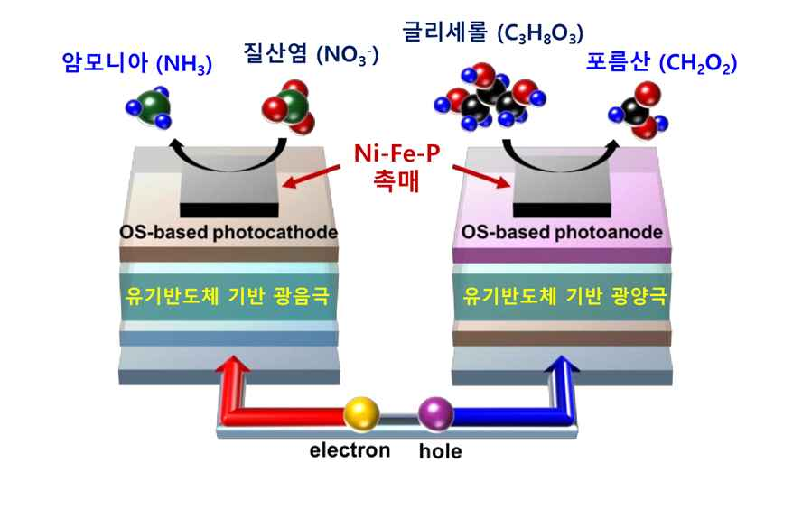

▲ Schematic diagram of the voltage-free solar upcycling system used in this study. We have developed a nitrate-glycerol solar upcycling technology that exhibits high efficiency and stability, utilizing organic semiconductor-based photoelectrodes and a Ni-Fe-P catalyst.

This system converts glycerol to formic acid and nitrate to ammonia, simultaneously converting both waste products into high-value chemicals without requiring electricity.

In actual reaction experiments, this system demonstrated a reaction current density of 11.04 milliamperes per square centimeter (mA/cm2), and the Faradaic efficiency* for both formic acid and ammonia production exceeded 95%, demonstrating high reaction activity and selectivity.

The produced ammonia* is a key industrial raw material used in various fields, including the global fertilizer industry, plastics, refrigerants, and hydrogen storage. Formic acid* is an eco-friendly energy source that has recently attracted attention as a preservative, dye, hydrogen carrier, and liquid fuel for fuel cells.

* reaction current density: A crucial concept in electrochemistry, it represents the amount of current flowing per unit area. It is primarily used to evaluate the activity of electrochemical reactions occurring on the electrode surface.

* Faradaic efficiency: This indicator indicates how effectively the current supplied in an electrochemical reaction is used to produce the desired product. Higher efficiency means a more selective reaction without energy waste. This study demonstrated the system's high reaction efficiency and selectivity by achieving a Faradaic efficiency of over 95% for both ammonia and formic acid production.

* ammonia: A key raw material in the global nitrogen fertilizer market, it is an essential chemical that determines agricultural productivity. It is also used in various industries, including plastics, refrigerants, and hydrogen storage, and is a representative industrial raw material consumed in the hundreds of millions of tons annually.

* formic acid (formic acid): Used as a preservative, disinfectant, and dye, it has recently gained attention as a hydrogen carrier and liquid fuel for fuel cells. Demand is rapidly increasing, particularly in the energy industry, as a potential carbon-neutral fuel.

This research establishes the technological foundation for the eco-friendly production of various high-value-added chemicals, including ammonia and formic acid, and is expected to have broad ramifications across the chemical and energy industries.

In particular, the durability of organic semiconductor photoelectrodes is greatly improved, and the possibility of expansion into large-area solar-based chemical processes is highly evaluated.

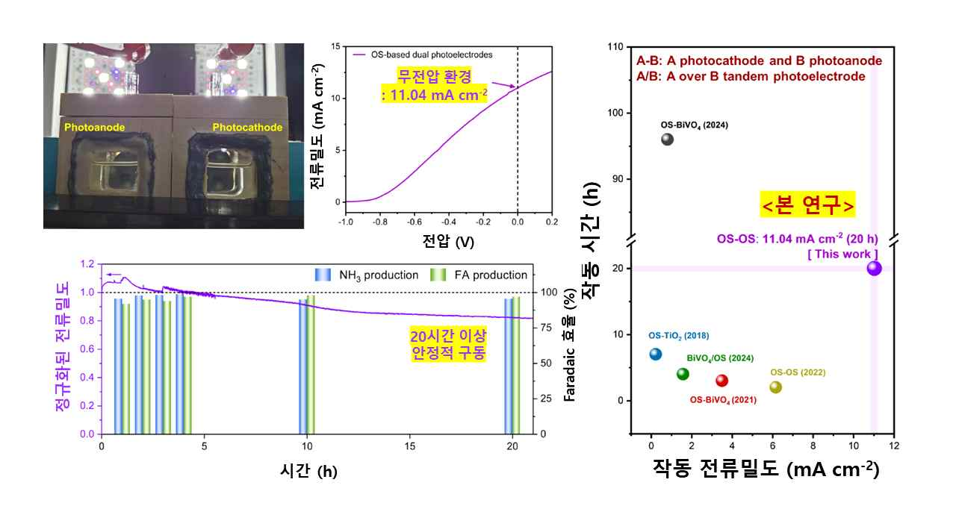

▲ The actual appearance and performance of the zero-voltage solar upcycling system, as well as a performance comparison with other research. It demonstrated high current density and stability, and demonstrated the best performance compared to other organic semiconductor-based zero-voltage systems.

Professor Sanghan Lee stated, "This research is a decisive technological breakthrough that will accelerate the commercialization of an eco-friendly upcycling system that operates solely on solar energy without external power," and praised it as "a result that opens new possibilities for the development of sustainable processes that convert industrial waste into high-value-added chemicals."

This research, supervised by Professor Sanghan Lee and conducted by doctoral student Yejoon Kim in the Department of Materials Science and Engineering, was supported by the Individual Basic Research Program (Mid-career Researcher) and the Future Hydrogen Source Technology Development Program of the Ministry of Science and ICT and the National Research Foundation of Korea. The results were published online in the international journal 《Advanced Materials》 on August 1, 2025.



