"The invisible link of immunity discovered in microvilli." GIST research team has become the first in the world to elucidate the mechanism of Cdc42, a key protein in T cell immune regulation

- Professor Chang-Duk Jun's team from the Department of Life Sciences has discovered the mechanism of action of the "Cdc42" protein, which is essential for the formation of microvilli on the surface of T cells... Underdeveloped microvilli lead to T cells having difficulty recognizing pathogens and a weakened immune response

- The study demonstrates the correlation between immune cell surface structure and function at the molecular level, opening up new possibilities for the prevention and treatment of immune diseases such as autoimmune diseases, infectious diseases, and cancer... Published in the international journal 《Proceedings of the National Academy of Sciences (PNAS)》 of the United States of America



▲ (From left) Professor Chang-Duk Jun of the Department of Life Sciences and Ph.D. student Won-Chang Soh

The Gwangju Institute of Science and Technology (GIST, President Kichul Lim) announced that a research team led by Professor Chang-Duk Jun of the Department of Life Sciences has identified the role of a key protein (Cdc42) in regulating the formation of microvilli* on the surface of T cells and immune function, suggesting the potential for developing new immunotherapies.

T cells are key cells of the immune system that recognize and defend against external pathogens (antigens*) such as viruses and bacteria. In particular, microvilli*, which densely cover the surface of T cells, play a crucial role in detecting traces of pathogens and inducing an immune response.

Previously, T cell microvilli were thought to play a passive role in simply detecting external signals (antigens). However, through this study, the research team has demonstrated for the first time at the molecular level that microvilli function as active "immune antennas" responsible for antigen recognition, immune synapse formation, and immune signal amplification and transmission.

* microvilli: These are very thin and short protruding structures on the surface of T cells. Although they are only a few tens of nanometers in diameter and a few hundred nanometers in length, they play a crucial role. These structures not only increase the cell surface area, but also act as “immune antennas” that detect external stimuli, performing a key function in allowing T cells to recognize antigens and exchange signals with other immune cells.

* antigens: Proteins or molecules that the body's immune system recognizes as "foreign substances" and triggers a response. Surface proteins or fragments of pathogens such as viruses, bacteria, parasites, and fungi primarily serve as antigens. Upon entering the body, these antigens are broken down by antigen-presenting cells (APCs) and presented to T cells, encapsulated in MHC molecules. T cells use this information to recognize pathogens and induce immune responses.

The research team specifically confirmed that even after T cells contact antigen-presenting cells (APCs*), some microvilli detach from the T cells and remain on the APC surface, continuously transmitting signals.

This is a significant discovery, demonstrating the existence of a new pathway by which microvilli maintain long-term immune responses even after transient contact, much like a "USB memory stick" storing information.

* antigen-presenting cells (APCs): These are key cells of the immune system that capture and process protein fragments (antigens) from invading pathogens (viruses, bacteria, etc.) and then present them to T cells, thereby helping to initiate an immune response.

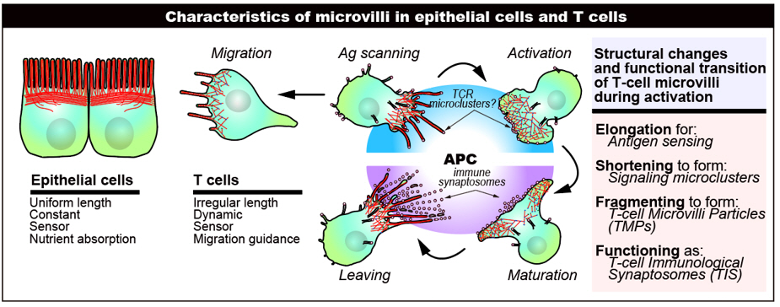

▲ Overview of the diverse physiological roles of T cell microvilli. Unlike intestinal epithelial cells, which aim to increase surface area, T cell microvilli are highly dynamic and perform diverse physiological functions, including antigen detection, TCR microcluster formation, and the production of microprotrusion fragments.

However, the formation of these crucial microvilli and the mechanisms by which they are regulated remain unclear.

The research team focused on the GTPase protein* "Cdc42," which regulates the cytoskeleton. They confirmed that during the differentiation and maturation of immune cells in the thymus, if the microvilli, the sensory projections of T cells that function like tentacles, are not properly formed, the overall immune response can be disrupted.

Indeed, when Cdc42 gene expression was reduced during the "double-positive (DP)" stage*, when T cells mature in the thymus, microvilli were observed to fail to form properly, resulting in shortened length and a significant decrease in number.

* GTPases: Enzymes that degrade guanosine triphosphate (GTP) within cells. They act as a "switch," becoming activated by binding to GTP and then deactivating by converting it to GDP. This process regulates signal transduction in cells and various physiological functions, including cell division, migration, morphological changes, protein transport, and immune responses.

* double-positive (DP) stage: A specific stage in T cell development that occurs in the thymus, where T cells simultaneously express both CD4 and CD8 surface proteins. During this stage, T cells undergo a selection process to differentiate into either CD4+ or CD8+ single-positive cells, a maturation stage essential for a healthy immune response.

To more precisely analyze the role of the Cdc42 protein, the research team conducted experiments using two mouse models: a genetically modified mouse model in which the Cdc42 gene was selectively deleted, and a mouse model administered an inhibitor (CASIN) that specifically targets Cdc42.

As a result, T cells lacking Cdc42 exhibited a significant reduction in the length and number of microvilli, and abnormalities were also observed in the formation of T cell receptor (TCR) microclusters* and immune synapses, which are essential for antigen recognition.

* TCR microclusters: When T cells recognize antigens from antigen-presenting cells (APCs), T cell receptors (TCRs) gather at specific sites via terminal structures such as microvilli, forming clusters called TCR microclusters. These microclusters serve as central hubs that initiate early immune signaling and, by interacting with other peripheral accessory proteins, play a key role in T cell activation, intracellular signaling, and immune response induction.

Ultimately, T cells were unable to effectively recognize foreign antigens, resulting in a weakened overall immune response. This molecular evidence demonstrates that Cdc42 plays a critical role in the formation of T cell microvilli and stable immune function.

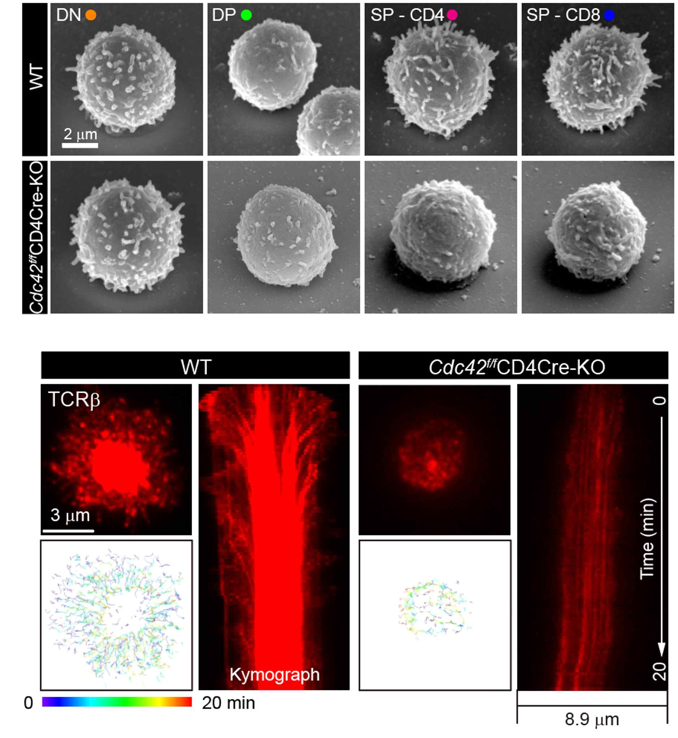

▲ Observation of microvilli and TCR microclusters in T cells from Cdc42 conditionally deficient mice. Electron microscopy images (top) show a reduction in the length and number of microvilli in T cells from Cdc42-deficient mice, and total internal reflection microscopy images (bottom) show a reduction in TCR microclusters upon inducing immune synapse formation.

The research team explained, "This suggests that T cells lacking Cdc42, like insects without antennae, are unable to properly sense external signals, resulting in a loss of directionality and precision in their immune responses."

This study was conducted using cutting-edge high-resolution imaging techniques, including electron microscopy, confocal microscopy, total internal reflection, and multiphoton fluorescence microscopy.

Through this, the study observed the relationship between ultrastructural changes in microvilli and immune function from a three-dimensional and multi-angle perspective, providing a new molecular immunological interpretation linking T cell structure and function.

This achievement is considered a paradigm-shifting study in immunology encompassing the structure and function of T cells. Based on this, the research team has also opened up the possibility of developing next-generation immunotherapies applicable to various immune-related diseases, including autoimmune diseases, infectious diseases, and cancer.

Since 2015, the research team has pioneered original research on the function of T cell microvilli. They are also developing anticancer treatments utilizing microvilli-based immunosynaptosome* technology.

* immunosynaptosome: An artificial structure that mimics the immunological synapse between T cells and antigen-presenting cells (APCs). It is a nanoscale biological sample that allows for the physical isolation and analysis of the contact site where these cells interact. Inspired by the concept of synaptosomes in neurons, it serves as a tool for precisely elucidating signaling and protein interactions between immune cells, and is particularly useful for elucidating key mechanisms of T cell activation and immune response regulation.

Professor Chang-Duk Jun stated, "Through this study, we have specifically elucidated the molecular-level mechanisms of T cell microvilli formation and functional regulation." He added, "Based on this, we expect to be one step closer to developing next-generation immuno-oncology drugs using 'immunosynaptosomes' derived from microvilli."

This research, supervised by Professor Chang-Duk Jun of the Department of Life Sciences at GIST and conducted by Ph.D. candidate Won-Chang Soh, was supported by the National Research Foundation of Korea's Leader Scientist Research Program, Mid-career Research Program, Science Challenge Convergence Research and Development Program, Basic Research Program, and Sejong Science Fellowship. The results were published online in the international journal 《Proceedings of the National Academy of Sciences (PNAS)》 on July 25, 2025.



