“As we age, we lose muscle, but there is a way to restore it” GIST is the first in the world to identify a protein that acts as a 'muscle recovery switch'... and even suggests a treatment candidate

- Professor Darren Williams' team of the Department of Life Sciences has discovered that DUSP22 protein acts on a common pathway to promote muscle breakdown under various muscle atrophy-inducing conditions... Proof of muscle recovery effect through DUSP22 regulation

- Candidate substance 'BML-260' targeting DUSP22 has been confirmed to have effects on muscle mass recovery, muscle fiber growth promotion, and muscle function improvement, raising expectations for the development of a treatment... Published in the international academic journal 《EMBO Molecular Medicine》



▲ (From left) Professor Darren Williams of the Department of Life Sciences, Research Professor Da-Woon Jung, and Ph.D. student Sang-Hoon Lee

Sarcopenia*, which occurs mainly in the elderly due to aging, is a disease in which the amount and function of muscles gradually decreases, and it has a significant impact on falls, fractures, and walking difficulties, as well as the worsening of chronic diseases and increased mortality. However, there are currently no approved drugs that can treat or suppress this disease.

* sarcopenia: A disease in which the amount and function of skeletal muscles gradually decrease with aging. Even in the normal aging process, muscle mass decreases by about 1% and muscle strength decreases by 3% every year, which is directly related to falls, fractures, decreased mobility, and increased mortality. In addition to simple aging, sarcopenia can be worsened by various factors such as chronic diseases, steroid drugs, malnutrition, and long-term hospitalization.

The Gwangju Institute of Science and Technology (GIST, President Kichul Lim) announced that the research team of Professor Darren Williams of the Department of Life Sciences has newly identified the over-activation of the protein ‘DUSP22*’ as a major cause of sarcopenia due to aging, and announced the results of a study showing that muscle loss can be effectively prevented by inhibiting it.

This achievement scientifically proves that sarcopenia is not a simple aging phenomenon but a ‘controllable disease’, and is expected to be a turning point in suggesting a new treatment strategy for muscle atrophy diseases that currently have no treatment.

* DUSP22 (dual specificity protein phosphatase): A type of protein dephosphorylation enzyme known to be involved in various cellular processes such as cell proliferation, differentiation, and apoptosis by activating the JNK signaling pathway. However, its role in muscle tissue has not yet been clearly identified.

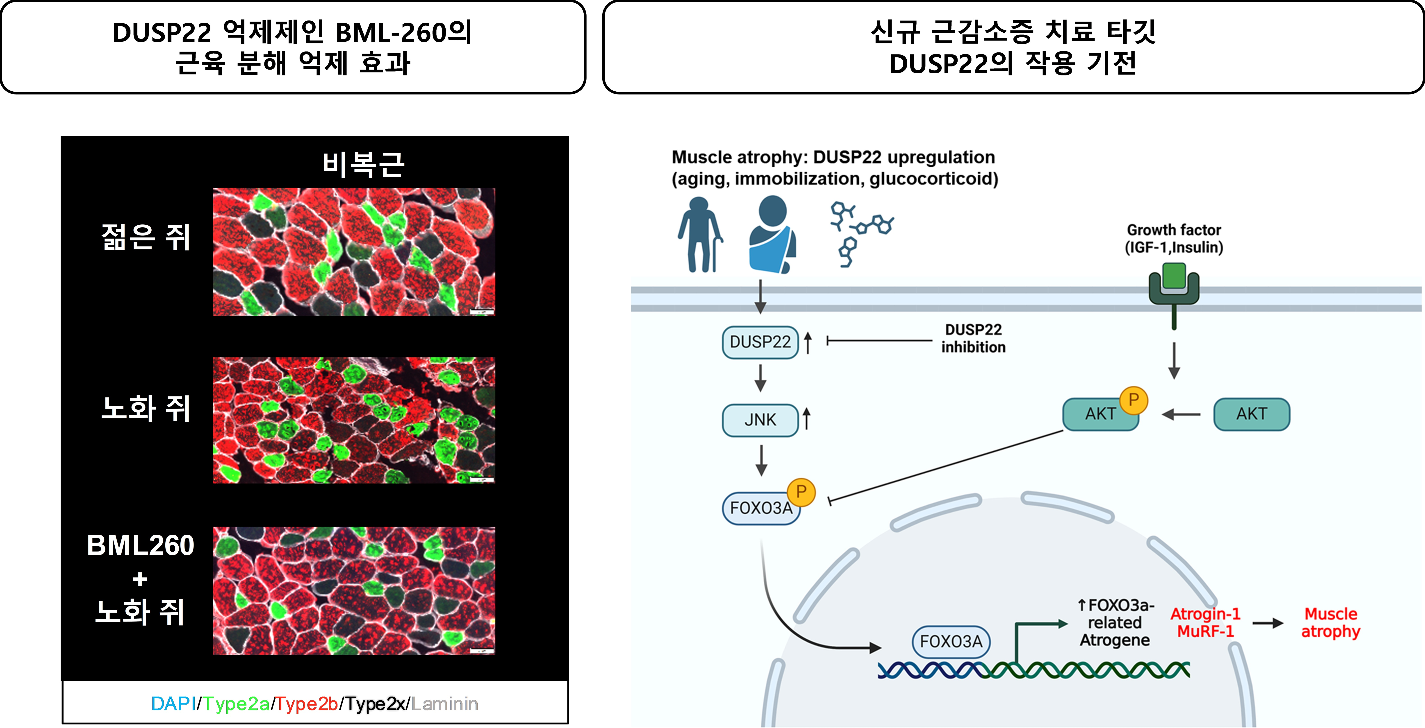

▲ Muscle degradation inhibition effect and mechanism of action of DUSP22 inhibitor BML-260. (Left) Muscle atrophy inhibition effect was confirmed through recovery of muscle fiber area and Type II fiber structure of gastrocnemius (the largest proportion of calf muscles) of aged mice when administered BML-260. (Right) DUSP22 inhibition regulates the activity of JNK/FOXO3a axis and suppresses the expression of muscle protein degradation genes Atrogin-1 and MuRF-1, suggesting a mechanism of action that reduces muscle atrophy.

The research team analyzed various muscle atrophy animal models induced by conditions such as aging, steroid drug (dexamethasone*), and limb fixation* along with skeletal muscle tissue of patients with sarcopenia, and discovered that the DUSP22 protein was commonly overexpressed.

DUSP22, a dual-specificity protein phosphatase, is known to be involved in cell proliferation, differentiation, and apoptosis through the JNK signaling pathway*, but its function in muscle tissue has not been clearly identified.

Accordingly, the research team systematically verified whether muscle atrophy was alleviated when DUP22 was inhibited using gene silencing (siRNA) techniques* and a DUSP22-selective inhibitory compound (BML-260).

* dexamethasone: A potent synthetic corticosteroid (steroid) drug used to suppress inflammation and immune responses. Administration of dexamethasone to experimental animals or cells induces various physiological changes, such as modulation of inflammatory responses, induction of muscle atrophy, or mimicking stress responses, and is used to study their effects and treatment methods.

* limb immobilization: In experimental animals, a specific limb is fixed to limit muscle use, and muscle atrophy, bone density changes, and neural responses are studied accordingly.

* JNK signaling pathway (c-Jun N-terminal kinase pathway): An important signaling process that allows cells to respond to stress and regulate growth and death. It is activated by external stimuli (e.g., ultraviolet rays, oxidative stress, and inflammatory signals), and the activated JNK protein regulates specific transcription factors within the cell to induce changes in gene expression. This pathway is related to various diseases such as cancer, neurodegenerative diseases, and inflammatory diseases, and is attracting attention as a therapeutic target.

* gene silencing (siRNA) technique: This is a method that uses siRNA, a double-stranded RNA molecule with a length of approximately 20 to 25 nucleotides, to target the mRNA of a specific gene and induce binding and degradation, thereby inhibiting the production of the protein of the gene. This selectively blocks gene expression, and is used in gene function research or disease treatment research, and is used as an important tool for analyzing the role of a specific gene or alleviating disease symptoms caused by abnormal genes.

As a result of the experiment, in cells that overexpressed DUSP22, muscle formation was suppressed, and the expression of genes related to muscle loss (Atrogin-1*, MuRF-1*, etc.) increased, accelerating muscle atrophy.

On the other hand, when BML-260 was administered or the DUP22 gene was suppressed, the expression of Atrogin-1 and MuRF-1 decreased by 52% and 57%, respectively, and a significant improvement in muscle atrophy was observed.

In particular, when BML-260 was administered to an aging mouse model, a significant improvement effect was observed, such as an increase in skeletal muscle weight by approximately 26%, a recovery in muscle fiber diameter by approximately 25%, and a maximum improvement in muscle strength of up to 55%.

* strogin-1 (muscle-specific F-box protein 1, muscle atrophy F-box protein): It plays an important role in the ubiquitin-proteasome system, a protein degradation pathway, and its expression increases during muscle atrophy, promoting muscle protein degradation.

* MuRF-1 (Muscle RING-finger protein-1): It also acts in the ubiquitin-proteasome system and is a representative E3 ubiquitin ligase that induces muscle protein degradation.

This effect was also reproduced in a limb fixation model and a human muscle cell model, proving its clinical applicability.

The research team explained, “The fact that DUSP22 acts as a key factor in inducing muscle atrophy suggests that drug strategies targeting it may be effective in treating not only sarcopenia but also various muscle degenerative diseases.”

Professor Darren Williams said, “The significance of this study is that it is the first in the world to elucidate the pathological function of DUSP22, which acts as a key factor in muscle loss, and to demonstrate that sarcopenia can be effectively alleviated by utilizing gene suppression and a small molecule compound (BML-260),” and added, “We plan to continue follow-up research to develop it into a treatment applicable to sarcopenia and other muscle degenerative diseases.” The research team has completed domestic and international patent applications for the DUP22 protein and inhibitory compound.

This study, led by Darren Williams of the Department of Life Sciences at GIST and participated by Professor Da-Woon Jung and Ph.D. student Sang-Hoon Lee, was supported by the National Research Foundation of Korea’s Mid-career Researcher Support Program and the National Information Society Agency. The results of the study were published in the May 2025 issue of the international academic journal 《EMBO Molecular Medicine》.



