“Catching Antibiotic-Resistant Bacteria with AI” GIST develops AI model 'LLAMP' that quickly and accurately designs customized antibiotics for resistant bacteria

- Professor Hojung Nam of the Department of Electrical Engineering and Computer Science and Professor Jiwon Seo of the Department of Chemistry jointly developed an AI model ‘LLAMP’ capable of designing antibacterial peptides specific to resistant bacteria... Learning 1.7 million sequences and 40,000 active data

- Up to 40% improvement in prediction accuracy compared to existing models, proven to be effective even against highly toxic and resistant ESKAPE pathogens... Published in the international academic journal 《Briefings in Bioinformatics》



▲ (From left) Professor Hojung Nam of the Department of Electrical Engineering and Computer Science, Professor Jiwon Seo of the Department of Chemistry, Master’s degree student Daehun Bae of the Department of Electrical Engineering and Computer Science, and Ph.D. candidate Minsang Kim of the Department of Chemistry

Since the discovery of penicillin, antibiotics have revolutionized the treatment of infectious diseases, but as their misuse continues, multidrug-resistant bacteria (MDR)* that are resistant to multiple drugs at the same time have emerged through genetic mutations, posing a new threat to human health.

In this situation, domestic researchers are attracting attention by presenting next-generation antibiotic development technology based on artificial intelligence (AI) that can quickly discover new drug candidates specialized for resistant bacteria.

* multidrug-resistant bacteria (MDR): Bacteria that have become resistant to multiple antibiotics through natural selection or mutation, and thus have limited antibiotics that can be used to treat infectious diseases in clinical settings.

The Gwangju Institute of Science and Technology (GIST, President Kichul Lim) announced that a joint research team led by Professor Hojung Nam of the Department of Electrical Engineering and Computer Science and Professor Jiwon Seo of the Department of Chemistry has developed an AI model that proposes peptide-based antibiotic candidates specific to the species by analyzing the relationship between the genetic information of various bacteria and the activity of antimicrobial peptides.

This model can select antimicrobial peptides optimized for bacteria that cause infectious diseases by learning the correlation data between the unique genetic information of each bacterial species and various antimicrobial peptides.

This has enabled the development of customized treatment candidates that can precisely respond to pathogens that have become resistant to existing antibiotics through genetic mutations as well as species-specific precision medicine.

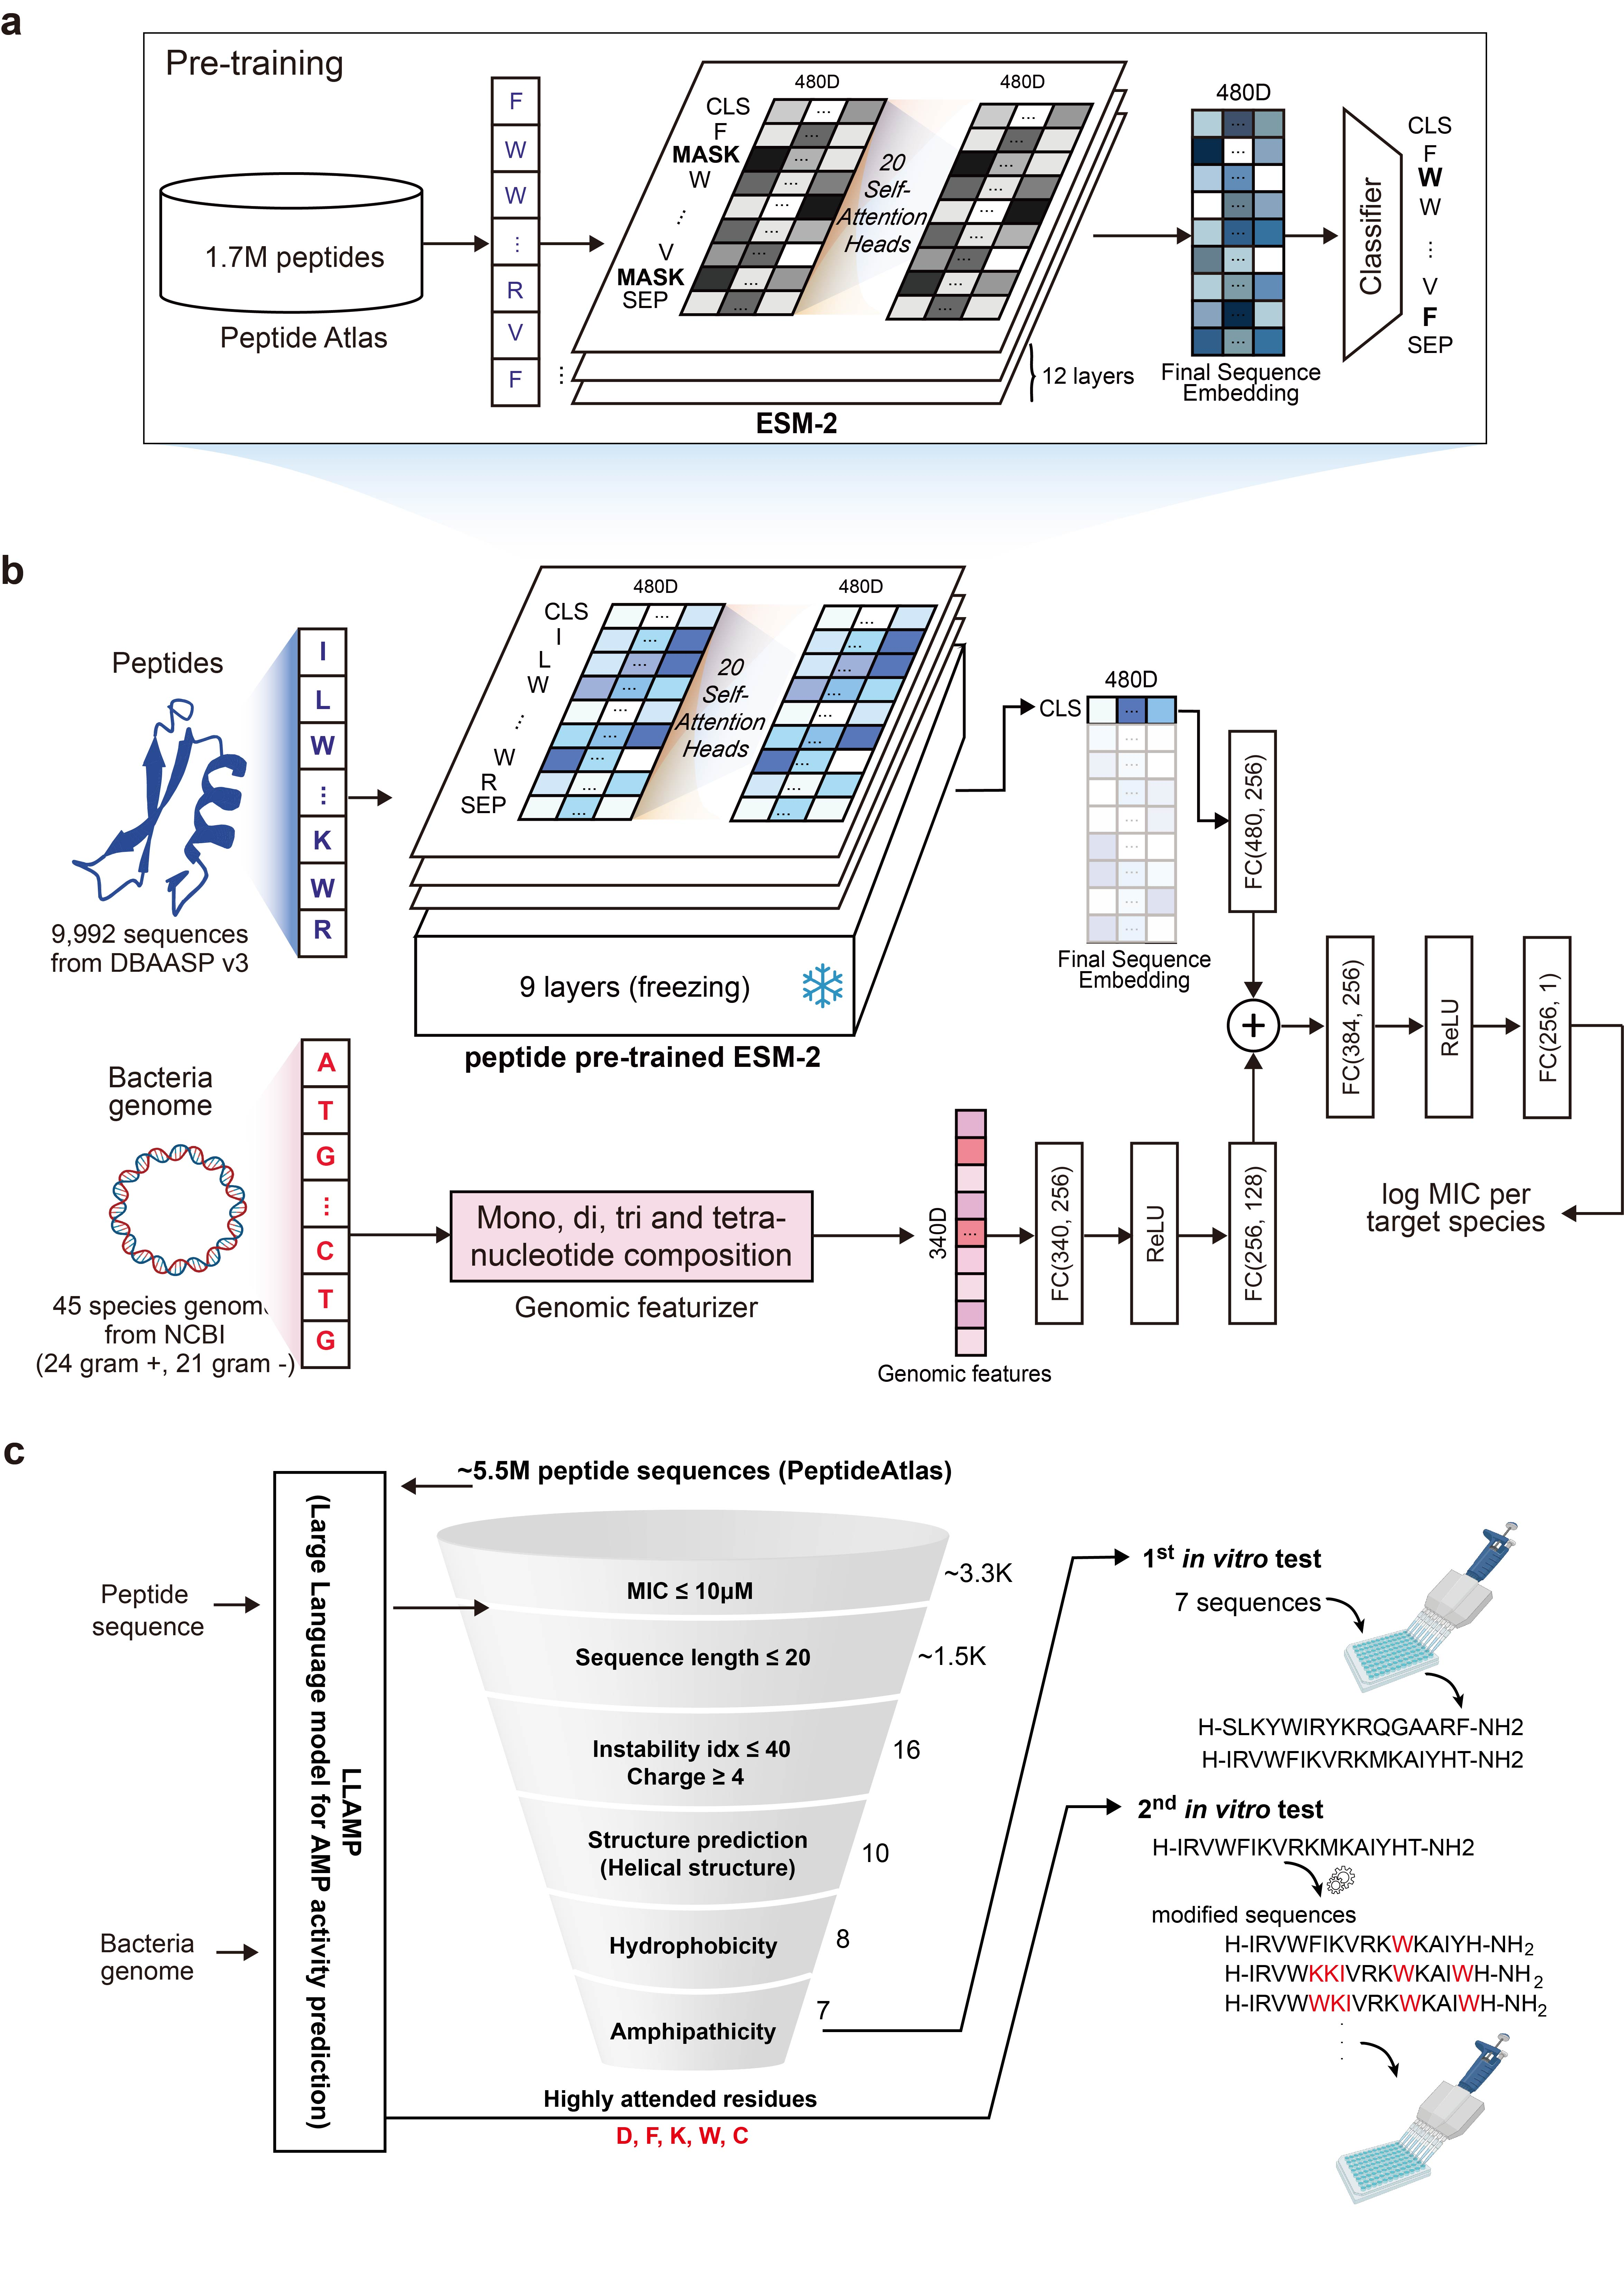

▲ LLAMP model overview. a) Pre-learning process: The LLAMP model is pre-learned with approximately 1.7 million peptide sequences to learn sequence patterns. b) Fine-tuning process: Afterwards, it learns the activity of each species and predicts the MIC value. c) AI-based screening process: It selects effective candidates using the learned model and peptide characteristics.

Previous AI-based antimicrobial peptide studies have had limitations in practical use because they simply predicted antimicrobial activity or did not consider the target bacterial species.

To overcome this, the research team developed the world's first AI model, 'LLAMP (Large Language model for AMP activity prediction)', which learns large-capacity peptide data and utilizes the genome information of the target bacterial species.

‘LLAMP’ predicts the minimum inhibitory concentration (MIC)* as an activity indicator of a peptide for a given bacterial species when the genome information and peptide sequence of a specific bacteria are input.

This model was completed by additionally training a large amount of peptide data on a pre-trained language model based on protein data to understand the ‘language’ unique to peptides, and then fine-tuning* based on the bacterial genome-peptide combination.

Compared to the existing model, the antibacterial prediction accuracy improved by at least 4% and up to 9%, and the activity value prediction power improved by at least 3% and up to 40%, showing excellent performance in all performance indicators.

* minimum inhibitory concentration (MIC): This refers to the lowest concentration required for a specific antibacterial agent to inhibit bacterial growth. The lower the MIC value, the better the effect of the antibacterial agent, and it is used as an important indicator for evaluating the efficacy of antibiotics and determining the appropriate dosage.

* fine-tuning: This refers to the process of retraining an already learned AI model in detail to fit a specific task or dataset. This allows the basic model to perform optimized performance for a specific purpose based on the knowledge it has generally learned.

In particular, the research team screened approximately 5 million peptide sequences existing in nature using ‘LLAMP’ and identified specific amino acids that contribute to antibacterial activity through attention analysis*.

Based on the results of this analysis, the peptides were redesigned (sequence engineered) to further enhance antibacterial properties and directly applied to pathogenic bacteria to confirm antibacterial activity.

As a result, candidate substances that were screened* by inputting the genetic information of the pathogen showed a minimum inhibitory concentration (MIC) value of up to 3.1 micromolar (μM) even against highly toxic and resistant pathogens (ESKAPE*), showing a strong antibacterial effect. This experimentally proved that they have high potential as actual therapeutic candidates.

* screening: A step in the new drug development process to select substances with a high probability of being effective from among numerous candidate substances.

* attention analysis: A method to check which part of the input the model paid attention to in a transformer-based model.

* ESKAPE: An acronym for six pathogens with high toxicity and high antibiotic resistance. They are Enterococcus faecium, Staphylococcus aureus, Klebsiella pneumoniae, Acinetobacter baumannii, Pseudomonas aeruginosa, and Enterobacter.

In addition, as a result of conducting a hemolytic toxicity* test on red blood cells targeting these peptide compounds, they showed a similar level of safety (hemolytic toxicity) and selectivity to the peptide antibiotic ‘pexiganan’*, which has actually progressed to phase 3 clinical trials.

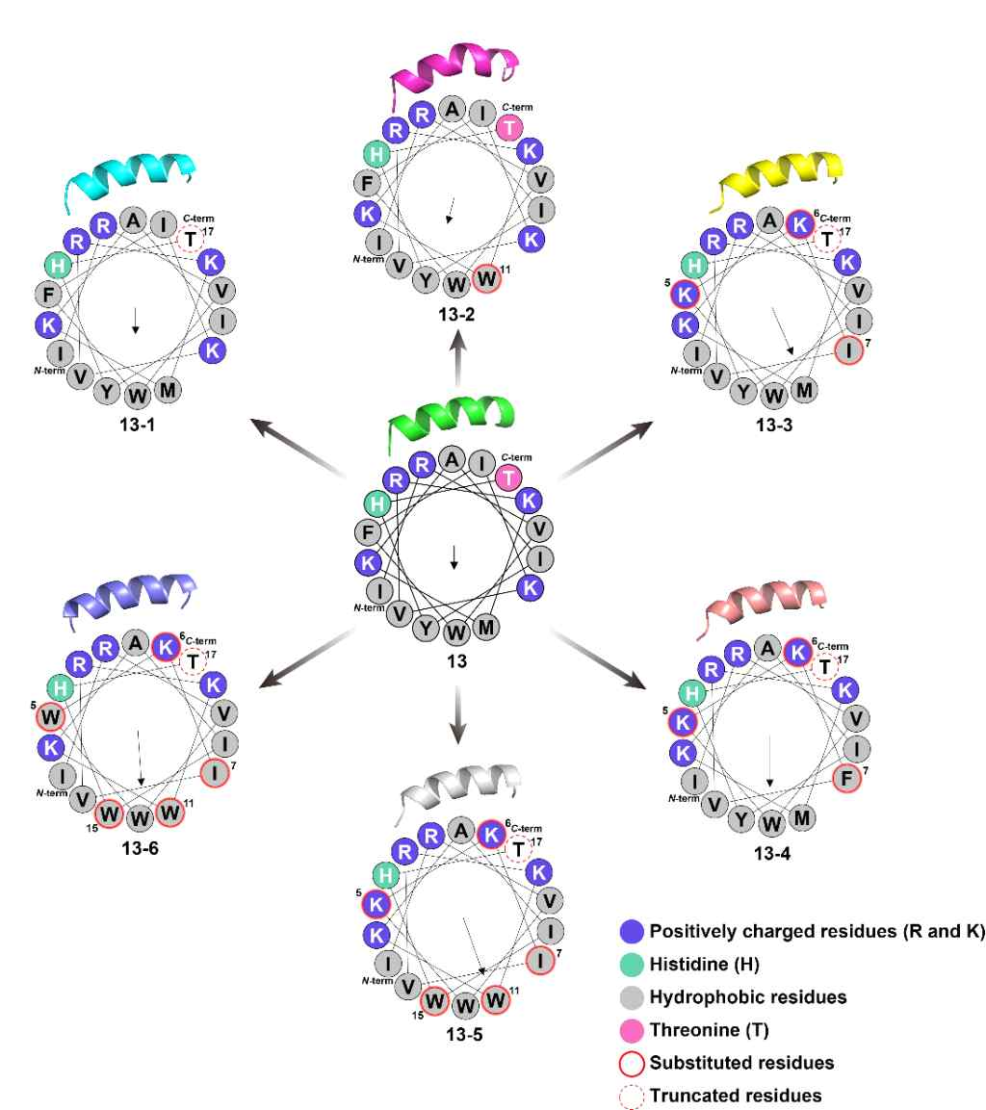

▲ Structural analysis of peptide 13 and its derivatives. Through the helical wheel and 3D structure, the characteristics of residues such as positive charge (purple), hydrophobicity (gray), and substitution/cleavage sites are visualized. The arrow indicates the hydrophobic moment, and the ‘N-term‘ and ‘C-term‘ marks indicate the terminal positions.

In addition, through additional research, it was revealed that antimicrobial peptides with excellent activity and selectivity act as a mechanism to directly destroy bacterial cell membranes through the arrangement of specific amino acids derived from the helical structure and amphipathic* characteristics.

* pexiganan: A synthetic peptide antibiotic developed based on an antimicrobial peptide derived from frogs. It destroys bacterial cell membranes to suppress infection and is mainly developed for the treatment of local infections.

* hemolytic toxicity: A toxicity that damages or destroys red blood cells in the blood. When red blood cells burst, their oxygen transport function is reduced, which can cause health problems such as anemia. Therefore, when developing new drugs or antibiotics, it is evaluated that safety is secured when hemolytic toxicity is low, and it is used as an important indicator to reduce the risk of side effects of the treatment.

* amphiphilicity: A property in which a molecule has a part that is friendly to water (hydrophilic) and a part that is friendly to oil (hydrophobic) at the same time

The research team evaluated that this achievement is significant in that it showed that AI does not simply imitate existing drugs but can analyze the genetic characteristics of pathogens and design new treatments optimized for them.

In particular, it is noteworthy that the achievement of presenting a new drug development platform that can track and respond to the evolution of antibiotic resistance in real time has great academic and industrial ramifications.

Professor Hojung Nam said, “The core of this study is that we have established an AI-based new drug development system that can quickly suggest antibiotic candidates based on the genetic information when a new resistant bacteria appears,” and “It is differentiated from existing models in that it can discover strain-specific peptides and develop antibiotics specialized for resistant bacteria.”

This study, supervised by Professor Hojung Nam of the Department of Electrical Engineering and Computer Science and Professor Jiwon Seo of the Department of Chemistry at GIST and conducted by Master’s student Daehun Bae of the Department of Electrical Engineering and Computer Science and Ph.D. candidate Minsang Kim of the Department of Chemistry, was supported by the Mid-career Researcher Support Project of the Ministry of Science and ICT and the National Research Foundation of Korea, the Regional Innovation Leading Research Center (RLRC), the Biomedical Technology Development Project Program, and the Joint Learning-based New Drug Development Acceleration Project (K-MELLODDY) of the Ministry of Health and Welfare and the Ministry of Science and ICT. The results of the study were published online on July 18, 2025 in the international journal 《Briefings in Bioinformatics》.



