“Aerosol Paradox: Clean Air Actually Causes Heat Waves” GIST research team discovers climate paradox where aerosol reduction actually worsens heat waves and humidity

- An international joint research team led by Professor Jin-Ho Yoon of the Department of Environment and Energy Engineering, through analysis of densely populated areas, has revealed the opposing climate effects of greenhouse gases and aerosols and the mechanism of increasing relative humidity (surface cooling → reduced evaporation → water vapor retention)

- Revealing the paradoxical fact that ‘clean air does not necessarily guarantee a safe climate’... “Policies that consider climate and atmosphere integration are urgent” Published in the international academic journal 《Communications Earth & Environment》



▲ (From left) Professor Jin-Ho Yoon and PhD student Jina Park of the Department of Environment and Energy Engineering

□ A study has shown that not only is the temperature rising due to climate change, but the phenomenon of fine particles (aerosols) in the air reflecting sunlight and cooling the surface can actually increase relative humidity. The research team warned that this could further aggravate heat stress experienced by people.

∘ The Gwangju Institute of Science and Technology (GIST, President Kichul Lim) announced that the research team led by Professor Jin-Ho Yoon of the Department of Environment and Energy Engineering, along with Korean and international researchers, have discovered that the cooling phenomenon of the surface of the earth due to aerosol* is the main cause of the increase in relative humidity*.

* relative humidity (RH): This is the value expressed as a percentage (%) of the amount of water vapor contained in the air (actual amount of water vapor) compared to the maximum amount of water vapor that the air can contain at a given temperature (saturated amount of water vapor). Unlike absolute humidity, it is used to indicate the degree of dryness and humidity because humidity varies depending on temperature even when the amount of water vapor is the same.

* aerosol: This refers to fine particles in a solid or liquid state floating in the atmosphere, and can be generated from both natural causes (volcanic eruptions, wind-blown dust, salt particles in the ocean, etc.) and anthropogenic causes (fossil fuel combustion, industrial activities, vehicle emissions, etc.). These particles reflect or absorb sunlight in the atmosphere, changing the temperature of the Earth's surface and influencing cloud formation, thus exerting a complex influence on the climate system.

□ The research team precisely analyzed the changes in relative humidity and their causes for approximately 60 years (1961-2020) using high-resolution atmospheric reanalysis data (ECMWF Reanalysis v5, ERA5) provided by the European Centre for Medium-Range Weather Forecasts and large-scale climate model simulations*.

∘ As a result, the ‘aerosol-humidity mechanism’ was revealed, in which aerosol particles emitted from factories and vehicles scatter sunlight and cool the ground surface, while reducing evaporation → water vapor stagnation → increasing relative humidity.

* large-scale climate model simulation: Community Earth System Model Large Ensemble Project (CESM LENS) and Coupled Model Intercomparison Project Phase 6 (CMIP6)

□ This mechanism shows that a certain level of aerosol increases relative humidity and acts as a ‘buffering effect’ to suppress temperature increases.

∘ However, if aerosol emissions are drastically reduced, this cooling effect will disappear, rapidly increasing the temperature, and the heat stress index (discomfort index, risk index, etc.) combined with humidity will rapidly increase, which may lead to new climate risks for human health and society as a whole.

∘ This result reveals the paradoxical fact that ‘clean air does not necessarily guarantee a safe climate.’

□ In fact, the relative humidity (RH) has been increasing significantly in the Indo-Gangetic Plain (IGP) region spanning northern India, Bangladesh, and eastern Pakistan in recent decades.

∘ This region is one of the most densely populated regions in the world with a population of approximately 1.4 billion, and the threat of heat stress, decreased agricultural productivity, and the spread of infectious diseases is very high during the hot and humid summer.

∘ In particular, when the relative humidity is maintained at high temperatures, it prevents sweat evaporation, making it difficult to control body temperature, and it can directly pose a risk to the health of vulnerable groups such as the elderly and children.

□ Using the CESM2-LE* model along with multi-satellite and observation data, the research team confirmed that the relative humidity in the IGP region increased by an average of approximately 10.3% from 1961 to 2020.

* CESM2-LE (Community Earth System Model version 2 – Large Ensemble): This is a large ensemble simulation version of the Community Earth System Model version 2 (CESM2), an Earth system climate model developed by the U.S. National Center for Atmospheric Research (NCAR). It comprehensively simulates major elements of the Earth’s climate system, including the atmosphere, ocean, land, and sea ice. By repeatedly performing dozens of simulations under the same external conditions, it is possible to separate and analyze the effects of natural internal variability and external factors caused by human activities (e.g., greenhouse gases, aerosols), and it is particularly strong in quantitatively identifying long-term climate change trends and their causes.

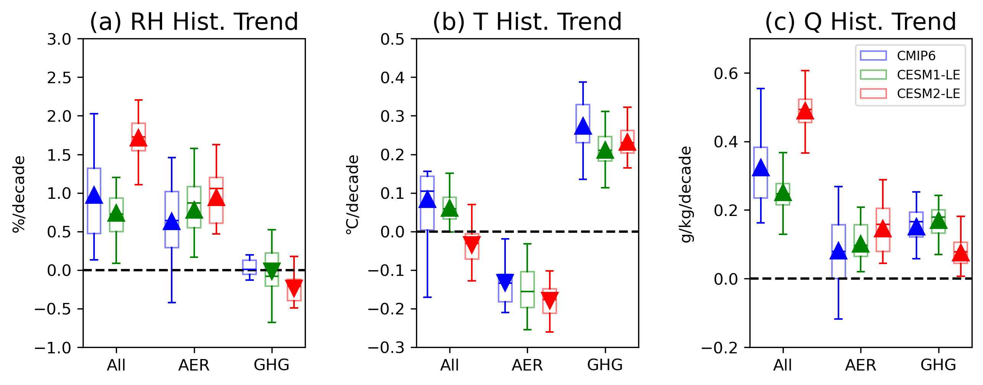

▲ Comparison of the effects of greenhouse gases and aerosols on relative humidity (RH), temperature (T), and specific humidity (Q). The results of analyzing the trends in relative humidity, temperature, and specific humidity for 60 years using CMIP6, CESM1-LE, and CESM2-LE data are presented. They are classified by three forced scenarios (including the overall effect, including only the aerosol effect, and including only the greenhouse gas effect), and show that aerosols cool the surface and increase relative humidity, while greenhouse gases increase temperature and have little or no effect on RH change or even decrease it.

□ The analysis results show that approximately 95% of the increase in relative humidity is due to an increase in the amount of water vapor in the atmosphere, and although a decrease in temperature also contributed to the increase in relative humidity (5%), its effect was relatively small.

∘ In particular, it was confirmed that aerosols (sulfates, organic carbon, etc.) with a large scattering effect cooled the surface, thereby stabilizing the atmosphere and inducing water vapor accumulation, which led to a series of processes that increased relative humidity.

□ In addition, the research team conducted a single forcing* experiment to separately identify the effects of greenhouse gases (GHGs)* and aerosols.

∘ As a result, greenhouse gases increased the surface temperature and lowered the relative humidity, while aerosols showed the opposite effect of lowering the surface temperature and increasing the relative humidity.

* greenhouse gases (GHGs): Refers to gases that trap heat in the atmosphere by absorbing infrared radiation emitted from the Earth while allowing solar radiation energy entering the Earth to pass through. Major greenhouse gases include carbon dioxide (CO2), methane (CH4), nitrous oxide (N2O), water vapor (H2O), and anthropogenic fluorinated gases, which play a role in increasing the temperature of the Earth's surface and atmosphere. The increase in greenhouse gas concentration is considered a major cause of global warming and climate change.

* single anthropogenic forcing: A concept that analyzes the pure impact of one of several anthropogenic factors on the climate system by independently considering only one. This allows us to clearly understand the individual impacts and mechanisms of various anthropogenic factors, such as greenhouse gases, aerosols, and land use changes, on the climate, and plays an important role in isolating and evaluating complex climate change causes.

□ For example, when only greenhouse gases were changed, water vapor increased, but relative humidity tended to decrease due to the rise in temperature.

∘ On the other hand, when only aerosols were changed, relative humidity increased as the surface temperature decreased.

□ Through analysis of various future climate scenarios, the research team predicted that relative humidity may peak at a certain point in the future and then turn into a downward trend.

∘ In particular, in the high-emission scenarios (SSP3-7.0, SSP5-8.5), the ‘cooling loss-rapid heating’ turning point appeared around 2040, and the relative humidity peaked and then decreased, indicating a high possibility of heat waves becoming more severe.

∘ On the other hand, in the low-emission scenarios (SSP1-2.6, SSP2-4.5), the warming rate was slow and aerosols gradually decreased, so the relative humidity tended to remain relatively stable or increase slightly.

∘ These conflicting results imply that if aerosol concentration decreases due to future air pollution reduction policies, unexpected decreases in relative humidity and increases in temperature may occur simultaneously, suggesting that climate policies that consider the combined effects of greenhouse gases and aerosols are necessary.

□ Professor Jin-Ho Yoon said, “If we overlook the duality of greenhouse gases and aerosols affecting climate in opposite directions, ‘clean air’ can actually increase the risk of short-term heat waves and humidity,” and “In high-risk areas with high population densities like IGP, the aspects of climate risk that humanity will face will greatly differ depending on how greenhouse gas reduction and aerosol reduction policies are harmoniously promoted.” He also emphasized, “It is urgent for our country to establish and implement an integrated strategy that considers both climate and atmosphere.”

∘ The first author of this study, doctoral student Jina Park, said, “High humidity prevents sweat evaporation, hinders body temperature control, and explosively increases heat stress indicators such as wet bulb temperature,” and “This study shows that air quality improvement and carbon neutrality policies must be established from an integrated perspective.”

□ This study was led by Professor Jin-Ho Yoon and Ph.D. candidate Jina Park of the Department of Environment and Energy Engineering at GIST, and was a joint study with domestic researchers including Professor Hyungjun Kim of KAIST, Professor Jee-Hoon Jeong of Sejong University, and Dr. Suyeon Moon of the APEC Climate Center, as well as many international researchers. It received support from the National Research Foundation of Korea's Mid-career Researcher Support Project and the Overseas Excellent Scientist Attraction Project, and the Korea Meteorological Administration's Climate Change Response Research Project.

∘ The research results were published online on July 8, 2025 in 《Communications Earth & Environment》, a prominent international academic journal in the field of meteorology and a sister journal of 《Nature》. <End>



