"Discarded disposable masks threaten life in the ground" GIST's research team investigates the soil toxicity of microplastics and additives from discarded masks

- Professor Tae-Young Kim's team from the Department of Environment and Energy Engineering, through joint research with German and Brazilian research teams, revealed that microplastics and chemical additives derived from discarded masks disrupt the fertility and metabolism of soil organisms

- Microplastics detected in dust masks reduce the fertility of soil nematodes by up to 46%, "Long-term environmental impact assessment of mask waste and development of eco-friendly materials and treatment methods are urgently needed"

- Published in the international academic journal 《Ecotoxicology and Environmental Safety》



▲ (From left) Professor Tae-Young Kim and postdoctoral researcher Jonghyun Kim of the Department of Environmental and Energy Engineering

A study has shown that billions of disposable masks used and discarded around the world during the COVID-19 pandemic could have serious effects on the soil ecosystem.

The Gwangju Institute of Science and Technology (GIST, President Kichul Lim) announced that Professor Tae-Young Kim's research team from the Department of Environment and Energy Engineering conducted an international joint study with the Free University of Berlin (Freie Universität Berlin) in Germany and scientifically demonstrated that discarded disposable masks could have serious effects on the soil ecosystem.

According to the study, microplastics* and chemical additives derived from discarded masks disrupted the reproductive and metabolic systems of the soil organism Caenorhabditis elegans*.

* microplastics: refers to solid plastic particles that are 5 mm or less in size and 1 nm or more that are created by the decomposition of plastic products or produced for commercial and industrial purposes.

* caenorhabditis elegans: A tiny organism about 1 mm long that lives widely in the soil, it plays a very important role in providing nutrients to crops and maintaining the soil ecosystem.

During the pandemic, hundreds of billions of disposable masks were used worldwide annually, resulting in massive waste.

Most masks made of synthetic fibers such as polypropylene (PP) can emit microplastics, which can potentially affect not only water quality but also the soil ecosystem, but research on this has been very limited.

Through this study, the research team proved for the first time at the molecular level that microplastics from discarded masks are not simply plastic particles, but can cause biological toxicity by combining with specific chemicals added during the manufacturing process.

In particular, the decline in reproductive function of soil organisms such as C. elegans can threaten the structural stability of the entire ecosystem, suggesting that a comprehensive assessment of the ecological hazards of discarded masks is urgent.

The research team mixed three types of disposable masks (KF94, medical, dustproof) and a comparative polypropylene (PP) raw material into standard soil and tested the effects on the reproduction and metabolism of C. elegans.

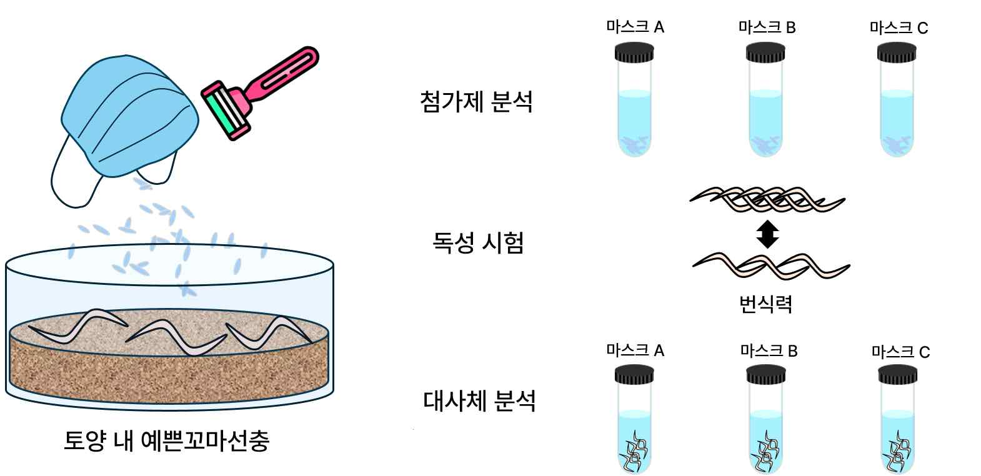

▲ Soil toxicity of microplastics derived from disposable masks. The research team discovered that microplastics generated from disposable masks cause reduced reproductive capacity in C. elegans, and that the causative agent is an additive released from the microplastics.

The experimental concentration (the ratio of microplastics in the soil) was set to 0.1% and 0.3%, and the reproductive capacity (the number of hatched larvae) of each group of C. elegans was quantitatively measured. Afterwards, the metabolic changes of the nematodes and the chemical additives detected in the masks were precisely analyzed using liquid chromatography-mass spectrometry (LC-MS)*.

* liquid chromatography-mass spectrometry (LC-MS): A precise analysis technique that separates each chemical substance from a complex mixture and then accurately measures the weight of its molecules to identify the substance.

The experimental results showed that the reproductive capacity of nematodes exposed to microplastics in KF94 and dust masks at a concentration of 0.3% decreased by 33% and 46%, respectively, which was a significant result.

On the other hand, medical masks and polypropylene (PP) raw fibers did not show any significant effects on reproductive toxicity.

In addition, metabolomics analysis confirmed that there were changes in the metabolic pathways of nematodes.

The microplastics in KF94 masks and dust masks commonly disrupted the polyamine* biosynthesis pathway, and since different additives were presumed to have been used in each, the effects on metabolites also showed differences.

* polyamines: Amines refer to basic functional groups and compounds containing nitrogen atoms, and polyamines are small molecules that play an important role in growth and reproduction in the cells of living organisms, and are also involved in cell metabolism and gene regulation.

The high-resolution mass spectrometry results detected chemical additives such as phthalates* in the mask, which are known as endocrine disruptors that cause reproductive toxicity.

The research team analyzed that these additives are likely the main cause of metabolic disturbances and decreased fertility.

* phthalates: Chemicals used to make plastic soft and flexible, and some types are known as endocrine disruptors that are harmful to the human body.

Professor Tae-Young Kim said, “This study scientifically elucidated the complex biological toxicity of microplastics discharged from disposable masks and chemical additives used in the mask manufacturing process on soil organisms,” and emphasized, “It is urgent to evaluate the long-term environmental impact of mask waste and develop eco-friendly mask materials and treatment methods.”

This study was conducted with the support of the Basic Research Project (Mid-career Research) of the National Research Foundation of Korea, and was led by Professor Tae-Young Kim and postdoctoral researcher Jonghyun Kim of the Department of Environment and Energy Engineering at GIST.

The research team of Professor Shin Woong Kim, a postdoctoral researcher at the Free University of Berlin, Professor Matthias C. Rillig, Professor Walter W. Waldman at the Universidade Federal de São Carlos in Brazil, and Professor Sunghwan Kim at Kyungpook National University participated as collaborators.

The research results were published online in an international academic journal in the field of toxicology, 《Ecotoxicology and Environmental Safety》, June 3, 2025.



