“The robot that got lost on the stairs now has a sense of direction” GIST develops 'SLOPe', a robot pathfinding technology that allows robots to freely navigate uphill roads

- Professor Pyojin Kim's research team in the Department of Mechanical and Robotics Engineering develops stable 3-DOF rotation estimation technology even in complex sloped terrain... High-precision visual compass based on the new structural model 'San Francisco World (SFW)' model

- SFW-based open dataset shared with the world along with the SLOPe algorithm... Expected to expand technology to autonomous robots, drones, and AR navigation... Published in the international academic journal 《IEEE RA-L》

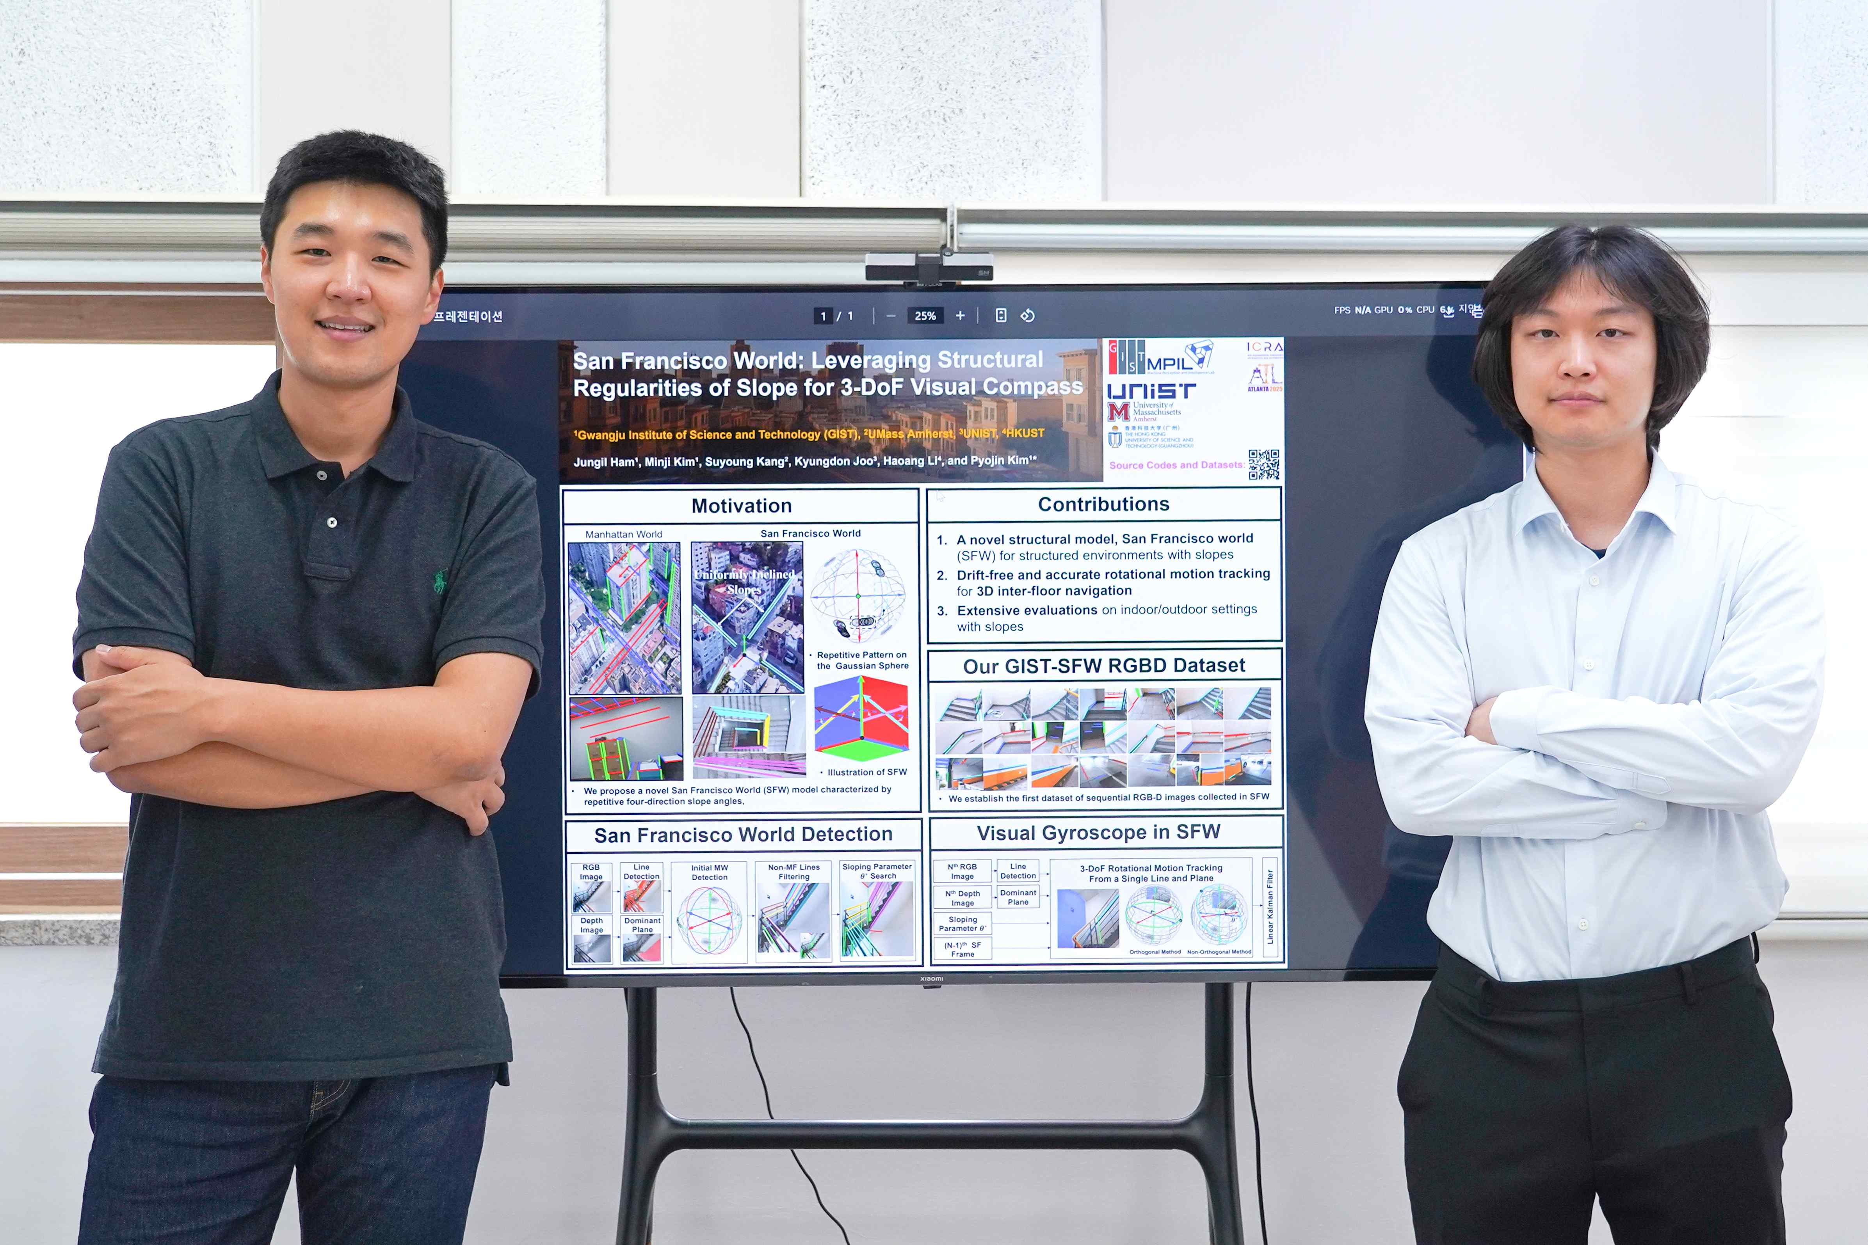

▲ (From left) Professor Pyojin Kim of the Department of Mechanical and Robotics Engineering, and student Jungil Ham

The Gwangju Institute of Science and Technology (GIST, President Kichul Lim) announced that Professor Pyojin Kim's research team in the Department of Mechanical and Robotics Engineering, in collaboration with the University of Massachusetts Amherst (UMass Amherst), Ulsan National Institute of Science and Technology (UNIST), and the Hong Kong University of Science and Technology (HKUST (GZ)), has developed a new vision-based compass technology called ‘SLOPe (Single Line and Plane-based Absolute Orientation Perception)’ that allows robots to accurately recognize directions in indoor and outdoor inclined environments.

The newly developed SLOPe technology is a lightweight algorithm that can estimate a robot’s three-degrees of freedom (3-DoF) rotation with only a single line segment and plane information. In particular, it can stably recognize directions even in spaces with complex structures and inclines, such as stairs or ramps, and thus works accurately even in environments where existing vision-based technologies showed limitations.

Existing robot pathfinding technologies* have mainly worked well in flat indoor environments, but have often lost their orientation in urban environments that require various turning movements, such as on hills or stairs.

SLOPe is gaining attention as a core technology that overcomes these limitations and helps robots determine their own direction and move stably even in inclined spaces.

* robot pathfinding technology (Visual Odometry / SLAM): A technology that allows robots to determine "where I am now" and "where I should go" on their own. It mainly recognizes its surroundings by looking at camera images or distance sensors and determines its own location.

The basis of SLOPe technology is a new structural model called 'San Francisco World (SFW)'.

While the existing 'Manhattan World' and 'Atlanta World' models were designed with a focus on vertical and horizontal structures and had limitations in reflecting the slope structure, SFW was designed to effectively reflect the slope structure based on the hilly terrain of San Francisco.

This model can precisely express complex urban environments, including one vertical direction, two horizontal directions, and four main slope directions with the same slope angle.

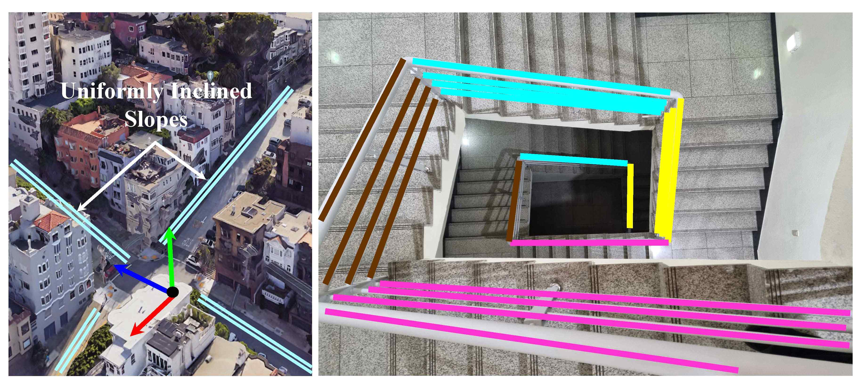
▲ Representative urban scenes (top) for the San Francisco world structure model and image samples (bottom) from the dataset collected by the research team. Inspired by the sloping terrain of San Francisco, the research team designed the San Francisco world with multiple sloping directions (cyan) that share the same slope angle and three mutually orthogonal directions (red, green, blue).

The SLOPe technology developed by the research team is more computationally simplistic and accurate than existing techniques, and it secures high precision and stability even in environments with frequent inter-floor movement such as stairs or ramps in the city.

In fact, in experiments using the SFW-based RGB-D* image dataset captured on the GIST campus and the public dataset of Texas A&M University (TAMU), it demonstrated higher rotation estimation accuracy and precision than existing state-of-the-art techniques.

In addition, the research team released GIST-SFW*, the world's first SFW-based RGB-D sequence dataset, securing the reproducibility and expandability of the research.

* RGB-D: An image format that provides color images (RGB) and depth information (Depth), including not only the color of each pixel but also the distance from the camera. It is acquired through RGB-D sensors such as Microsoft Kinect and Intel RealSense, and is used in various fields such as robot vision, 3D space recognition, and augmented reality (AR).

* GIST-SFW dataset release website: https://SanFranciscoWorld.github.io

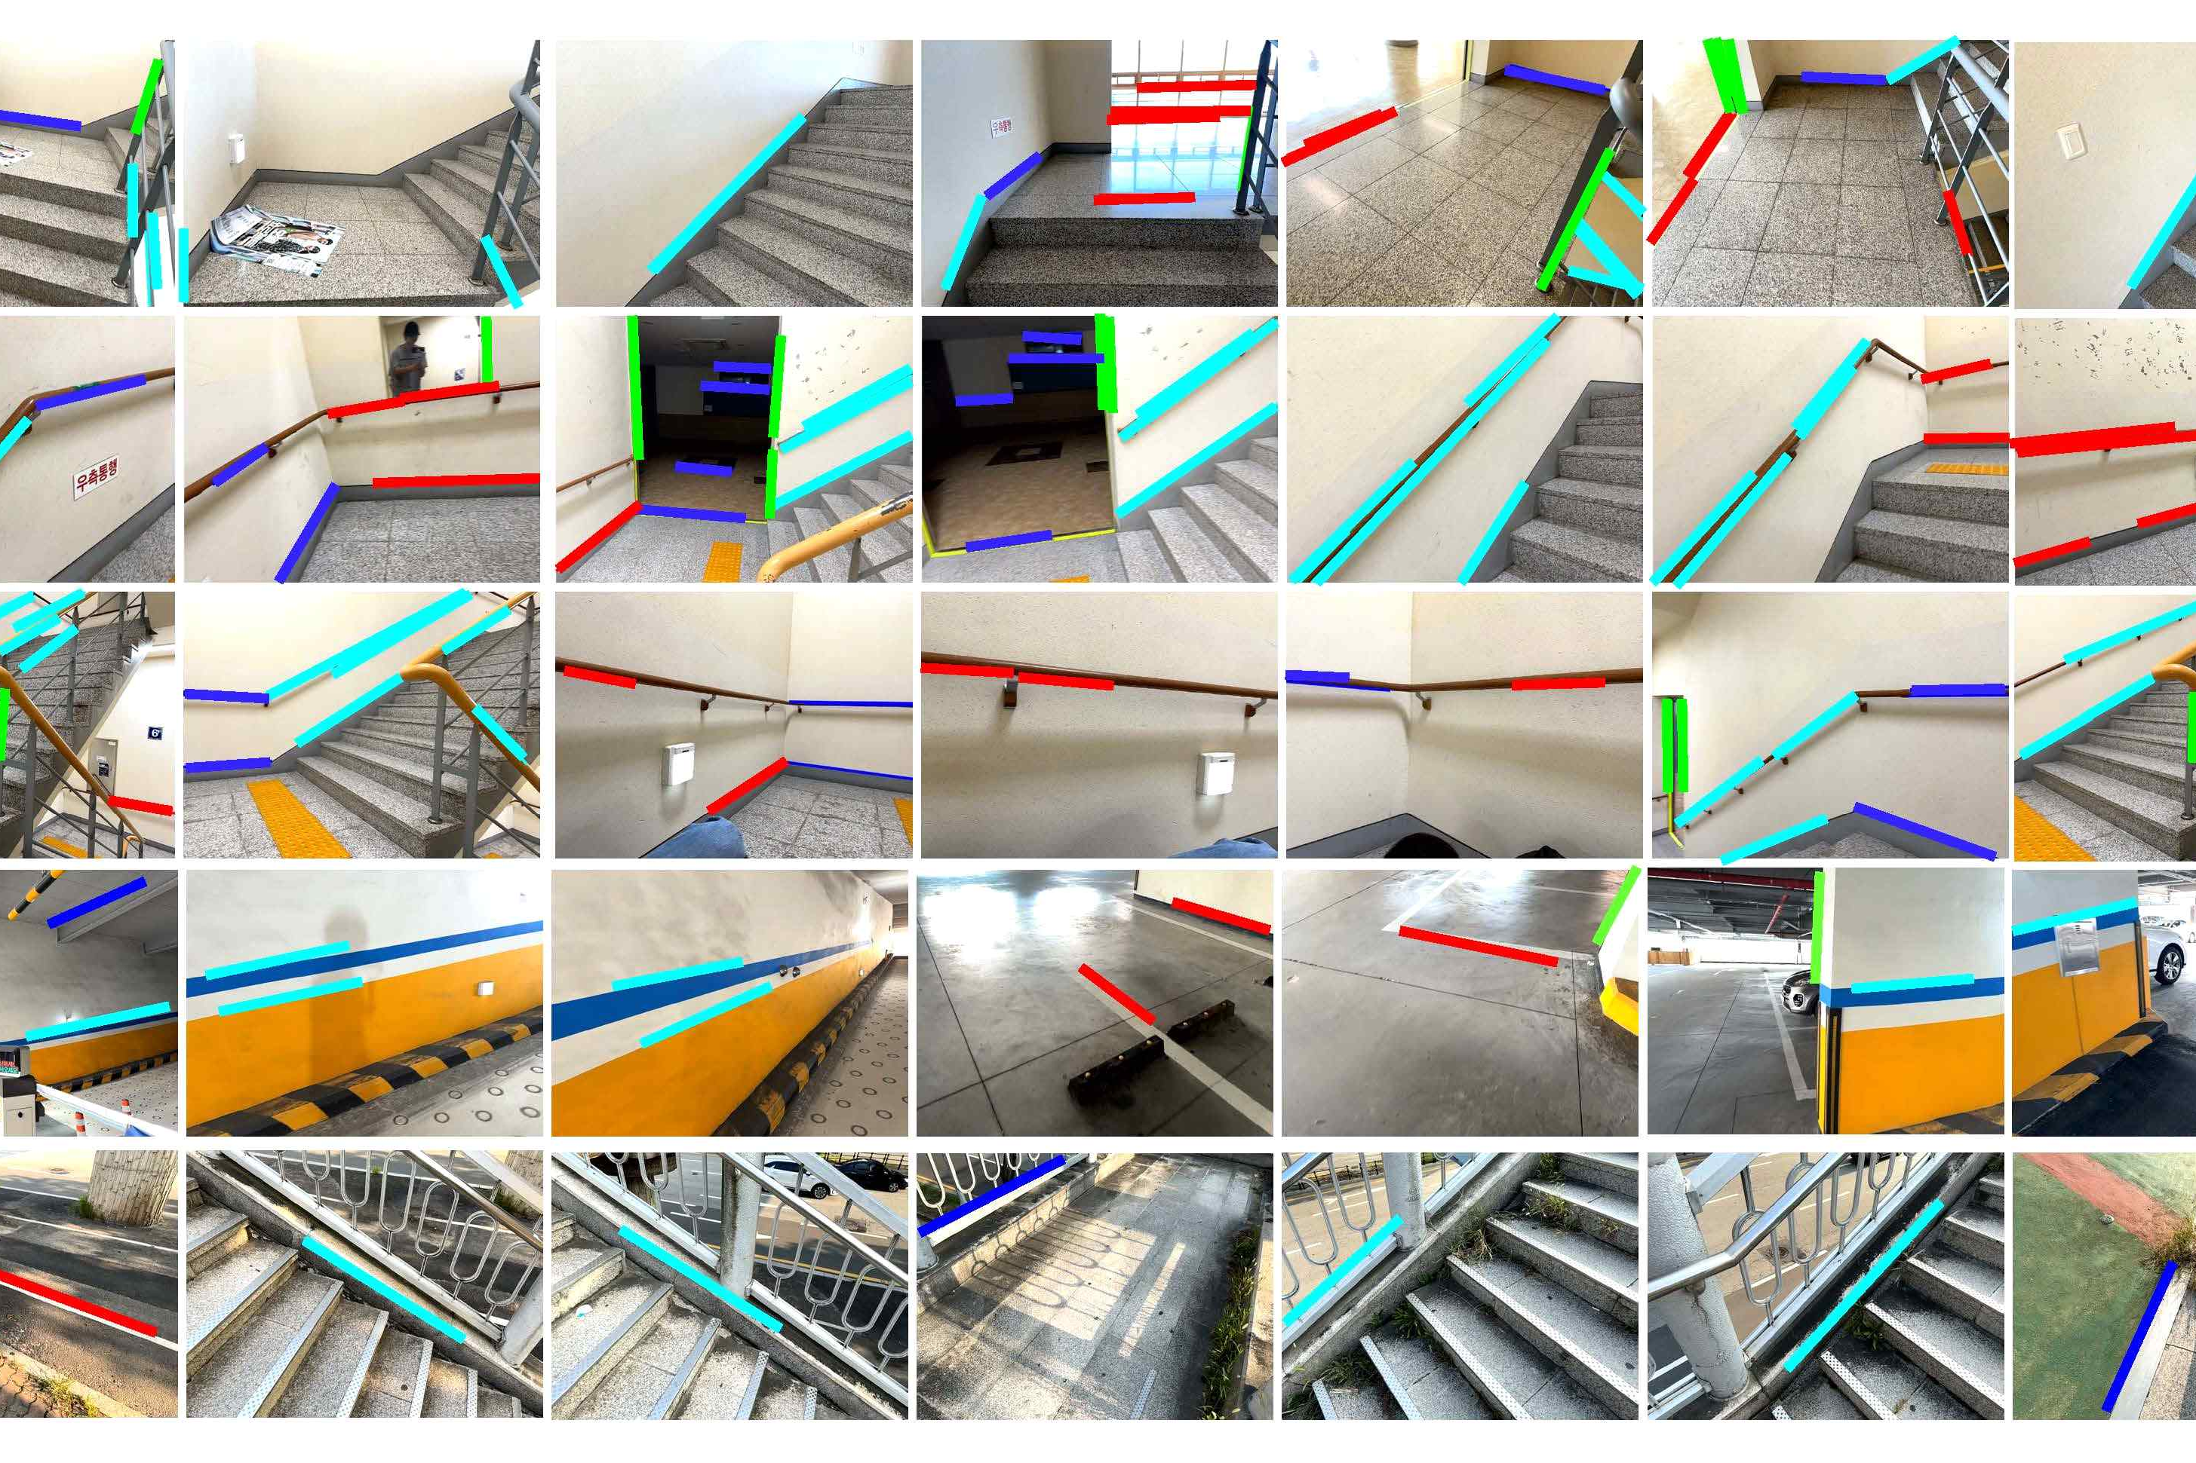
▲ Camera 3-DoF rotational motion estimation and line clustering results. The research team verified the accuracy of the "camera 3-DoF rotational motion estimation" method developed through experiments in various indoor and outdoor environments, and released GIST-SFW, the first indoor RGB-D dataset based on San Francisco World.

The research team plans to expand the research to 3D vision-based SLAM technology capable of inter-floor movement and autonomous robot navigation systems based on SLOPe technology in the future.

* SLAM (Simultaneous Localization and Mapping): Technology that allows robots to identify their location in real time and simultaneously generate a map of their surroundings

Professor Pyojin Kim said, “SFW is a basic technology that can implement an accurate and efficient robot vision system even in complex terrain, beyond a simple structural model,” and “This research will bring us closer to an era where robots can move freely on stairs and hills and become more real-life.”

This research, supervised by Professor Pyojin Kim of the Department of Mechanical and Robotics Engineering at GIST and conducted by doctoral student Jungil Ham, was supported by the Ministry of Science and ICT and the National Research Foundation of Korea’s Individual Basic Research Program (Excellent New Researcher), and was published in the January 2025 issue of the international academic journal IEEE Robotics and Automation Letters 《IEEE RA-L》.



