GIST, the world's first to elucidate the principle of hydrogen generation catalytic reaction: Molecules (ligands) surrounding metals, which were considered ‘supporting actors’, were revealed to be ‘leading actors’ in leading hydrogen bonding reactions... Rewriting the principle of eco-friendly hydrogen production

- Professor Junhyeok Seo's team in the Department of Chemistry, along with the research teams at Suncheon National University, KBSI, and Jeonbuk National University, elucidated the reaction path in which electrons and protons move simultaneously in a highly oxidized metal state... Optimized electrochemical reactions by precisely controlling molecular structures and interactions


- Laying the foundation for next-generation energy conversion technologies such as artificial photosynthesis... Published in the international academic journal 《Angewandte Chemie International Edition, ACIE》
▲ (From left) Professor Junhyeok Seo of the Department of Chemistry and Wonjung Lee, a student in the combined master's and doctoral program

Research results that suggest an important turning point in the development of next-generation electrochemical catalysts for producing hydrogen have been announced. A Korean research team has drawn attention by elucidating a new reaction principle and pathway in which the hydrogen evolution reaction (HER)* occurs in a highly oxidized state* in which metals have lost many electrons.

The Gwangju Institute of Science and Technology (GIST, President Kichul Lim) announced that the research team of Professor Junhyeok Seo of the Department of Chemistry has proven how ‘hydrogen bonding’ can help the hydrogen evolution reaction by dissolving a complex compound in which a unique ligand* molecule called dithiolene is bonded to tungsten (W) metal.

* high oxidation state: This refers to a metal atom having a higher oxidation state than its normal oxidation number, which means that the metal has lost more electrons. Metals in this highly oxidized state exhibit strong electron-pulsing properties and can exhibit unique reactivity or catalytic activity in electrochemical reactions. In particular, in electrocatalytic reactions such as the hydrogen evolution reaction (HER), the high oxidation state can play an important role in inducing new reaction paths or increasing reaction efficiency.

* hydrogen evolution reaction (HER): An electrochemical reaction that supplies electrons from water or hydrogen ions (H+) to produce hydrogen gas (H2), and is a key process for producing hydrogen in an environmentally friendly manner. This reaction is the basis for various clean energy technologies such as water electrolysis, fuel cells, and the development of hydrogen production catalysts, and is particularly receiving attention as an essential technology for producing ‘green hydrogen’ that does not emit carbon. In order to increase the efficiency of HER, the development of a catalyst that can effectively transfer electrons and induce hydrogen bonding is very important.

* ligand: A molecule or ion that binds to a metal ion to stabilize the structure of the metal and controls catalytic activity by affecting the electron distribution or reaction path. It acts as an important factor in the electrochemical performance of a complex compound.

This study has great significance in that it has revealed the operating principle of the hydrogen evolution reaction using metals in a highly oxidized state, and has suggested a new direction for how to design next-generation catalysts.

In particular, it has confirmed that when a catalyst operates, not only the metal itself but also the interaction with the ligands bound around the metal is very important, and it has shown that surrounding molecules that have not been paid attention to until now can have a critical effect on the actual reaction efficiency.

The hydrogen evolution reaction is a key technology for utilizing hydrogen gas as an eco-friendly energy source. Previously, interest was mainly focused on the electronic structure of the metal at the center of the catalyst, but recently, interest has been growing in the role of molecules attached to the metal in changing the properties of the metal and controlling the reaction.

In particular, dithiolene was well known as a ligand that stably maintains metal ions, but it has not been experimentally confirmed that this molecule binds to hydrogen and even helps transfer protons in highly oxidized tungsten compounds.

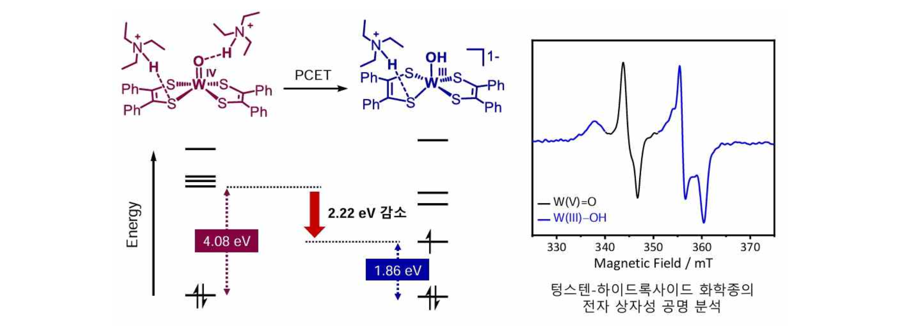
Through experiments, the research team proved for the first time in the world that a weakly acidic substance in a tungsten complex simultaneously forms hydrogen bonds between the oxygen (W=O) bonded to the metal and the sulfur (S) atom of the dithiolene molecule, thereby creating an electronic structure in which electrons and protons move together and the hydrogen generation reaction occurs smoothly.
▲ The phenomenon of a decrease in the molecular orbital energy level due to hydrogen bonding (left) and the tungsten-hydroxide chemical species whose creation was first observed through electron paramagnetic resonance (EPR) analysis (right): The proton-linked electron transfer (PCET) reaction through hydrogen bonding lowered the energy required for the transfer of protons and electrons, enabling the creation of a tungsten-hydroxide intermediate, a key intermediate for hydrogen production.

Through single crystal X-ray structural analysis, the research team confirmed that when the weakly acidic substance triethylammonium was added to the compound, hydrogen bonds were simultaneously formed between the oxygen (W=O) of the metal and the sulfur (S) atom of the dithiolene molecule.

In this process, the electronic structure of the molecule changed, making it easier for electrons to move, and the tungsten reduction reaction (W(IV) → W(III)) became possible even at lower voltages than before, effectively reducing the energy required for the hydrogen generation reaction.

In addition, through electron paramagnetic resonance (EPR) analysis, we succeeded in directly detecting the W(III)–OH intermediate generated after hydrogen bonding, which is conclusive evidence that the ‘proton-coupled electron transfer (PCET)*’ mechanism, in which electrons and protons move together, actually occurred.

In experiments using the heavy isotope deuterium (D) instead of hydrogen (H), a difference in reaction speed (H/D ratio of 1.62) was also observed, proving that the proton transfer process through hydrogen bonding directly affects the reaction speed.

Theoretical calculation (DFT) results also showed that double hydrogen bonding effectively stabilizes the electronic structure of the molecule, acting as an active species in actual catalytic reactions.

The catalytic performance was also proven through experiments, and the tungsten complex showed excellent hydrogen production capability, recording a Faraday efficiency* of up to 99% and a turnover frequency (TOF)* of approximately 122,277 times per second.

* proton-coupled electron transfer (PCET): A reaction mechanism in which protons (H⁺) and electrons (e⁻) are mutually related and move simultaneously or in stages, and is a central concept in various fields such as biological energy conversion, electrochemistry, and catalytic reactions. This mechanism lowers the energy barrier of the reaction and can control the reaction path more than simple electron or proton transfer, enabling efficient chemical conversion. In particular, it is drawing attention as an important principle that can maximize reaction efficiency through the cooperative action of electrons and protons in hydrogen generation, oxidation/reduction reactions, and metal-ligand systems.

* Faraday efficiency: An indicator of how effectively the electricity used in an electrochemical reaction was actually used to create the desired chemical substance.

* turnover frequency (TOF): A value indicating how many chemical reactions a catalyst molecule performs per unit time, and is an indicator that quantitatively evaluates the reaction speed and efficiency of the catalyst. It is generally expressed as the number of reactions per second (s⁻¹), and a higher TOF means that the catalyst works faster and more efficiently. It is used in various fields such as electrochemistry and catalytic chemistry, and in particular, TOF is used as one of the key measures for comparing practical catalyst performance in electrochemical reactions such as hydrogen production reactions.

Professor Junhyeok Seo stated the significance of the study, saying, “Through this study, we experimentally proved that molecules bound around a metal do not simply stabilize the metal, but actually help the movement of electrons and protons.” He added, “This has allowed us to more deeply understand and explain the basic principles of next-generation energy conversion reactions such as artificial photosynthesis, carbon dioxide conversion, and water electrolysis technology.”

This study, supervised by Professor Junhyeok Seo and Professor Jin Kim (Suncheon National University), Dr. Sun Hee Kim (KBSI, Chung-Ang University), and Professor Kyung-Bin Cho (Chonbuk National University) of the Department of Chemistry at GIST, with GIST PhD candidate Wonjung Lee of the Department of Chemistry participating as the main author, was supported by the Ministry of Science and ICT, the National Research Foundation of Korea (NRF), the Ministry of Education’s LAMP program, and the Korea Basic Science Institute (KBSI). The results of the study were published online in the international academic journal 《Angewandte Chemie International Edition, ACIE》, published by the German Chemical Society, on May 22, 2025.



