“Grandma, you don’t have to drag the stroller around anymore!”
GIST-MIT, AI-based walking assistance robot ‘Adaptive Walker’ for the elderly uses arms to adjust the speed, OK even on slopes

- Department of AI Convergence Professors Kyung-Joong Kim and SeungJun Kim's team, MIT and Washington University research teams develop a walking assistance robot that recognizes user intention and ground slope with tactile and inertial sensors... Stable and intuitive walking support

- Expected to be utilized by the elderly and those with impaired walking ability... Announced at the world's largest robotics conference 'IEEE ICRA' on May 20

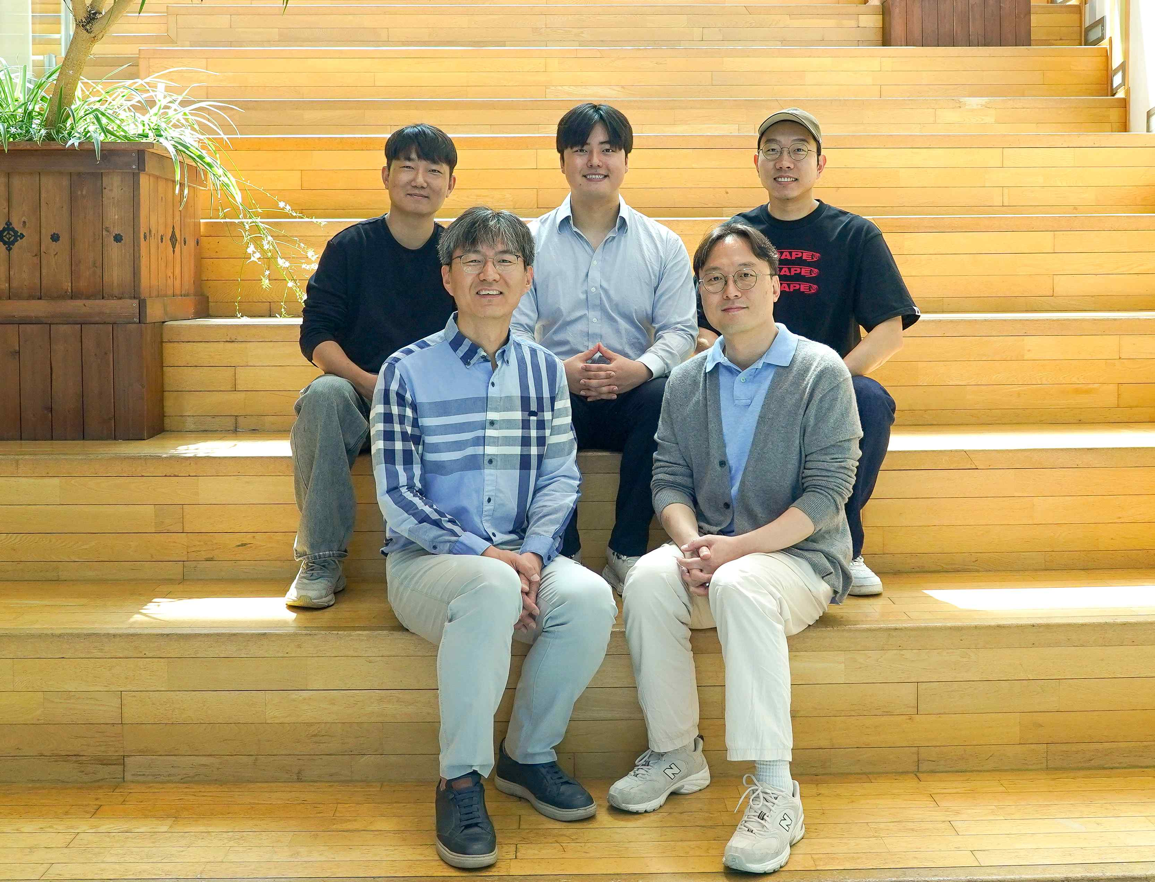

▲ (Counterclockwise from bottom left) Department of AI Convergence Professor Kyung-Joong Kim, Professor SeungJun Kim, and students Dohyeon Yeo, Yunho Choi, and Minwoo Seong

The Gwangju Institute of Science and Technology (GIST, President Kichul Lim) announced that the research team of Professor Kyung-Joong Kim and Professor SeungJun Kim of the Department of AI Convergence has developed the ‘Adaptive Walker’, a walking assistance robot that applies artificial intelligence (AI) technology.

This robot is expected to overcome the complexity of operation and stability issues that were pointed out as limitations of existing walking assistance devices, and provide safer and more intuitive mobility support to the elderly.

Existing walking assistance technology has continued to develop, but it has had limitations in that it is difficult for the elderly with impaired cognitive function to operate it, and it has had difficulties in responding immediately to various indoor and outdoor environments. In particular, maintaining balance on slopes and controlling walking speed have been major obstacles in actual use.

Accordingly, the research team began developing an AI-based walking assistance robot that can minimize the user's cognitive burden and actively respond to the environment.

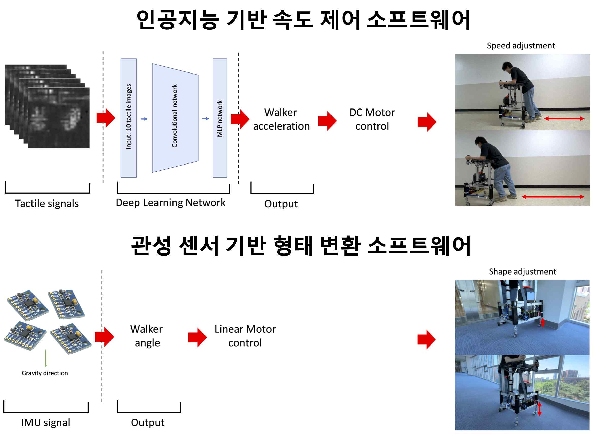

▲ Speed control and shape transformation software of the developed AI walking assistance robot and its operation. The tactile sensor information is learned by the AI model to control the rotation motor so that the walker can achieve the acceleration intended by the walker. Based on the inertial sensor, the current degree of inclination of the walker is detected and the shape is transformed through the vertical motor so that the walker can maintain parallelism even on slopes.

The newly developed 'adaptive walker' is equipped with two key functions: ▴ automatically adjusting the speed according to the user's intention and ▴ helping maintain a stable posture even on slopes.

The first is a speed control function using a tactile sensor.

A high-resolution tactile sensor developed through joint research by GIST and MIT is attached to the armrest of the walker. This sensor precisely detects the user's arm movements, and an AI model based on an artificial neural network analyzes the collected data to predict the acceleration intended by the user.

The predicted information is reflected in the robot's motor control, so that speed control is possible with only the user's natural movements without separate button operation.

As a result of the experiment, the effectiveness of intuitive speed control was proven by accurately tracking the user's walking speed with an error of less than 20%.

The second is a posture control function using an inertial sensor.

The robot is equipped with an inertial measurement unit (IMU)* that detects the slope of the ground in real time. When entering a slope, the robot detects this and automatically adjusts the length of the front or rear legs, effectively maintaining the user's balance.

In actual experiments, it was confirmed that the robot could maintain a horizontal level with an error of less than 1 degree and secure a stable posture even on a slope.

* Inertial Measurement Unit (IMU): A device that combines an accelerometer and a gyroscope, it is a sensor that measures changes in posture such as movement, rotation, and inclination of an object in real time. The IMU can accurately determine movement and direction even in indoor environments where GPS does not work, so it is used in various fields such as smartphones, drones, self-driving cars, and robots.

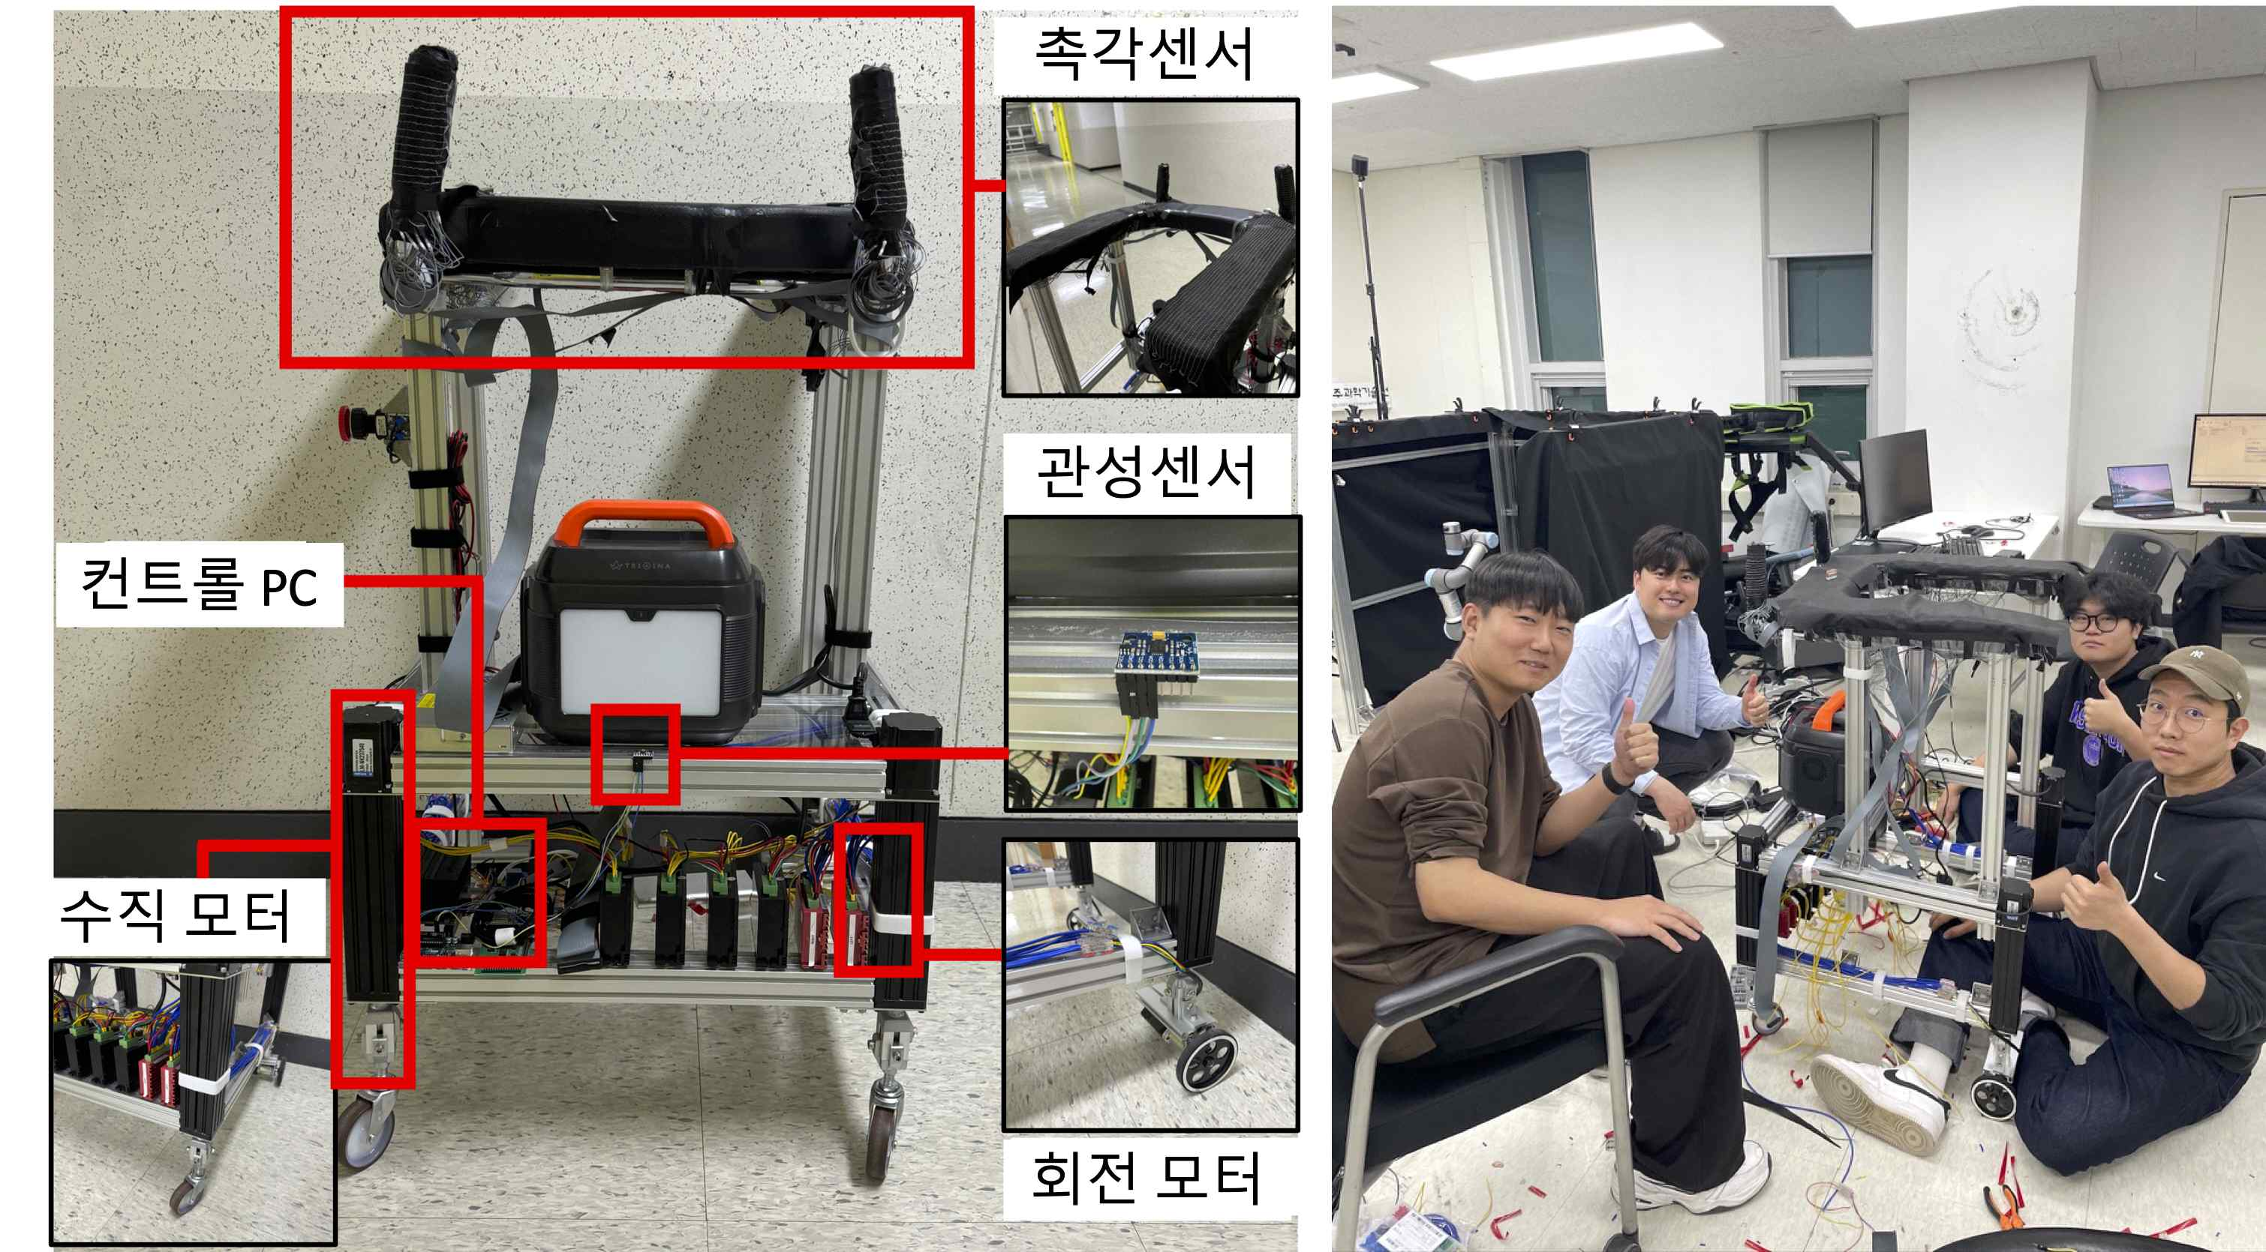

▲ (Left) The developed AI walking assistance robot and sensors installed in each part. A tactile sensor is attached to the part that supports the user's arm, and an inertial sensor is attached to the walker body. The speed of the walker is controlled by a rotary motor attached to the rear wheel of the robot, and the shape of the walker is changed using a vertical motor attached to the four legs of the robot. (Counterclockwise from bottom left) AI Convergence Department students Seong Min-woo, Yeo Do-hyeon, Hwang Seok-hyeon, and Choi Yun-ho

Professor Kyung-Joong Kim said, “This study presents a technical solution that can provide practical help to the elderly who have difficulty walking,” and added, “We plan to continue developing next-generation walking assistance devices with more functions in the future to maximize the convenience of movement for the elderly.”

This study is a joint research result of GIST and MIT’s Computer Science and Artificial Intelligence Laboratory (CSAIL) in the United States, and was supported by the GIST-MIT Joint Research Project and the Korea Institute for Advancement of Technology.

The results of the study were announced on May 20, 2025 at the IEEE ICRA (International Conference on Robotics and Automation), the world’s most prestigious robotics academic conference.

A total of 11 people participated in the research, including GIST Department of AI Convergence Professors Kyung-Joong Kim and SeungJun Kim and doctoral students Yunho Choi, JaeYoung Moon, Dohyeon Yeo, and Minwoo Seong, as well as MIT Professor Daniela Rus and Professor Wojciech Matusik, and Washington University Professor Yiyue Luo and student Seokhyun Hwang.



