"Muscles come alive with one injection" Professor Jae Young Lee and Chungnam National University joint research team develop 'injectable conductive hydrogel': Shaped to fit the damaged area and regenerates muscles with electrical stimulation

- Professor Jae Young Lee's team from the Department of Materials Science and Engineering at GIST and Professor Kang Moo Huh's team from Chungnam National University jointly developed customized tissue regeneration technology using electrically conductive nanomaterials... Electrical stimulation combined with body temperature-responsive materials

- Proof of marked improvement in contractile power and recovery power when electrical stimulation was combined in a muscle mass loss (VML) model experiment “Overcoming the limits of autologous transplantation treatment” Published in the international academic journal 《Chemical Engineering Journal》

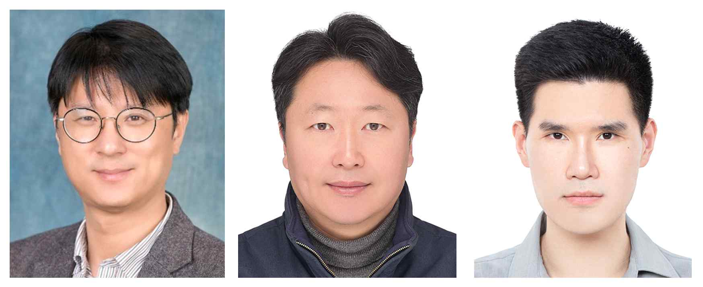

▲ (From left) Professor Jae Young Lee of the Department of Materials Science and Engineering at GIST, Professor Kang Moo Huh of the Department of Polymer Science and Engineering at Chungnam National University, and Ph.D. candidate Sehyeon Park of the Department of Materials Science and Engineering at GIST

Korean researchers have developed a ‘conductive hydrogel platform’ that can treat extensive muscle damage with a simple injection method, drawing attention as a next-generation regenerative medicine treatment.

This hydrogel platform, when injected into the body, responds to body temperature and takes shape according to the damaged area, and when combined with electrical stimulation, it has been confirmed that it can restore function to a level close to normal muscle.

The Gwangju Institute of Science and Technology (GIST, President Kichul Lim) announced that a joint research team of Professor Jae Young Lee of the Department of Materials Science and Engineering and Professor Kang Moo Huh of the Department of Polymer Science and Engineering at Chungnam National University has developed an injectable conductive hydrogel that can effectively treat volumetric muscle loss (VML).

This study is significant in that it is not simply a ‘physical supplement’ that fills damaged tissue, but an active regenerative treatment platform that induces cell activation and functional recovery in the body.

VML is a disease in which skeletal muscle tissue is extensively damaged due to traffic accidents, military injuries, surgical operations, or intense exercise. It is an intractable injury that is difficult to recover naturally.

Up to now, autologous tissue transplantation has been the main method used, but the amount of tissue that can be transplanted is limited, and secondary complications such as infection, pain, and scarring can occur at the site where the tissue is removed (donor site), making treatment difficult.

As an alternative to overcome these limitations, tissue regeneration technology based on ‘hydrogel’ has recently been attracting attention. Hydrogel is based on natural and synthetic polymers and can mimic the structure and mechanical properties similar to living tissue and has high biocompatibility, so it is actively being studied as a promising alternative for tissue transplantation.

In particular, in the case of skeletal muscle, cardiac muscle, and nerve tissues where electrical properties are important, hydrogels utilizing conductive materials can promote the electrical activity of cells and enhance the effect of tissue regeneration, drawing more attention.

The research team developed a temperature-responsive hydrating agent by introducing a hexanoyl structure, which has the characteristic of not mixing well with water, to glycol chitosan, a natural polymer, and completed an injectable conductive hydrogel by mixing it with ‘MXene’ nanoparticles with excellent electrical conductivity.

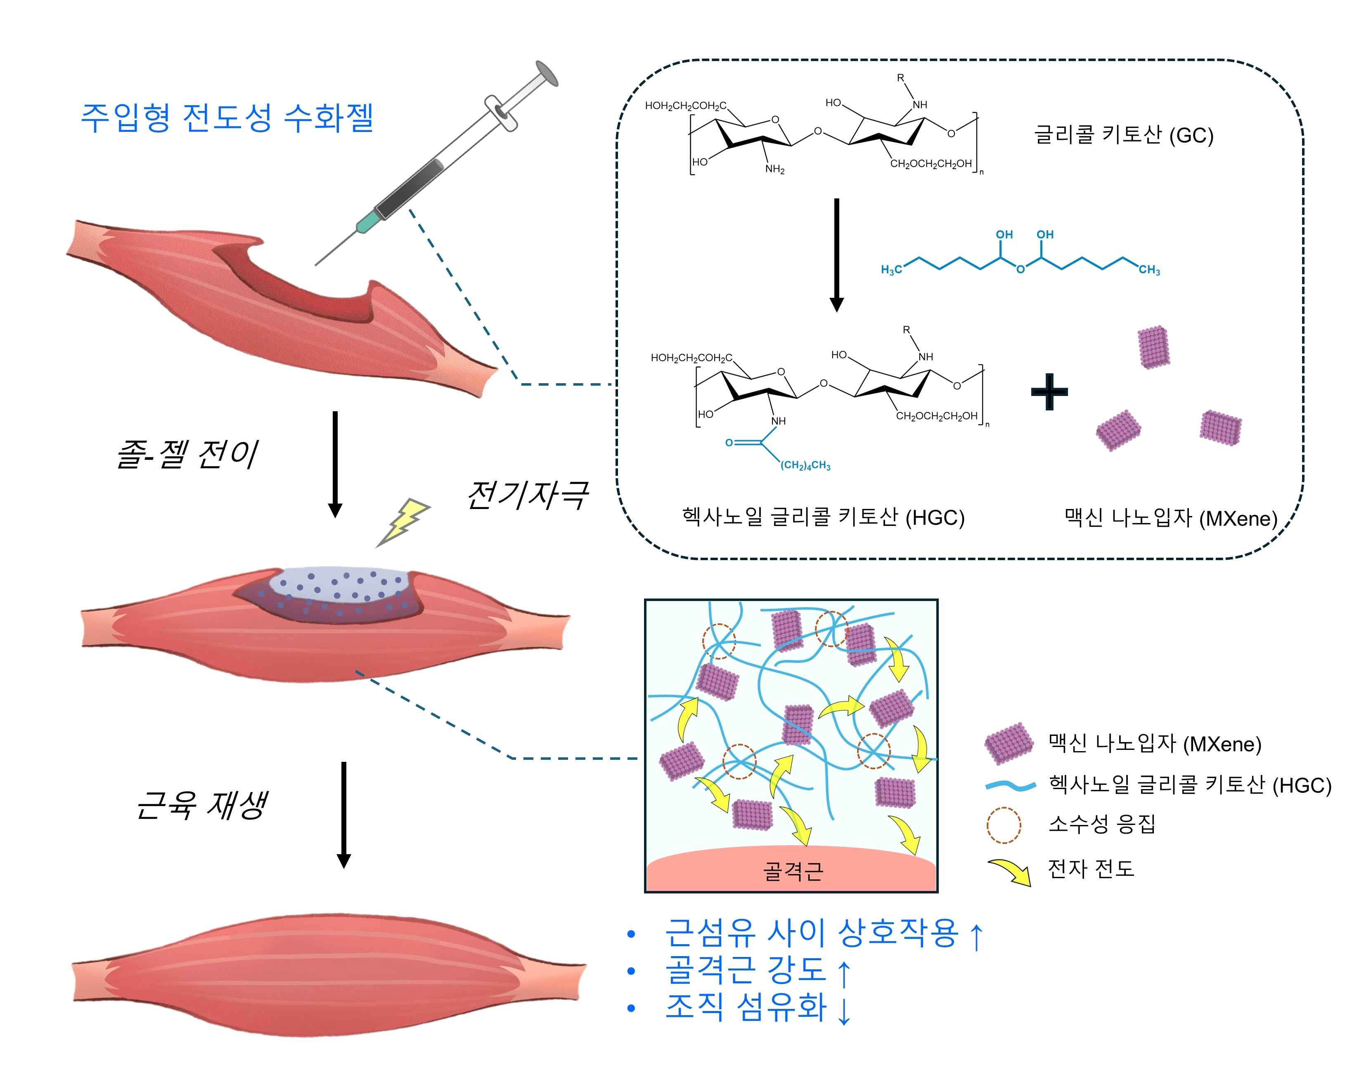

▲ Schematic diagram of an injectable conductive hydrogel based on hexanoyl glycol chitosan and containing MXene. By introducing a hydrophobic hexanoyl functional group to glycol chitosan, a sol-gel transition is induced within the body temperature range, and by introducing MXene nanoparticles with excellent electrical conductivity, a hydrogel with improved conductivity was created. This hydrogel can be precisely injected into irregular muscle loss areas, and maximizes the skeletal muscle regeneration effect based on electrical conductivity and electrical stimulation.

This hydrogel maintains a liquid state at room temperature, but when it reaches body temperature (approximately 30°C), it changes to a gel state, making it easy to inject, and it precisely settles and fixes even in irregular muscle damage areas.

In addition, it has high electrical conductivity (0.72 mS/cm) and low impedance (2.03 kΩ), so it promotes regeneration of electrically active tissues such as skeletal muscle and is also suitable for electrical stimulation transmission.

In order to confirm the bioapplicability of this hydrogel, the research team conducted an injection experiment on a VML-induced experimental mouse model.

As a result of comparing the group that was injected with the hydrogel alone and the group that was injected with electrical stimulation, the hydrogel alone was able to regenerate muscle tissue and restore function, and when electrical stimulation was combined, muscle contractility (85.4 ± 13.5% compared to normal skeletal muscle tissue) and tissue regeneration effect (weight recovery 86.6 ± 4.4%) were more significantly improved.

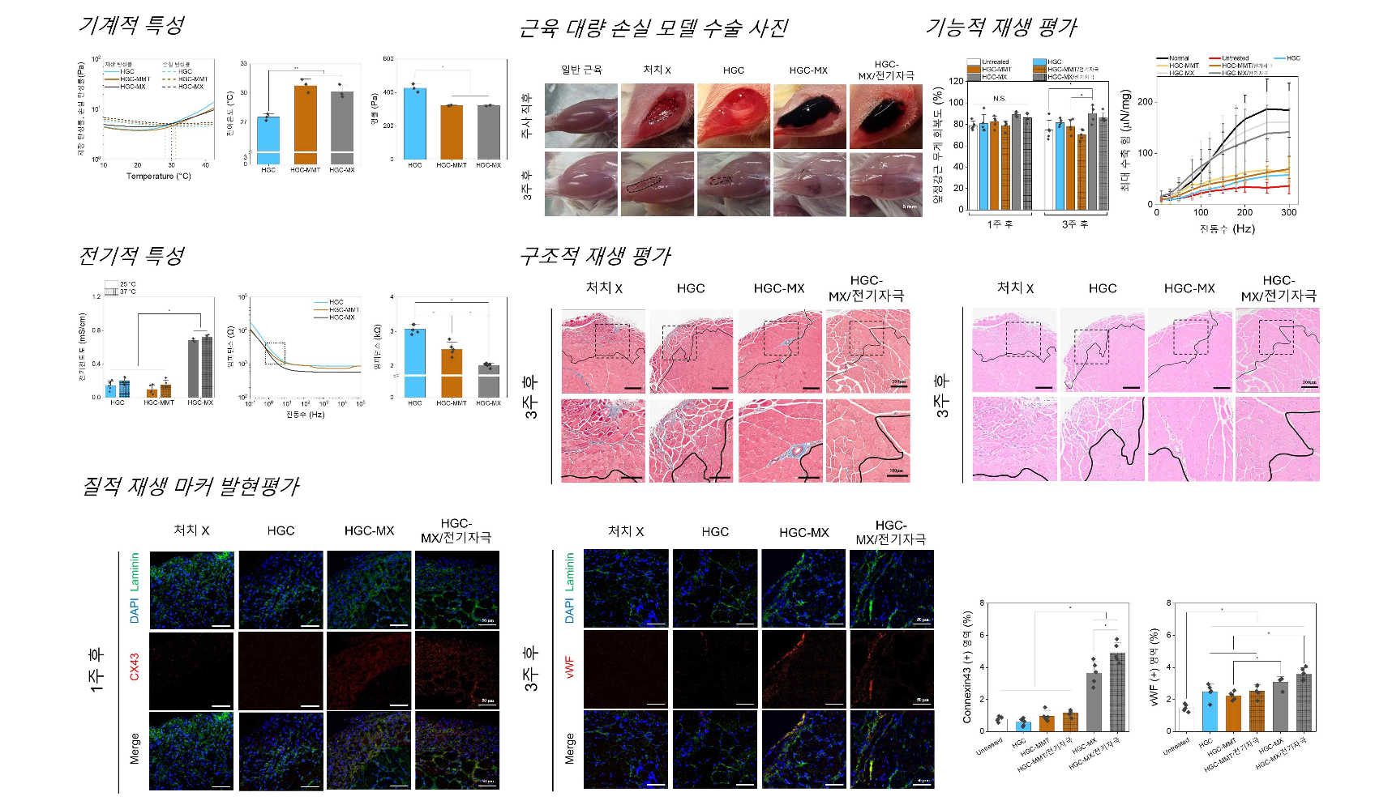

▲ Evaluation of sol-gel transition, improved electrical properties, and muscle regeneration effects in the body temperature range. The fabricated injectable conductive hydrogel undergoes sol-gel transition at physiological temperature (approximately 30°C), and the introduction of MXene nanoparticles confirmed an increase in electrical conductivity and a decrease in impedance. When applied to an animal model of muscle mass loss, excellent regeneration effects were confirmed in functional (muscle strength and weight recovery) and histological (muscle fiber maturation, fibrosis inhibition) indicators.

Professor Jae Young Lee of GIST said, “The injectable conductive hydrogel developed this time can be used for the regeneration of various electrically active tissues such as the heart, peripheral nerves, and brain beyond muscle tissue regeneration. It will be a new treatment paradigm that overcomes the limitations of existing autologous transplantation treatments.”

This research, supervised by Professor Jae Young Lee of the artment of Materials Science and Engineering at GIST and Professor Kang Moo Huh of the Department of Polymer Science and Engineering at Chungnam National University, and conducted by GIST doctoral student Sehyeon Park, was supported by the National Research Foundation of Korea’s Mid-career Researcher Support Project and the Nano and Materials Technology Development Project. The results of the research were published in the international academic journal 《Chemical Engineering Journal》 on May 15, 2025.



