“Making alcohol from CO₂” GIST develops world’s No. 1 conversion efficiency technology to produce high value-added chemical fuels from CO₂, achieving world’s highest production scale with new paradigm

- Professor Jaeyoung Lee's team from the Department of Environment and Energy Engineering succeeds in selectively producing alcohol through a new catalytic reaction pathway... Opens the way to mass production of high value-added chemical raw materials with an efficiency four times higher than before (less than 15% → 66.9%)

- Presenting a new breakthrough in the carbon neutral era... Published in the international academic journal 《Nature Catalysis》

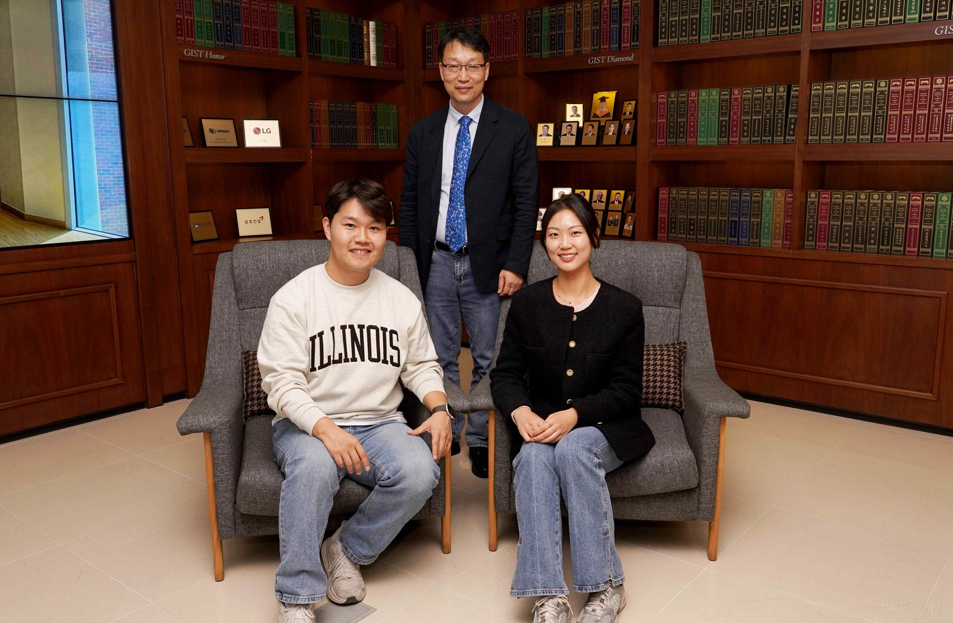

▲ (From left) Dr. Minjun Choi of GIST (currently UIUC), Professor Jaeyoung Lee of GIST (corresponding author), Dr. Sooan Bae of GIST (co-author)

The Gwangju Institute of Science and Technology (GIST, President Kichul Lim) announced that the research team of Professor Jaeyoung Lee (Director of the Future Research Center for Chemical Energy Storage and Conversion Processes) of the Department of Environment and Energy Engineering has developed an electrochemical conversion technology that can produce the high value-added compound ‘allyl alcohol’ using carbon dioxide (CO₂) at the world’s highest ‘partial high current density’.

This technology is expected to suggest new possibilities for economical electrochemical carbon capture and utilization technology (e-CCUs) by selectively converting carbon dioxide with one carbon atom into allyl alcohol, a multi-carbon high value-added compound (C3+) with three or more carbon atoms, by configuring the self-developed reduction electrode catalyst copper phosphate (CuP₂) and oxidation electrode catalyst nickel iron (NiFe) into a membrane-electrode assembly without a gap between the anodes.

Allyl alcohol (C₃H₆O) is a very useful substance that can be used in various chemical reactions because it has a structure that contains an allyl group (-CH₂CH=CH₂)* and a hydroxyl group (-OH)* with a double bond.

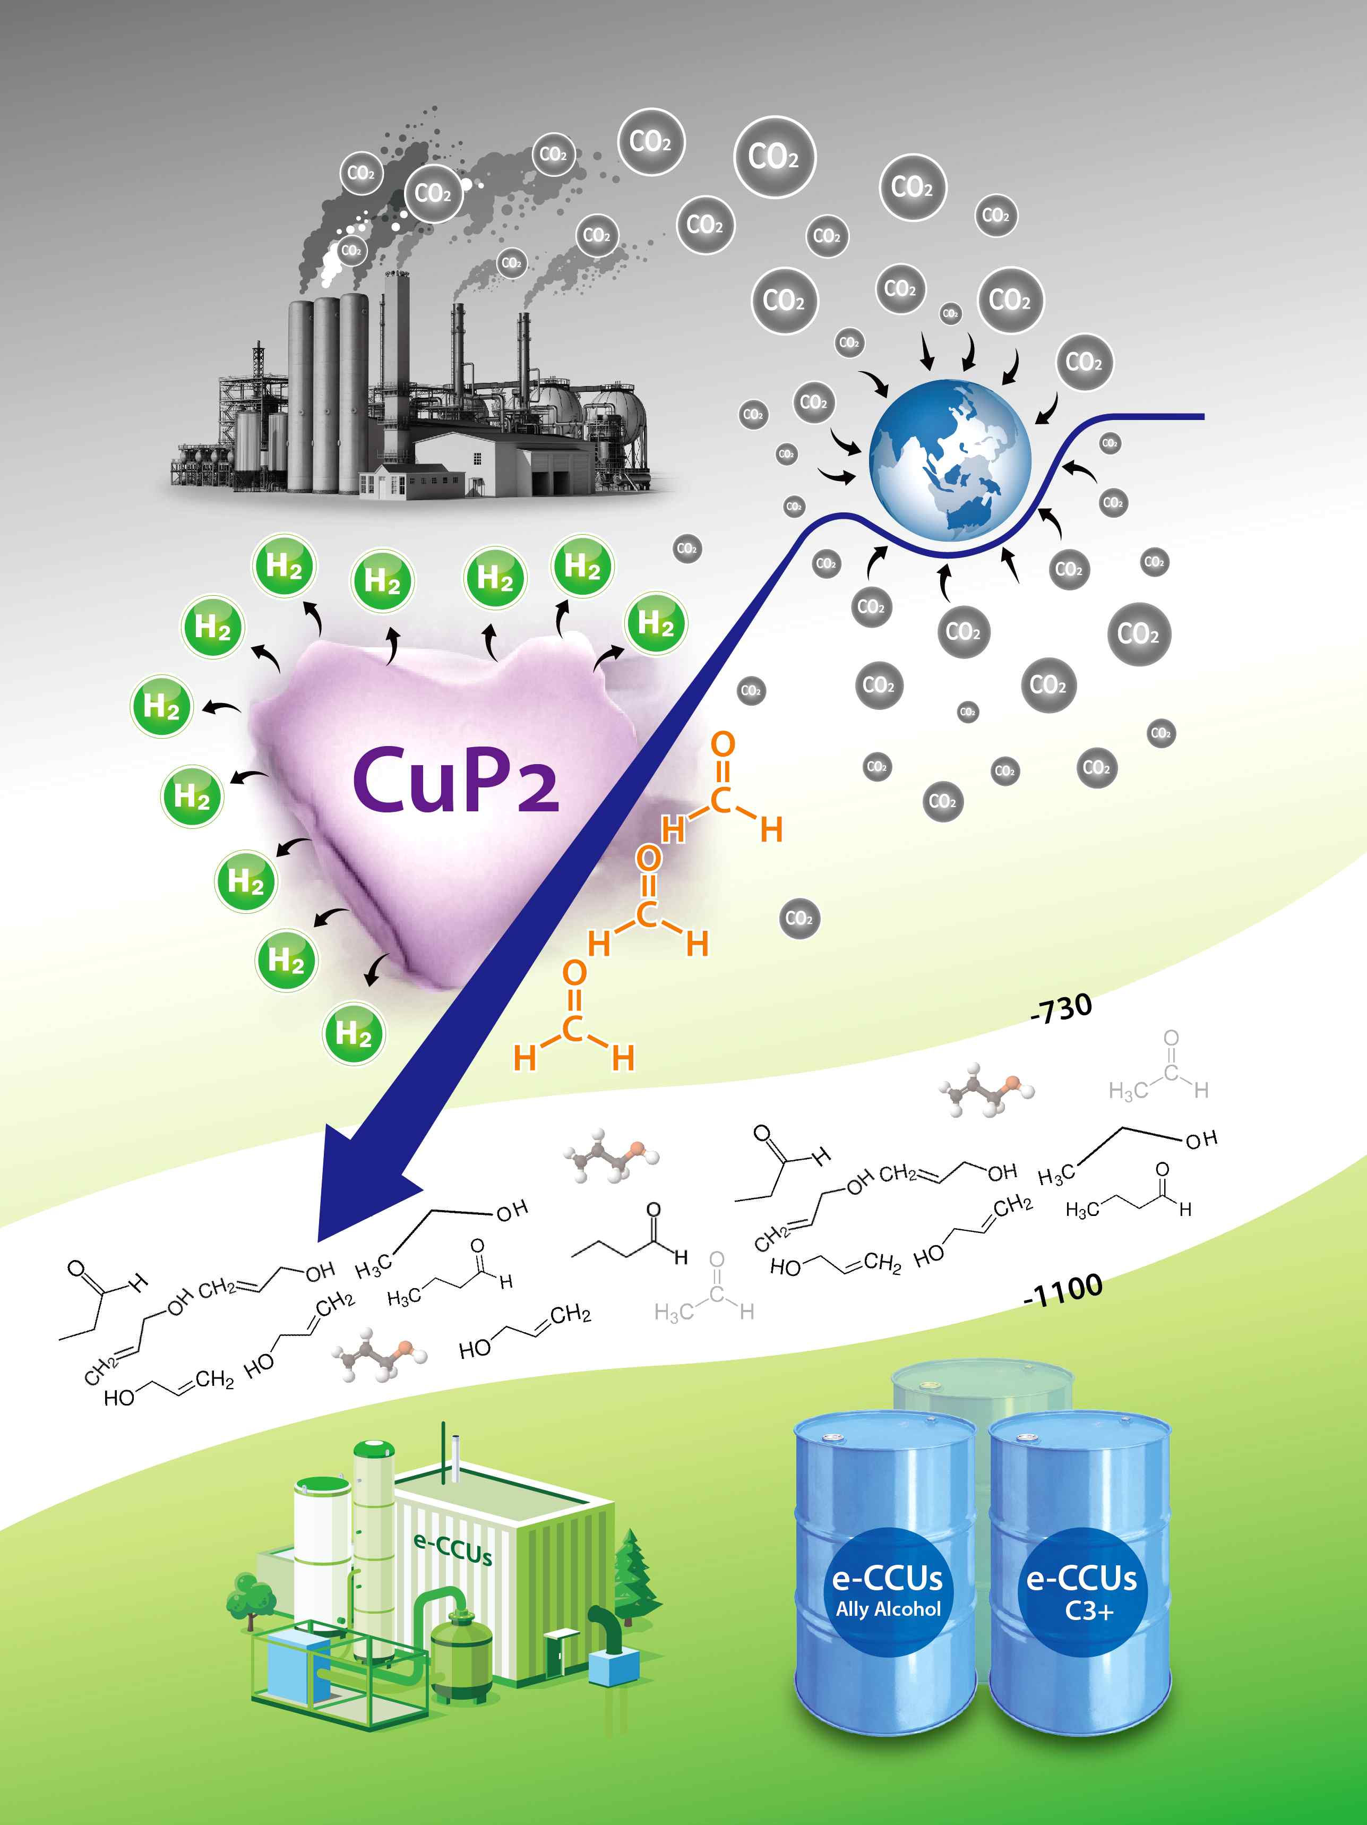

▲ e-CCUs (electrochemical Carbon Capture Utilization and storage) technology capable of producing multi-carbon compounds (C₃₊) from carbon dioxide using copper CuP₂ electrode catalyst. The high current density of -700 mA cm⁻² per unit area is a standard value that can be used to commercialize the carbon dioxide conversion electrolytic process through scale-up in the industry.

In particular, it is used as an essential raw material for synthesizing polymer compounds in various industrial fields such as plastics, adhesives, sterilizers, and fragrances, and its industrial value is very high.

* allyl group (-CH₂CH=CH₂): It is a highly reactive functional group in organic chemistry in the form of a methylene group (-CH₂) attached to an alkene structure including a double bond. This structure shows stability in a free radical or anion state because the allyl carbon located next to the double bond can form a resonance structure. Therefore, it easily participates in various substitution reactions, radical reactions, etc., and it becomes the basic unit of compounds that are frequently used experimentally, such as allyl chloride or allyl alcohol.

* hydroxyl group (-OH): A highly polar functional group that combines oxygen and hydrogen, which mixes well with water and forms hydrogen bonds to increase the boiling point and make it hydrophilic. This functional group exists in various organic compounds such as alcohol, phenol, and carboxylic acid, and plays an important role in oxidation reactions and esterification reactions. In particular, alcohols are widely used not only in daily life but also in industry and life sciences.

Electrochemical reduction technology of carbon dioxide is a key technology in the carbon-neutral era that can convert carbon dioxide, the main culprit of global warming, into useful substances, but selectively producing high value-added compounds with three or more carbon atoms, such as allyl alcohol, has a very low Faraday efficiency* of less than 15%, and the reaction path is complex and the stability of the intermediate is low, so there are significant technical limitations.

In particular, high value-added compounds in a liquid state are known to be very difficult to produce because it is difficult to create carbon-carbon (C–C) bonds and the stability of the reaction intermediate is low.

* Faraday efficiency: This is an indicator of how effectively the electricity used in an electrochemical reaction was actually used to create the desired chemical substance. It is a figure that shows how accurately the current contributed to the production of the target substance, and the higher this value, the more efficiently the desired result was obtained without wasting electricity.

However, the technology developed in this study achieved a Faraday efficiency of 66.9%, which is about 4 times higher than the existing best technology. This high efficiency proves the excellent selectivity of the catalyst that can minimize the production of unnecessary byproducts and selectively produce only the desired substance.

In addition, it demonstrated the world's highest performance by recording a partial current density of 735.4 mA cm⁻² and a production rate of 1643 μmol cm⁻² h⁻¹ in a process that can apply 1100 mA cm⁻² per unit area of ​​the electrode. As allyl alcohol, a high value-added chemical, can be stably mass-produced in this way, the possibility of its use in actual industrial sites has greatly increased.

In particular, this study revealed a new reaction pathway in which a carbon-carbon (C–C) bond is formed in the process of converting an intermediate called formate (HCOOad)* to formaldehyde (HCOad)*, rather than the previously widely known 'reaction pathway via carbon monoxide'.

This is a reaction mechanism that overturns the existing general theory, and greatly increases commercial value in that most of the products are liquid compounds that are easy to store and transport.

* formate (HCOOad): An intermediate formed in the CO₂ reduction process, it is adsorbed on the catalyst surface in the form of formate ions and plays an important role in the progress of the reaction.

* formaldehyde (HCOad): An intermediate converted from formate, a key material converted into a multi-carbon compound through a condensation reaction.

Professor Jaeyoung Lee emphasized, “The carbon dioxide conversion process technology developed this time can be evaluated as a breakthrough that can suggest a new business direction for overcoming the crisis for the coal/petrochemical and steel industries, which are increasingly burdened by carbon dioxide emissions.” He also said, “We expect it to be an important stepping stone for advancing into the carbon neutral era through scale-up, that is, a science and technology approach of scale.”

This study, supervised by Professor Jaeyoung Lee (corresponding author) of the Department of Environmental and Energy Engineering at GIST and led by Dr. Min-Jun Choi (first author) and Dr. Bae Soo-An (second author), was supported by the Overseas Excellent Research Institute Cooperation Hub Construction Project and the Leading Research Center Support Project funded by the Ministry of Science and ICT and the National Research Foundation of Korea.

The research results were published online on May 22, 2025 in the world-renowned physical chemistry journal 《Nature Catalysis》.

Meanwhile, Professor Jaeyoung Lee is collaborating with Esus (www.esus.co.kr) to commercialize electrolytic process technology based on a large-area membrane electrode assembly (MEA) with minimized inter-electrode gap, and the first author, Dr. Minjun Choi, is currently conducting follow-up research at the University of Illinois at Urbana-Champaign in the United States.



