GIST succeeds in observing and clarifying the evolution process of polymer nanostructures for the first time in the world: ‘Scaling theory’ core hypothesis experimentally proven, opening new horizons for next-generation nanomaterial design

- Professor Eunji Lee's team of the Department of Materials Science and Engineering experimentally elucidates the core principles of polymer crystallization-induced self-assembly using real-time electron microscopy and ultra-low temperature analysis... Real-time capture of the 'invisible' nanostructure evolution process

- "Establishing the foundation for designing high-performance nanomaterials for organic electronics and biosensors" published in the international academic journal 《Matter》

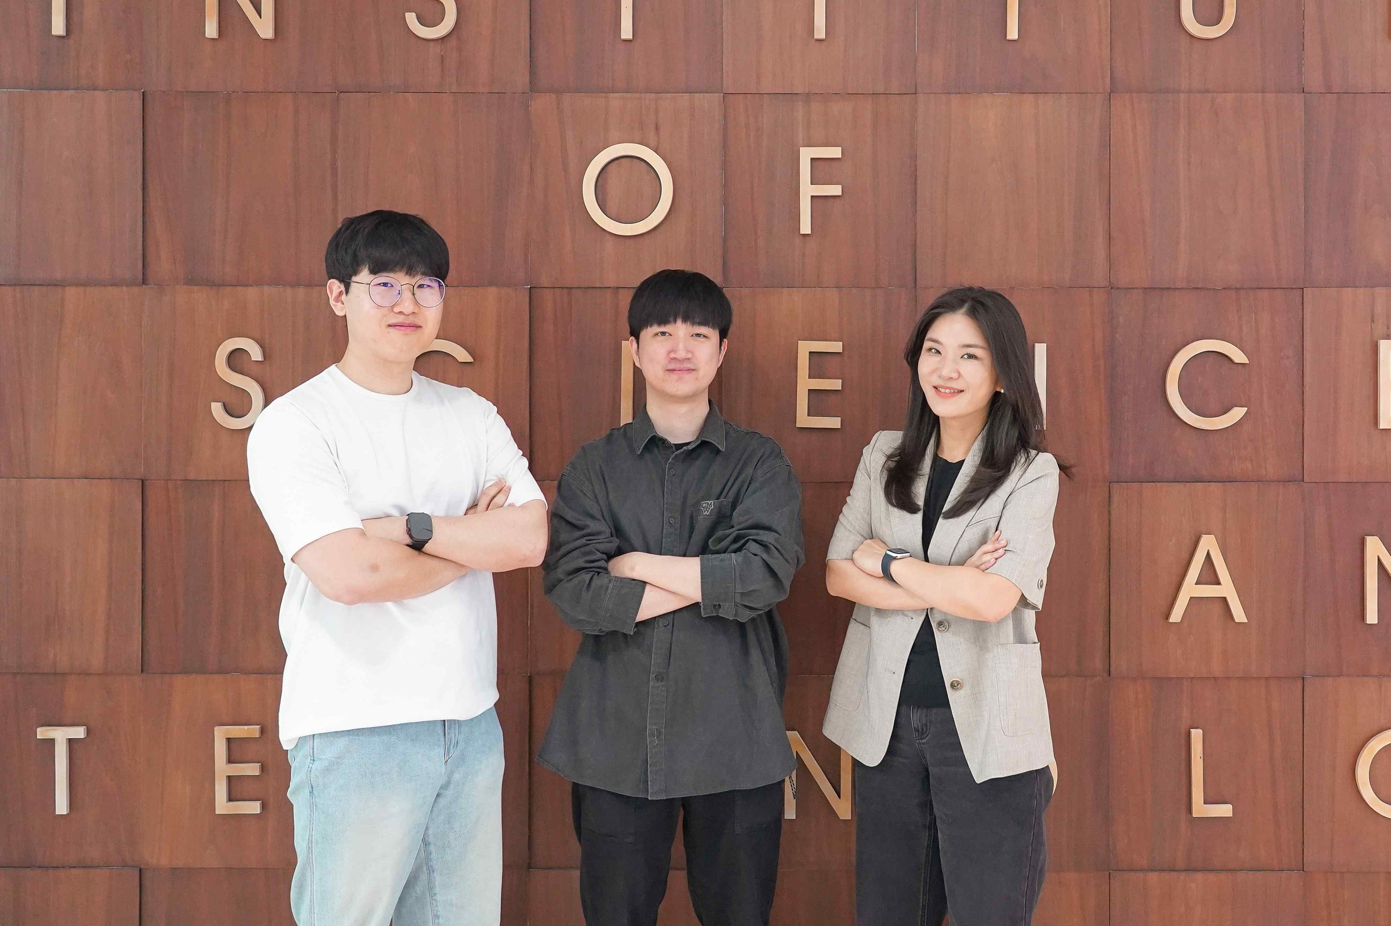

▲ (From left) GIST Department of Materials Science and Engineering Ph.D. student Junyeon Yoon, Ph.D. student Jun Ho Hwang, and Professor Eunji Lee

A Korean research team has succeeded in observing the entire process of block copolymers* self-assembling in solution and evolving into nanostructures in real time using a real-time liquid-phase transmission electron microscope (LP-TEM)* and elucidating the principles behind it.

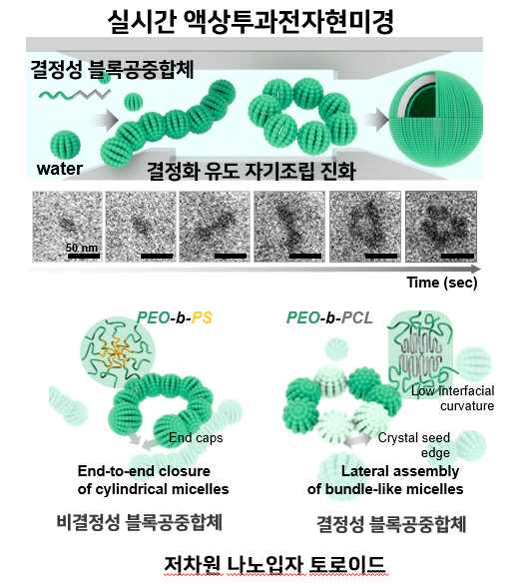

▲ Real-time observation of crystallization-induced self-assembly process of amphiphilic block copolymers: Liquid-phase transmission electron microscope study

This study is the world's first experimental verification of the core hypothesis of the 'scaling theory'*, which had existed only theoretically until now, and is evaluated to have established a scientific foundation for the design of sophisticated nanomaterials.

* real-time liquid-phase transmission electron microscope (in-situ LP-TEM): A special electron microscope that can observe liquid-state samples, allowing real-time, high-resolution observation of the process in which polymers are deformed or assembled in solution.

* block copolymer: A polymer in which different types of polymer blocks are chemically linked. Various nanostructures can be formed depending on the characteristics of each block.

* scaling theory: Theory that crystalline block copolymers fold themselves to avoid contact with solvents and assemble in the most energy-stable form. In particular, the key point is that they prefer low curvature (a form with little bending).

The Gwangju Institute of Science and Technology (GIST, President Lim Ki-chul) announced that Professor Eunji Lee's research team from the Department of Materials Science and Engineering observed and quantitatively analyzed the entire process of crystalline block copolymers self-assembling in solution and evolving into nanoparticles in real time.

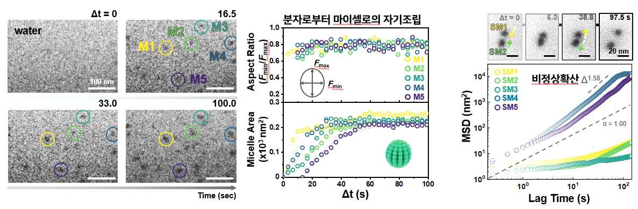

▲ Micelle formation and dynamic behavior through molecular self-assembly: (Left) Image of micelle formation observed with a real-time liquid transmission electron microscope, (Middle) Graph of micelle area change over time, (Right) Graph showing micelle non-dispersive diffusion movement.

In particular, a clear path was captured in real time as polymer nanostructures evolve from spherical micelles* → cylindrical micelles → toroids* → vesicles with a double-layer structure.

* micelle: A small structure that block copolymers create themselves in water. The hydrophilic portion surrounds the outside, and the hydrophobic portion gathers inside to form the center.

* toroid: A donut-shaped nanostructure. It has both internal and external curvatures, giving it unique physicochemical properties for material transport and stress distribution.

* vesicle: A structure that resembles an empty ball, wrapped in a double membrane, capable of containing different substances inside and outside. Used in various fields such as drug delivery and nanoreactors.

The natural world has the ability to ‘self-assemble’ to create complex structures on its own, which plays a key role in the development of high-performance nanomaterials.

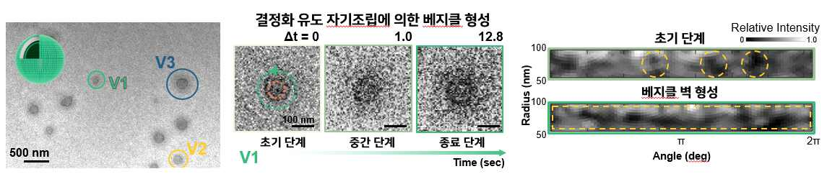

▲ Vesicle formation process through micelle self-assembly: (Left, center) Images of vesicle formation observed with a real-time liquid transmission electron microscope. (Right) Circular angle transformation map showing the process of forming vesicle walls by micelle self-assembly.

Among them, ‘polymer crystallization’ is a phenomenon in which polymer chains fold themselves and are arranged regularly, and plays an important role in forming complex structures where order and disorder coexist.

A technology related to this, ‘crystallization-induced self-assembly*’, is the principle in which polymer crystallization leads to structure formation, and it can simultaneously secure the regularity of molecular arrangement and the stability of particle structure, so it is attracting attention in various fields such as optoelectronics and biomaterials.

However, due to the complexity in which crystallization and block separation occur simultaneously, it has been difficult to experimentally elucidate the specific mechanism of structural transition until now.

* crystallization-driven self-assembly: A phenomenon in which block copolymers crystallize in solution and simultaneously self-assemble into a specific structure

The research team observed the self-assembly process according to molecular weight and block composition ratio in real time using LP-TEM using PEO-b-PCL*, a representative biodegradable biocompatible polymer.

As a result, the phenomenon in which spherical nanoparticles, which were not observed in non-crystalline polymers, evolved into cylinders or donut-shaped toroids through lateral bonding was clearly captured.

This is due to the characteristic of crystalline core blocks preferring low curvature, i.e. flatter interfaces, to lower the energy of the system, and it is a very important discovery that experimentally verified the core assumption of the ‘scaling theory’ that existed only in theory.

Through this, the research team experimentally confirmed that crystallization is very advantageous for forming stable low-dimensional (1D, 2D) nanostructures.

* PEO-b-PCL (poly(ethylene oxide, PEO)-b-poly(ε-caprolactone), PCL): A polymer that combines water-soluble PEO and hydrophobic, crystalline PCL. It is environmentally friendly and is used for various purposes such as drug delivery.

Polymer self-assembly technology is attracting attention as a core technology for the development of next-generation nanomaterials because it can implement various uniform nanostructures.

However, research has been conducted so far centered on amorphous polymers, and there were limitations in elucidating the principles of structure formation due to the difficulty in real-time observation in a solution state.

Another significance of this study is that it does not simply visualize the shape of the nanostructure, but quantitatively analyzes the image data by time period to obtain numerical data such as particle movement path and assembly speed.

In particular, by tracking the method and time of spherical particle combination, the interaction between particles and the self-assembly mechanism were quantitatively explained.

The analysis results showed that the rigidity (stiffness) and curvature control ability of crystalline blocks play a key role in the evolution of nanostructures (spherical micelle → cylinder → donut-shaped toroid → double-layer vesicle), and this process shows the aspect of abnormal diffusion* in which particles assemble by influencing each other through long-range interactions, rather than normal diffusion* in which they spread randomly.

* normal diffusion: A phenomenon in which particles or molecules spread uniformly over time due to random thermal motion.

* anomalous diffusion: The speed or method of diffusion is not constant, and a more complex pattern is shown.

In particular, the difference in the formation path of the donut-shaped toroidal structure was also revealed. In general, in amorphous polymers, both ends of the cylinder structure are connected to form a donut-shaped toroid, whereas in this study, it was experimentally confirmed that crystalline polymers follow a previously unknown non-equilibrium path in which they directly evolve from spherical micelles to donut-shaped toroids.

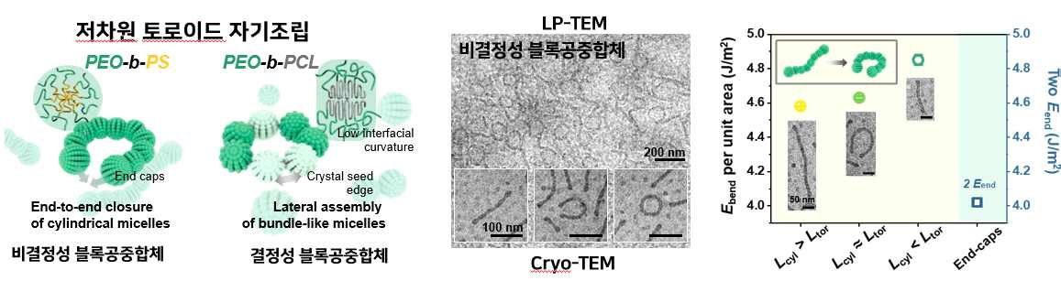

▲ Effect of the crystallinity of the block copolymer core block on the self-assembly path of toroid formation: (Left) Schematic diagram of the toroid formation path through cylinder-end bonding of amorphous core block copolymers and the toroid formation process through micelle-side bonding of crystalline core block copolymers, as proven by liquid-phase transmission electron microscope imaging.

(Center) Toroidal self-assembly path of amorphous core block copolymer observed through coupled analysis of cryo-TEM and LP-TEM. (Right) Calculation result of bending energy generated when cylinder ends are joined.

This unique evolution path was clearly elucidated by real-time LP-TEM and cryogenic transmission electron microscopy (cryo-TEM)* that preserves the structure of the sample in a frozen state.

* cryogenic transmission electron microscopy (Cryo-TEM): A transmission electron microscopy technique that rapidly freezes a sample to liquid nitrogen temperature (approximately -170°C or lower) to observe the sample while preserving its original structure as much as possible. It is very useful for analyzing the three-dimensional structure of biomolecules such as proteins, viruses, and cell organelles or nanomaterials at high resolution.

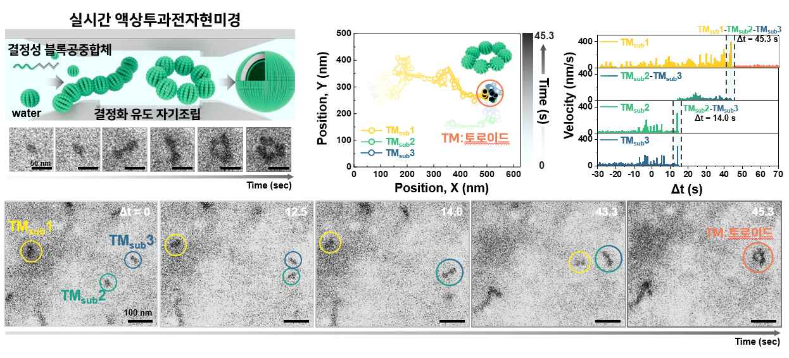

▲ Crystallization-induced self-assembly process of amphiphilic block copolymers using real-time liquid-phase transmission electron microscopy: (Top) Schematic diagram of the stepwise self-assembly process of amphiphilic crystalline block copolymers observed using liquid-phase transmission electron microscopy. It evolves into spheres, cylinders, toroids, and vesicles over time, and includes images of the toroid formation process and the results of kinetic analysis based on individual tracking of the elemental micelle particles that compose it. (Bottom) Evolution process from elemental micelles to toroids.

“This study is the first case to precisely elucidate the molecular-level principles and dynamics of polymer self-assembly,” said Jun Ho Hwang, PhD student (first author). “It can serve as a basis for the precise design of nanostructures required for advanced technologies such as organic electronics, biosensors, and drug delivery systems in the future.”

Professor Eunji Lee said, “This study has great academic significance in that it tracked and quantitatively analyzed the formation and evolution of polymer nanostructures in real time,” and explained, “In particular, by experimentally proving how the complex phenomenon of crystallization-induced self-assembly affects the evolution of nanostructures, it was possible to suggest a new design direction for functional nanomaterials.”

This study was supervised by Professor Eunji Lee (corresponding author) of the Department of Materials Science and Engineering at GIST and conducted by Ph.D. student Jun Ho Hwang (first author) and Ph.D. student Junyeon Yoon (co-author). Professor Myungeun Seo-eun of the Department of Chemistry at KAIST (Korea Advanced Institute of Science and Technology) and Professor Joseph P. Patterson of the Department of Chemistry at the University of California, Irvine participated as co-authors.

The research was supported by the Ministry of Science and ICT, the National Research Foundation of Korea’s Mid-career Researcher Support Project and the Nano and Materials Technology Development Project, and the Samsung Future Technology Promotion Project.

The research results were published online in 《Matter》, published by Cell Press, on May 12, 2025.



