GIST and Dongguk University joint research team develop next-generation zinc ion battery source technology, drastically improving lifespan and durability with graphene coating

- GIST Advanced Insitute of Instrumental Analysis Dr. Yong-Ryun Jo and Dongguk University Professor Geon-Hyoung An joint research team, overcoming the structural limitations of zinc-ion batteries by coating graphene on stainless steel foil using the ‘Roll-to-Roll’ method

- Expected to be an eco-friendly, low-cost, and high-stability technology applicable to various fields such as electric vehicles and energy storage systems (ESS)... Published in the international academic journal 《Advanced Energy Materials》



▲ (From left) Dr. Yong-Ryun Jo of GIST Advanced Insitute of Instrumental Analysis, Professor Geon-Hyoung An of Dongguk University Department of Energy and Materials Engineering, and Heeyeon Heo, a student at Gyeongsang National University Department of Energy System Engineering

The Gwangju Institute of Science and Technology (GIST, President Kichul Lim) announced that the joint research team of Dr. Yong-Ryun Jo of the Advanced Insitute of Instrumental Analysis and Professor Geon-Hyoung An of Dongguk University developed a core technology that can significantly improve the performance and durability of zinc-ion batteries* by using stainless steel foil* coated with graphene*.

This technology can make the current collector, a core component of the battery, stronger and longer lasting, and its structure is simple but its performance is excellent, making it suitable for mass production and industrial applications. In particular, both the material and the process are eco-friendly, and it is safer and more cost-competitive than existing lithium-ion batteries.

* graphene: A very thin carbon material with a honeycomb structure. It is light, strong, and has excellent electrical and thermal conductivity. * Stainless Steel Foil: A metal sheet made from stainless steel, a metal that does not rust, in a very thin and flexible manner, with high strength and durability.

* zinc-ion Batteries: Secondary batteries that use zinc instead of lithium, are inexpensive, have a low risk of explosion, and have a stable supply of raw materials.

Zinc-ion batteries are cheaper than lithium-ion batteries, have a low risk of explosion, and are easier to secure resources, so they are receiving great attention in the next-generation large-capacity energy storage system (ESS)* and renewable energy fields.

However, there were disadvantages such as rapid performance degradation during repeated charging and discharging processes, and corrosion due to aqueous electrolytes easily occurring, shortening the battery life.

* energy storage system (ESS): An energy storage system that stores electricity generated by solar and wind power in a battery and uses it when there is a temporary power shortage.

To solve this problem, the research team developed a technology to thinly and evenly coat graphene on the entire surface of the current collector, which is a thin metal plate that transmits current, and greatly improved the stability, life, and performance of the battery at the same time.

In particular, excellent electrical characteristics and durability were secured with just a simple process of continuously coating graphene on a long metal foil using the ‘Roll-to-Roll’* method and then heat-treating it at 400°C.

* roll-to-roll: A process of continuously moving a long, thin material (such as metal foil) as if printing and uniformly coating the surface. Excellent in mass production and quality uniformity, widely used in battery and electronic device manufacturing.

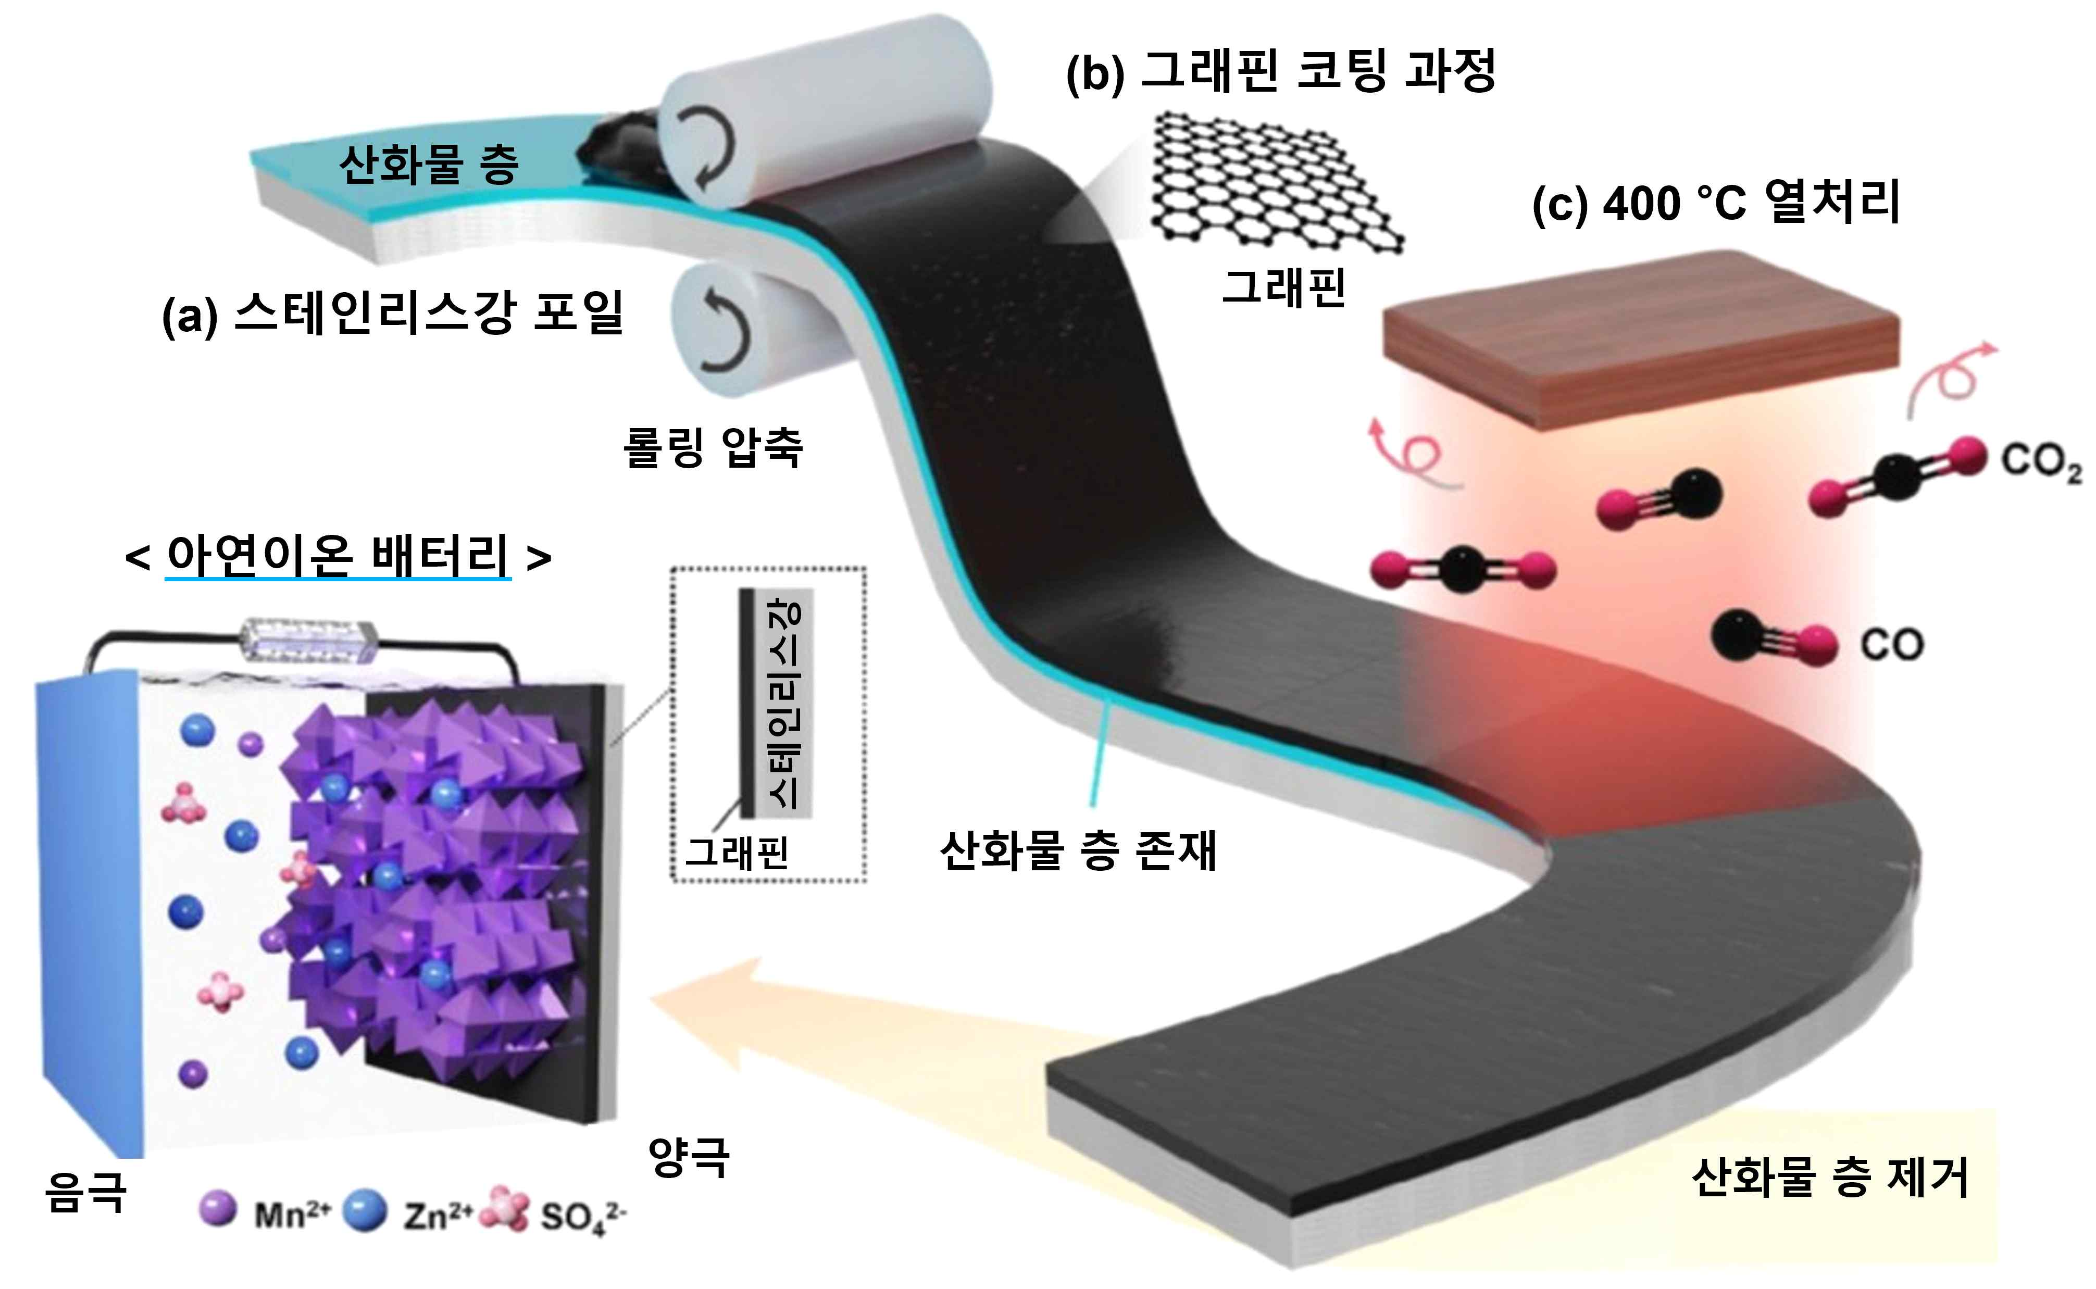

▲ Schematic diagram of the manufacturing process of graphene-coated stainless steel foil heat-treated at 400 °C used as a positive current collector for zinc-ion batteries. a) Preparation of stainless steel foil to be used as a current collector, b) Graphene roll-to-roll coating process, c) 400 °C heat treatment process to remove the oxide layer and improve adhesion and electrical conductivity

As a result of the experiment, this battery operated stably even under high energy density conditions (high capacity) and maintained approximately 88.7% of the initial capacity even after 1,500 charge/discharge cycles, demonstrating excellent life performance.

This is comparable to that of commercial lithium-ion batteries, and is expected to be an important stepping stone for advancing the commercialization of zinc-ion batteries.

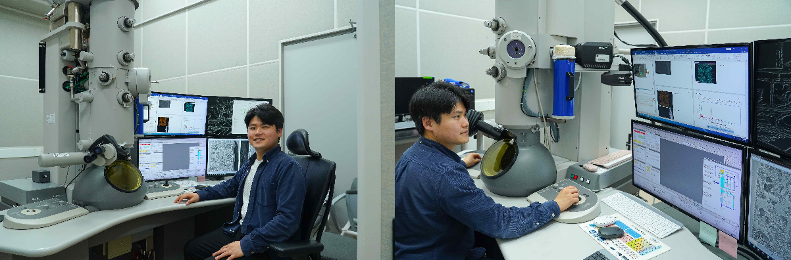
The research team precisely analyzed the structure and formation process of the graphene coating layer, which formed the basis of this study, at the atomic level using the transmission electron microscope (TEM)* at the GIST Advanced Insitute of Instrumental Analysis.
▲ Dr. Yong-Ryun Jo of the Advanced Insitute of Instrumental Analysis is analyzing the microstructure of a sample using a transmission electron microscope (TEM) and checking the high-resolution image and composition analysis data obtained as a result.

Through this, the nano-level composition information such as the thickness, shape, and layer structure of the graphene film were identified in detail, which played a decisive role in identifying and optimizing key factors that affect battery performance.

* transmission electron microscope (TEM): This is a device that can observe atomic-level structures by transmitting an electron beam (E-beam) through a sample, and it provides very high resolution, so it is used to analyze the microstructure of nanomaterials or biomolecules.

The technology developed by the research team is a key source technology that solves the structural limitations of zinc-ion batteries, and is expected to be an eco-friendly energy solution suitable for various applications such as batteries, home storage devices, electric vehicles, and ESS, as well as standalone power systems (off-grid*) in rural areas or developing countries that lack power infrastructure.

* off-grid system: A standalone power system that is not connected to the central power grid of a power company and produces and uses electricity on its own using solar power, wind power, batteries, etc.

Dr. Yong-Ryun Jo of GIST said, “TEM is an advanced analysis tool that can simultaneously identify the atomic arrangement and chemical composition inside a material, beyond simply obtaining images,” and “By precisely analyzing the structure of graphene-based electrodes, the material design and process control of zinc-ion batteries have become more sophisticated.”

Professor Geon-Hyoung An of Dongguk University emphasized, “This technology is an alternative that can overcome the limitations of existing lithium-ion batteries in the energy storage field,” and “It will greatly contribute to reducing energy costs and improving the stability of the supply chain as a sustainable energy technology.”

This study, in which Yong-Ryun Jo of the GIST Advanced Insitute of Instrumental Analysis and Professor Geon-Hyoung An of the University Department of Energy and Materials Engineering at Dongguk University participated as corresponding authors and Heeyeon Heo of the Department of Energy System Engineering at Gyeongsang National University, was conducted with the support of the Korea Institute of Energy Technology Evaluation and Planning's Energy International Joint Research Program, the National Research Foundation of Korea's Individual Basic Research Program, the Korea Institute of Industrial Technology Evaluation and Planning's Materials and Components Technology Development Program, and the Electronic Components Industry Technology Development Program.

The research results were published online on April 2, 2025 in the international academic journal 《Advanced Energy Materials》.



