GIST and KENTECH joint research team develop next-generation fuel cell catalyst surpassing platinum

- GIST Professor Hyunseob Lim and Kentech Professor Jong Wook Hong joint research team, utilizing mixed-phase nanostructures based on palladium selenide (Pd-Se), precise crystal phase control, and interaction identification to demonstrate electrochemical performance and durability surpassing existing platinum catalysts

- “Expected to be utilized as a key material for future eco-friendly energy technology” published in international academic journal 《Chemical Engineering Journal》



▲ (From left) Professor Hyunseob Lim of GIST Department of Chemistry, Professor Sukwon Hong of GIST Department of Chemistry, Professor Jong Wook Hong of Korea Institute of Energy Technology (KENTECH), and PhD student Hyeonju Kim of GIST Department of Chemistry

The Gwangju Institute of Science and Technology (GIST, President Kichul Lim) announced that a joint research team led by Professor Hyunseob Lim of the Department of Chemistry and Professor Jong Wook Hong of the Korea Institute of Energy Technology (KENTECH) developed a next-generation fuel cell catalyst with electrochemical performance and durability superior to existing commercial platinum catalysts (Pt/C) in the oxygen reduction reaction (ORR)* using a mixed-phase nanostructure based on palladium selenide (Pd-Se).

This study is significant in that it focused on the synergy effect that occurs when different crystal phases coexist, that is, in mixed-phase materials, and suggests a new direction for designing high-performance and high-durability catalysts that can replace existing platinum-based electrocatalysts. It is expected to make a significant contribution to the effective design strategy of mixed-phase materials that can be applied to advanced energy conversion technologies such as fuel cells in the future.

* palladium selenide (Pd-Se): A compound that combines palladium (Pd) and selenium (Se), it has properties suitable for electrochemical reactions through various crystal structures. In particular, it is attracting attention as a next-generation catalyst to replace platinum (Pt) by showing high catalytic activity in the oxygen reduction reaction (ORR) of fuel cells, and the mixed phase structure in which multiple crystal phases coexist simultaneously improves performance and durability through synergy effects.

* oxygen reduction reaction (ORR): It is an essential reaction in fuel cells, metal-air batteries, etc. that reduces oxygen molecules to water to generate electricity. However, the reaction speed is slow and a lot of energy is required, so the development of a high-performance catalyst is essential.

Since Pd-Se catalysts have been studied mostly with a single crystal phase, the fact that the interaction between different Pd-Se crystal phases can contribute to improving catalytic performance was hardly known.

Here, the research team newly discovered that the mixed-phase structure is advantageous in improving the electron transfer path and effectively forming the reaction active site.

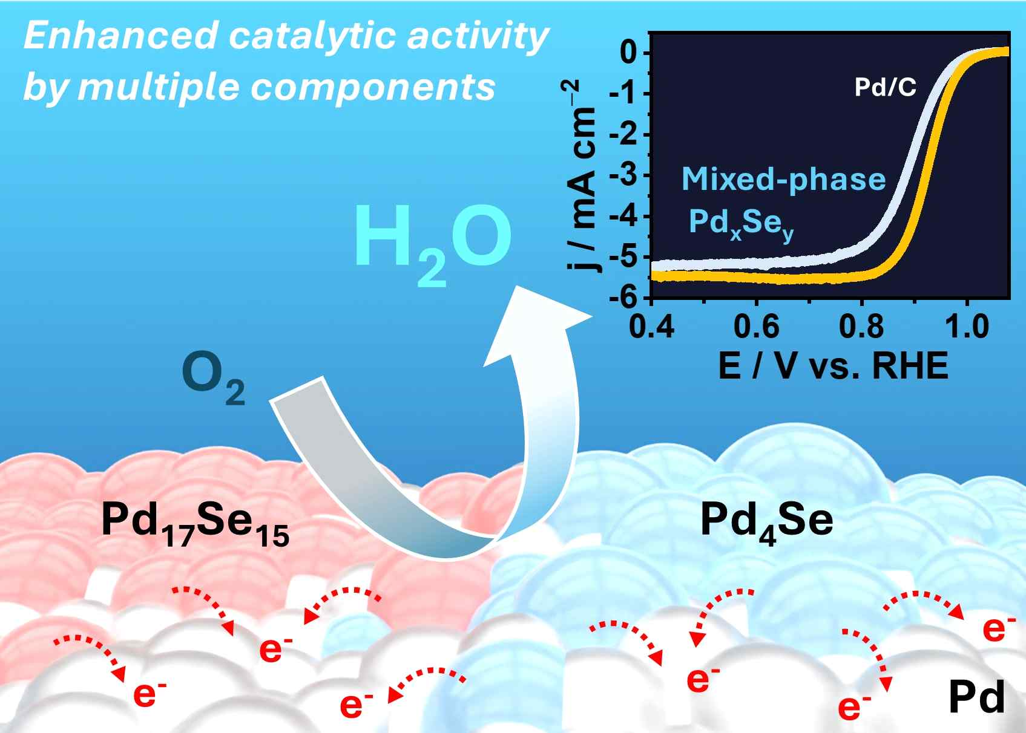

▲ Development of a palladium selenide (Pd-Se) multiphase structure catalyst. The synergistic effect between the crystal phases of the mixed-phase catalyst, which contains crystal phases such as Pd17Se15 and Pd4Se, enables improved oxygen reduction reaction performance and durability compared to commercial Pt/C.

The core of the research is to design a single organometallic precursor without a complex process and synthesize a ‘mixed-phase nanostructure*’ in which various Pd-Se crystal phases (PdSe2, Pd17Se15, Pd4Se, etc.) coexist by precisely heat-treating it.

The synergistic effect of the electronic structure interaction at the interface between different crystal phases accelerates the reaction rate of the oxygen reduction reaction and reduces energy loss. As a result, the reaction efficiency and durability were confirmed to be superior to the existing Pd/C or Pt/C catalysts based on a single phase in a mixed phase material where multiple crystal phases coexist.

* mixed phase nanostructure: A structure where different crystal structures coexist in a single nanomaterial, and each phase takes on a different stage of the electrochemical reaction and enhances performance. It is very effective in improving catalytic performance because the electron transfer and reaction control effects at the interface are large.

In particular, it is noteworthy that the fact that different Pd-Se crystal phases can increase the overall reaction efficiency and minimize energy loss by demonstrating their respective strengths at different reaction stages of the oxygen reduction reaction was proven through theoretical calculations and experiments. The Pd-Se catalyst synthesized at 1000°C showed a half-wave potential of 0.931 V for the oxygen reduction reaction, which is higher than that of commercialized platinum-based catalysts (Pt/C).

This means that oxygen can be reduced with less energy under the same conditions, and is a representative indicator showing the excellent electrochemical activity of the Pd-Se catalyst.

In addition, the change in reaction voltage was only 7 mV after 20,000 durability tests, confirming excellent stability even in long-term use environments.

Based on density functional theory (DFT), the research team calculated the electronic structure of each Pd-Se crystal phase and discovered that they each optimize various intermediate stages of the oxygen reduction reaction process, thereby improving catalytic performance.

Specifically, it was confirmed that the three Pd-Se materials play different roles in the oxygen reduction reaction (ORR) process and are mutually complementary. ▴ Pd helps the initial adsorption of oxygen molecules, ▴ Pd17Se15 stabilizes the intermediates in the early stages of the reaction to prevent the reaction from stopping, and ▴ Pd4Se stably adsorbs the intermediates in the subsequent stages to increase the overall reaction rate.

Professor Hyunseob Lim said, “This study is a case that experimentally and theoretically proves that different Pd-Se crystal phases can be in harmony and optimize each step of the electrochemical reaction,” and added, “This technology has great potential to be utilized as a core technology in the next-generation eco-friendly energy field, such as high-performance fuel cells, metal-air batteries, and water electrolysis systems.”

This study, supervised by Professor Hyunseob Lim and Professor Hong Seok-won of the Department of Chemistry at GIST and Professor Jong Wook Hong of the Korea Institute of Energy Technology (KENTECH) and conducted by Ph.D. candidateHyeonju Kim of the Department of Chemistry at GIST, was supported by the National Research Foundation of Korea (NRF) and the Korea Electric Power Corporation (KEPCO) under the R&D program. The results of the study were published online in the international academic journal 《Chemical Engineering Journal》 on April 1, 2025.



