GIST develops next-generation supercapacitor technology... Fast charging and long life are the same, but energy density is 'upgraded' to battery level

- Professor Chanho Pak of the Department of Chemistry and Professor Seung Joon Yoo of the Department of Materials Science and Engineering jointly researched dual redox system and porous carbon electrode to suppress self-discharge and maximize performance... Securing energy storage capacity and efficiency at the same time

- Achieving energy density of 125Wh/kg with carbon material that precisely controls electrode-electrolyte interface and balances micro- and mesopores... Expected to develop high-performance water-based energy storage devices, published in international academic journal 《Small》

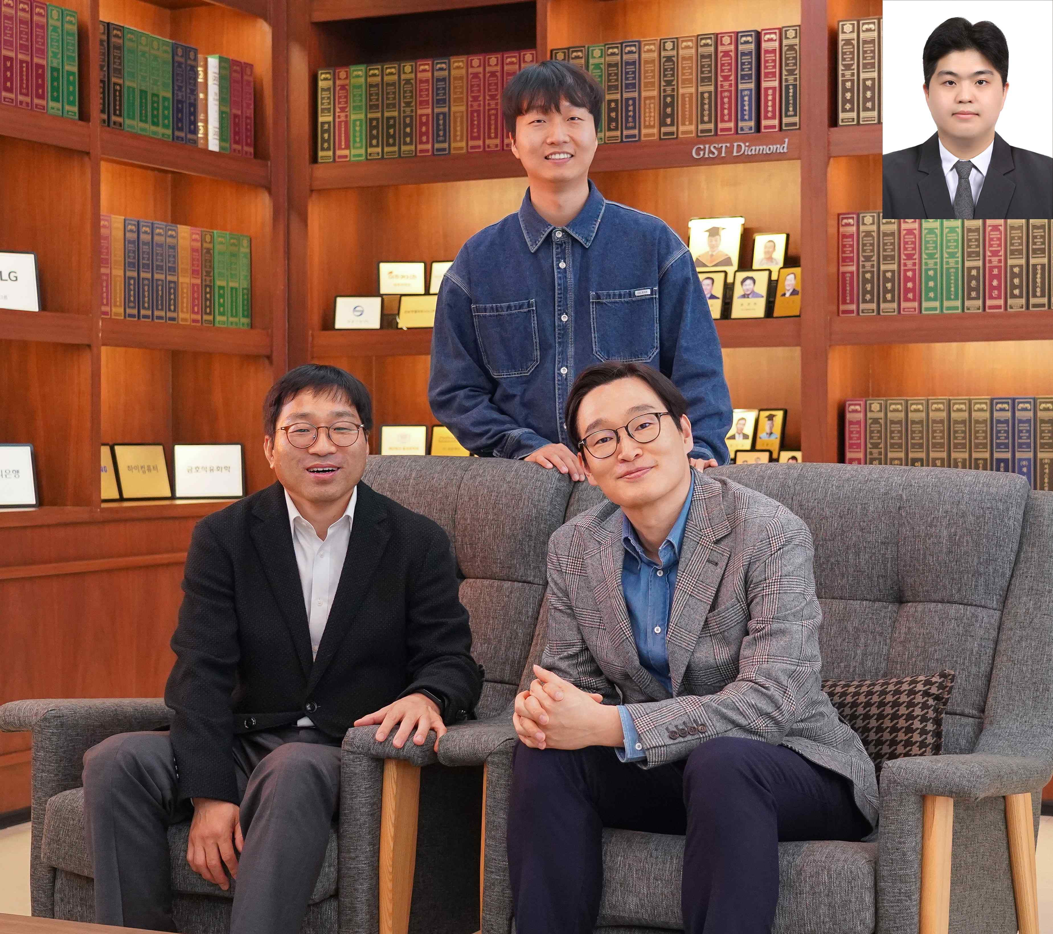

▲ (From left) GIST Department of Chemistry Professor Chanho Pak, Department of Materials Science and Engineering PhD candidate Young Hun Cho, Department of Materials Science and Engineering Professor Seung Joon Yoo, (Top right) Dr. Jong Gyeong Kim (GIST Department of Chemistry graduate)

As the use of renewable energy increases, interest in energy storage devices that can efficiently store excess electricity is increasing.

In particular, capacitors* with fast charge/discharge speeds and long lifespans are attracting attention, but their low energy storage capacity (density) limits their ability to replace batteries. Accordingly, the development of next-generation energy storage technologies that maintain the advantages of capacitors while also having energy density at the level of batteries is required.

* capacitor: A component that stores and quickly releases electricity, and has the advantages of fast charge/discharge speeds and long lifespans, so it is used in devices that require high-speed response.

The Gwangju Institute of Science and Technology (GIST, President Kichul Lim) announced that a joint research team led by Professor Chanho Pak of the Department of Chemistry and Professor Seung Joon Yoo of the Department of Materials Science and Engineering succeeded in significantly improving the energy storage performance of redox supercapacitors by precisely controlling the interaction that occurs at the interface between the electrode and the electrolyte.

This research is expected to be an important turning point in the development of next-generation energy storage devices in that it achieved high energy density similar to that of a battery while maintaining the fast response and long life of a capacitor.

Existing redox supercapacitors mainly used a method of increasing the concentration of redox active substances in the electrolyte to increase energy density. However, this method had the disadvantage of causing self-discharge phenomenon in which the active substances freely moved between the electrodes and energy leaked, and also lowering the charge/discharge efficiency (Coulomb efficiency)*.

In addition, the reaction characteristics at the interface where the electrode and the electrolyte meet can vary greatly depending on the molecular size or structure of the active substance, but research on this is relatively lacking.

* Coulombic efficiency (CE): This is an indicator of the ratio of the amount of charge that the battery can actually discharge compared to the amount of charge charged, and shows how efficiently the battery performs charging and discharging.

Accordingly, the research team introduced a dual redox system* that uses pentyl viologen (PV) and bromide (Br) as the electrolytes of the cathode and anode, respectively. The two materials form solid compounds during the charging and discharging process, suppressing self-discharge and minimizing energy loss.

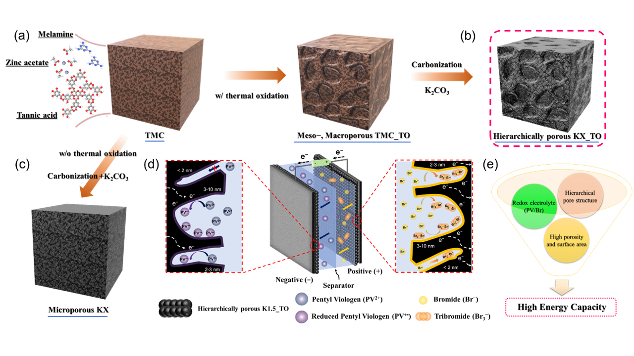

▲ a-c) Low-cost precursor design and TO-based porous carbon synthesis process: Controlling the balance of micro-mesopores and implementing a high-specific surface area carbon electrode through the thermal oxidation (TO) process. d, e) Schematic diagram of redox electrolyte-electrode interaction and synergy: The design of a pore structure optimized for the size and properties of redox active materials induces efficient interaction between electrodes/electrolytes, indicating that this is a key factor in improving the performance of redox supercapacitors.

In addition, the research team developed a porous carbon* electrode with an appropriate distribution of micropores (2 nm or less) and mesopores (2–50 nm) so that redox active substances can be effectively adsorbed and diffused, thereby maximizing the reaction at the interface between the electrode and the electrolyte.

* This system uses PV as the cathode electrolyte and bromide as the anode electrolyte, and the two substances react together to increase energy storage efficiency.

* porous carbon: A carbon material with a large number of pores (holes), which has a large surface area and is advantageous for energy storage.

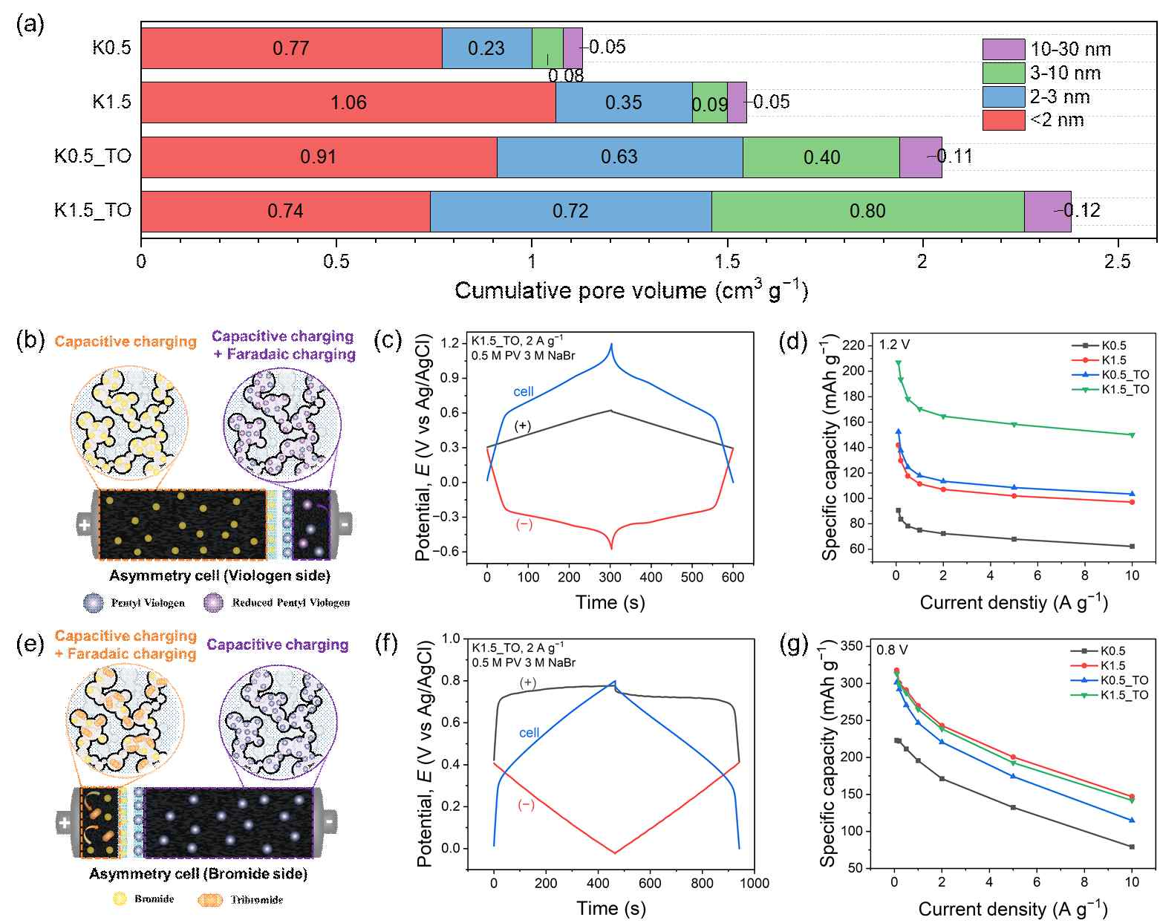

▲ a) Volume distribution by pore size of carbon material, b–d) PV-centered asymmetric cell configuration and electrochemical performance, e–g) Br-centered asymmetric cell configuration and electrochemical performance: Through asymmetric cell-based analysis, the contribution of each redox substance to the reaction and performance was quantitatively identified, and it was confirmed that mesopores (2–10 nm) play a critical role in the adsorption and diffusion of PV.

Pentylviologen (PV) and bromide (Br) have molecular sizes of approximately 2 nm and 0.19 nm, respectively, and pore size control is key to effectively handling all active substances with such large size differences. However, existing pore control methods required complex and expensive processes due to the risk of micropores collapsing.

To solve this problem, the research team developed a simple and inexpensive synthesis method to create a new carbon material that effectively increased the ratio of mesopores without damaging micropores.

The experimental results of applying this carbon electrode to a PV/Br-based redox supercapacitor confirmed that the adsorption amount of PV molecules significantly affects the energy density, and that mesopores with a size of 2–10 nm are most effective for the adsorption and diffusion of PV molecules.

The research team achieved a high energy density of 125 Wh/kg in an aqueous redox capacitor system by maximizing the electrolyte concentration and using a carbon electrode (K1.5_TO) with a specific surface area of 3,309 m²/g and a pore volume of 2.38 cm³/g.

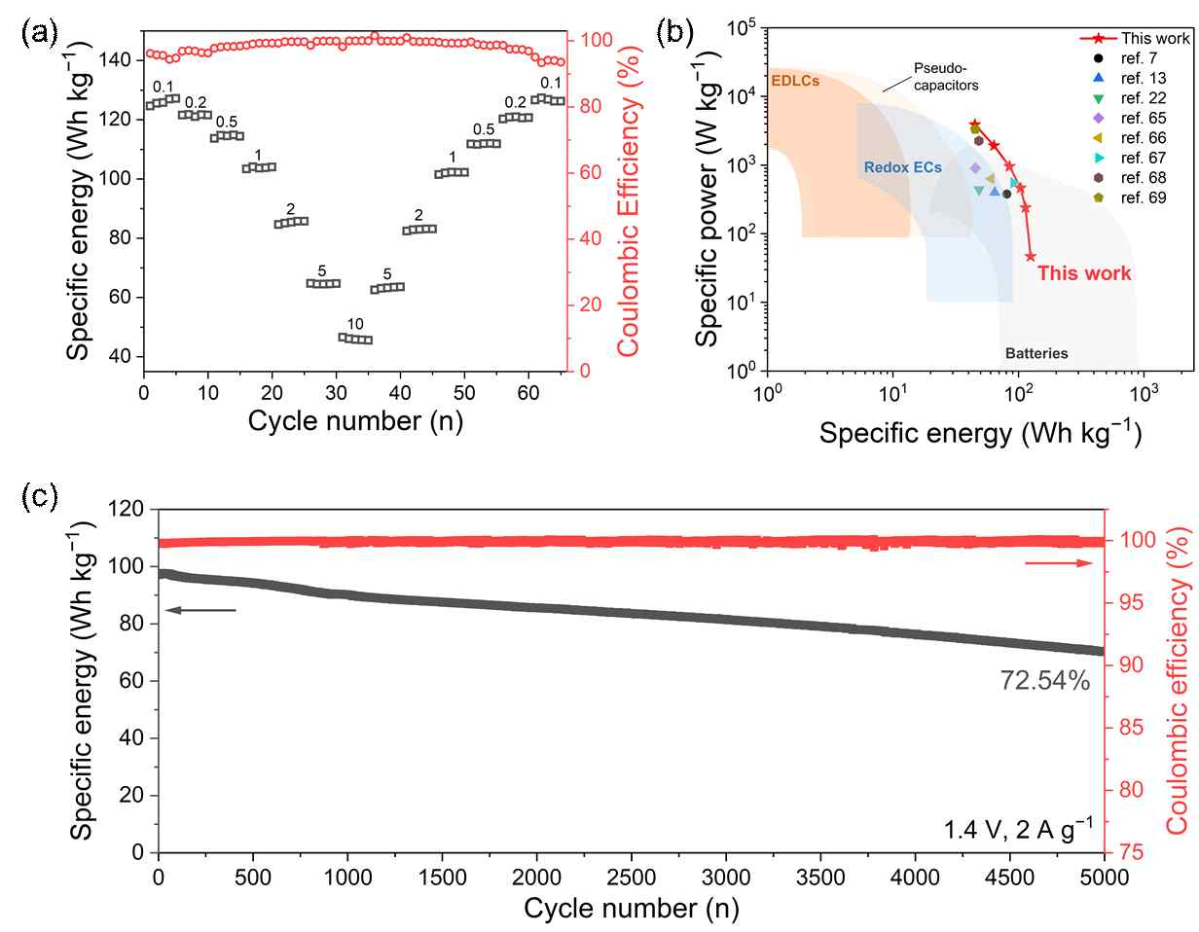

▲ a) Energy density and Coulombic efficiency at various current densities, b) Performance comparison with existing redox supercapacitors, c) 5,000-cycle life stability and Coulombic efficiency: Energy density of up to 125 Wh/kg and long-term cycle stability were secured by applying a high-concentration electrolyte and K1.5_TO electrode. Pore structure optimization contributed to the performance improvement by maximizing PV diffusion and adsorption.

Professor Chanho Pak said, “This study is a case that proves that the performance of redox supercapacitors can be dramatically improved by precisely controlling the material interaction at the electrode and electrolyte interface,” and “It will suggest a new direction for the development of high-performance aqueous energy storage devices.”

Professor Seung Joon Yoo emphasized, “In order to improve the performance of energy storage devices, it is essential to understand not only the performance of materials but also the interaction between materials,” and “This study is a case that implemented high energy density based on the interaction between redox electrolyte and porous carbon electrode, and will serve as an important guideline for the design of various high-performance redox batteries in the future.”

This study, led by Professor Chanho Pak and Professor Seung Joon Yoo, with Dr. Jong Gyeong Kim and PhD student Young Hun Cho as co-first authors, was supported by the National Research Foundation of Korea’s Step-up Carbon Neutral Technology Development Project and the Mid-career Researcher Support Project. The results of the study were published online in the international academic journal 《Small》 on April 28, 2025.



