"We found a solution by designing electrolytes, not electrodes" GIST significantly improves the performance of next-generation redox supercapacitors by precisely controlling molecular size

- Professor Seung Joon Yoo's research team in the Department of Materials Science and Engineering realizes high-performance and long-life energy storage technology through electrode-customized molecular design... Solving energy density, lifespan, and self-discharge issues simultaneously without high-cost ion exchange membranes

- Opens the possibility of next-generation energy storage devices... Published in the international academic journal 《Chemical Engineering Journal》

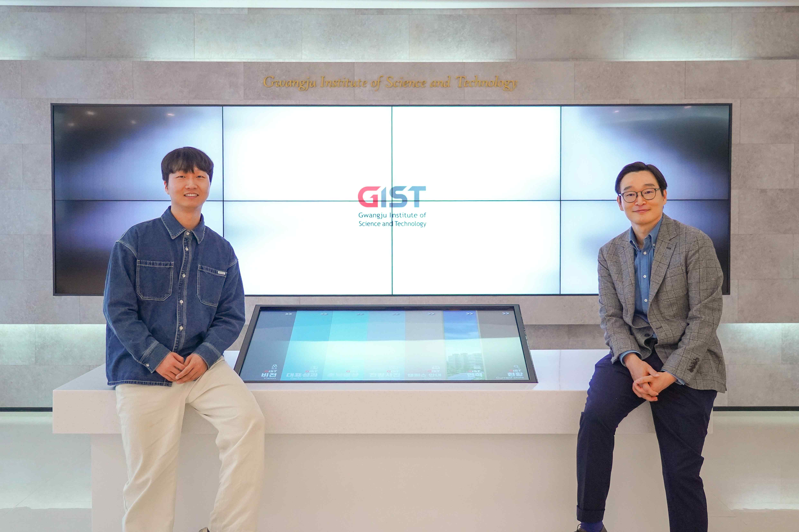

▲ (From left) GIST Department of Materials Science and Engineering Ph.D. student Young Hun Cho and Professor Seung Joon Yoo

The Gwangju Institute of Science and Technology (GIST, President Kichul Lim) announced that Professor Seung Joon Yoo's research team in the Department of Materials Science and Engineering has developed a technology that can dramatically improve the performance of redox supercapacitors (Redox EC)* by precisely controlling the size of molecules.

The research team precisely designed the size of organic redox molecules down to the angstrom (Å) level and optimized them to react effectively with porous carbon* electrodes.

* redox supercapacitor (Redox EC, Redox-Enhanced Electrochemical Capacitor): A device that places redox active substances (substances that can undergo oxidation-reduction reactions) in an electrolyte so that these substances can exchange electrons and store additional energy.

* porous carbon: A carbon material with numerous microscopic holes on its surface, which has a very large surface area and excellent electrical conductivity. It is advantageous in storing electrical energy or promoting chemical reactions, and is used in various fields such as batteries, supercapacitors, adsorbents, and catalyst supports.

Through this, the research team succeeded in developing a high-performance water-based redox supercapacitor with high energy density, low self-discharge, and long lifespan.

Existing supercapacitors have the advantages of fast charging speed and long lifespan, but their storage capacity is limited due to their low energy density. Redox supercapacitors, which complement these shortcomings, are a next-generation technology designed to store additional energy by allowing redox active substances dissolved in the electrolyte to exchange electrons.

However, commercialization has been difficult due to the problem of self-discharge occurring when the active substance freely diffuses within the electrolyte and the need to rely on expensive ion exchange membranes.

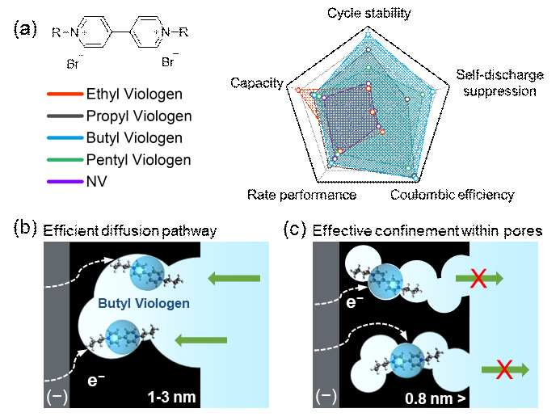

▲ a) Schematic diagram of cell performance changes according to changes in the substituent of biologen, b) BV adsorption and diffusion trends in pores sized 1-3 nm, c) Self-discharge suppression mechanism through BV and pore matching in micropores sized 0.8 nm or less. Cell performance varies depending on the size of the redox molecule. BV showed the highest structural compatibility among the electrodes used, indicating optimal capacity, speed, self-discharge suppression, and long-term stability.

To solve these problems, the research team presented a new solution that can achieve high performance without a separate ion exchange membrane by precisely designing the size of the active material* molecules to match the microscopic pore structure of the porous carbon electrode.

* active material: A key material that stores or releases electrical energy during the charge/discharge process

The core of this technology lies in the reaction that occurs at the ‘interface’ where the electrode and electrolyte come into contact. Previously, the interfacial reaction was controlled by changing the pore size of the electrode, but this method had the limitation of being complicated and expensive in terms of manufacturing process.

In response, the research team succeeded in securing both manufacturing efficiency and performance by switching to a method of precisely designing the interfacial interaction by controlling the molecular size in the electrolyte rather than changing the electrode structure.

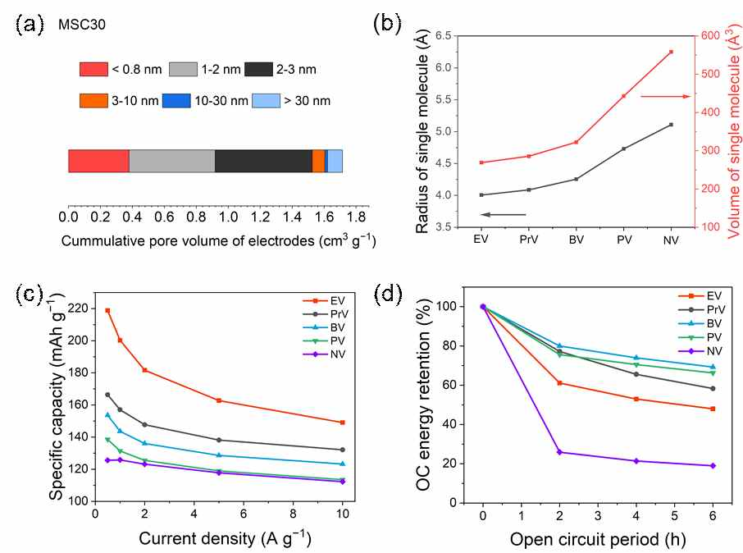

▲ a) Pore volume distribution of MSC30, b) Radius and molecular volume of viologen (DFT calculation), c) Comparison of asymmetric cell capacity by type of viologen, d) Comparison of self-discharge suppression performance by type of viologen. Performance changes according to viologen size can be observed through the asymmetric cell. In the MSC30 electrode where micropores are mainly developed, a clear difference in performance was observed according to molecular size, confirming the importance of interface control through organic molecule structure adjustment.

* asymmetric cell: This is a cell designed to prevent redox reactions from occurring at the electrode by significantly increasing the mass of the opposite electrode in order to selectively observe and compare only the redox reaction at one electrode.

The research team synthesized various forms of ‘viologen’* derivatives with excellent electrochemical properties and adjusted them to fit the electrode structure exactly.

As a result of the experiment, it achieved a high energy density of 82.3Wh/kg (watt-hour energy density per kilogram) at 1.4V, and confirmed excellent durability that maintained more than 95% of the initial performance even after 10,000 charge and discharge cycles. Even after 6 hours of charging, 88.4% of the energy remained, showing almost no self-discharge.

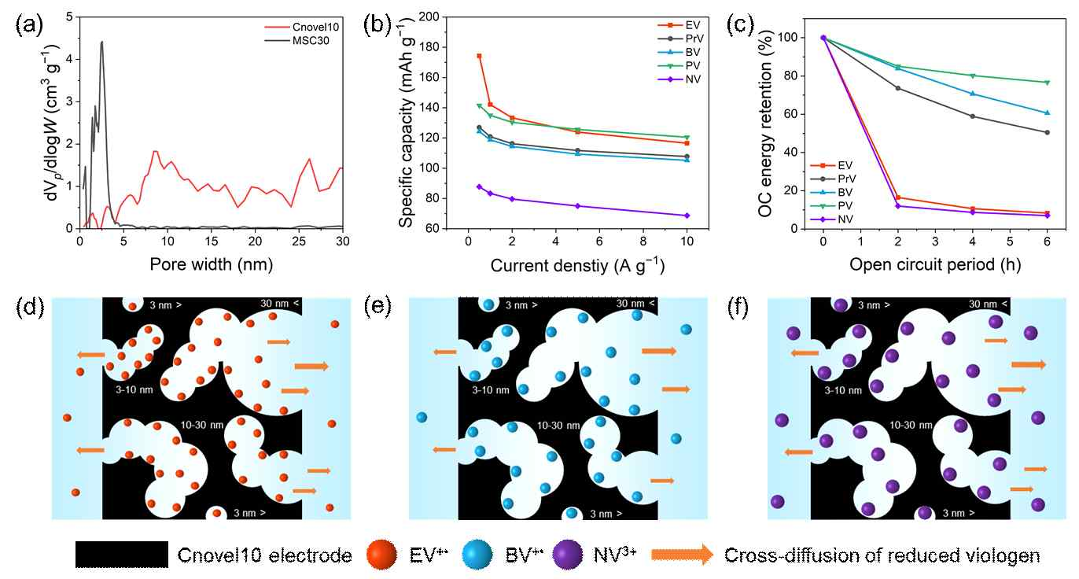

▲ a) Comparison of pore size distributions between MSC30 (black) and Cnovel10 (red), b) Comparison of electrostatic capacity of asymmetric cells by type of viologen, c) Comparison of self-discharge rates of asymmetric cells by type of viologen, d) Schematic diagram of adsorption and diffusion behaviors of EV⁺·, e) BV⁺·, and f) NV⁺· within the pores of Cnovel10. It was confirmed that as the pore size increases, the performance difference trend according to the size of the viologen molecule disappears and the self-discharge suppression effect decreases.

In addition, a new injection technique called ‘vacuum/nitrogen pressure cycling immersion’ was developed to enable the electrolyte to effectively penetrate deep into the electrode. Through this, the adsorption amount of the active material increased by more than two times and the reaction efficiency at the electrode interface was also maximized.

* viologen: It is an organic compound that is basically purple (violet) and has unique electrochemical properties. By modifying the basic structure of biologen with various chemical functional groups, the electrochemical properties, solubility, and molecular size can be freely controlled through biologen derivatives.

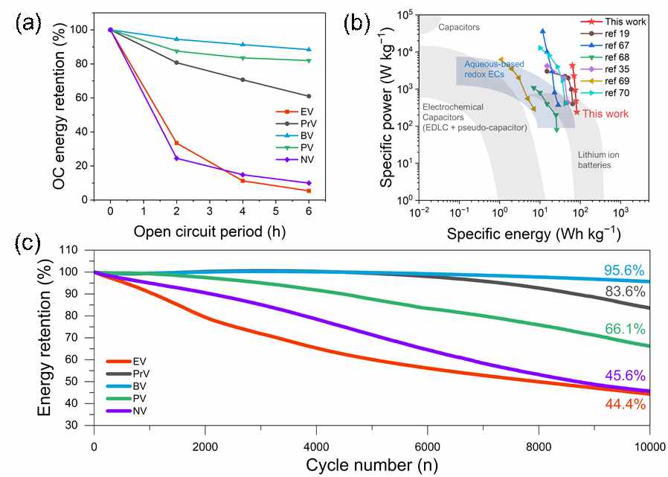

▲ a) Comparison of symmetric cell self-discharge suppression performance by type of biologen, b) Comparison of energy and power density of aqueous-based redox supercapacitors, c) Comparison of symmetric cell long-cycle performance by type of biologen. The best self-discharge suppression and long-cycle stability were confirmed when the most well-matched BV was used, and it was confirmed that it showed superior performance compared to existing aqueous redox supercapacitors.

Professor Seung Joon Yoo explained, “We implemented the optimal electrolyte-electrode combination that perfectly meshes with the micropore structure of the electrode by precisely controlling the molecular size in angstrom units,” and “This study is a result that newly elucidates the core principles that determine the performance of redox supercapacitors.”

He also added, “It suggests a new direction for designing high-performance energy storage devices, and it has high potential for application in various fields in the future.”

This research, led by Professor Seung Joon Yoo (corresponding author) of GIST and conducted by Ph.D. candidate Young Hun Cho, was supported by the National Research Foundation of Korea’s Mid-career Researcher Support Program. The research results were published online in the international academic journal 《Chemical Engineering Journal》 on April 19, 2025.



