"Even in a shaking car, immerse yourself in your own space" GIST develops VR technology that is free from motion sickness

- Department of AI Convergence Professor SeungJun Kim's research team, the first to implement VR technology that enables active movement of users while ensuring user immersion and stability even when moving vehicles... Minimizing sensory mismatch and maximizing autonomy

- Opening the possibility of learning, collaboration, and creation without time and space constraints even while moving... Presented at the international academic conference CHI 2025



▲ (From left) GIST Professor SeungJun Kim, GIST master’s student Bocheon Gim, University of Washington PhD studentSeokhyun Hwang, GIST PhD students Seongjun Kang, Gwangbin Kim, and Dohyeon Yeo

The Gwangju Institute of Science and Technology (GIST, President Kichul Lim) announced that Professor SeungJun Kim’s research team in the Department of AI Convergence has developed a ‘VR movement technology’ that allows users to move freely while standing in a vehicle and a ‘visual assistance device’ that reduces motion sickness while driving.

While existing vehicle-based VR (Virtual Reality) was a method in which VR content passively reacted to the movement of the vehicle, the newly developed technology was designed to allow users to move freely in VR as if in reality while simultaneously securing immersion and stability.

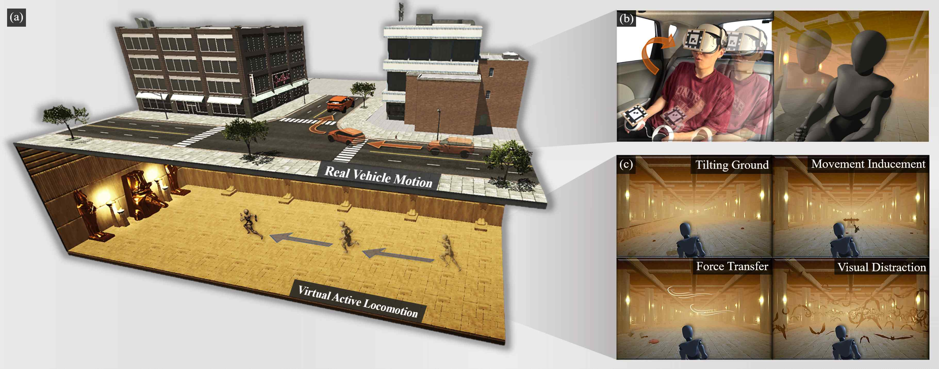

▲ Overview of ‘I Want to Break Free’ technology. When a passenger in a vehicle wears VR, it shows that they move freely in a virtual space in a state unsynchronized with the movement of the vehicle, and contextual clues are provided according to the movement of the vehicle.

The research team implemented five VR movement methods that can be applied in a vehicle (▴ joystick operation, ▴ upper body tilt, ▴ arm movement-based, ▴ walking in place, ▴ teleportation) and compared the effects of each method on the degree of motion sickness, immersion, task fatigue, and preference in a stationary vehicle environment and an actual moving vehicle environment with 20 participants.

The results of the experiment showed that the joystick method was evaluated as not only the least physically burdensome but also most naturally linked to the actual movement of the vehicle. On the other hand, leaning the body or walking in place tended to cause motion sickness by colliding with the movement of the vehicle.

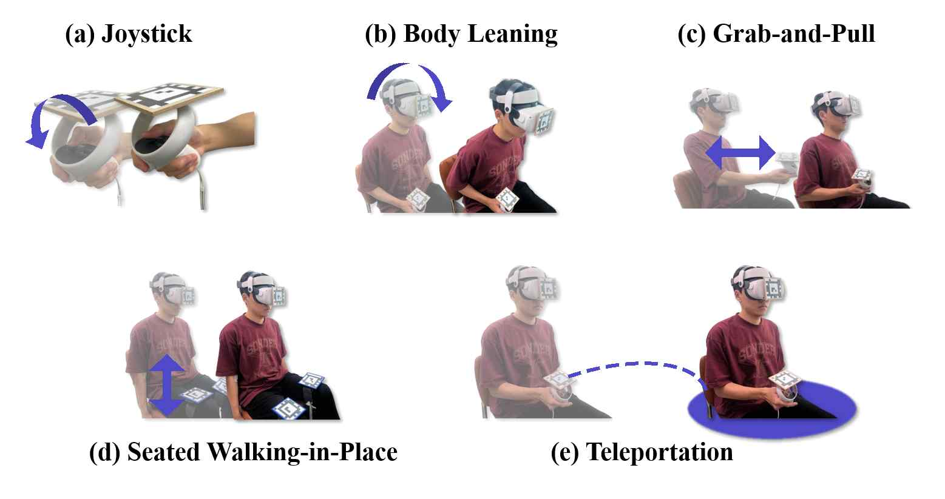

▲ Implementation and analysis of in-vehicle VR movement methods. Five VR movement methods that can be used by passengers in the vehicle were implemented, and the effects of each method on the user experience in the vehicle environment during driving were quantitatively and qualitatively analyzed through human subject experiments.

In addition, the research team designed four ‘context-based visual cues (▴ slanted ground ▴ motion induction ▴ force transmission ▴ visual interference)’ that visually and naturally interpret real movement in the virtual environment to solve the motion sickness problem that occurs due to the mismatch between the movement of the vehicle and the user’s senses.

These visual cues adjust the terrain, objects, and visual effects of the virtual space in real time in response to acceleration, deceleration, and rotation, helping the user to naturally recognize the movement of the actual vehicle without any sense of incongruity even in VR.

‘Tilting Ground’ effectively reduces motion sickness by matching the user’s posture changes and visual information by tilting the ground in VR according to the vehicle’s movement. ‘Movement Inducement’ provides visual elements that induce the user to tilt or dodge in the virtual space, thereby inducing active responses and increasing immersion.

‘Force Transfer’ naturally reproduces a sense of reality by expressing the physical force of the actual vehicle, such as acceleration or rotation, as indirect visual effects such as wind in the virtual space. Finally, ‘Visual Distraction’ alleviates discomfort caused by the difference in sense between the actual vehicle movement and the virtual environment by dispersing the user’s attention through highly immersive visual elements.

In the follow-up experiment, we conducted an experiment applying four visual cues based on the ‘joystick method’, which was evaluated as the most suitable VR movement method.

As a result, the ‘tilted ground’ and ‘motion induction’ cues showed excellent effects in reducing motion sickness most effectively while simultaneously increasing immersion. On the other hand, the ‘visual interference’ cues caused distraction to some participants, and the ‘force transmission’ cues were confirmed to be flexibly utilized to express the sense of speed and direction in the virtual space.

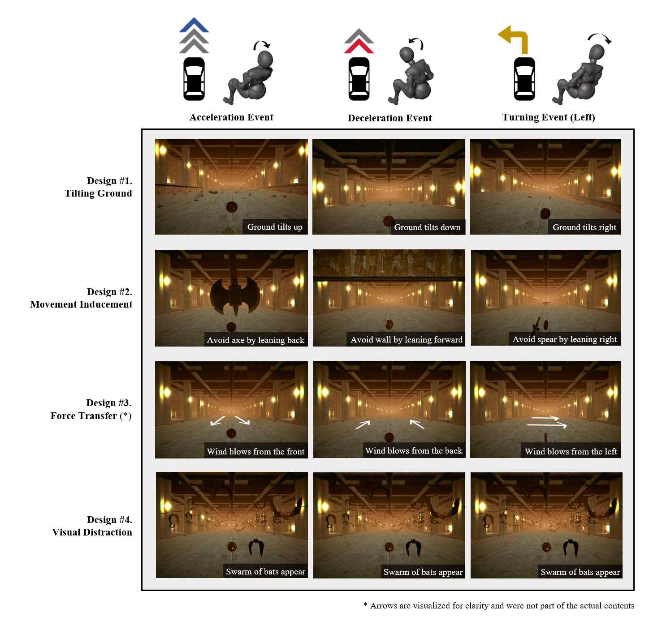

▲ Providing contextual cues to alleviate sensory mismatch. This table organizes contextual visual cues designed to alleviate sensory mismatch that occurs during vehicle driving. Each cue aims to naturally interpret the vehicle’s movement within the virtual environment and increase the user’s immersion and comfort.

Professor SeungJun Kim explained, “This study presents a new possibility that allows users to freely move and experience VR content even in the special environment of a vehicle,” and added, “In particular, it is significant in that it presents an innovative technological direction that can simultaneously maintain user immersion and autonomy while minimizing sensory mismatch.”

Professor Kim continued, “This technology will go beyond simple games or entertainment VR and become a core foundation technology that opens a future where people can learn with an immersive feeling as if they were actually in the field while on the move, collaborate efficiently without spatial and temporal constraints, and immerse themselves in creative activities that realize their imaginations into reality.”

This study, supervised by Professor SeungJun Kim and conducted by master’s student Bocheon Gim as the first author, was supported by the National Information Society Agency-University ICT Research Center (ITRC) ‘SpaceTop: Spatial Computing HCI Technology for Providing XR Productivity Spaces Without Location Restrictions’ and the National Research Foundation of Korea ‘Research on Development of Actuated XR System Based on Soft Robotics and Sensory Intelligence for Embodiment between Reality and Virtuality’, and was conducted as part of the GIST-MIT joint research project ‘HCI+AI Convergence Research for Human-Centered Physical System Design’.

The results of the study were announced on April 30 at the ‘CHI 2025 (Conference on Human Factors in Computing Systems),’ the most prestigious international academic conference in the field of human-computer interaction.

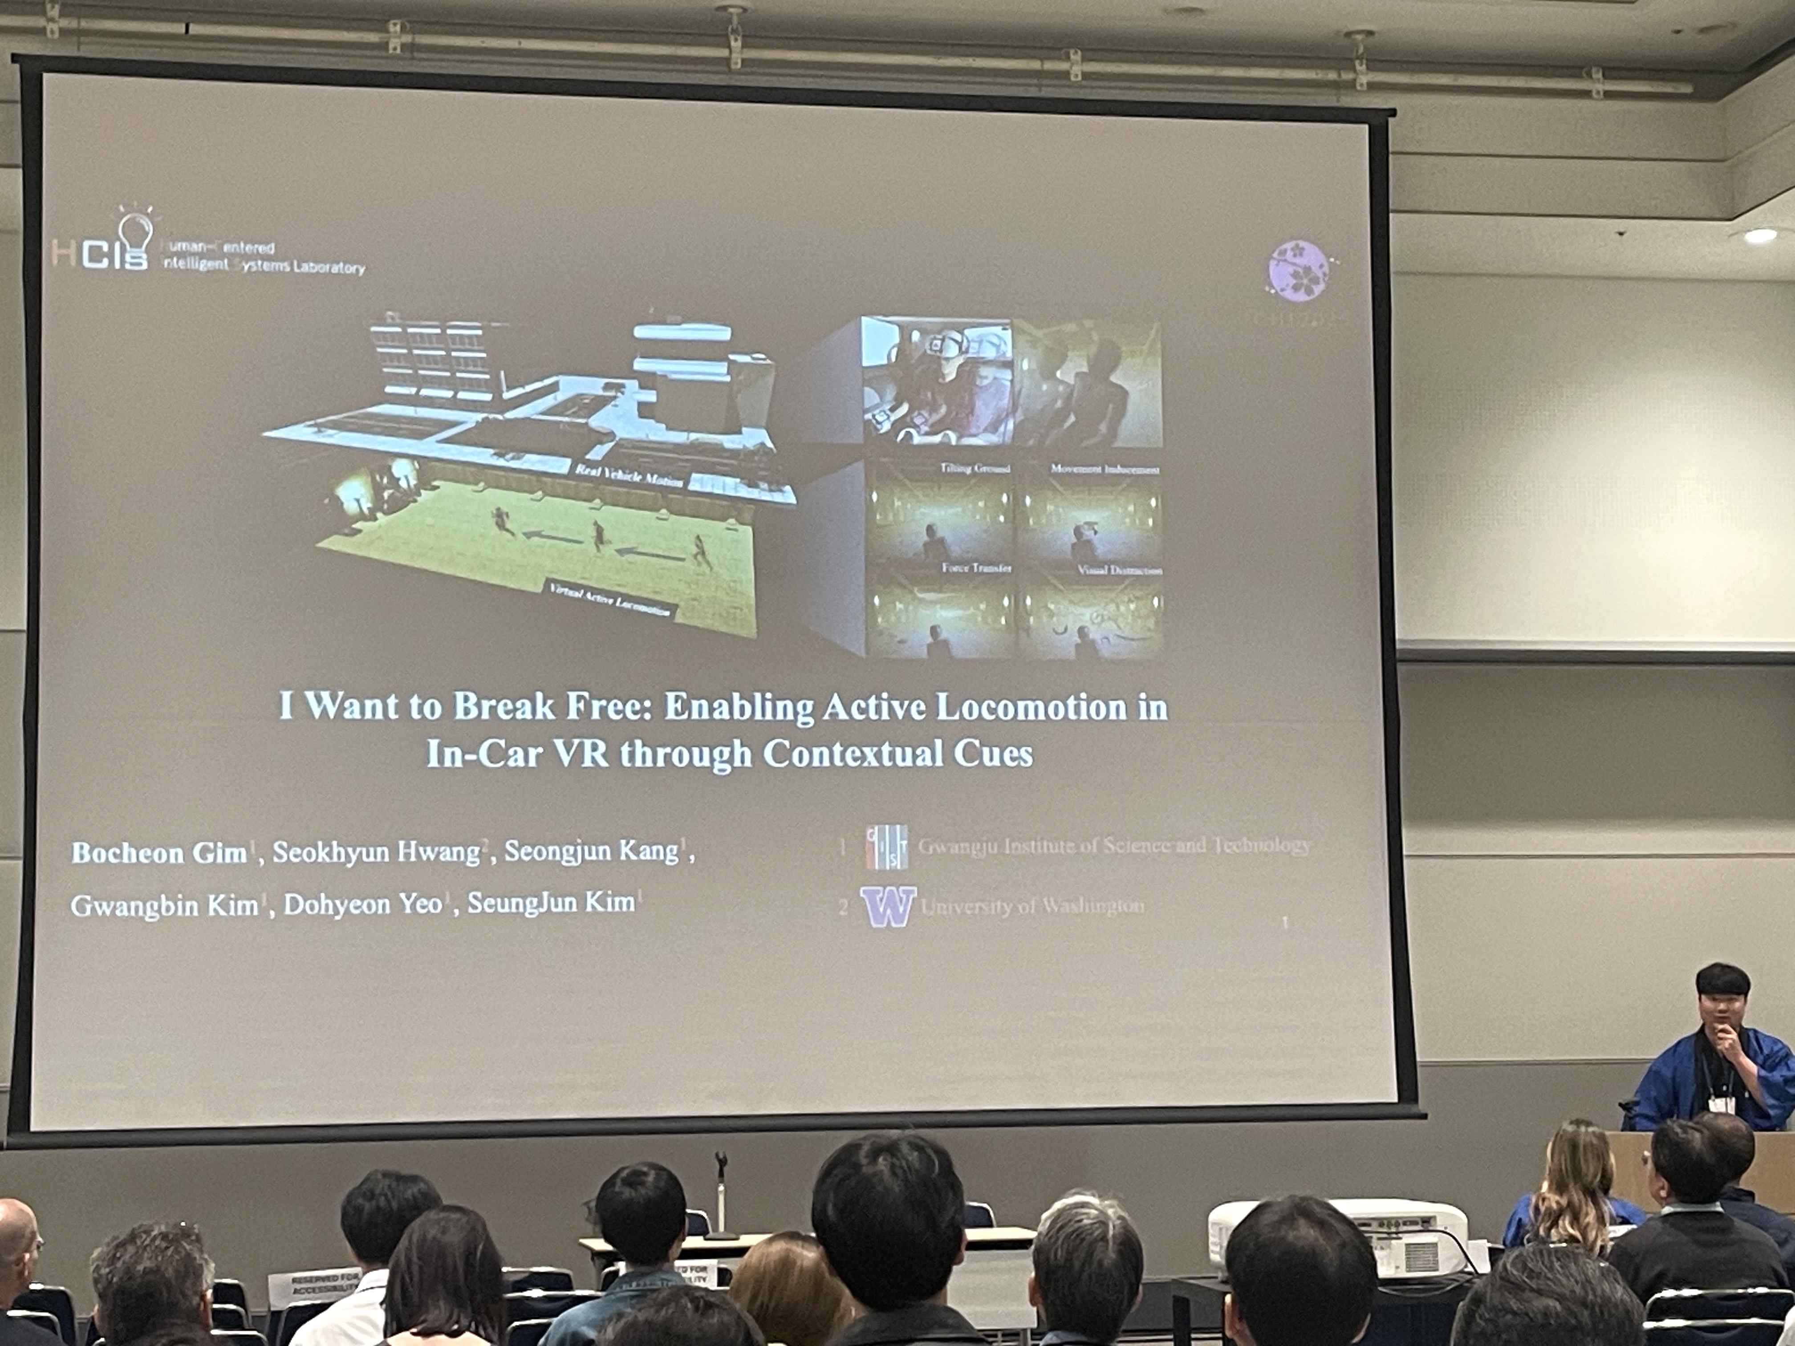

▲ Professor Seungjun Kim's research team presents at CHI 2025 conference

Meanwhile, Professor SeungJun Kim, who is also an adjunct professor at the Graduate School of AI Policy and Strategy, leads the HCIS (Human-Centered Intelligent Systems) Lab and is actively conducting research in the fields of HCI (Human-Computer Interaction) and VR for designing human-centered interactive systems. Including this research, he presented a total of three papers and three posters at CHI 2025.



