"As clear as the stars in the night sky" GIST develops the world's first 'black background rapid antigen kit'

- Research team led by Senior Researcher Kihyeun Kim of the Advanced Photonics Research Institute, implementing PCR-level ultra-sensitive diagnostic technology that clearly captures even trace amounts of viruses through a ‘change in thinking’ that introduces a black background structure instead of a white background

- Expected to drastically improve the accuracy of infectious disease diagnosis with a fine scattering signal capture technology that overcomes low sensitivity and false negative limitations... Published in the international academic journal 《Nature Communications》

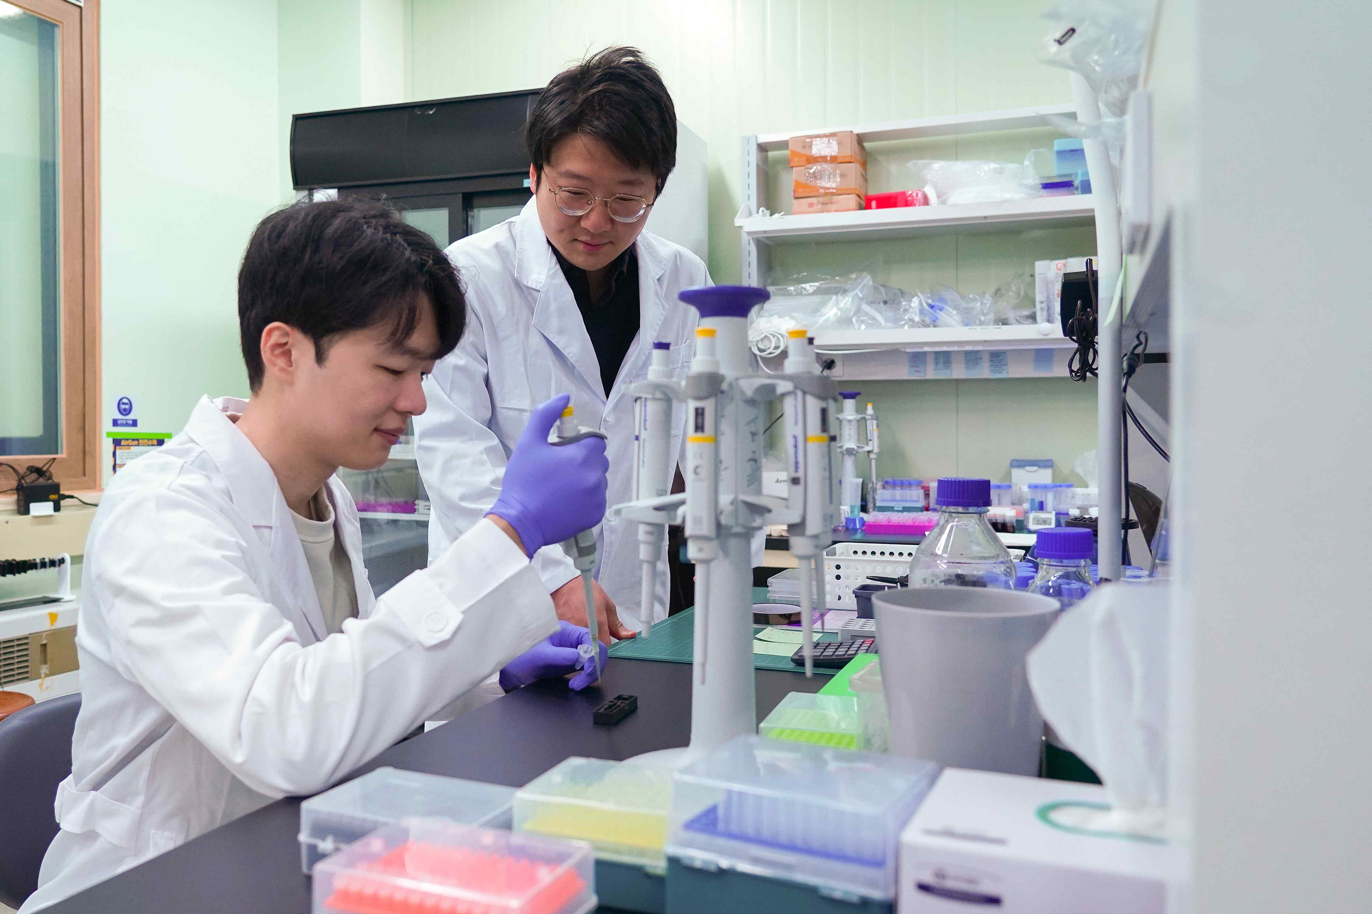

▲ (From left) GIST Advanced Photonics Research Institute Dr. Bobin Lee and Senior Researcher Kihyeun Kim

The Gwangju Institute of Science and Technology (GIST, President Kichul Lim) announced that the research team led by Senior Researcher Kihyeun Kim at the Advanced Photonics Research Institute has developed the world’s first ‘black background-based rapid antigen kit’ that can dramatically improve the sensitivity of rapid antigen kits.

This study is an innovative approach that applies the principle of observing stars in the night sky to diagnostic kits, overcoming the low sensitivity and false negative* occurrence problems of existing kits and implementing performance close to the PCR* level.

* false negative: An error in which the test result comes out as negative despite the actual presence of a disease or target substance, and is considered a major problem in infectious disease diagnosis.

* PCR (polymerase chain reaction): A technology that can rapidly and accurately amplify specific DNA, allowing for the exponential amplification and analysis of a small amount of genetic information. With high sensitivity and accuracy, it can quickly confirm the presence of genes even with a small amount of samples. However, it has the disadvantage of requiring expensive equipment and specialized skills, and may take more time and money than other methods based on PCR itself. In addition, it is very sensitive to contamination, so thorough management is required to maintain reliability.

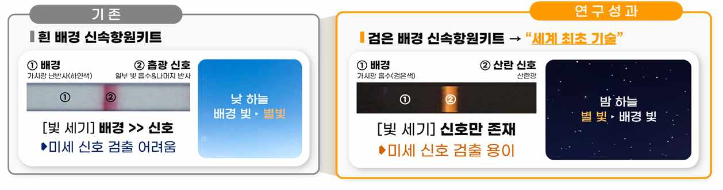

▲ The principle of capturing the scattering signal of gold nanoparticles on a black background. Just as starlight that is not visible during the day due to sunlight can be observed in the night sky, the fine scattering signal of gold nanoparticles can also be observed if the background signal is suppressed.

Rapid antigen kits are widely used for COVID-19 or pregnancy diagnosis, and have the advantage of being able to perform on-site diagnosis easily and quickly, making them useful for early screening of high-risk groups for infectious diseases.

However, when the antigen concentration is low, the signal appears faintly, which increases the possibility of false negatives, and this limits accurate infection diagnosis.

In fact, during the COVID-19 pandemic, rapid antigen kits received emergency use approval as a supplementary means in situations where the demand for PCR tests could not be met, but it was difficult to secure reliability in terms of diagnostic accuracy.

Accordingly, rapid antigen diagnostic technology was mainly used for pregnancy diagnosis, where accuracy is relatively unimportant, and was used in a limited way in the field of infectious disease diagnosis, where high accuracy is essential.

To overcome these limitations, the research team introduced a structural improvement that designed the background of the diagnostic kit to be black. The existing kit visually observed the red absorption signal* created by gold nanoparticles* on a white background, but there was a problem that the fine signal was not visible due to the strong reflection and scattered light on the white background.

The research team applied a black background to reduce unnecessary light reflection, inspired by the natural phenomenon that ‘stars in the night sky are not visible during the day, but are clearly visible at night.’ As a result, the signal of gold nanoparticles was observed much more clearly, and detection of extremely small amounts of viruses became possible.

* gold nanoparticles: Fine gold particles measuring only a few tens of nanometers (nm) in size, and are often used as diagnostic indicators because they have the characteristic of taking on a unique color when exposed to light.

* absorption signal: A phenomenon in which a substance absorbs specific light and changes color, which is used to confirm the presence or absence of a substance.

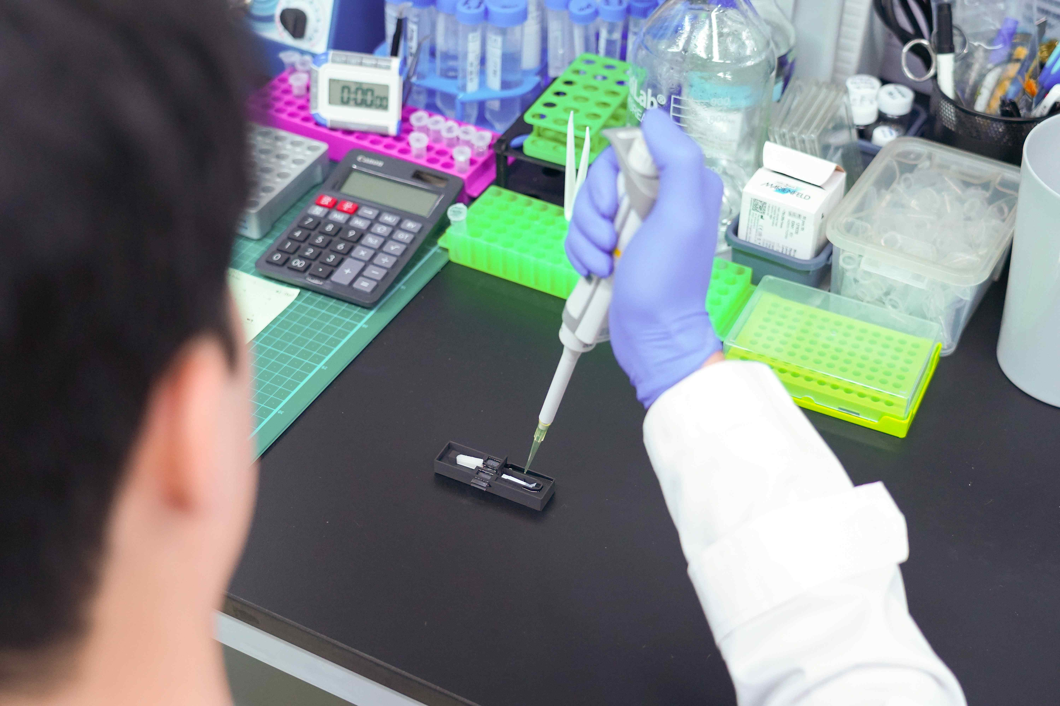

▲ Dr. Bobin Lee is conducting an experiment with a black background rapid antigen kit.

Senior Researcher Kihyeun Kim said, “This study maintains the convenience of the rapid antigen kit while dramatically improving its sensitivity, enabling detection of even extremely small amounts of viruses that were difficult to detect with existing methods,” and “This will be an important turning point for rapid antigen kits to achieve PCR-level accuracy in various clinical and public health fields including infectious diseases.”

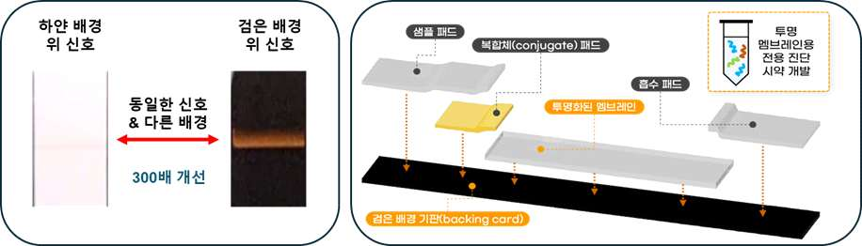

▲ (Left) Comparison of signal intensity by background. You can see that observation is more than 300 times better even when the background is simply changed in the same signal. (Right) Structure of a rapid antigen diagnostic kit based on a black background. The sensitivity was dramatically increased by removing the background signal by introducing a black background without significantly changing the structure of the existing rapid antigen diagnostic kit.

This study, supervised by Senior Researcher Kihyeun Kim and conducted by postdoctoral researcher Dr. Bobin Lee at the GIST Advanced Photonics Research Institute, was supported by the Basic Research Project of the GIST Advanced Photonics Research Institute, the Material and Components Technology Development Project of the Ministry of Trade, Industry and Energy, the Mid-career Researcher Support Project of the Ministry of Science and ICT, and the Overseas Excellent Research Institute Cooperation Hub Establishment Project. The results of the study were published online in the international academic journal 《Nature Communications》 on April 9, 2025.



