"Transmitting the robot's tactile sensation to the human arm" GIST and MIT develop the next-generation haptic system 'TelePulse'

- GIST Department of AI Convergence Professor SeungJun Kim's research team, in collaboration with MIT, presents precision haptic technology based on biomechanics... Real-time physical feedback implemented by combining electrical stimulation and bio-simulation

- Maximizing immersion by sharing tactile sensation between robot and user in VR environment, proving practicality in remote industry, surgery, rehabilitation, etc.... Received Best Paper Award at the world's most prestigious CHI 2025 conference

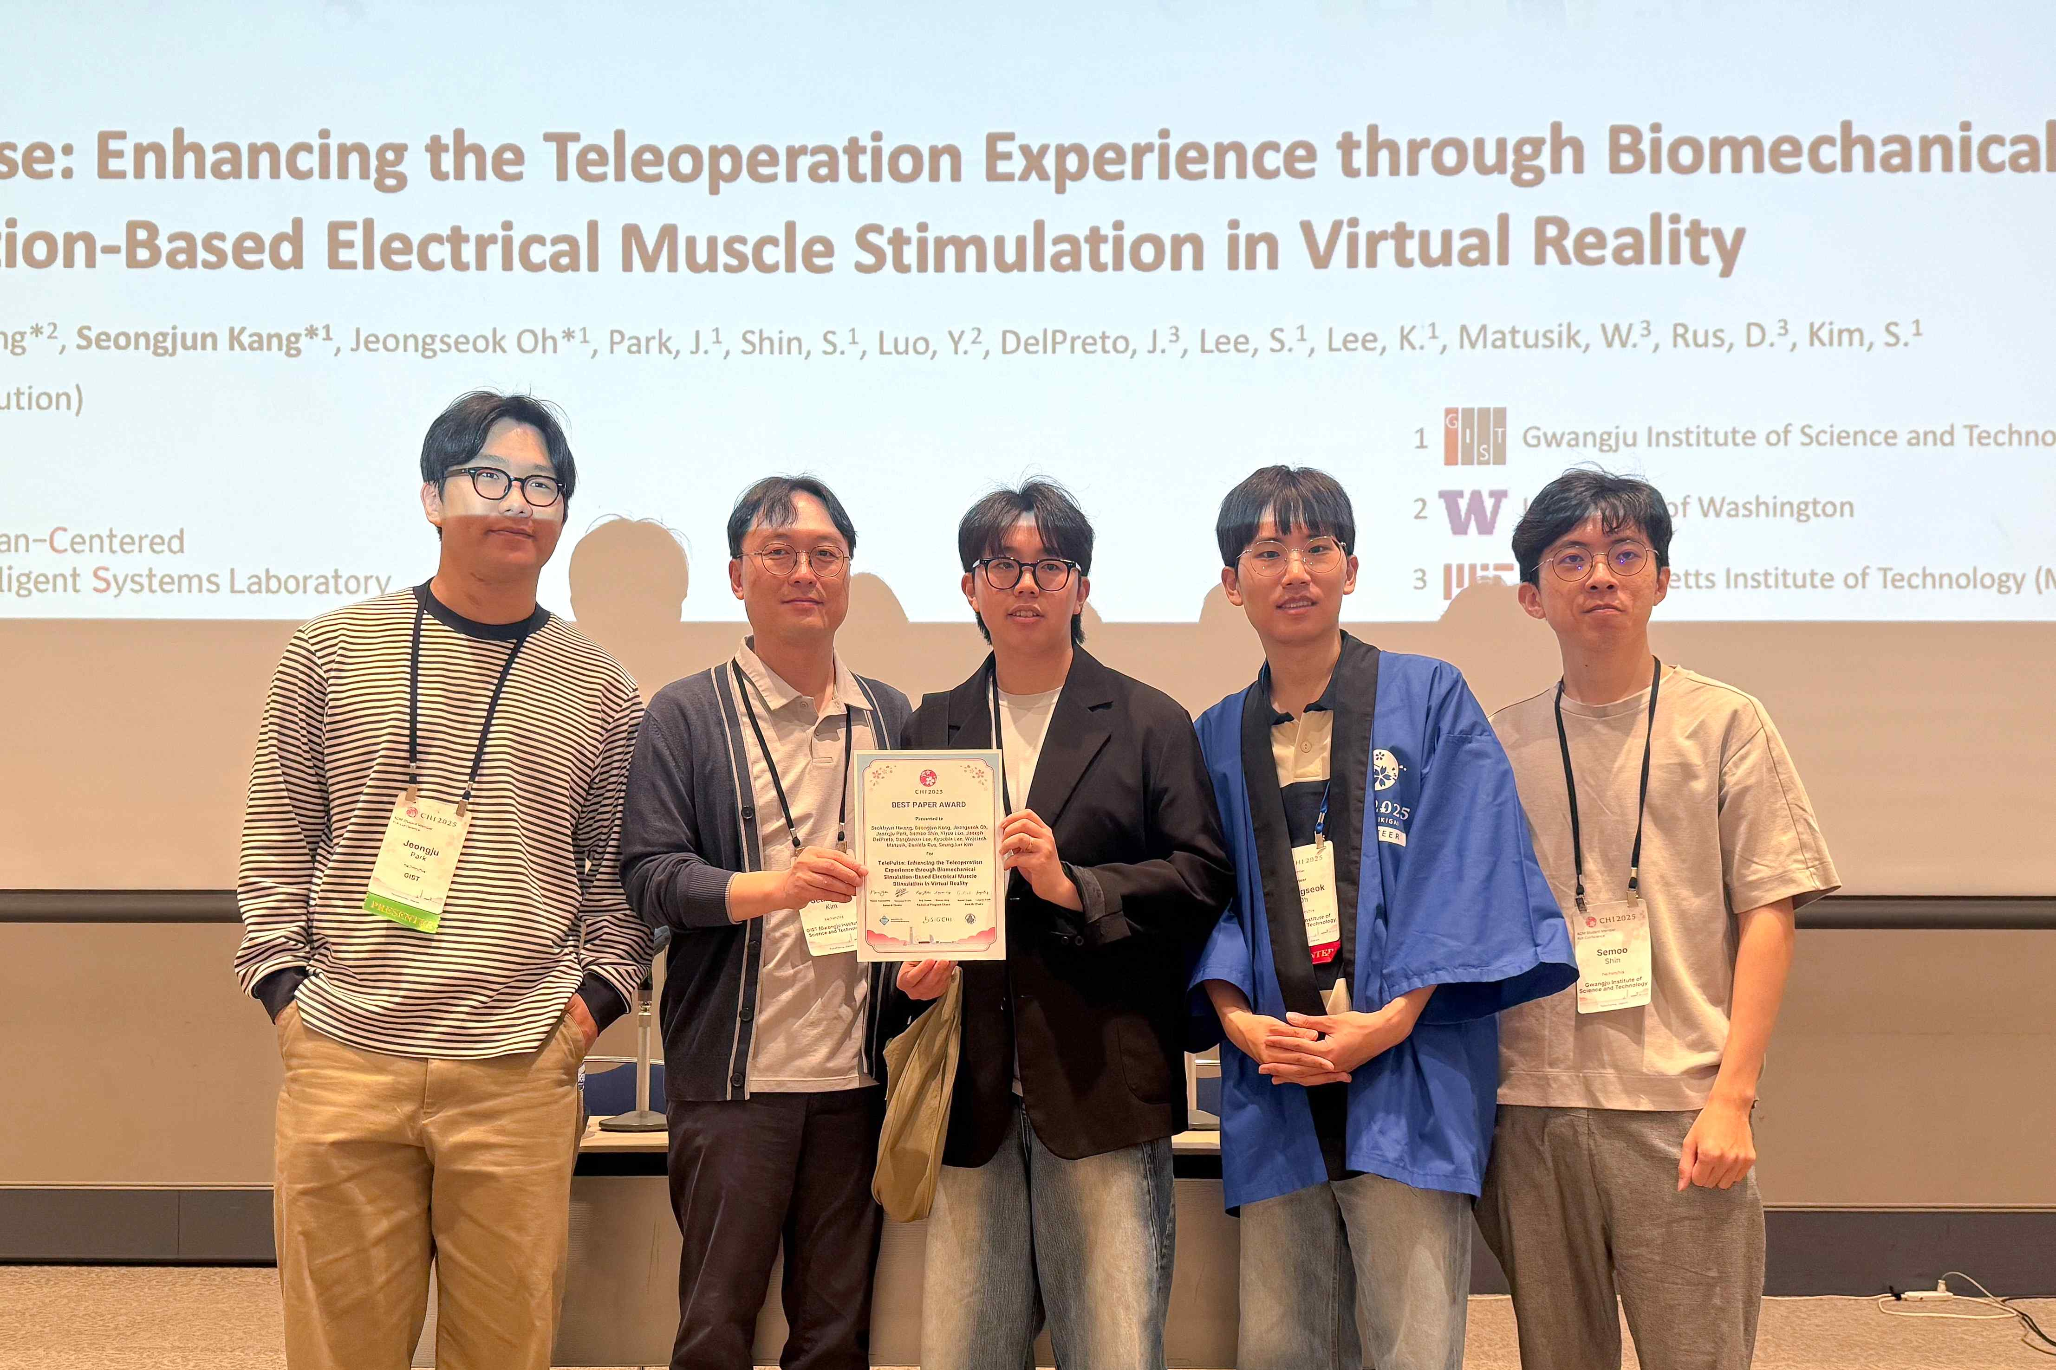

▲ TelePulse development team receives Best Paper Award at CHI 2025 conference. The research team was recognized for dramatically improving the immersion and precision of human-robot interaction through the TelePulse system.

A new concept haptic* system that transmits the physical force received by a robot to a human arm in real time has been developed.

This technology maximizes immersion by allowing users in a virtual reality (VR) environment to directly feel the movement of the robot or the physical changes in the external environment with their skin. It is also noteworthy because it can provide a new interface for users with visual or auditory limitations.

* haptic: refers to technology that transmits information through touch, and is generally a method of providing sensory feedback when a user interacts in a digital environment by utilizing physical senses. For example, it is used in vibration of smartphones, shock feedback of game controllers, and tactile sensation in VR (virtual reality) devices.

The Gwangju Institute of Science and Technology (GIST, President Kichul Lim) announced that Professor Seungjun Kim's research team in the Department of AI Convergence, in collaboration with a research team at MIT in the United States, developed 'TelePulse', a next-generation haptic feedback system that physically connects remote robots and humans.

This system accurately transmits the physical force that the robot touches to the arm when the user manipulates a remote robot arm in a VR environment. To achieve this, it combines electrical muscle stimulation (EMS) technology and biomechanical simulation.

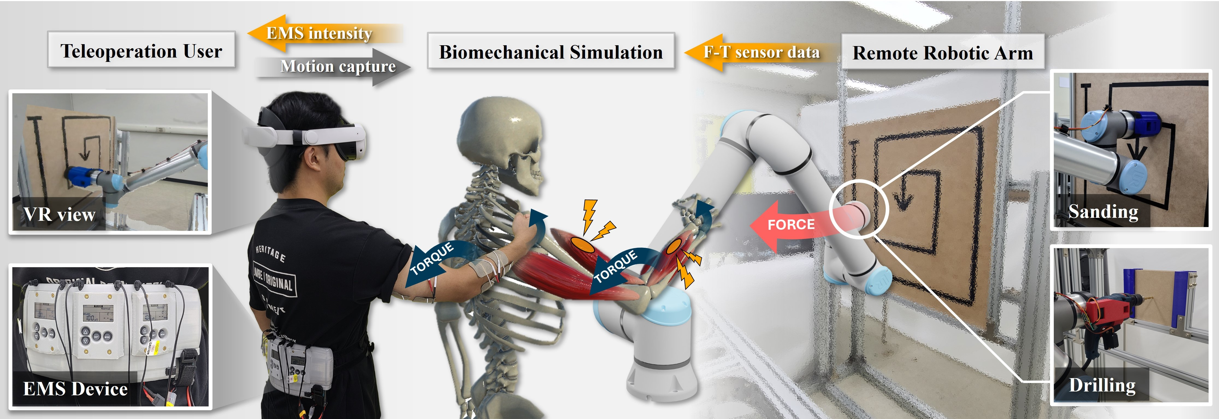

▲ TelePulse system overview. It is a two-way remote manipulation system that calculates the working force of the remote robot arm through biomechanical simulation and transmits it to the user through EMS.

By allowing the user to perceive the subtle difference in force that occurs when pressing or grabbing an object in real time, the user can experience vivid haptic feedback that goes beyond simple vibration or surface stimulation and actually causes muscles to contract.

EMS is a technology that directly induces contraction by transmitting electrical signals to muscles, which are the ‘biological actuators*’ of the human body, and provides intuitive and powerful haptic feedback without a separate motor or mechanical device.

* actuator: A component that receives signals such as electricity, pressure, and heat and actually moves a machine or device. If a sensor is a sensory organ that detects information, an actuator acts like a muscle that performs an action based on that information.

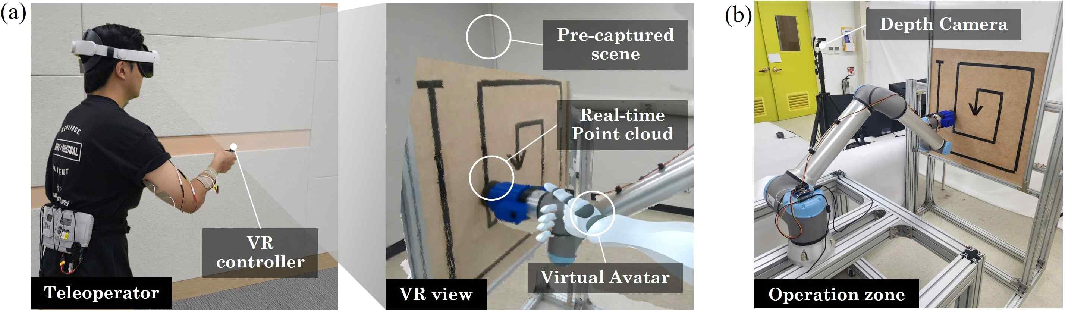

▲ TelePulse remote operation interface. (a) The user performs remote operations while viewing real-time point clouds and pre-captured scenes through a virtual avatar in a VR environment. (b) The workspace where the robot arm is placed is scanned by a depth camera and reflected in VR in real time.

Existing EMS-based haptic systems usually only stimulate muscles in proportion to a set intensity, but TelePulse analyzes the user's physical condition, posture, and joint position in real time to precisely calculate which muscles should be stimulated and how much, and provides optimized feedback.

To this end, the research team introduced 'OpenSim', a biomechanical simulation tool used in physical therapy and rehabilitation research, and succeeded in implementing a more delicate and realistic haptic experience by performing user-customized joint torque calculation and stimulation intensity adjustment in real time.

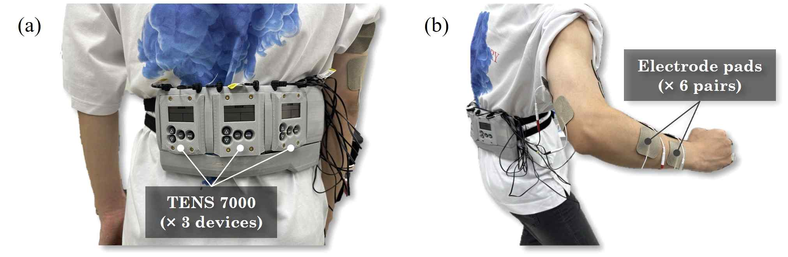

▲ TelePulse EMS device configuration. (a) Three TENS 7000 devices are mounted on the waist to implement multi-channel muscle stimulation. (b) A total of six pairs of electrode pads are attached to various muscles in the arm to provide precise electrical stimulation.

To verify practicality, the research team applied TelePulse to a simulated experiment of remote industrial tasks such as drilling and sanding, which virtually implemented industrial sites. As a result, participants who used TelePulse showed significant improvements in force control accuracy and task consistency.

In the sanding task, which required a constant pressure while polishing the surface along a spiral path, participants who used TelePulse showed a significant improvement in precision, reducing the mean absolute error (MAE) by about 22% in this task that required continuous force control.

In the drilling task, which required precise force control to drill a wooden board of a certain thickness, TelePulse users showed about 30% higher accuracy than non-users, and also had a significantly lower failure rate due to excessive force.

In a survey conducted after the experiment, participants reported that TelePulse gave them a strong sense of immersion, “a feeling of sharing senses with the robot,” beyond simple mechanical vibration stimulation. In fact, the immersion (presence) scale score also showed an average improvement of more than 15%.

Unlike complex mechanical haptic devices, TelePulse is designed to be easy to wear and lightweight, providing high mobility and usability. Based on this, it is expected to be widely used in various difficult remote work environments such as remote robot operation, remote surgery, disaster relief, and space exploration.

This research result, which achieved technological advancement in real-time precision control of electrical stimulation technology, is attracting attention as a new interface model that can simultaneously improve the immersion and precision of human-robot interaction.

Professor SeungJun Kim said, “TelePulse is a technology that transmits physical stimulation received by a robot to the human body in real time, opening an era where people and robots share ‘sense’ beyond simple mechanical operation,” and “It will be usefully utilized in various fields such as remote collaboration, precision work, training, and rehabilitation in the future.”

This study was recognized for both its innovation and practicality, and was accepted by the ACM CHI 2025 (Conference on Human Factors in Computing Systems), the most prestigious international academic conference in the field of HCI (human-computer interaction) and user interface. In particular, it won the ‘Best Paper Award’, which is awarded to the top 1% of all papers.

The research results were presented at the CHI 2025 conference held in Yokohama, Japan on May 1.

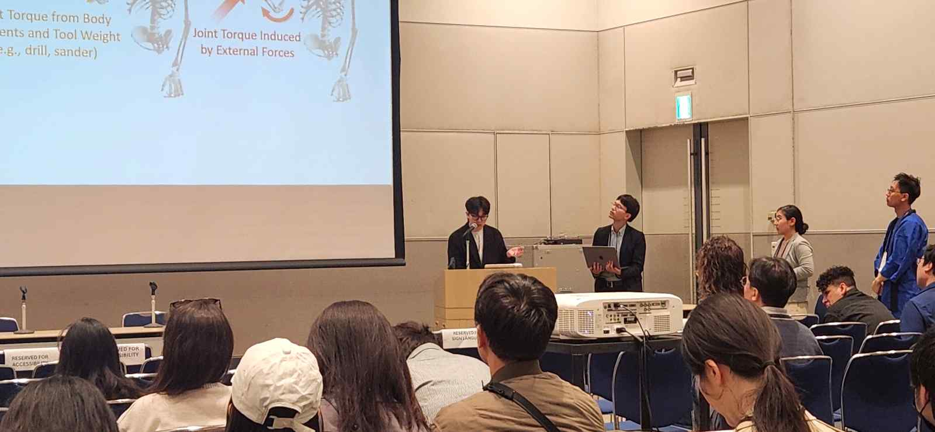

▲ TelePulse presentation site. The research team explains the principles and performance of the TelePulse system, which transmits the working force of a remote robot arm to the user in real time, to the audience at the CHI 2025 conference.

This study was conducted as a result of joint research between GIST and the Computer Science and Artificial Intelligence Laboratory (CSAIL) at MIT in the United States, and was supported by the Ministry of Science and ICT (MSIT) through the University ICT Research Center (ITRC) project of the Institute of Information and Communications Technology Planning and Evaluation (IITP), the National Research Foundation of Korea (NRF) research support project, and the GIST-MIT joint research project.

Meanwhile, a total of four researchers from GIST, including Professor SeungJun Kim, Researchers Seokhyun Hwang, Seongjun Kang, and Jeongseok Oh, as well as Professor Daniela Rus, Professor Wojciech Matusik, and two MIT researchers, participated in this study. Both institutions have been continuously researching core technologies in the field of human-centered next-generation interfaces, such as realistic interaction technology in VR environments and development of multi-sensory interfaces.



