"Adding Emotion and Intention to AI Motion" GIST develops 'MoWa', a custom authoring tool for animators

- Professor SeungJun Kim's research team from the Department of AI Convergence, unveils 'MoWa', an innovative avatar motion editing system that can finely adjust emotional expression and movement intentionality through collaboration with AI and experts

- Overcoming the limitations of AI-generated motion and maximizing expressiveness based on intuitive control and animation principles to increase production efficiency... Announced on April 30 at the world-renowned AI academic conference 'CHI 2025'

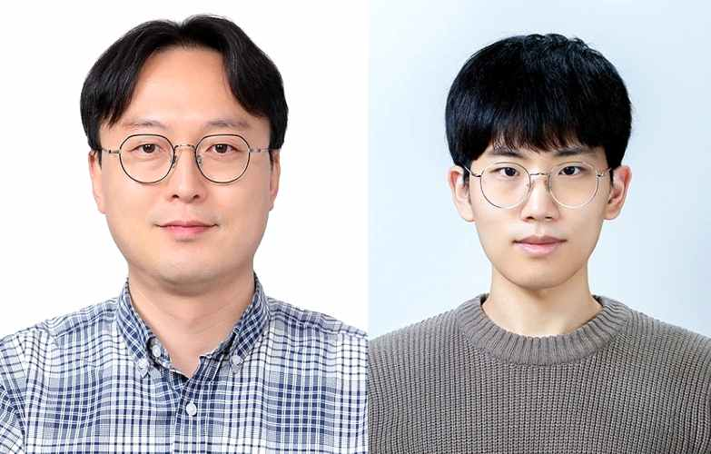

▲ (From left) Professor SeungJun Kim and PhD student Jeongseok Oh

Although generative AI has recently achieved results in creating realistic movements, it still lacks aspects such as emotional expression and intentionality of movements that professional animators value.

The Gwangju Institute of Science and Technology (GIST, President Kichul Lim) announced that Professor SeungJun Kim and Ph.D. candidate Jeongseok Oh of the Department of AI Convergence have developed an authoring tool called ‘MoWa (Motion Waveform Authoring Tool)’ that can more precisely modify and supplement the motion of avatars created by generative AI.

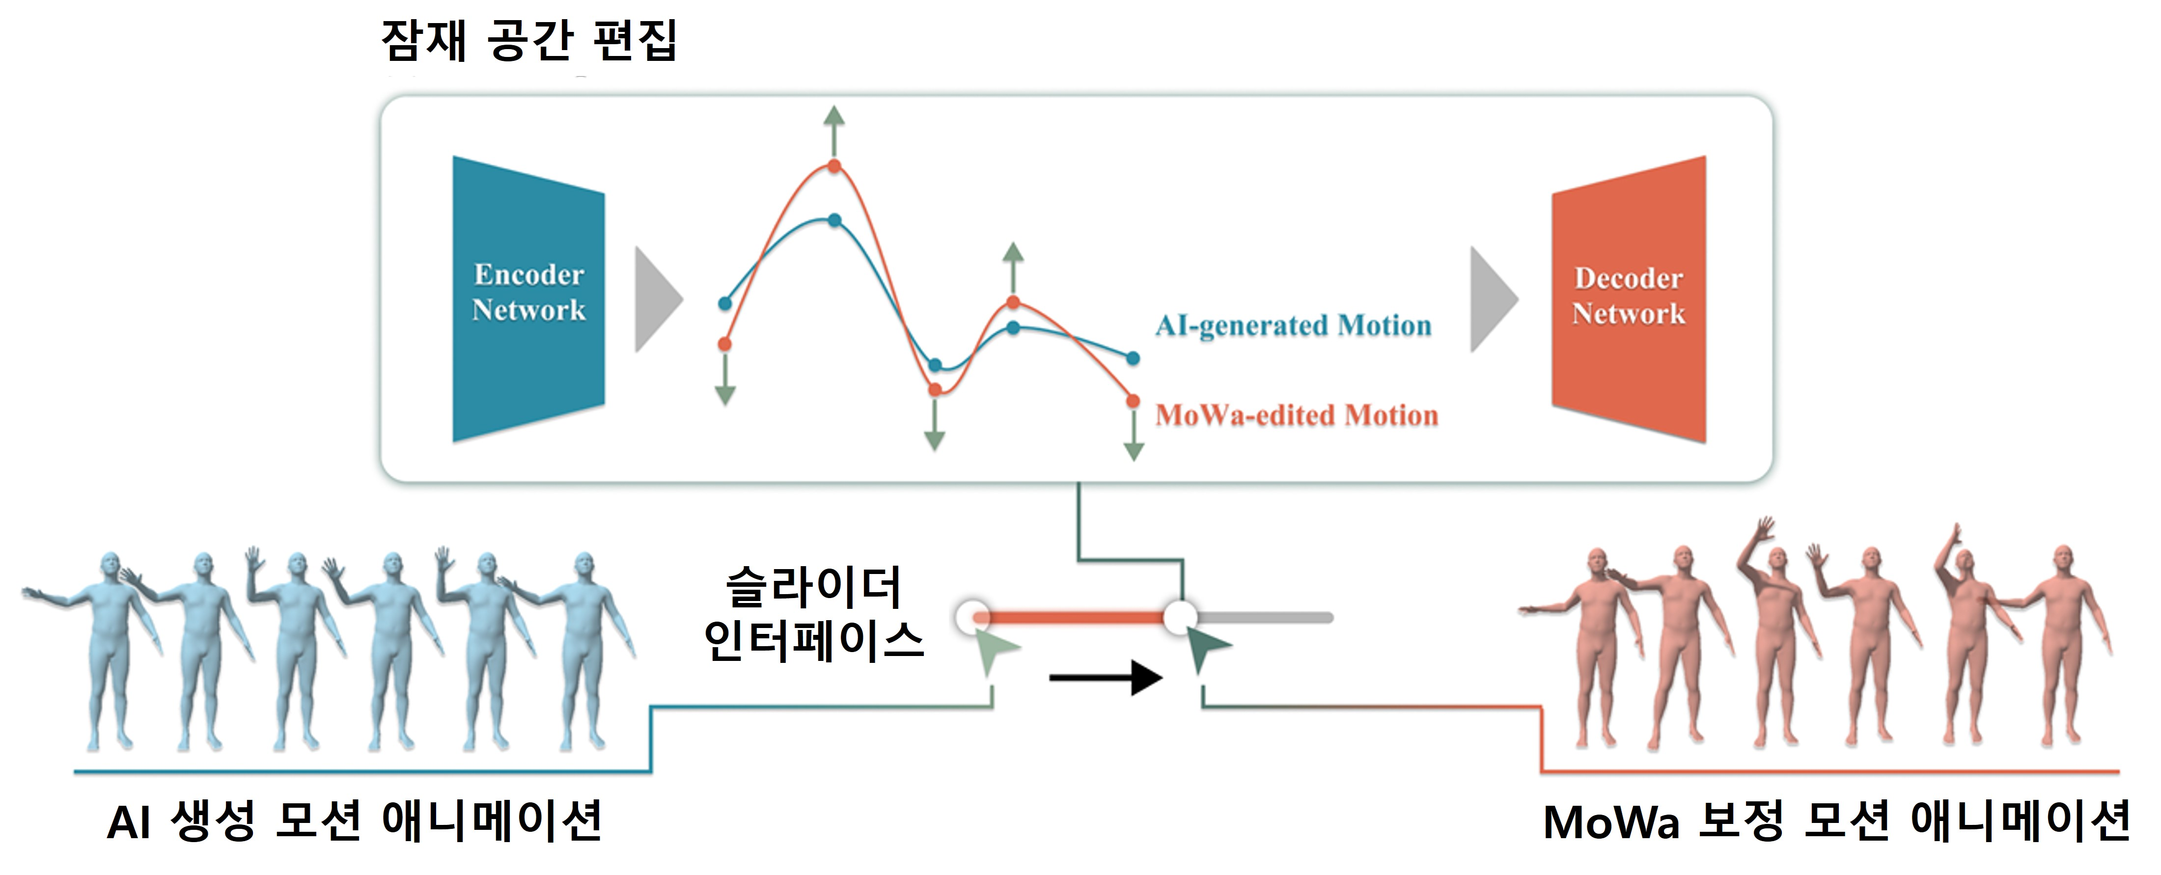

▲ Overview of the MoWa system. MoWa is a system that receives motion animation generated by generative AI as input and precisely corrects the motion by adjusting it according to the designer’s intention in latent space.

MoWa is a tool suitable for the creative process of professional animators, helping to add the meaning of the emotion and movement intended by the designer to the basic motion generated by AI.

It is also expected to be practical as it can reduce repetitive work and increase overall production efficiency.

This system visualizes the motion of the avatar generated by text-based commands as a waveform in the ‘latent space’ and is designed so that the user can intuitively manipulate it.

Users can easily adjust and strengthen the expression elements of the motion such as ‘anticipation’, ‘exaggeration’, and ‘arc’ through a simple UI.

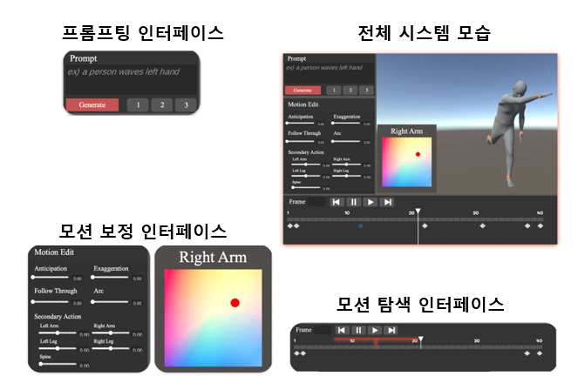

▲ Avatar motion animation correction. MoWa’s user interface supports the exploration of various motion designs using a text-based motion generation model, and is configured to allow adjustments to the generated motion based on animation principles. Users can complement the expressiveness of motion through simple slider manipulation, and can play/pause motion or freely add and edit keyframes through the timeline interface.

The starting point of MoWa development was the limitations of text-to-motion technology. The research team conducted formative research* with six professional animators and repeatedly confirmed that existing AI-generated motions did not sufficiently reflect the core principles of animation (preliminary motion, exaggeration, curved motion, etc.).

To solve this, the research team developed an algorithm that can edit waveforms in latent space using VAE (variational autoencoder)*.

* formative study: This is an exploratory study in the early stages to deeply understand a problem or phenomenon and design future research or interventions, and is used importantly in practical fields such as user experience (UX), education, health science, and design research.

* VAE (Variational AutoEncoder): A deep learning-based generative model that can efficiently compress input data while also generating new data based on it.

Users can input keywords to create basic motions, and then use sliders or 2D keyframe editors to fine-tune the motions.

Since it adjusts curved waveforms in potential space rather than actual space, more precise and intuitive corrections are possible. In addition, thanks to the UI implemented based on the game engine Unity, users familiar with commercial 3D tools can easily use it without much learning.

The research team conducted two user studies targeting 12 professional animators to verify the effectiveness of MoWa.

In the first experiment, the results of existing text-to-motion were compared with the results modified through MoWa. Participants evaluated that MoWa allowed them to quickly create more diverse motions, and that both the expressiveness and satisfaction with the results were high.

In the second experiment, the existing inpainting* method, manual editing method, and MoWa method were compared. As a result, MoWa received positive evaluations in that it was the most efficient and allowed for editing based on animation design principles.

* inpainting: A technology that naturally restores damaged or missing parts of an image or video using surrounding information. Originally a concept derived from the restoration of artwork, it is now widely used in digital image processing and computer vision.

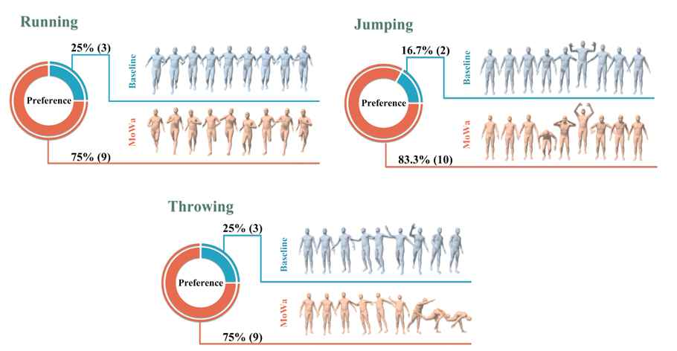

▲ User evaluation results for professional designers. When professional and novice designers used the system developed in this study, they were able to produce better designs with less time and effort.

Professor SeungJun Kim said, “MoWa goes beyond simply utilizing motion automatically generated by AI and shows the new possibility of a ‘collaborative AI tool’ that allows experts to directly intervene and finely refine the expressiveness.” He continued, “This study has proven that generative AI can be practically integrated into professional design work, and will be able to suggest important directions for the design of AI-based animation authoring tools in the future.”

This study, supervised by Professor SeungJun of the Department of AI Convergence at GIST and conducted by Ph.D. candidate Jeongseok Oh, was supported by the Ministry of Culture, Sports and Tourism’s Content Source Technology Development Project and the GIST-MIT Joint Research Projects, ‘HCI + AI Convergence Research for Human-Centered Physical System Design’, ‘Fusion-type Cultural Virtual Studio for Implementing AI-based Metaverse’, and ‘Development of Actuated XR System Based on Soft Robotics and Sensory Intelligence for Embodiment between Reality and Virtuality’.

The results of this study will be presented on April 30 at ‘CHI 2025’, the world’s most prestigious academic conference in the field of human-computer interaction (HCI).

Meanwhile, Professor SeungJun Kim, who is also an adjunct professor at the Graduate School of AI Policy and Strategy, has developed a number of AI-based interaction technologies and digital creation support systems. Including the results of this study, he presented three full-papers and three posters at the CHI 2025 conference.



