"Unraveling the hidden link of fat cell differentiation" GIST - Soonchunhyang University, world's first identification of the fat cell metabolism control mechanism

- GIST Department of Biomedical Science and Engineering Professor Jun Cho's research team and Soonchunhyang University Professor Mihye Lee's research team jointly succeeded in experimentally proving for the first time in the world the process by which metabolites precisely regulate gene translation through multi-body analysis

- Presenting a new breakthrough in the treatment of metabolic diseases such as obesity and diabetes, published in 《Nature Communications》



▲ (From left) Professor Jun Cho of the Department of Biomedical Science and Engineering at GIST, Professor Mihye Lee of the Soonchunhyang University Department of Integrated Biomedical Science, GIST student Daehwa Youn, Soonchunhyang University student Boseon Kim, and GIST student Dahee Jeong

A research team in Korea has discovered a new fact that gene translation and cell metabolism closely interact and influence each other during the process of fat cell differentiation.

This study is expected to provide important clues for understanding the metabolic function control mechanism of fat cells at the molecular level, thereby opening an important breakthrough in establishing new treatment strategies for metabolic diseases such as obesity and diabetes.

The Gwangju Institute of Science and Technology (GIST, President Kichul Lim) announced that a joint research team led by Professor Jun Cho of the Department of Biomedical Science and Engineering and Professor Mihye Lee of the Soonchunhyang University Department of Integrated Biomedical Science has for the first time elucidated the previously unknown mechanisms of mutual regulation between two types of gene translation and metabolism through multiomics* analysis that integrates transcriptome*, translatome*, and proteome*.

* transcriptome: RNA, the first product of gene expression starting from genetic material, is synthesized through transcription, and the sum total of all RNAs is called the transcriptome.

* translatome: mRNA or messenger RNA is translated to provide the information necessary to synthesize proteins. The total sum of information about how much of a certain mRNA is translated during this translation process is called the translatome.

* proteome: The total sum of all proteins produced through translation processes in cells is called the proteome.

* multiomics: Omics is a word that means ‘dealing with the whole’, and the analysis of multiple omics data in combination is called multiomics or multiomics.

Fat cells are divided into white fat cells that store energy and brown/beige fat cells that consume energy and generate heat. In particular, beige fat cells are derived from white fat cells and have similar characteristics to brown fat cells when stimulated by exercise or cold, and have been noted as promising targets for treating metabolic diseases.

However, most studies to date have focused only on the transcription stage, that is, the initial stage in which genes are copied into RNA, and comprehensive analysis of the translation stage that actually produces proteins or the protein itself (proteome) has been insufficient.

Accordingly, the research team introduced the ‘multiomics’ technique that comprehensively analyzes transcriptome, transcribe, and proteome data acquired under the same conditions, and systematically traced how gene translation and cell metabolism are organically regulated during the fat cell differentiation process.

The research team first analyzed the protein translation regulation process that occurs in mitochondria, the core organelle of energy production within cells.

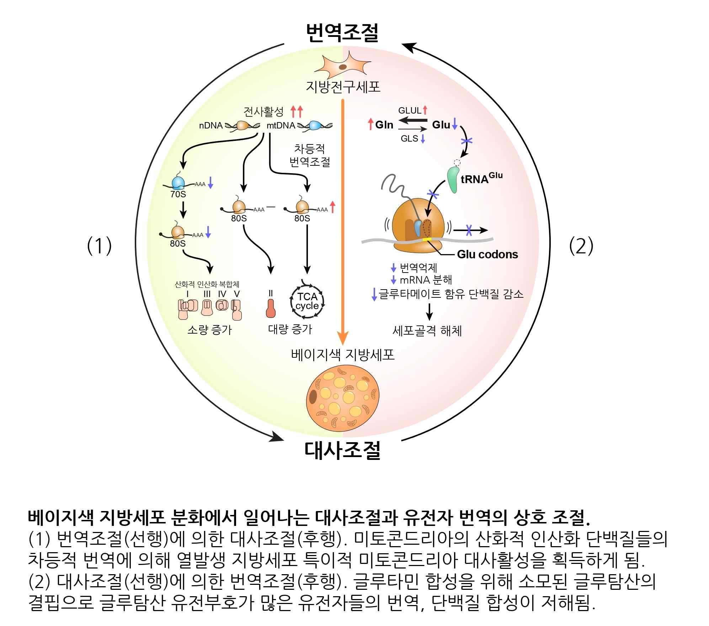

Mitochondria are composed of oxidative phosphorylation complexes I to V, and each complex is composed of several protein units. As a result of the analysis, it was observed that genes constituting complexes I, III, IV, and V were repressed in translation during the process of adipocyte differentiation, but complex II was excluded from this repression and rather increased in proportion.

These results suggest that beige adipocytes that generate heat adjust the composition of mitochondrial complexes according to their metabolic characteristics, and that this regulation is precisely carried out at the protein synthesis stage.

The research team discovered that during adipocyte differentiation, the translation of proteins containing a large amount of this amino acid is inhibited due to the decrease in glutamic acid caused by metabolic regulation.

The research team confirmed that during adipocyte differentiation, the expression of genes that consume glutamic acid and produce glutamine increases, which lowers the concentration of glutamic acid, causing ribosomes to stall in mRNAs with glutamic acid genetic codes and inhibiting protein production.

This ribosome stalling phenomenon was shown to inhibit the translation of genes with a large glutamic acid genetic code, and in particular, to reduce the production of proteins involved in cytoskeletal composition, which ultimately promotes adipocyte differentiation.

Professor Jun Cho of GIST said, “This is the first case to experimentally prove at the molecular level that metabolic substances in the process of adipocyte differentiation can directly participate in gene translation regulation,” and explained, “This shows that metabolism and gene translation regulation are not independent and separate, but actively involved in the complex biological phenomenon of adipocyte and tissue generation.”

He added, “Understanding this mechanism could be a very important foundation for the development of next-generation treatment strategies based on precise metabolic regulation in the future.”

Professor Mihye Lee of Soonchunhyang University said, “This study is a meaningful result that proves that gene regulation related to adipocyte metabolism is precisely carried out not only at the transcription stage but also at the translation stage,” and “It is very significant in that it revealed the importance of a multilayered regulatory structure in adipocyte differentiation.”

This study, supervised by Professor Jun Cho of the Department of Biomedical Science and Engineering at GIST and Professor Mihye Lee of the Soonchunhyang University Department of Integrated Biomedical Science, and conducted in collaboration with GIST PhD students Daehwa Youn and Dahee Jeong and Soonchunhyang University Department of Integrated Biomedical Science PhD student Boseon Kim, was supported by the Basic Research Program of the National Research Foundation of Korea, the 2022 Korean Advanced Institute of Science and Technology Joint Research Project, the GIST-Chonnam National University Hospital Joint Research Project, and the Korea Basic Science Institute. The results of the study were published online in the international academic journal 《Nature Communications》 on April 9, 2025.



