"Universal 'adhesive' stacks without contamination using Van der Waals force" GIST develops high-purity precision process technology for 2D materials

- Professor Jae Hun Seol's team from the School of Mechanical and Robotics Engineering develops a process technology that can manipulate various materials using the Van der Waals force between homogeneous two-dimensional materials... Solving the problem of polymer residues, green light for development of high-performance devices

- Confirmation of applicability to various two-dimensional materials, production of high-quality heterostructures with contamination-free, high-purity manipulation technology, and improvement of performance of next-generation electronic and optical devices... Published in the international academic journal 《Advanced Materials》

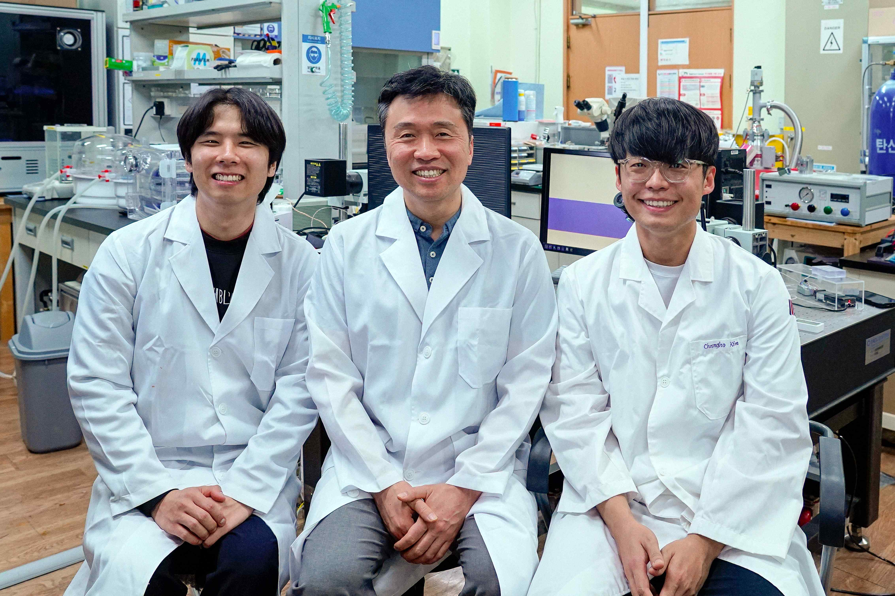

▲ (From left) School of Mechanical and Robotics Engineering Ph.D. student Minyoung Lee, Professor Jae Hun Seol, and integrated master's and doctoral student Changho Kim

The Gwangju Institute of Science and Technology (GIST, President Kichul Lim) announced that the research team led by Professor Jae Hun Seol of the School of Mechanical and Robotics Engineering has developed a groundbreaking process technology that can secure two-dimensional materials* with high purity without external contamination and manipulate them precisely.

In this study, a method was presented that can fundamentally solve the contamination problem that commonly occurs when manufacturing two-dimensional material-based devices by utilizing the ‘Van der Waals force’* that acts between similar types of materials. It is expected that this will greatly improve the performance and reliability of the devices.

* two-dimensional materials: They have an ultra-thin film structure that is only a few atomic layers thick, so they are very light and thin, but they also have excellent electrical and thermal conductivity and mechanical strength. They also have excellent interaction characteristics with light, making them suitable for optical devices and sensors, and they are attracting attention as a material that is highly suitable for next-generation electronic devices such as flexible displays and wearable devices due to their flexible yet strong properties.

* Van der Waals force: A weak attractive force that acts between molecules or atoms. It is not a strong chemical bond like ionic or covalent bonds, but it plays a key role in holding the layers of two-dimensional materials together. This force, which is generated from a temporary difference in charge distribution, helps two-dimensional materials such as graphene or molybdenum disulfide to stack layers, and it can be used to bond different materials without chemical damage when attaching them, so it is very useful in the production of precise devices or heterostructure processes.

Two-dimensional materials with unique physical properties, such as ‘graphene’ or ‘molybdenum disulfide (MoS₂)’, are being actively studied in various fields such as electronics, optics, and energy. However, since these materials are so thin and sensitive, impurities or minute mechanical damage that occur during the manufacturing process can significantly reduce their properties.

In particular, existing process methods that use polymer materials such as ‘polymethyl methacrylate (PMMA)*’ are still widely used, but there is a problem that residues remain on the surface even after the material is removed. This can deteriorate the performance of the device and reduce reliability. To overcome these limitations, a new process technology that does not require the material removal process itself is required, and this is attracting attention as a key solution that can fully utilize the unique properties of two-dimensional materials.

* polymethyl methacrylate (PMMA): A type of transparent plastic that is lightweight and easy to process, so it is used in various industries. It is widely used as a support in the 2D material transfer process, but residues on the surface can remain during the removal process, which can deteriorate the performance of the material.

The research team succeeded in securing pure 2D material flakes without impurities by using molybdenum disulfide*, a 2D material widely used in electronic devices, as the main material.

What is particularly notable is that a new process technology has been developed that allows precise manipulations such as transfer (attachment), flipping, and stacking (stacking) without using polymer materials such as PMMA as before, by utilizing the Van der Waals force that acts between the same materials.

* molybdenum disulfide (MoS2): A 2D material that combines molybdenum (Mo) and sulfur (S), it has a thin layer structure and semiconductor properties, so it is widely used in electronic devices, sensors, and energy storage devices.

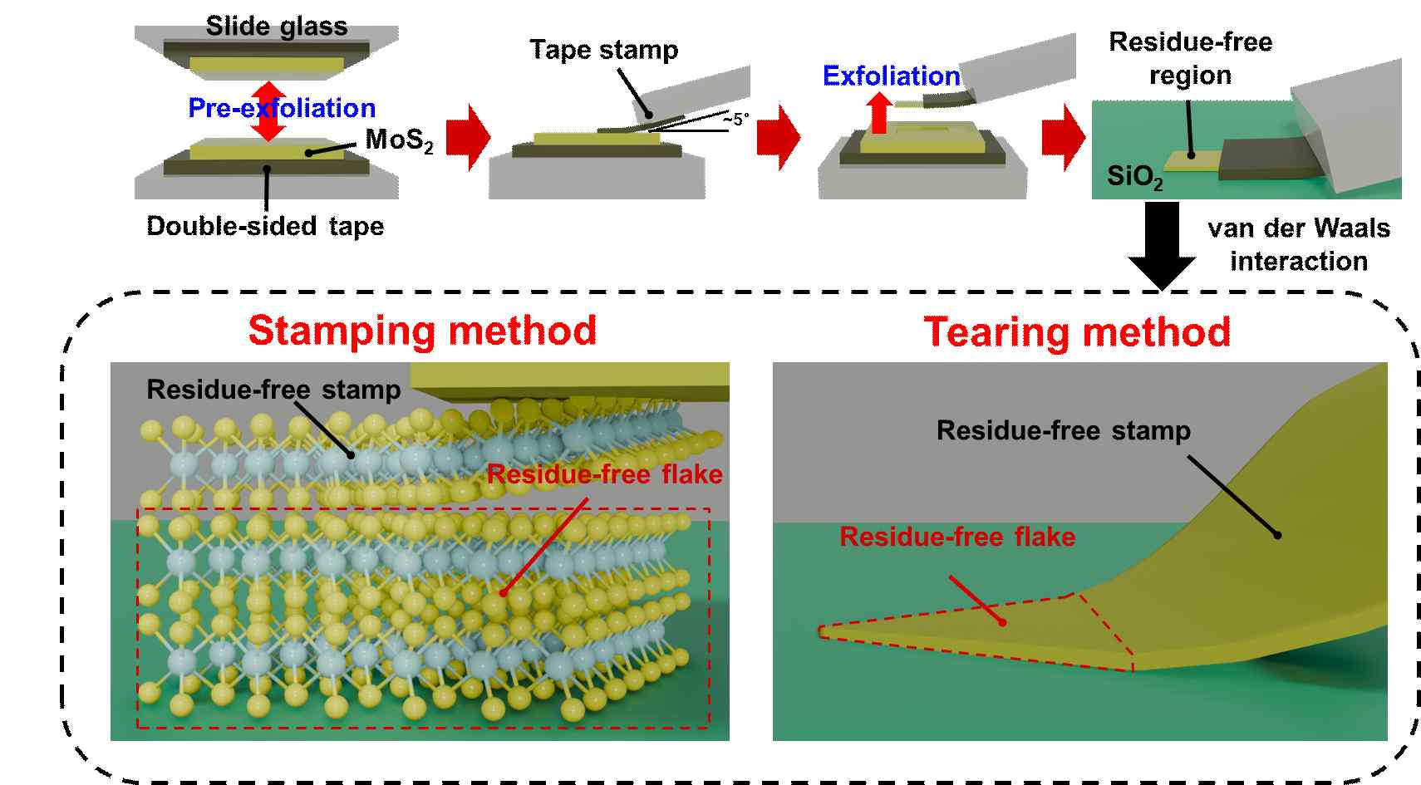

▲ Schematic diagram of the process of obtaining 2D materials using Van der Waals interactions. This paper presents a process for simultaneously obtaining a high-purity two-dimensional material flake and a stamp made of the same material by separating a clean region free of impurities from the surface of a pre-exfoliated two-dimensional material crystal using two methods (stamping method, tearing method).

As a result of various optical analyses, it was confirmed that the 2D material developed through the new process this time remains very clean without residue, defects, oxidation, or mechanical deformation.

It also showed excellent results in electrical performance experiments. In the measurement using a field-effect transistor (FET)*, the field-effect mobility* was 60 cm²/V·s, and the On/Off current ratio* was approximately 10⁸, proving that it is suitable for implementing high-performance electronic devices.

* field-effect transistor (FET): A device that controls the flow of current using an electric field. It is often used to evaluate the performance of transistors and plays a key role in semiconductor devices and logic circuits.

* field-effect mobility: A value indicating how fast electrons can move within a field-effect transistor. A higher value means faster electron movement and better performance.

* on/off current ratio: An indicator of the current difference between when the transistor is 'off' and 'on'. A higher ratio means better current control capability and superior device performance.

In addition, the research team confirmed that the technology developed this time can be applied to various two-dimensional materials such as multilayer graphene (MLG),* molybdenum disulfide (MoS₂), and hexagonal boron nitride (h-BN)*.

Based on this, they succeeded in precisely stacking Van der Waals heterostructures* made by stacking different two-dimensional materials in layers according to the desired order and location.

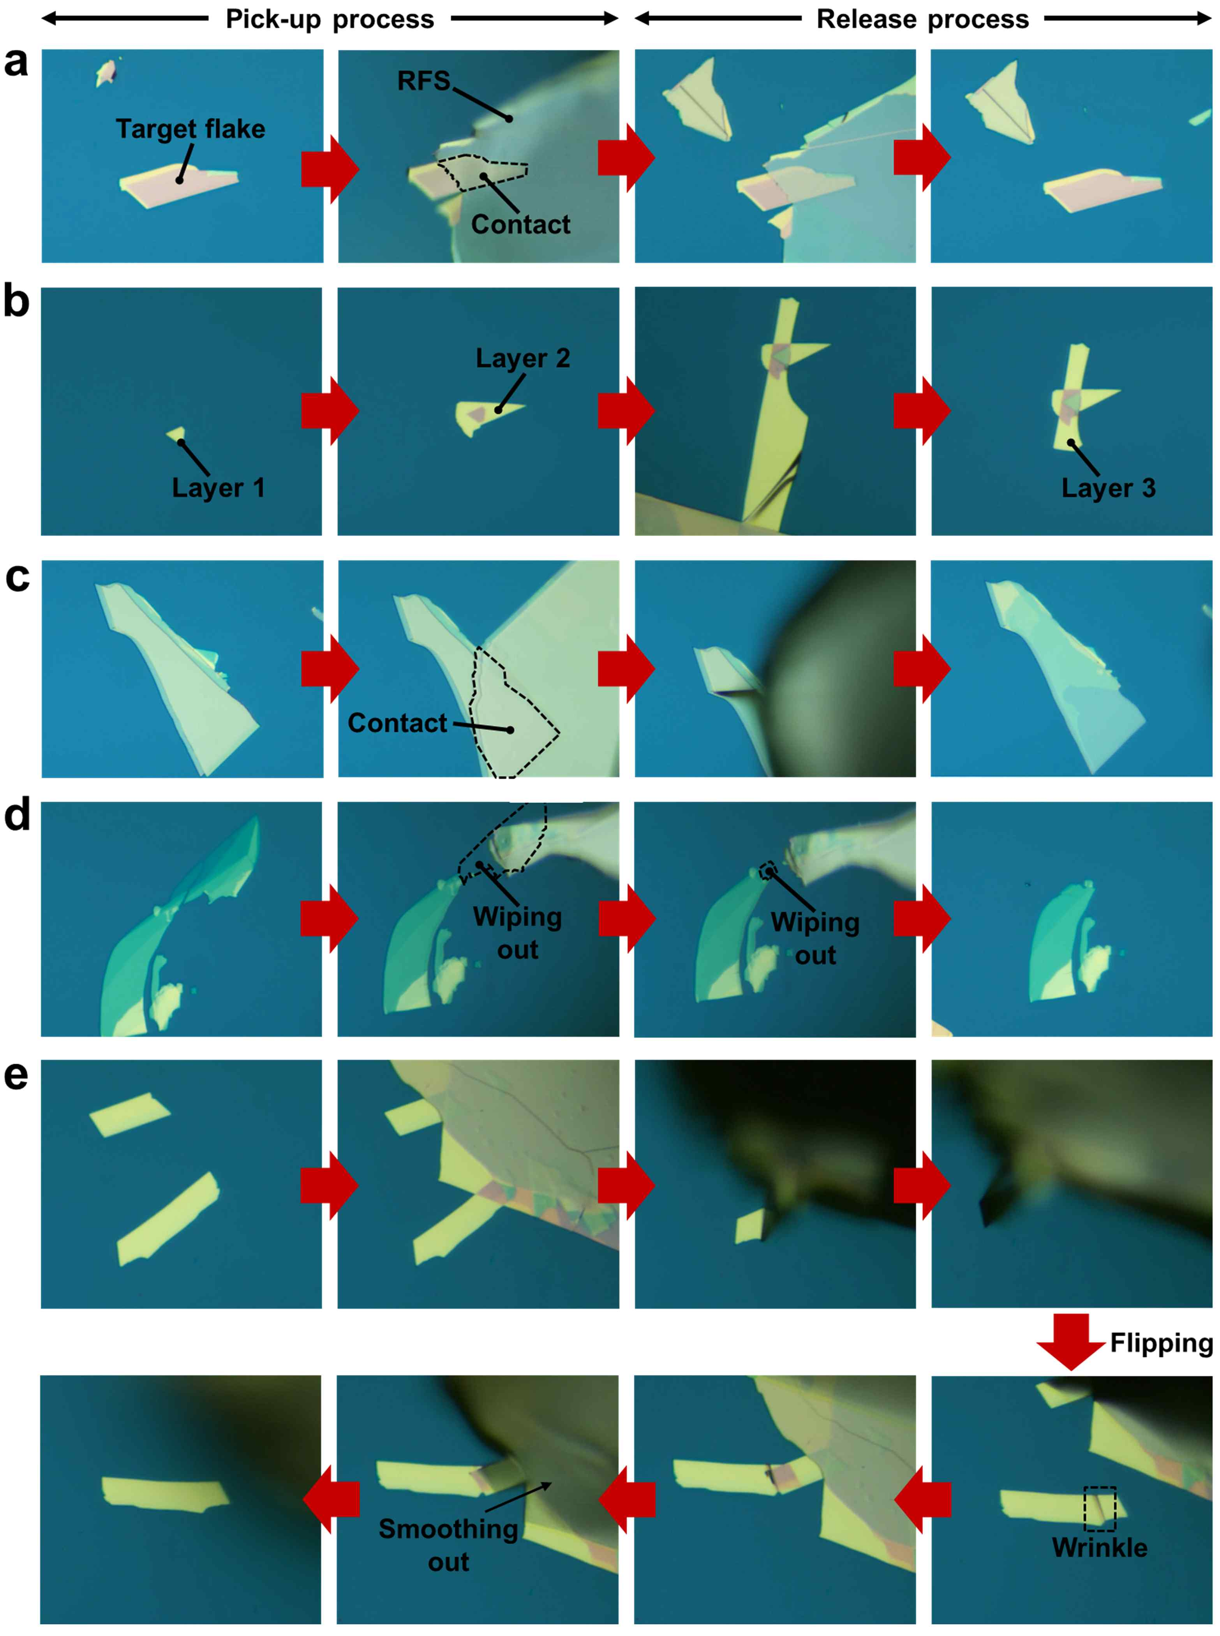

▲ Various material manipulation processes usingVan der Waals forces. The method of moving, stacking, peeling, removing, flipping, and removing wrinkles using high-purity molybdenum disulfide obtained through a two-dimensional material acquisition process using Van der Waals interactions is sequentially shown. It shows that additional manipulation is possible using Van der Waals forces for materials already obtained.

* multilayer graphene (MLG): Graphene consisting of a single atomic layer is stacked in multiple layers, and has high conductivity and mechanical strength, so it is used in various electronic devices.

* mhexagonal boron nitride (h-BN): An insulating two-dimensional material with a hexagonal structure. It has excellent electrical insulation and thermal stability, so it is often used as a protective layer or substrate in two-dimensional devices.

* Van der Waals heterostructure: A structure made by stacking different two-dimensional materials in layers, and can implement new functions by combining the characteristics of each material. A weak interaction called Van der Waals force acts between the layers.

Unlike existing methods, the process developed through this study does not generate impurities because it stacks each layer using a stamp made of the same material. As a result, the purity and precision of the structure are very excellent, and it has been proven that high-quality and high-precision Van Der Waals heterostructures can be stably implemented. It was also confirmed that this technology has high versatility as it can be applied to various two-dimensional materials.

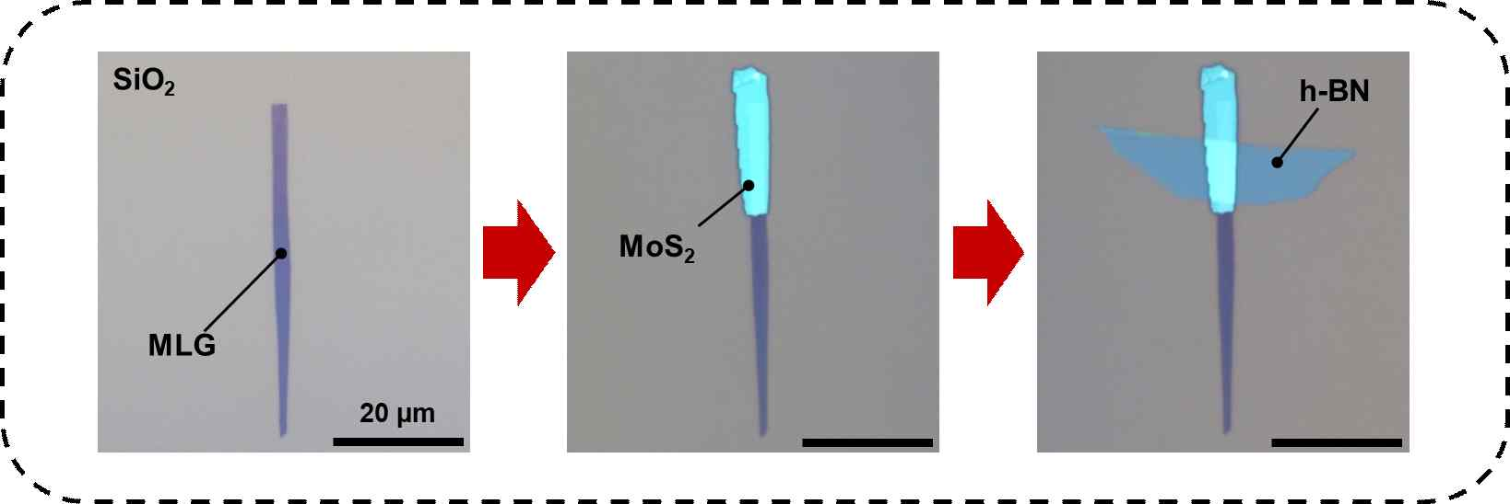

▲ Manufacturing process of hexagonal boron nitride/molybdenum disulfide/multilayer graphene Van der Waals heterostructure. It shows the process of sequentially stacking high-purity hexagonal boron nitride, molybdenum disulfide, and multilayer graphene flakes secured using Van der Waals forces. Each material was placed in a precise location without contamination through a stamp based on the same material, proving that the production of high-quality Van der Waals heterostructures is possible.

Professor Jae Hun Seol said, “This study is very meaningful in that it opens the way to freely manufacture customized device structures using various two-dimensional materials while maintaining the unique characteristics of two-dimensional materials,” and “It is expected to greatly contribute to the performance improvement of two-dimensional material-based electronic and optoelectronic devices in the future.”

This research, supervised by Professor Jae Hun Seol of the School of Mechanical and Robotics Engineering at GIST and conducted by Ph.D. student Minyoung Lee and integrated master’s and doctoral student Changho Kim, was supported by the Ministry of Science and ICT and the National Research Foundation of Korea’s Mid-career Researcher Support Program, Basic Research Lab (Advanced), Nanomaterial Technology Development Program, and GIST-MIT AI International Cooperation Program. The results of the research were published online in the international materials science journal 《Advanced Materials》 on April 2, 2025.



