GIST-KAERI-Institute of Science Tokyo implements world's first hydrogen anion conduction by complex ion energy revolution with anion hydrogen

- GIST Department of Chemistry Professor Sangryun Kim's Korea-Japan international joint research team confirms accelerated conduction of hydrogen anions by molecular complex ions... Suggests possibility of 1,000-fold improvement in conductivity and realization of next-generation hydrogen energy technology

- Establishment of new energy transfer principle different from existing lithium-ion batteries, establishment of new electricity for eco-friendly secondary batteries, fuel cells, and water electrolysis technologies... Published in the 《Journal of the American Chemical Society (JACS)》



▲ (From left) Professor Sangryun Kim and integrated master's and doctoral program students Taehyun Kim, Taeseung Kim, and Taegyoung Lee

A new technology that turns hydrogen into an anion and moves it quickly in a solid as if it were a liquid has been developed through international joint research between Korea and Japan.

This research is an energy transfer technology that is completely different from existing lithium-ion batteries or all-solid-state batteries, and has high academic and industrial value in that it greatly increases the possibility of realizing eco-friendly secondary batteries, fuel cells, and water electrolysis technologies that utilize hydrogen anions (H⁻).

The Gwangju Institute of Science and Technology (GIST, President Kichul Lim) has discovered through joint research with the Korea Atomic Energy Research Institute of Science Tokyo that the conduction speed of hydrogen anions in a solid can be dramatically increased by using molecular complex ions*.

* complex ion: A structure in which multiple molecules or ions are attached to a central atom, and is a polyatomic ion with a charge. In this study, BH₄⁻ (boron hydride anion) was used.

In general, it is difficult for ions to move freely in a solid state, but if certain ions can move quickly even within a solid, it can provide innovative electricity for energy storage and conversion technologies such as lithium-ion solid-state batteries.

For this reason, the discovery of a new conductive ion is considered a very important achievement not only in terms of academic significance but also in terms of future industrial application potential.

Hydrogen is attracting attention as an eco-friendly energy source, but it has limitations in that it is difficult to handle stably because it easily reacts with other substances.

Accordingly, the research team designed a new structure utilizing molecular complex ions to stabilize hydrogen in the form of anions (H⁻) and enable rapid movement within the solid.

The research team proposed an independent design principle that places complex ions BH₄⁻ and hydrogen anions together within the crystal of the perovskite structure* to stabilize hydrogen anions and increase their movement speed.

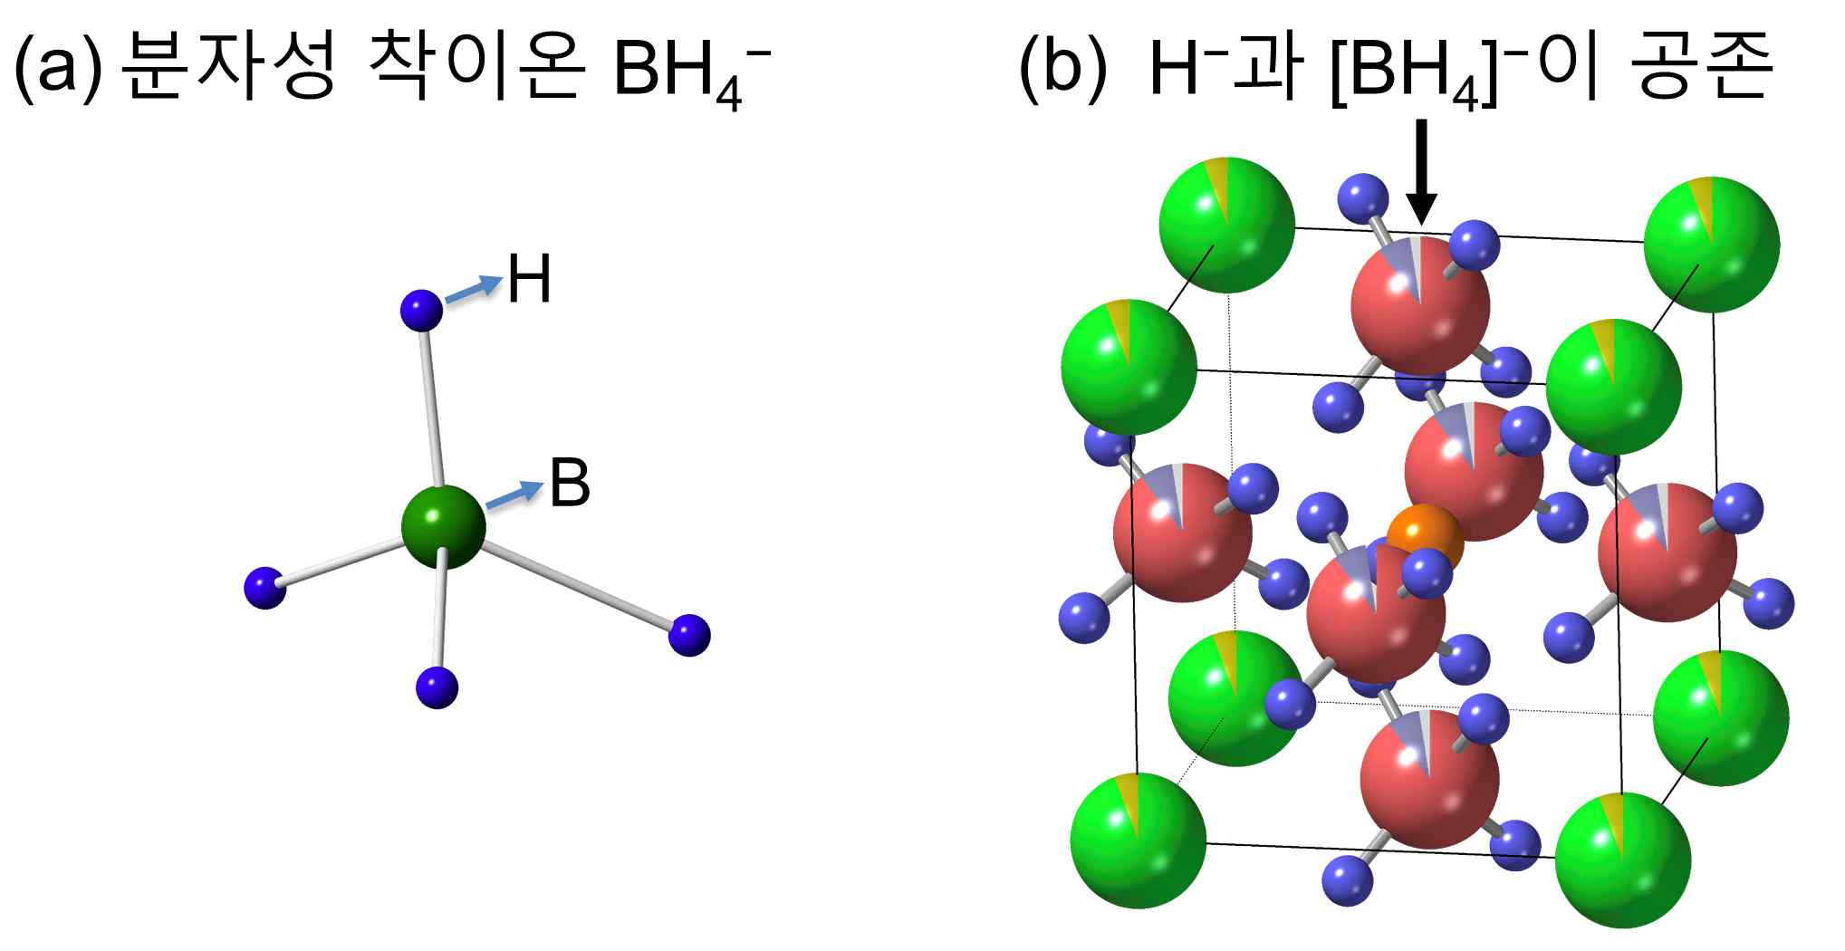

▲ Hydrogen anion-conducting perovskite structure containing molecular complex ions. (a) Structure of molecular complex ion BH₄⁻ used in this study. (b) Schematic diagram of perovskite structure in which hydrogen anions H⁻ and molecular complex ions BH₄⁻ coexist. In the ABC₃ structure of perovskite, H⁻ and BH₄⁻ exist in a disordered state at the C site.

As a result of analyzing their interactions at the atomic level, it was confirmed that not only is the hydrogen anion stabilized by the high reduction (electron-donating property) of the complex ion, but also in the region where the electrostatic interaction* of the complex ion is weak, a low energy barrier* is formed, allowing the hydrogen anion to move more easily.

* perovskite structure: Crystal structure expressed as ABX₃, like the mineral CaTiO₃

* electrostatic interaction: Attractive or repulsive force that occurs between charged particles (ions, molecules, etc.)

* energy barrier: Energy that must be overcome when the ion moves

The research team first discovered that the complex ion BH₄⁻ (borohydride ion), which has the property of donating electrons well (high reduction), can stabilize hydrogen in the anion state.

Based on these results, we successfully synthesized a new material (Sr_{0.925}Na_{0.075}LiH_{2.625}(BH₄)_{0.3}) in which BH₄⁻ and hydrogen anions coexist as a single phase (uniform crystal structure).

In order to more precisely analyze the single-phase structure and ion mobility characteristics in which complex ions and hydrogen anions coexist, the research team synthesized a compound (Sr_{0.925}Na_{0.075}LiD_{2.625}(¹¹BD₄)_{0.3}) with deuterium (D)* instead of hydrogen and conducted neutron diffraction experiments*.

As a result, it was revealed that complex ions and hydrogen anions are randomly mixed within the perovskite lattice*, and it was confirmed that the single-phase structure is more stably maintained thanks to this random arrangement (high entropy*).

* deuterium (D): A type of hydrogen that has one proton and one neutron. It is heavier than ordinary hydrogen, and has the same atomic number but about twice the mass. It is advantageous for precise atomic-level analysis because it gives a stronger signal in neutron diffraction experiments.

* neutron diffraction experiment: This experiment analyzes the pattern of neutrons reflected by atoms by shooting neutrons at a substance. Neutrons are not electrically charged, so they are suitable for precisely determining atomic structures or the arrangement of atomic nuclei.

* lattice: A three-dimensional structure in which atoms are arranged in a regular, repeating pattern, and can be seen as the basic framework (skeleton) of a substance.

* entropy: A concept indicating the degree of disorder, and the more complex or mixed the structure is, the higher the entropy is expressed.

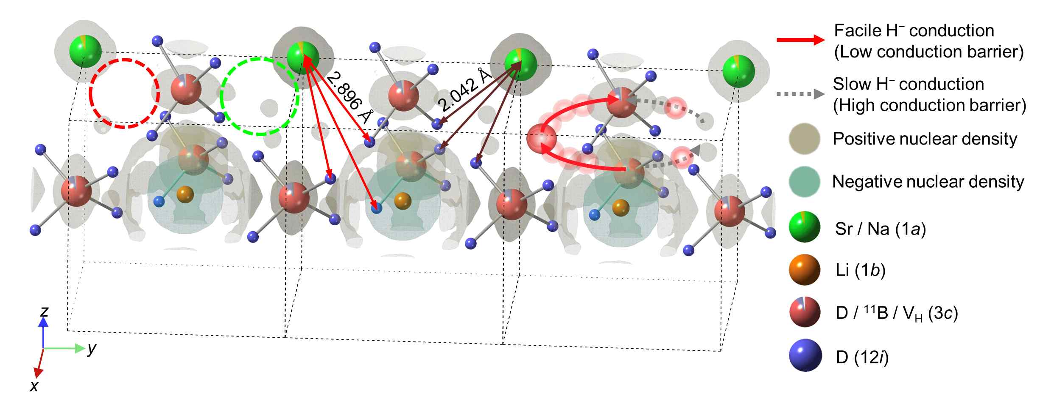

▲ Neutron diffraction experiment results. The three cubes indicated by the dotted lines each represent a lattice of the perovskite structure. Left lattice: Compared to the red circle, the interior of the green circle shows a high nuclear density around BD₄⁻, i.e., strong electrical interaction. Middle lattice: The area showing strong electrostatic interaction (brown line) is short in distance between BD4- and the surrounding ions, forming a high energy barrier. Right grid: Hydrogen anions are interpreted as being conducted along the weak electrostatic interaction of BD₄⁻.

In addition, the research team revealed through MEM (Maximum Entropy Method)* analysis that the complex ions are fixed in place by asymmetrically interacting with the surrounding ions.

What is particularly noteworthy is that the hydrogen anions move much faster along the path where the electrostatic interaction created by these asymmetric complex ions is weak.

In fact, compared to the existing structure without complex ions, it was confirmed that the ionic conductivity of hydrogen anions increased by more than 1,000 times.

* MEM (Maximum Entropy Method): This is a method that reproduces the distribution of atoms or molecules based on neutron diffraction data. It has the characteristic of estimating the structure based on the most disordered state.

* ionic conductivity: It indicates how well charged particles (ions) move. The higher the number, the better the ions move.

Professor Sangryun Kim said, “This study is the world’s first case of implementing hydrogen anion conduction by complex ions, and it will be able to provide an important turning point in the development of new hydrogen-based eco-friendly energy technology in the future.”

This study, supervised by Professor Sangryun Kim of the Department of Chemistry at GIST and co-authored by researchers Taehyun Kim, Taeseung Kim, and Taegyoung Lee from the combined master’s and doctoral programs, was supported by the National Research Foundation of Korea’s Individual Basic Research Project. The research results were published online on April 17, 2025, in the Journal of the 《Journal of the American Chemical Society》, a prestigious international academic journal in the field of chemistry.



