"Reading even the arrangement of red blood cells in flowing blood" Professor Sung Yang's research team develops real-time analysis technology for blood test indicators

- Professor Sung Yang's team from the School of Mechanical and Robotics Engineering, precise analysis of red blood cell arrangement and hemoglobin hydration structure in blood flow through electrochemical impedance spectroscopy (EIS)-microfluidic fusion... Development of EIS-based blood test technology

- High accuracy with an error of less than 3.5% compared to clinical blood tests, expected to be applied to smart healthcare and real-time diagnostic devices... Cover paper published in the international academic journal 《Analytical Chemistry》

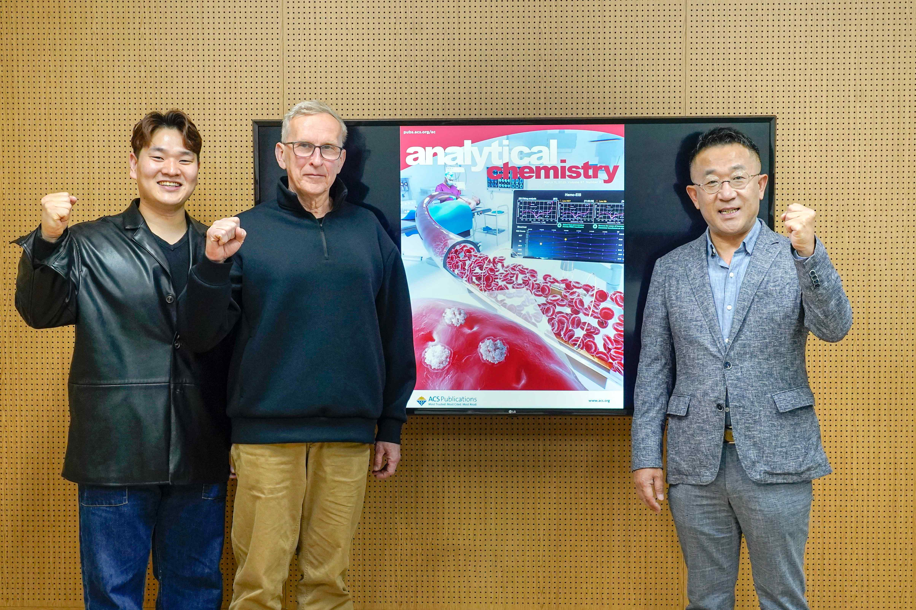

▲ (From left) , a student in the combined master's and doctoral program in the School of Mechanical and Robotics Engineering, Research Professor Alexander Zhbanov, and Professor Sung Yang

Blood is one of the most important indicators that directly show the state of human health. A Korean research team has developed a technology that can measure and analyze the dielectric properties of blood components in real time and electrically precisely derive blood test indicators.

The Gwangju Institute of Science and Technology (GIST, President Kichul Lim) announced that Professor Sung Yang's research team in the School of Mechanical and Robotics Engineering has developed a new sensor technology that can analyze the arrangement of red blood cells in blood flow and the hemoglobin hydration structure* inside red blood cells.

* hemoglobin hydration shell: A thin layer of water formed by water molecules bonding around hemoglobin molecules, which plays an important role in the function and stability of hemoglobin. This structure changes depending on the state of oxygen binding.

This technology combines electrochemical impedance spectroscopy (EIS)* and microfluidic* technology, and is characterized by its ability to precisely measure the arrangement directionality of red blood cells and the intracellular water structure in actual blood flowing conditions.

* electrochemical impedance spectroscopy (EIS): A technology that measures the electrical response of a material to electrical signals of various frequencies to analyze dielectric properties, ion movement, and changes in molecular structure. It is noninvasive and highly sensitive, making it suitable for analyzing complex biological samples such as living tissue or blood.

* microfluidic: A technology that precisely controls and analyzes liquids through microchannels the size of a hair.

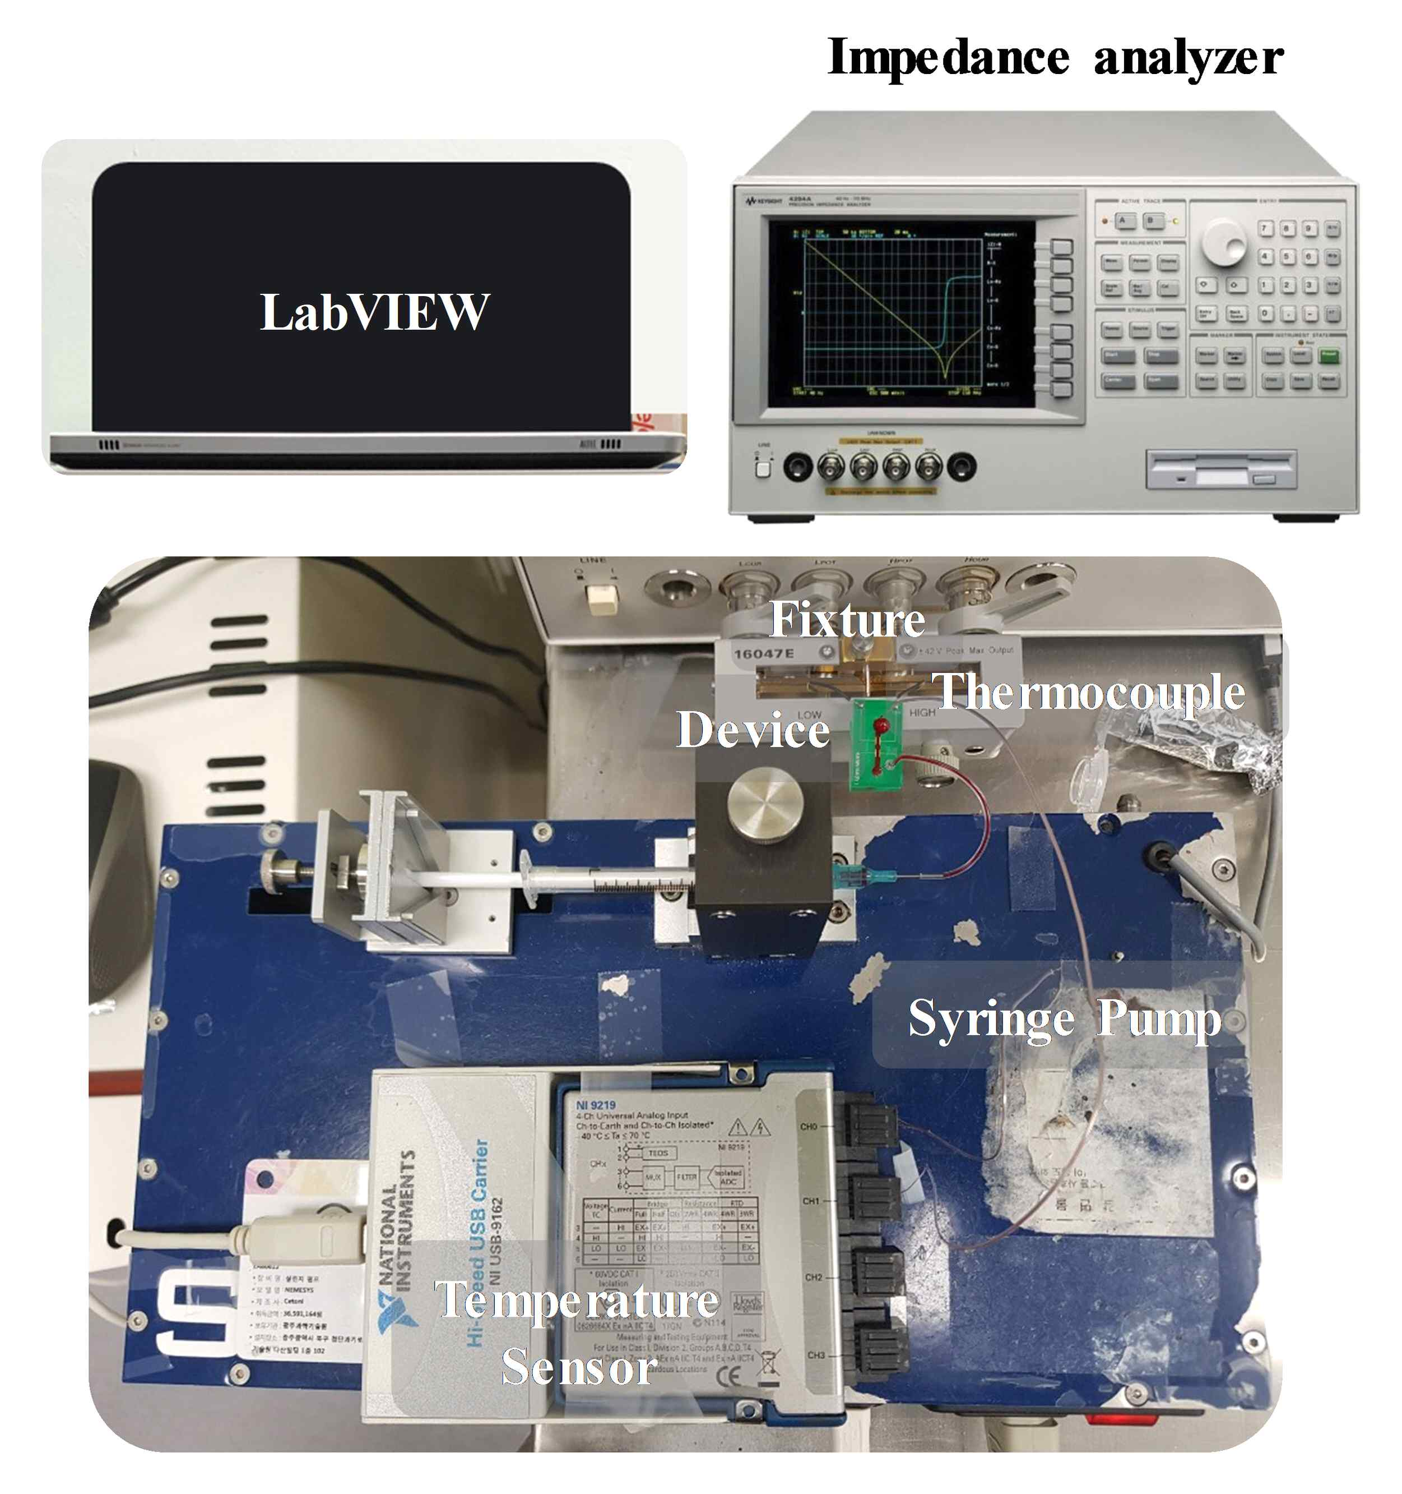

▲ Photo of the experimental set-up used to measure blood impedance

Rapid and precise blood diagnostic technology is considered a key field in the development of medical technology. Among these, EIS has been drawing attention as a technology suitable for blood component analysis because it is noninvasive and highly sensitive.

However, most of the previous studies used stationary blood as the analysis target, which resulted in red blood cell aggregation or sedimentation, which resulted in limited measurement accuracy.

In addition, the existing theoretical model did not consider the arrangement of red blood cells or the hydration structure of hemoglobin, which also limited the interpretation of impedance spectrum. It is necessary to develop technology to improve this for more precise analysis.

* red blood cell aggregation: Red blood cell aggregation is a phenomenon in which red blood cells (RBCs) combine with each other to form a ‘rouleaux’ structure. This appears as if coins are stacked on top of each other, and is well-known when blood is stationary or in a low-shear environment.

* red blood cell sedimentation: Red blood cell sedimentation is a phenomenon in which red blood cells sink due to gravity when the blood is stationary. It is generally measured through the erythrocyte sedimentation rate (ESR) and is used as an indirect indicator of systemic inflammation.

To solve this problem, the research team measured blood impedance in a microfluidic channel that simulated an actual blood flow environment and analyzed it by combining it with the effective medium theory* that reflects anisotropic dielectric properties*.

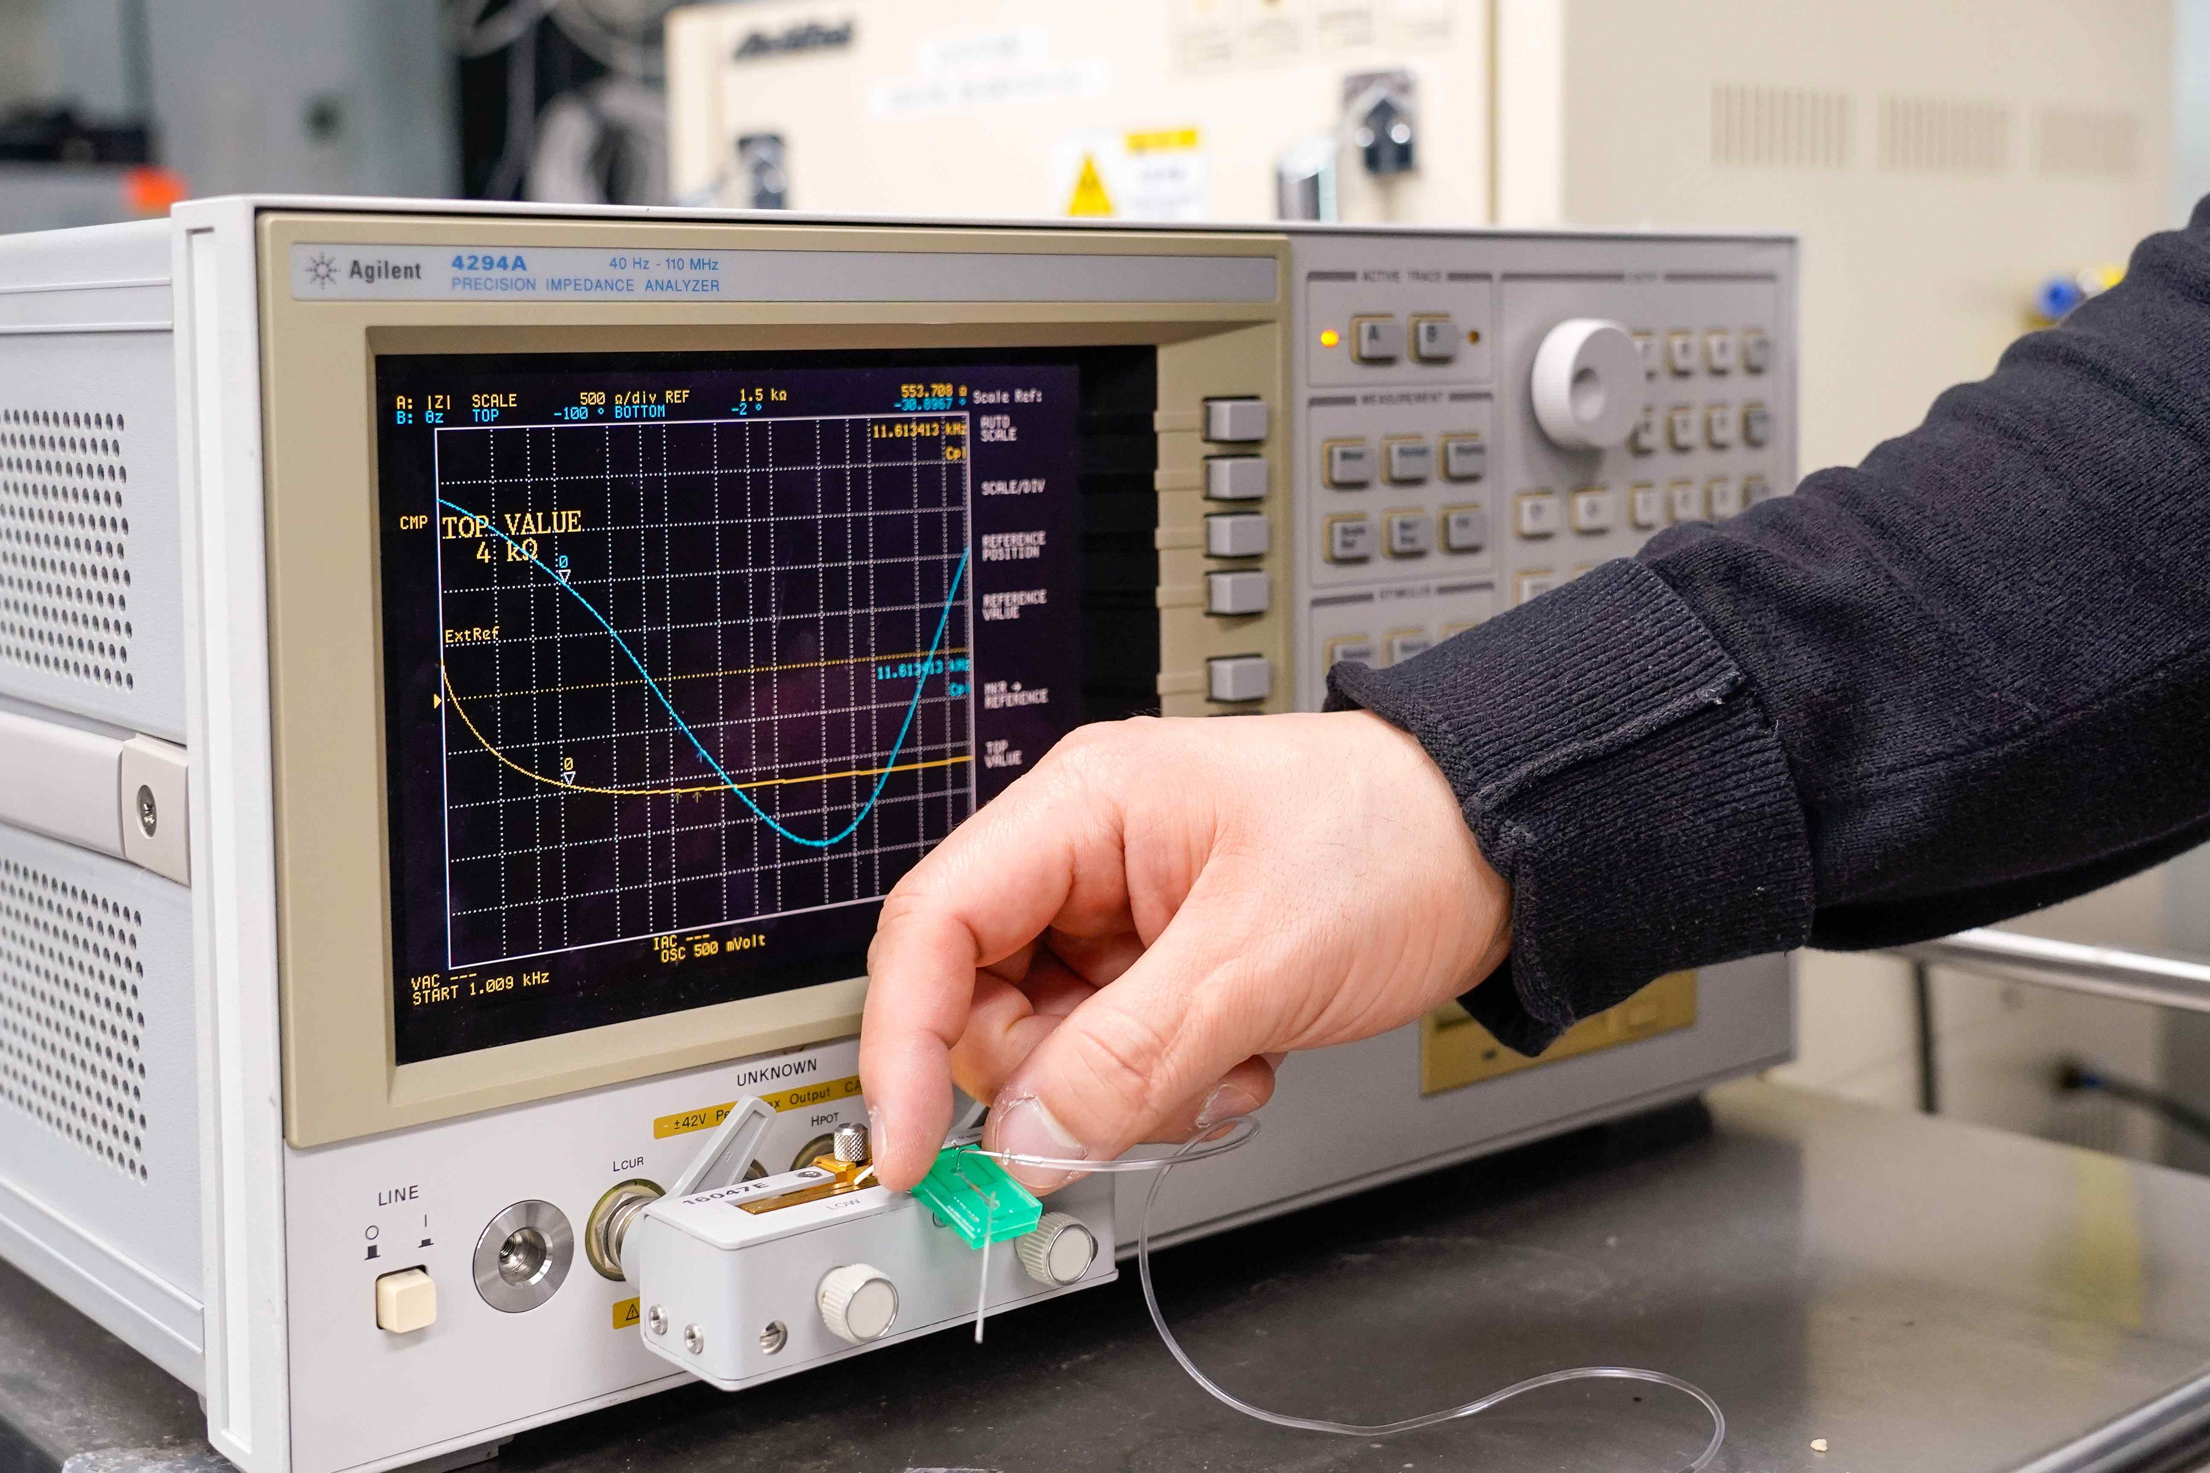

▲ Photo of measuring impedance by attaching a blood test indicator extraction device to an electrical impedance measurement device

In particular, the analysis results using the concept of ‘preferred arrangement index’* that can quantify the red blood cell arrangement state showed that approximately 34% of all red blood cells were aligned in the direction of flow, while the remaining 66% were randomly arranged.

* anisotropic dielectric properties: This refers to the phenomenon in which a material exhibits different dielectric properties depending on the direction in which an electric field is applied. In other words, when the electrical properties in a specific direction are different from those in other directions, it is called ‘anisotropy.’

* effective medium theory: This is a theory that predicts the macroscopic physical properties of a composite material based on its microscopic structure. This theory models the average behavior of the entire material by considering the properties and ratios of the components of the material.

* preferred orientation factor: An index indicating the degree to which a specific crystal orientation is more dominantly arranged than other directions in a crystalline material. This can affect the physical properties of the material.

The research team also explained that by modeling the interior of red blood cells not as a simple solution but as a hemoglobin colloid* with a double hydration shell*, more precise EIS analysis that considers the physical properties inside the cell is possible.

* double hydration shell: This refers to the phenomenon in which two distinct hydration shells are formed around one ion or molecule. Normally, one hydration shell is formed around an ion or polar molecule dissolved in water, but in the case of a double hydration shell, the two water molecule layers are arranged in different ways.

* colloid: This refers to a mixture in which fine particles of one substance are uniformly dispersed within another substance. These particles are too small to settle under gravity, and have properties intermediate between those of a solution and a suspension.

Through theory-based analysis, the research team derived six major hematological indices related to red blood cells in real blood. The derived indices are ▴ Red Blood Cell Count (RBC), ▴ Hemoglobin Concentration (Hb), ▴ Hematocrit (HCT), ▴ Mean Corpuscular Volume (MCV), ▴ Mean Corpuscular Hemoglobin (MCH), and ▴ Mean Corpuscular Hemoglobin Concentration (MCHC), which play an important role in accurately understanding the status and function of red blood cells in the blood.

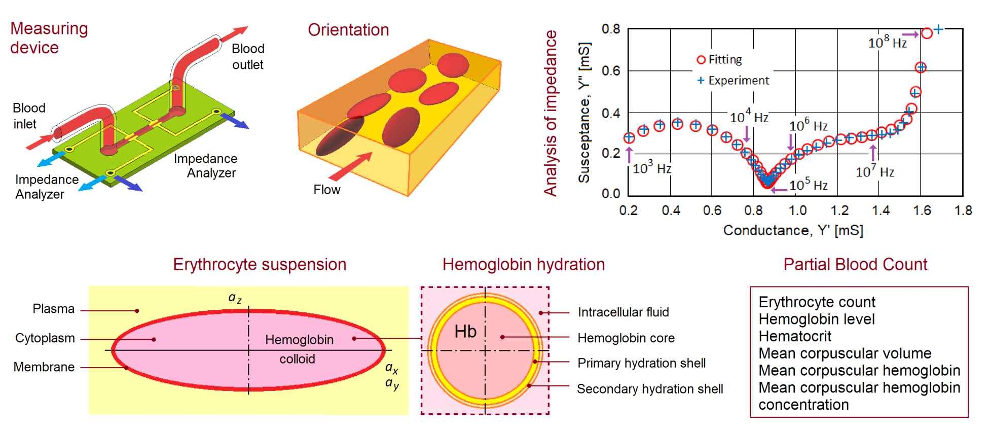

▲ Graphical Abstract. EIS measurement element, red blood cell arrangement theory model, impedance spectrum fitting analysis, red blood cell modeling using hemoglobin colloid with double hydration shell, and by synthesizing them, six hematological parameters can be derived.

In particular, when these parameters were compared with actual clinical blood test results, the error between the calculated values ​​and the actual values ​​was less than 3.5%, proving high accuracy and reliability.

* hematological parameters: Measurement values ​​related to blood components, including red blood cell count, hemoglobin concentration, and hematocrit. These parameters play an important role in evaluating the condition and function of blood, and are widely used in clinical practice to diagnose health conditions and monitor treatment processes.

Professor Sung Yang said, “This study is significant in that it does not simply measure the impedance of flowing blood, but also presents an analysis technique that can quantitatively interpret red blood cell arrangement characteristics and hemoglobin hydration structure,” and added, “This technology is expected to be widely applied to various medical fields such as smart healthcare devices and real-time blood testers for hospitals in the future.”

This study, supervised by Professor Sung Yang of the School of Mechanical and Robotics Engineering at GIST and co-authored by Research Professor Alexander Zhbanov and Ye Sung Lee, a combined master’s and doctoral student, was supported by the Ministry of Science and ICT and the National Research Foundation of Korea’s Mid-career Researcher Support Program. The results of the study were published as a front cover paper in the prestigious international academic journal in the field of chemistry, 《Analytical Chemistry》, on January 25, 2025.

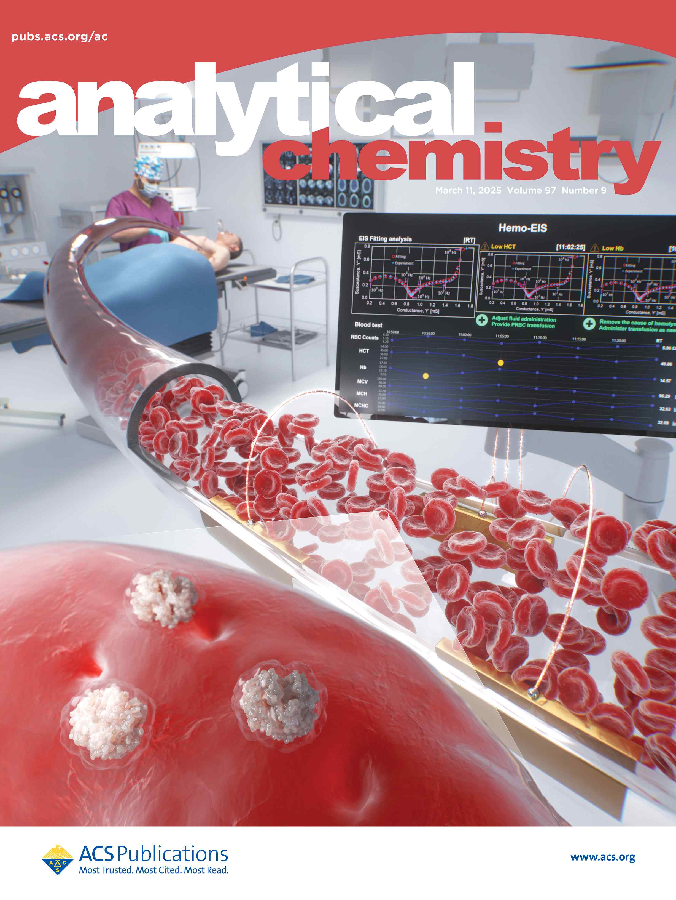
▲ Publication of cover paper in 《Analytical Chemistry》



