GIST succeeds in synthesizing 'Au@h-BN', a next-generation nanostructure that is stable even in a strong alkaline environment... "Expectations for innovation in energy and catalyst technology"

- Professor Hyunseob Lim's team in the Department of Chemistry, applied a 1-nanometer thick hexagonal boron nitride (h-BN) shell to overcome the limitations of existing silica-based core-shell structures... Real-time Raman spectroscopy possible while maintaining stability for over 120 hours

- Establishing a core foundation for future energy technology research... Published in the international academic journal 《Advanced Functional Materials》

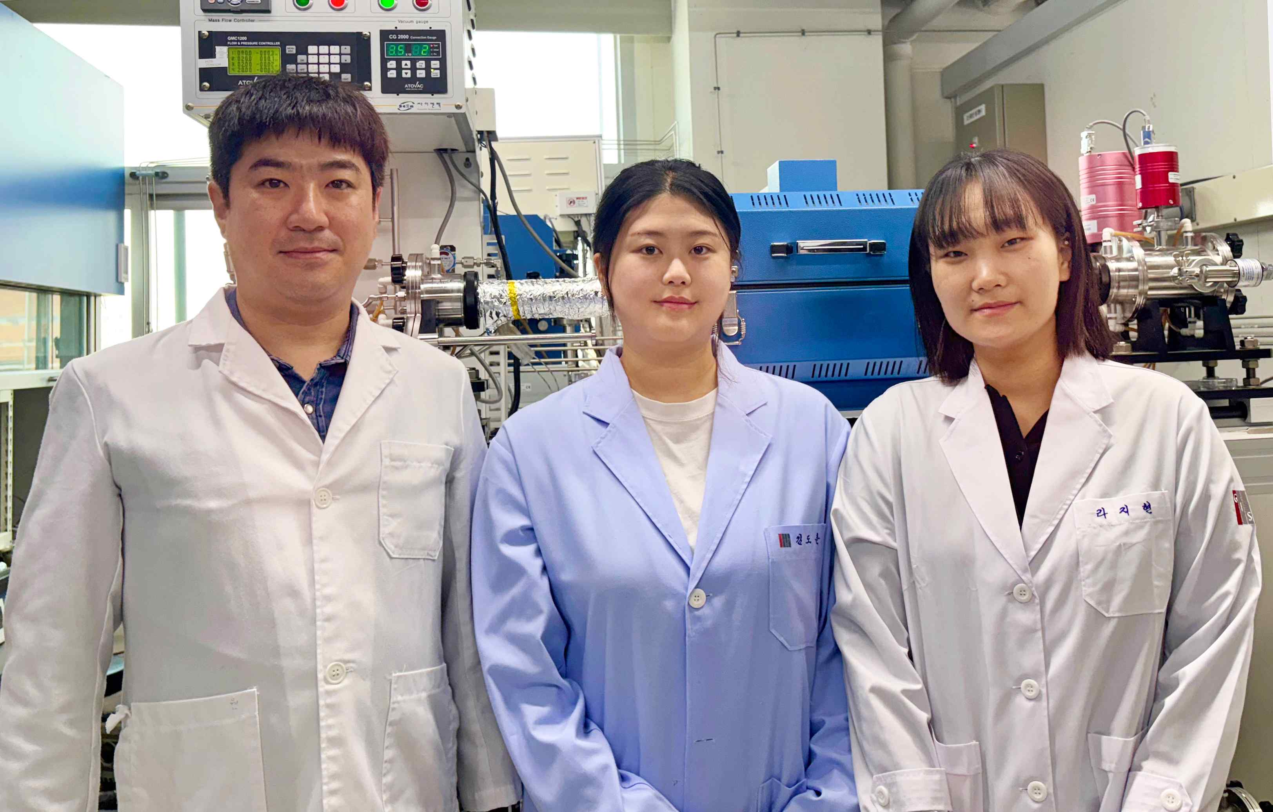

▲ (From left) Professor Hyunseob Lim, PhD student Jee Hyeon Kim, and master's student Jihyun Ra from the Department of Chemistry

The Gwangju Institute of Science and Technology (GIST, President Kichul Lim) announced that Professor Hyunseob Lim's research team in the Department of Chemistry succeeded in synthesizing a new nanostructure, 'Au@h-BN'.

This structure is characterized by applying a uniform hexagonal boron nitride (h-BN)* layer with a thickness of 1 nm (nanometer, one billionth of a meter) as a shell (outer protective layer), and can implement real-time Raman spectroscopy* that operates stably even in a strong alkaline environment.

* h-boron nitride (h-BN): A two-dimensional material with a structure similar to graphene, it is used in various electronic and catalytic applications due to its high chemical stability and electrical insulation.

* Raman spectroscopy: A technique to identify the chemical composition and structure of a material by analyzing the vibrational energy generated when light interacts with the material. Although there have been attempts to utilize h-boron nitride as a shell material*, a synthetic method that can actually implement this has not been developed.

This research result is expected to provide a new breakthrough in the development of electrochemical catalysts and energy conversion technology.

* shell material: A layer that surrounds the core in a nanostructure, and plays a role in protection, providing functionality, and improving stability. It exists in the form of coating the surface of nanoparticles, and can control various physical and chemical properties.

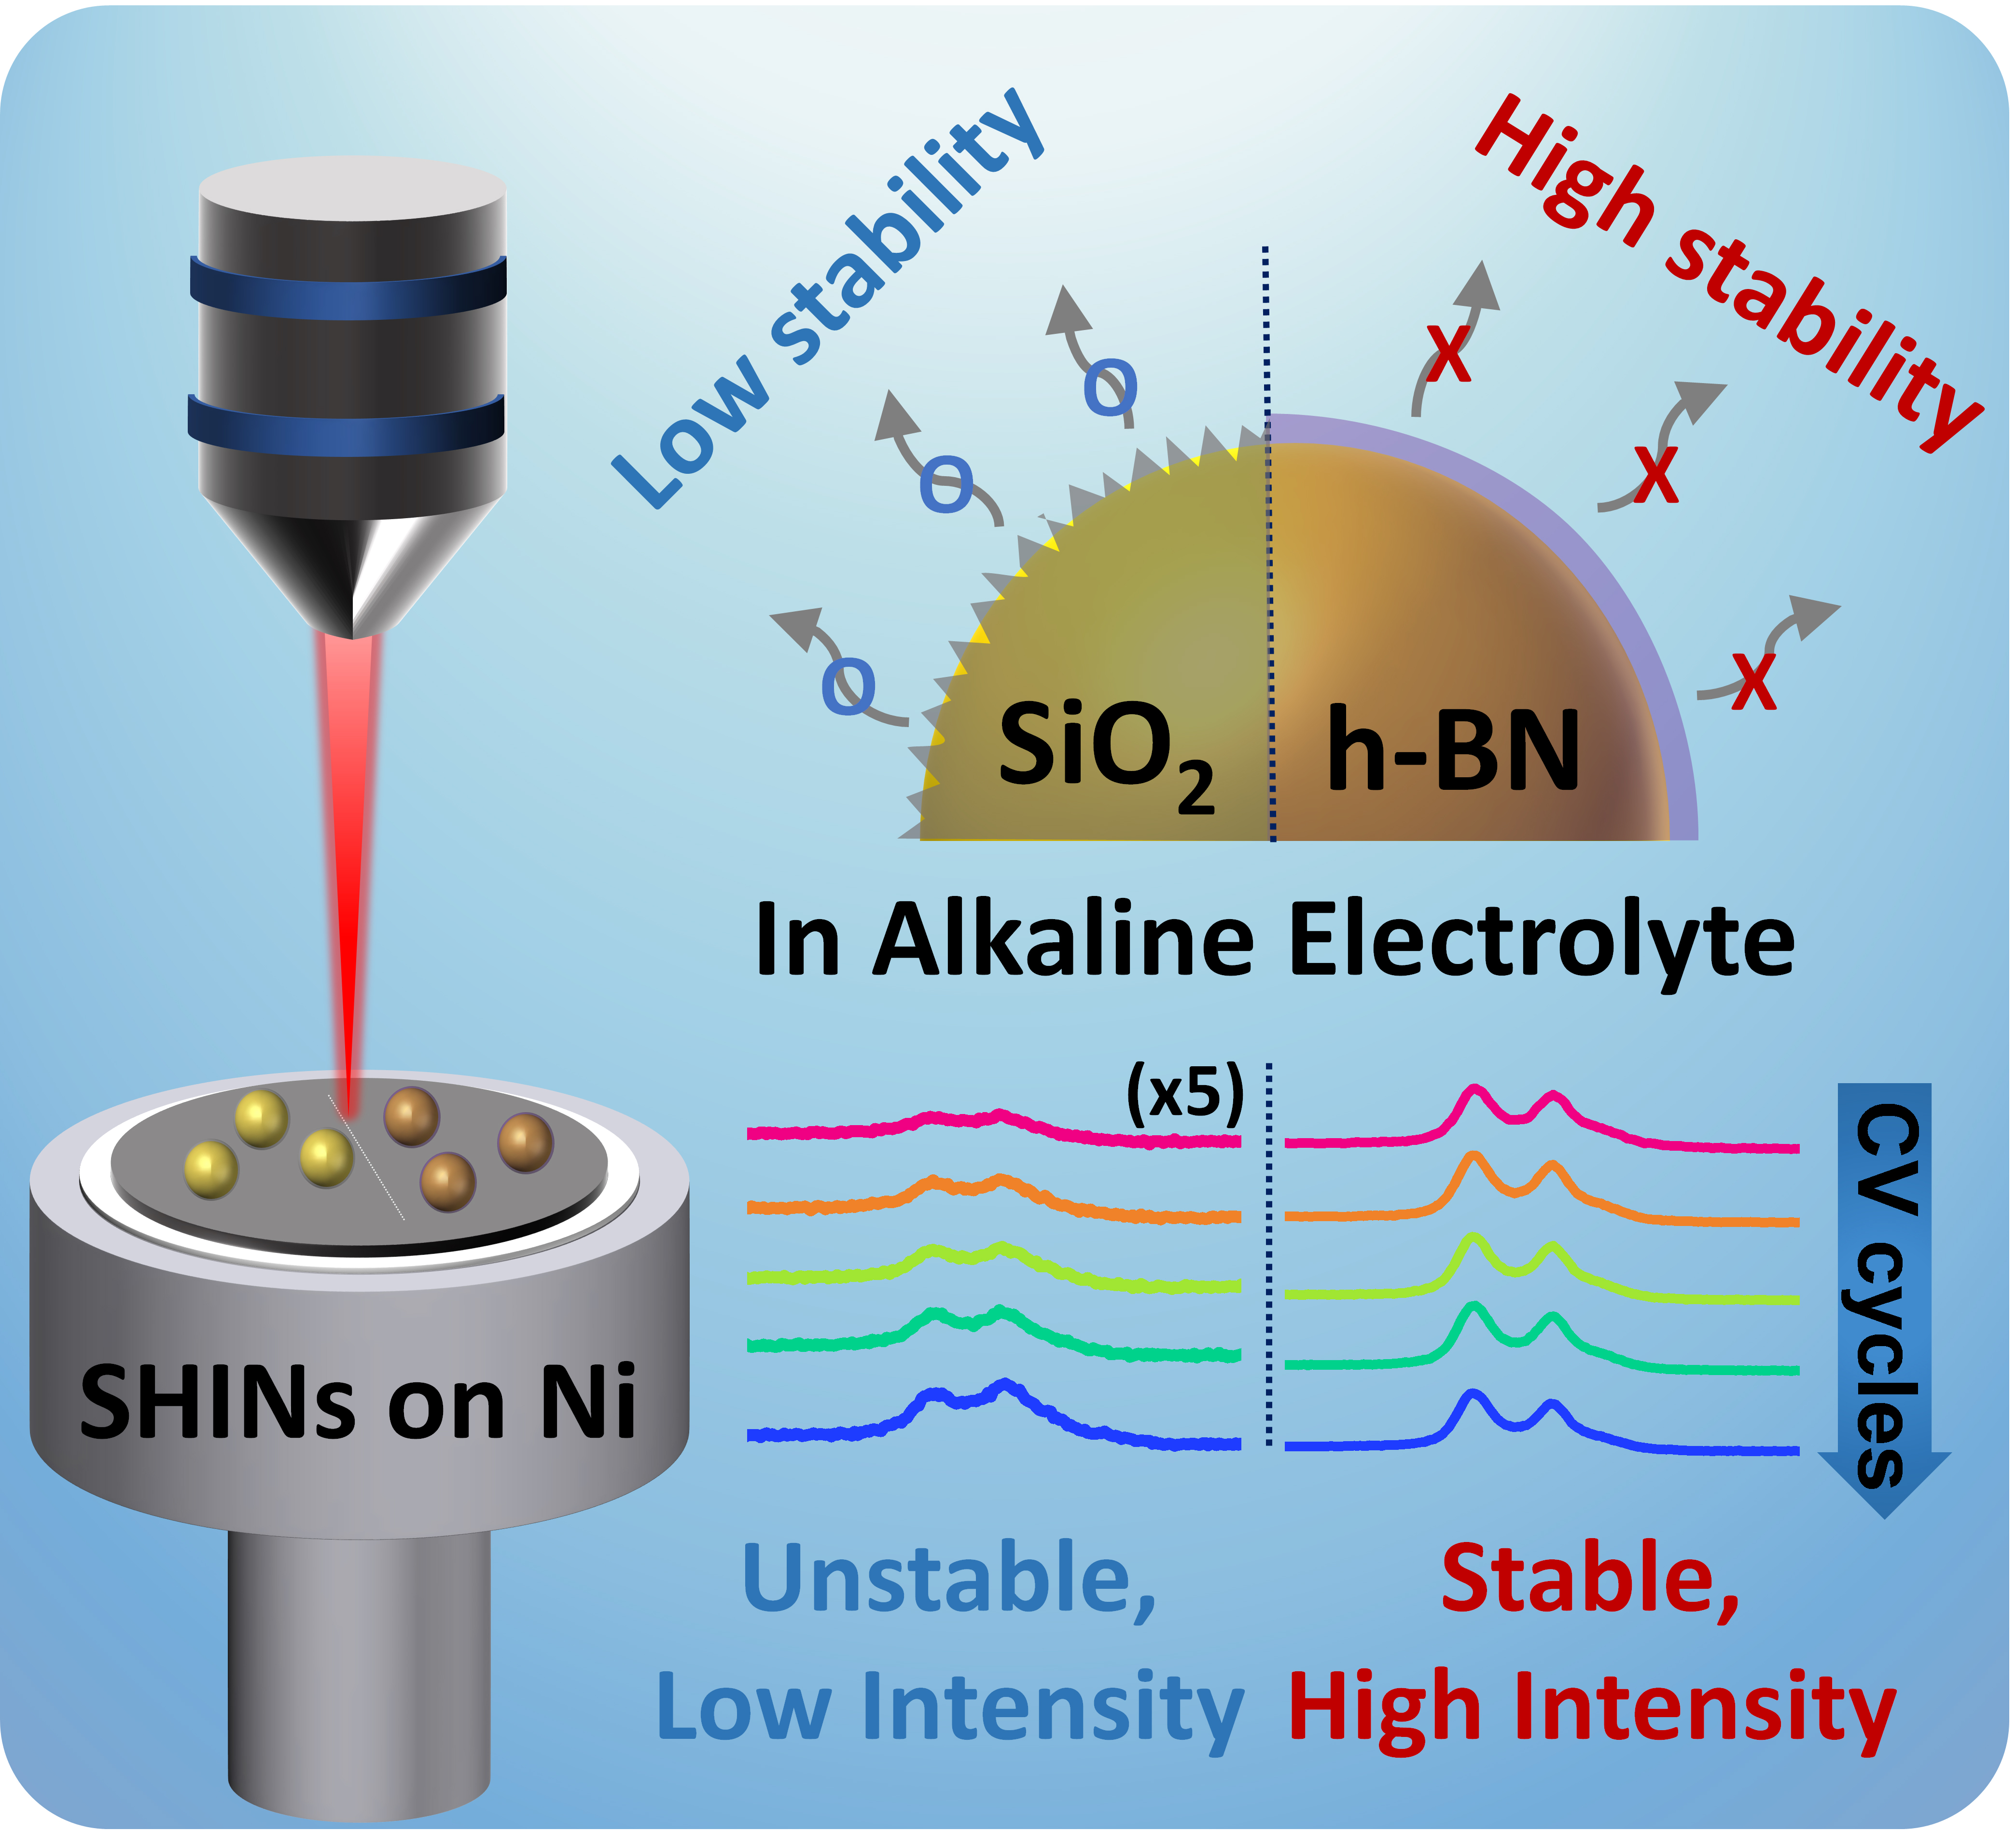

▲ Excellent stability and improved Raman signal intensity even in alkaline electrolytes: h-boron nitride (h-BN)-based core-shell nanoparticles overcome the limitations of existing silica (SiO₂)-based core-shell nanoparticles, and enable long-term real-time Raman analysis even in strong alkaline environments.

Existing silica-based core-shell nanostructures had the disadvantage of being easily deformed or damaged in strong alkaline environments. Therefore, the research team developed a technology to coat gold (Au) nanoparticles with h-boron nitride shells for the first time in the world to overcome these limitations.

This new nanostructure not only generates a strong Raman signal*, but also maintains high stability even when used for a long period of time.

In addition, real-time analysis of oxidation reactions at nickel (Ni) and copper (Cu) electrodes showed that the intensity and sustainability of the Raman signal were significantly superior to those of structures using existing silica shells. This is expected to enable more precise research and analysis in the fields of electrochemical catalysts and energy conversion.

* Raman signal: A light signal detected in Raman spectroscopy, which is used to analyze the molecular structure and chemical composition of a material. This is derived from the inelastic scattering phenomenon that occurs when light interacts with a material, and the frequency of the light changes during this process.

Electrochemical reactions are a key process in various eco-friendly and sustainable energy technologies such as batteries, fuel cells, hydrogen production, and carbon dioxide conversion. However, analyzing the electrode surface where these reactions occur in real time remains a major technical challenge.

In particular, since electrochemical changes occurring at the interface between the electrode and the electrolyte occur at the nanometer (nm) level, highly sensitive spectroscopic techniques are essential to accurately observe them.

Raman spectroscopy is widely used as a useful tool for analyzing electrochemical reaction mechanisms. However, there were limitations in obtaining reliable data due to the weak Raman scattering* signal.

To solve this problem, a technology was developed to amplify the Raman signal using localized surface plasmon nanoparticles. However, existing nanoparticles such as gold (Au) or silver (Ag) can be involved in catalytic reactions, which may affect the experimental results.

To prevent this, a technology has been introduced to coat the surface of nanoparticles with a nonconductive material to wrap the internal metal like a kind of ‘packaging’ so that it does not come into contact with the outside. However, ceramic coating materials such as silica or alumina used so far are easily deformed or damaged in strong alkaline environments, and are not suitable for long-term electrochemical reactions.

* Raman scattering: This is an inelastic scattering phenomenon that occurs when light interacts with a material. Generally, when light passes through or is reflected from a material, most photons undergo Rayleigh scattering, which is scattered as is without losing energy, but a very small number of photons interact with the molecular vibration mode of the material and exchange energy, causing Raman scattering. This changes the frequency of the scattered light, and analyzing this can identify the molecular properties of the material.

The research team successfully expanded the scope of application of Raman spectroscopy technology in electrochemical reaction research by utilizing h-boron nitride, a two-dimensional material that is chemically very stable and has electrical insulation properties, as a new shell material.

h-boron nitride, also known as ‘white graphene’, has a structure similar to graphene but is a non-conductive insulator. In particular, it is much more stable than existing ceramic materials such as silica even in strong alkaline environments, so it is evaluated as a more effective material for long-term electrochemical reaction monitoring.

While nanoparticles with existing ceramic shells are damaged within tens of hours in strong alkaline solutions, h-boron nitride shells were confirmed to maintain stability without structural deformation even in strong alkaline environments for more than 120 hours.

Through this, it was proven that it can be very effectively utilized in electrochemical reaction research that requires long-term real-time Raman analysis.

Based on this technology, the research team expects that major electrochemical reactions such as oxygen evolution reaction (OER) and carbon dioxide reduction reaction (CO₂RR) can be analyzed more precisely.

Professor Hyunseob Lim said, “This study is expected to present a new paradigm in electrochemical reaction research by overcoming the limitation that existing Raman technology was difficult to apply for a long time in a strongly alkaline environment.”

He added, “This technology will become a key foundation that can contribute to the development of the hydrogen economy and next-generation energy storage technology, and can be widely utilized in various fields such as water electrolysis systems, fuel cells, metal-air batteries, and carbon dioxide conversion catalysts.”

This study was conducted with the support of the National Research Foundation of Korea (NRF) and the Korea Electric Power Corporation (KEPCO) research and development program, and was published online on April 8, 2025, in the authoritative international academic journal in the field of materials science, 《Advanced Functional Materials.



