"Golden Ratio of Water and Organic Electrolyte" GIST develops next-generation electrolyte

- Professor Seung Joon Yoo's research team from the School of Materials Science and Engineering develops next-generation redox electrolyte with high voltage, non-flammability, and high efficiency

- Supercapacitor energy density and stability improvement... 10,000 charge/discharge cycles, high storage efficiency maintained even at high temperature charge/discharge

- Raising expectations for commercialization... Published in international academic journal 《Advanced Functional Materials》

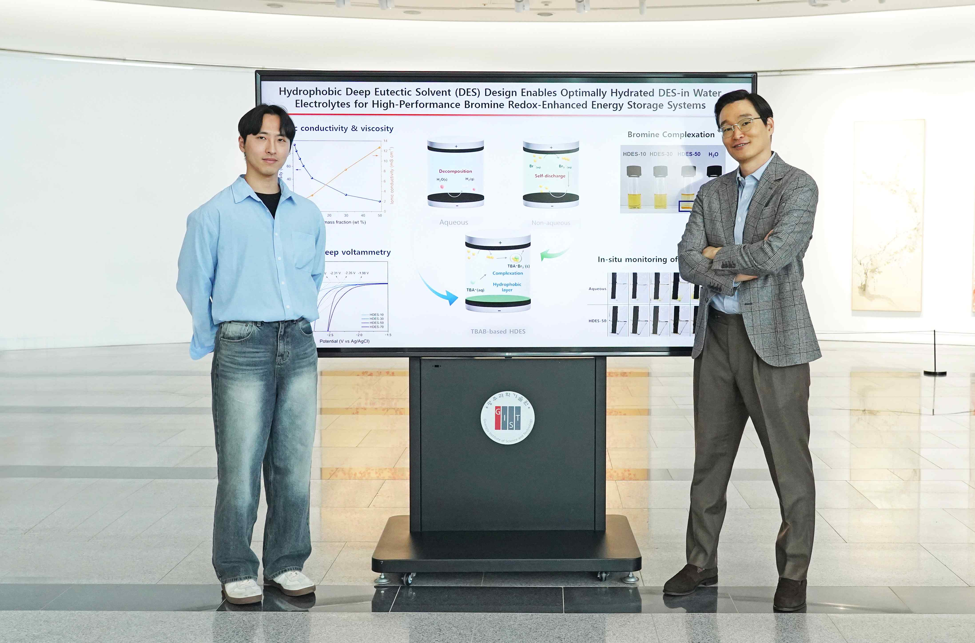

▲ (From left) GIST School of Materials Science and Engineering Ph.D. student Tae Pyeong Eom and Professor Seung Joon Yoo

The Gwangju Institute of Science and Technology (GIST, President Kichul Lim) announced that Professor Seung Joon Yoo's research team in the School of Materials Science and Engineering has developed a new electrolyte that can dramatically improve the performance of bromine-based redox supercapacitors (Redox ECs), which are attracting attention as next-generation energy storage devices.

This research result is expected to solve the problem of low efficiency caused by the problem of natural discharge after charging (self-discharge) and greatly improve the stability of existing aqueous electrolytes.

Supercapacitors are attracting attention as future energy storage devices with fast charging speeds and long lifespans. However, low energy density and self-discharge problems have been obstacles to commercialization.

The redox supercapacitor developed to overcome these limitations is designed to store additional charges by utilizing the redox reaction (oxidation-reduction reaction) that occurs in the electrolyte, and is evaluated as an innovative technology that simultaneously provides high energy density and fast reaction speed.

In particular, the bromine-based redox system* has been noted as a promising technology due to its ability to easily accept electrons (high reduction potential) and the property of bromine dissolving well in electrolytes (excellent solubility). However, it has the disadvantage of causing self-discharge and reducing charge/discharge efficiency (Coulombic efficiency*) due to the problem of polybromide generated during the charging process moving in an unexpected direction inside the battery (cross-diffusion problem). In addition, existing electrolytes have been chemically unstable and flammable, making them difficult to commercialize.

* bromine-based redox system: This is an energy storage technology that utilizes the oxidation/reduction reaction between bromine (Br2) and bromine ions (Br−).

* coulombic efficiency (CE): This is an indicator that shows the ratio of the amount of charge that can actually be discharged compared to the amount of charge that the battery has been charged with, and shows how efficiently the battery performs charging and discharging.

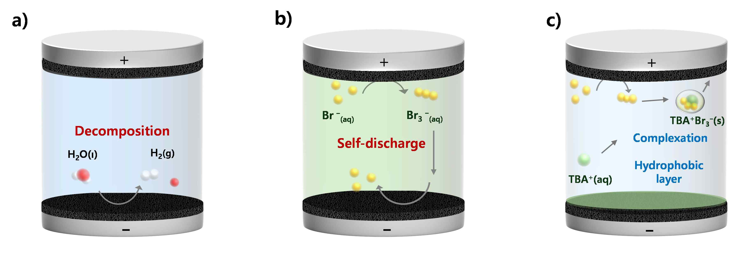

▲ Schematic diagram of a) problems of aqueous electrolyte, b) problems of non-aqueous electrolyte, and c) TBAB-based HDES electrolyte system in bromine batteries: There are difficulties in resolving the problems of water decomposition and electrochemical instability of aqueous electrolytes and cross-diffusion of polybromide in non-aqueous electrolytes. The problems of both the cathode and anode are solved simultaneously through the formation of a hydrophobic layer at the cathode of TBAB and bromine complexation at the anode.

To solve these problems, the research team developed a ‘deep eutectic solvent (HDES)’ electrolyte* containing water by combining tetrabutylammonium bromide (TBAB) and ethylene glycol (EG).

By utilizing the hydrophobicity (property that does not mix well with water) of TBAB, the electrochemical performance of the bromine-based redox system was improved and self-discharge was suppressed* successfully.

* hydrophobic deep eutectic solvent (HDES): A solvent that melts at a lower temperature than the original when two or more specific substances are mixed. In particular, it has the characteristic of not mixing well with water (hydrophobic).

* tetrabutylammonium (TBA+) ions form a hydrophobic layer on the electrode surface at the negative electrode to block direct contact with water, and form a complex with polybromide at the positive electrode to suppress cross-diffusion, thereby reducing self-discharge.

In addition, the research team succeeded in developing a ‘high water content (DES-in-Water)’ electrolyte, which had been difficult to implement in previous studies due to instability.

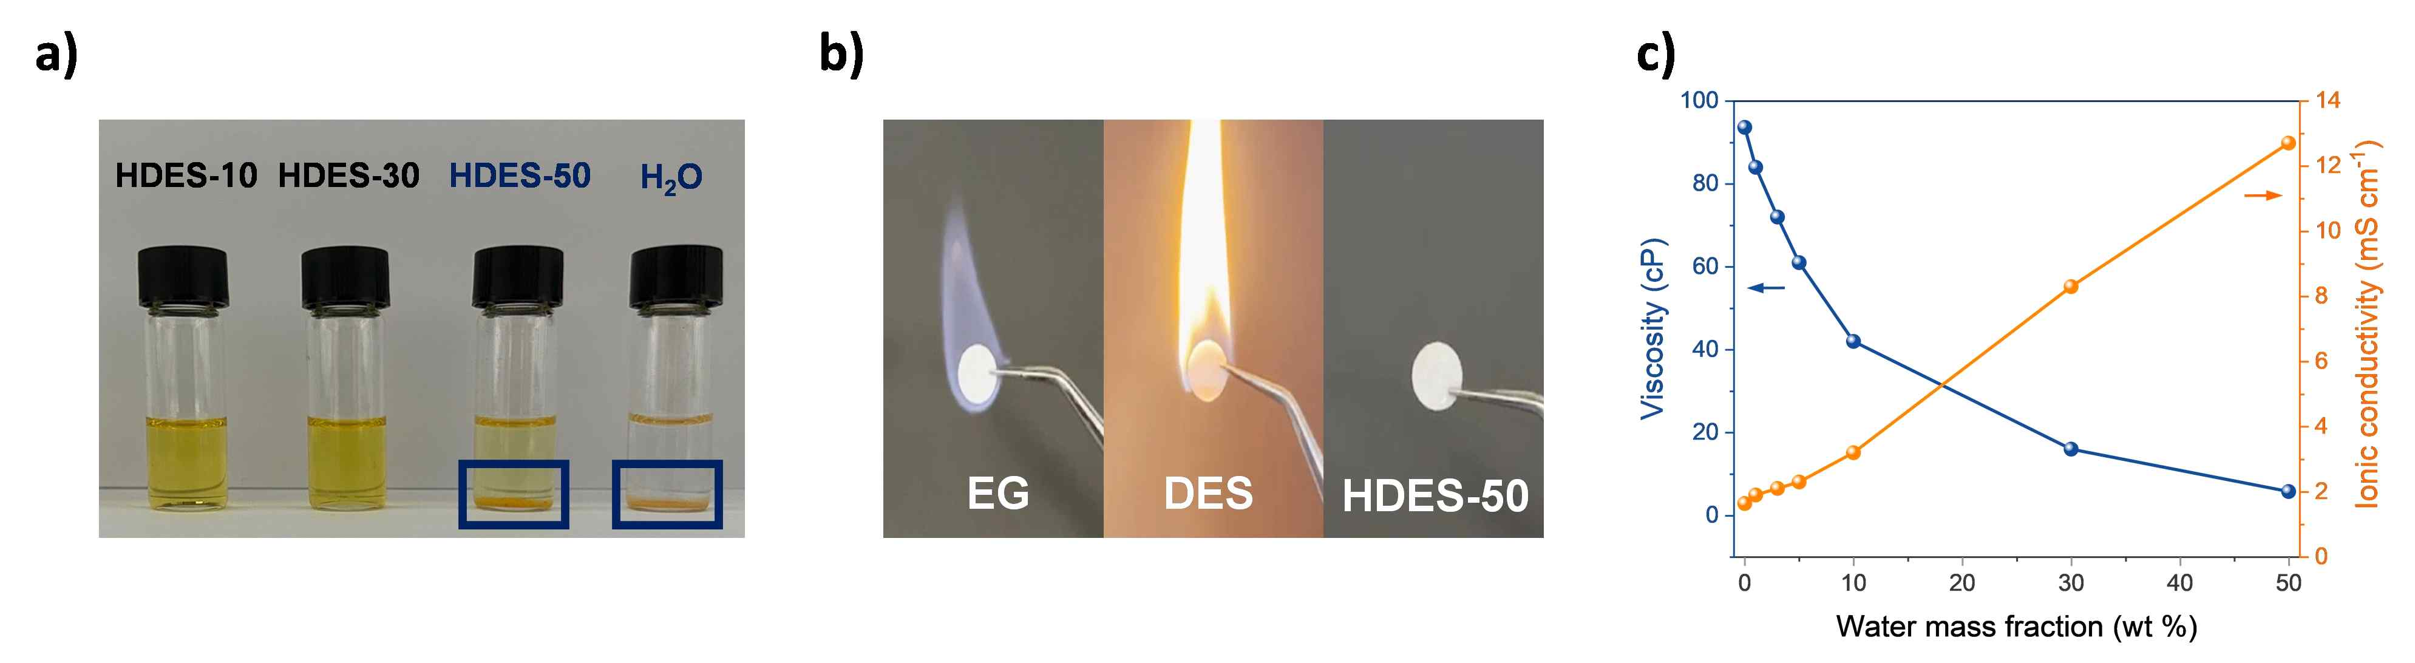

▲ Analysis of electrolyte characteristics according to moisture content control. a) Bromine complexation test, b) Ignition test, c) Ionic conductivity and viscosity analysis. : Electrolyte optimization is performed by analyzing characteristics according to moisture content. HDES with 50% moisture content has excellent bromine complexation as well as high conductivity and low viscosity without burning.

This electrolyte has both the electrochemical and thermal stability of organic electrolytes and the high ionic conductivity and flame retardancy (non-flammability) of aqueous electrolytes. In addition, by controlling the amount of water in the deep eutectic solvent (HDES), bromine is formed in a certain solid form, reducing self-discharge and securing long-term stability.

* DES-in-Water: Unlike general deep eutectic solvents with low moisture content, it refers to deep eutectic solvents containing a lot of water.

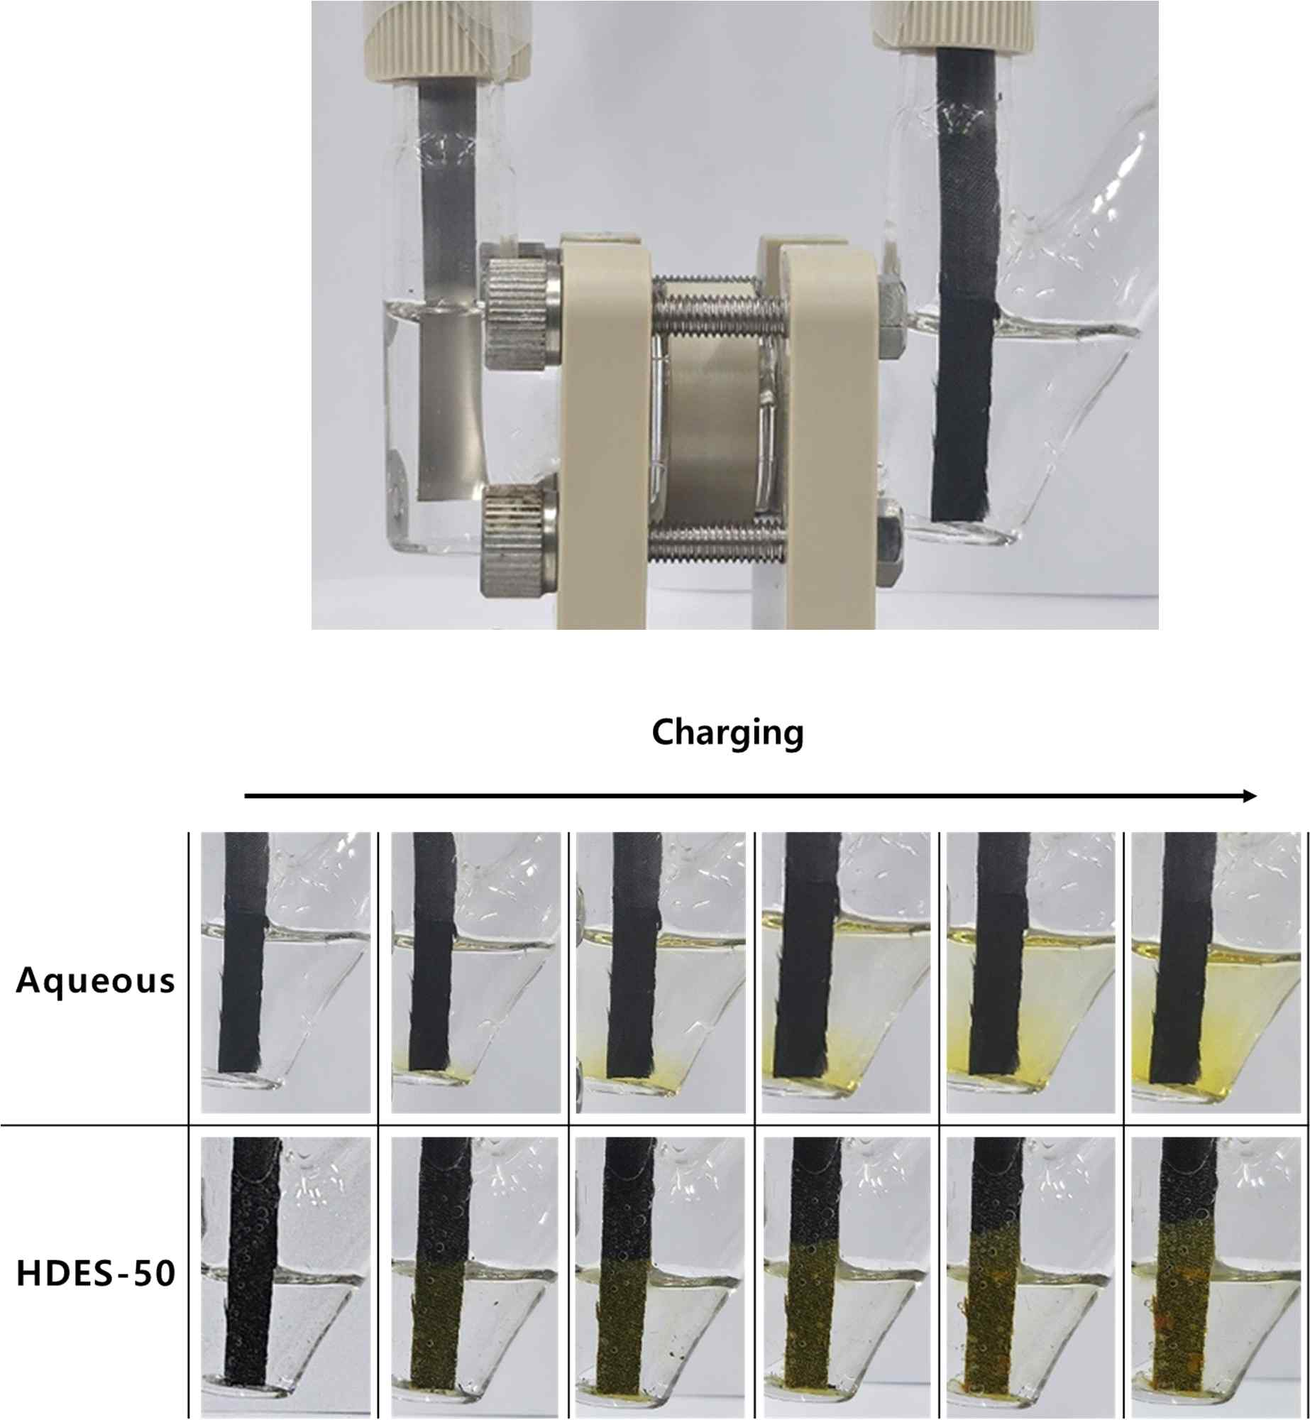

▲ H cell image and digital images according to the state of charge in each electrolyte. As the charging continues in the aqueous electrolyte, the formation and diffusion of yellow polybromide is observed. On the other hand, in the HDES-50 (HDES with optimized moisture content) electrolyte, it does not diffuse but is observed to be clumped up near the carbon electrode. The research team fabricated a ‘dual redox system full cell (a battery assembled to actually operate)’ using a butyl viologen cathode and a bromine anode and conducted long-term charge/discharge tests.

As a result of the experiment, it recorded an energy density of 36.3 Wh/kg at 1.4 V, showing a performance that is significantly higher than that of existing supercapacitors. In addition, it maintained more than 87% of the initial capacity after more than 10,000 charge/discharge cycles, and showed stable performance even in a high temperature environment of 60 °C, increasing the possibility of practical use.

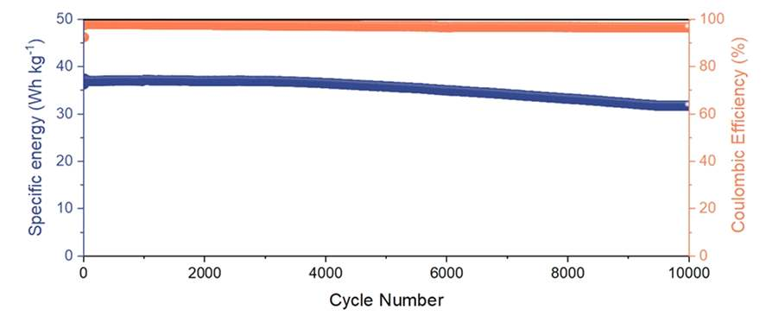

▲ Performance evaluation of butyl viologen/bromide full cell using HDES electrolyte: HDES electrolyte was applied in a full cell system that utilizes the redox reaction of viologen at the cathode and bromine at the anode. It operated stably while maintaining high coulombic efficiency (97.5%) and discharge capacity (36.3 Wh/kg) for more than 10,000 cycles.

Professor Seung Joon Yoo said, “Through this research, we have developed a next-generation electrolyte that is both eco-friendly and highly stable. In particular, by combining the advantages of existing aqueous and organic electrolytes, it is expected to contribute to extending the life of energy storage devices and maximizing charge/discharge efficiency.”

He also predicted, “The electrolyte developed in this research will greatly contribute to the development of various energy storage technologies such as bromine-based redox supercapacitors, large-scale energy storage systems (ESS), and next-generation batteries.”

This research, led by Professor Seung Joon Yoo (corresponding author) of the School of Materials Science and Engineering at GIST and co-first authors Tae Pyeong Eom, a doctoral student, and Gunwoo Lee, a master’s student, was supported by the National Research Foundation of Korea’s Mid-career Researcher Program, and the results of the research were published online in the international academic journal 《Advanced Functional Materials》 on March 27, 2025.



