GIST-KAIST develops of new drug candidate for liver fibrosis with strong anti-fibrotic effect and high safety in animal models

- Subtitle

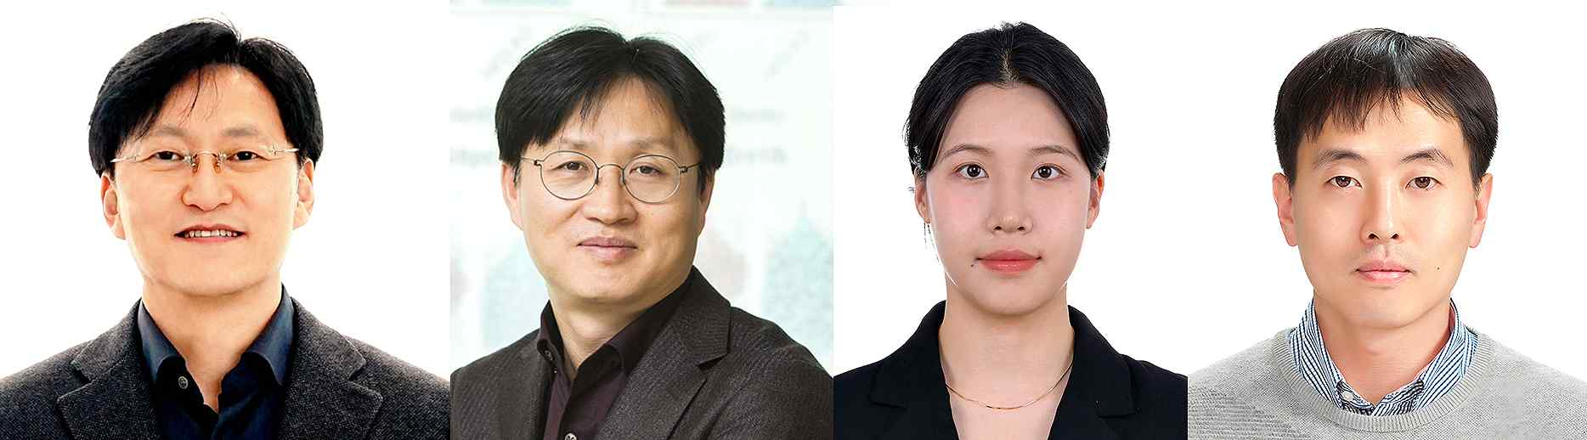

▲ (From left) Professor Jin Hee Ahn of the Department of Chemistry at GIST (CEO of JD Bioscience), Professor Hail Kim of the Graduate School of Medical Science and Engineering at KAIST, Dr. Jihyeon Yoon of the Department of Chemistry at GIST, and Professor Won-Il Choi of the Department of Physiology at Chonbuk National University College of Medicine

The Gwangju Institute of Science and Technology (GIST, President Kichul Lim) announced that a joint research team led by Professor Jin Hee Ahn of the Department of Chemistry (CEO of JD Bioscience Co., Ltd.) and Professor Hail Kim of the Korea Advanced Institute of Science and Technology (KAIST) has developed a new drug candidate that offers new possibilities for the treatment of liver fibrosis.

The substance developed by the research team, ‘19c’, showed the effect of suppressing the expression of proteins related to fibrosis (α -SMA*, TIMP1*, Col1a1, Col3a1*, etc.) in an animal model of liver fibrosis and significantly reducing the accumulation of extracellular matrix (ECM, Extracellular Matrix)*.

* α-SMA (alpha-smooth muscle actin): A protein expressed by activated hepatic stellate cells as liver fibrosis progresses. It gives cells the ability to contract like muscles.

* TIMP1 (Tissue Inhibitor of Metalloproteinase 1): Inhibits the decomposition of ECM and induces excessive ECM accumulation.

* Col1a1 & Col3a1 (Collagen type I alpha 1 & Collagen type II alpha 1): Types of collagen synthesized as liver fibrosis progresses. Major components of ECM.

* extracellular matrix: A complex network of proteins and polysaccharides existing outside the cell, which plays a role in maintaining the structural support and physiological function of cells. In the liver, ECM is essential for maintaining the structure and function of liver cells normally, but if liver damage is repeated, ECM accumulates excessively, causing liver fibrosis, inducing liver cell deformation and causing liver function deterioration.

Liver fibrosis is a disease in which liver structure and function are damaged as ECM accumulates excessively due to liver cell damage. The main causes are ▴long-term alcohol abuse ▴metabolic diseases due to obesity ▴autoimmune liver disease ▴viral hepatitis, etc. If liver fibrosis becomes severe, it can develop into cirrhosis or liver cancer, so early treatment is essential.

However, the only FDA-approved liver fibrosis treatment to date is ‘Resmetirom’, which shows a limited improvement effect of 12-14% compared to the placebo group*. Accordingly, there is an urgent need to develop a new treatment with a mechanism to preserve and improve the structure and function of the liver.

* placebo group: A group that took a fake drug given to patients to obtain psychological effects.

The research team discovered a new drug candidate substance ‘19c’ that acts as a serotonin receptor 2B (HTR2B) antagonist, which effectively inhibits the progression of fibrosis by blocking the action of serotonin receptor 2B (5HT2B) in hepatic stellate cells (HSC cells)*.

* hepatic stellate cells (HSC cells): Special cells present in the liver that store vitamin A. When the liver is damaged, it produces and releases fibrous substances such as collagen to contribute to healing, but if the damage persists chronically, it causes liver fibrosis.

This substance, which shows a strong antagonistic effect (IC₅₀*= 1.05 nM), is designed to have a limited blood-brain barrier penetration rate, thereby excluding any side effects that may affect the central nervous system.

* IC₅₀ (half maximal inhibitory concentration): The concentration of a substance that inhibits a specific biological or biochemical function by 50%

In addition, it has been confirmed to have a strong antifibrotic effect and excellent safety, such as not inhibiting the hERG channel* that can cause cardiac side effects and not showing cytotoxicity to normal cells.

* hERG (human Ether-a-go-go-Related Gene): An ion channel involved in the electrical activity of cardiac cells. When inhibited, it causes irregularities in heartbeat.

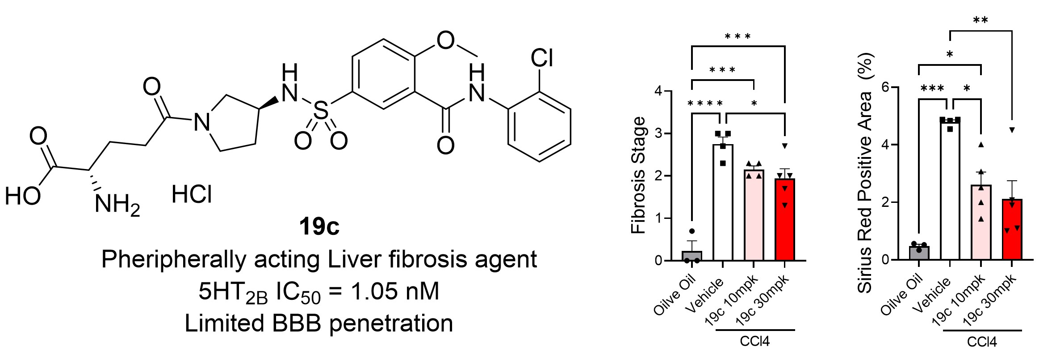

▲ Development of a new liver fibrosis treatment candidate: Based on a previous study that showed that serotonin receptor 2B could be a therapeutic target for liver fibrosis, we discovered a serotonin receptor 2B antagonist with excellent inhibitory efficacy of IC₅₀ = 1.05 nM. As a result of designing it to minimize blood-brain barrier (BBB) ​​penetration, the substance was selectively distributed to peripheral tissues, and effectively suppressed fibrosis-related factors and extracellular matrix accumulation in an animal model of liver fibrosis.

Activated hepatic stellate cells (HSC cells)* in damaged livers express 5HT2B during this process, synthesizing and releasing fibrotic substrates. The research team succeeded in effectively suppressing this fibrotic process by utilizing a selective 5HT2B antagonist (19c).

Serotonin is well known as a neurotransmitter that transmits feelings of happiness and satisfaction in the central nervous system, but there is a risk of side effects such as concentration disorder or impulsivity when 5HT2B receptors are suppressed.

Accordingly, the research team designed a compound (19c) with optimal polarity, lipophilicity, and flexibility that is selectively distributed only to peripheral tissues, thereby minimizing side effects in the central nervous system.

Professor Jin Hee Ahn of the Department of Chemistry at GIST, who led the research, said, “The ‘19c’ developed through this study is a drug that has both strong anti-fibrotic efficacy and safety, and is expected to provide a new turning point in the development of liver fibrosis treatments. If safety and efficacy are proven through future clinical studies, it is highly likely to develop into a practical treatment.”

This study, supervised by Professor Jin Hee Ahn of the Department of Chemistry at GIST (CEO of JD Bioscience Inc.) and Professor Hail Kim of the Graduate School of Medical Science and Engineering at KAIST, and conducted by Dr. Jihyeon Yoon of the Department of Chemistry at GIST and Professor Won-Il Choi of the Department of Physiology at Chonbuk National University College of Medicine, was supported by the National Research Foundation of Korea and the Basic Research Program (Mid-career Research) of the Ministry of Health and Welfare. The results of the study were published online in the international academic journal 《JMC (Journal of Medicinal Chemistry)》 on March 6.



