“Manipulating Molecules with Extreme Spatiotemporal Resolution” Korea-Japan joint research team succeeds in real-time control of quantum state of single molecule by ultra-high-speed charge manipulation using light

- GIST Department of Chemistry Professors Yousoo Kim and Hiroshi Imada, RIKEN, and a joint research team from Korea and Japan developed a technology to control energy conversion and chemical reactions occurring at the molecular level in real time by combining THz pulses and STM

- Opening the possibility of precise manipulation of ultra-fast charge transfer and luminescence phenomena, enabling a dramatic improvement in the efficiency of organic electronic devices such as OLEDs and solar panels... Published in the international academic journal 《Science》



▲ (From left) Professors Yousoo Kim and Hiroshi Imada of the Department of Chemistry at GIST, and Researcher Kensuke Kimura of RIKEN

A technology that combines scanning tunneling microscopy (STM)*, which can visualize and observe materials that are thinner than a hair in nanometers (nm, 1 nm is one billionth of a meter), and terahertz (THz)* light with an extremely short time scale in picoseconds (ps, 1 ps is one trillionth of a second) to control energy conversion and chemical reactions occurring at the molecular level in real time has been developed through joint research between Korea and Japan.

The results of this research, which are expected to open up new possibilities for measuring various optical phenomena with high time resolution*, were published in the world-renowned scientific journal Science on March 7, 2025.

* scanning tunneling microscope (STM): This device uses the tunneling phenomenon that occurs when a sharp metal needle (probe) on the atomic scale is brought as close as possible to the measurement surface as its measurement principle. The probe is scanned over the sample surface to observe the shape of the surface with atomic-level spatial resolution.

* terahertz (THz): refers to light with a frequency of 1 terahertz (THz, 1 trillion Hz) and a wavelength of approximately 300 micrometers (μm, 1 μm is 1 millionth of a meter). This frequency band is located between the frequency bands of radio waves, infrared rays, and visible light. In this study, terahertz light with a pulse width of 1 picosecond was generated and combined with an STM.

* resolution: refers to the ability of a measuring device or sensor to distinguish and identify minute differences or details. Equipment with high temporal resolution is essential for precisely measuring and analyzing ultra-fast phenomena or minute temporal changes.

The Gwangju Institute of Science and Technology (GIST, President Kichul Lim) announced that Professors Yousoo Kim (Director of the Center for Quantum Conversion Research at the Institute for Basic Science (IBS)) and Hiroshi Imada of the Department of Chemistry, together with the Institute of Physical and Chemical Research (RIKEN), Yokohama National University, the University of Tokyo, Hamamatsu Photonics K.K., and Ulsan University, have developed a technology that can observe and control phenomena occurring at the molecular level in real time and at ultra-high speed.

* Hamamatsu Photonics K.K.: Global manufacturer of electromagnetic devices and optoelectronic semiconductors

The phenomenon of charge transfer between molecules and electrodes (charge exchange) is one of the fundamental molecular science phenomena that occurs in chemical reactions occurring on the surface of organic devices or catalysts.

During this charge transfer process, a transient intermediate state such as a charge state* or exciton* is formed. However, these states have a very short lifetime, on the order of picoseconds (ps, 1ps is one trillionth of a second), so it is necessary to control the charge at an ultra-high speed to investigate their characteristics.

* charge state: A state in which electrons are injected into a molecule to create a negative charge, or a state in which holes are injected to create a positive charge.

* excitons: Excitons are quasi-quantum states in which negatively charged electrons and positively charged holes coexist. When the electrons and holes of the excitons combine, light is emitted. How to effectively utilize excitons in organic devices such as organic light-emitting diodes and organic thin-film solar cells plays an important role in improving performance.

Recent advances in optical technology have enabled ultra-high-speed charge control using optical pulses in the terahertz (THz) range with a short time span on the order of picoseconds. In particular, by combining terahertz (THz) pulses with scanning tunneling microscopy (STM), it has become possible to inject charges into materials at the nanometer (nm) level.

Conventional THz-STMs can only measure currents due to charge manipulation, so they have limitations in investigating changes in molecular states that occur when charges are injected into molecules. Therefore, the research team developed a device (optical STM) that combines optical technology with STM, and succeeded in observing various quantum phenomena at the single-molecule level more precisely.

Using a THz-optical STM device that combines optical STM and THz pulses, the research team conducted an experiment targeting a single Pd phthalocyanine molecule containing a palladium (Pd) atom at the center [Figure 1a, 1b].

By irradiating the STM with a THz pulse, the research team was able to detect the emission of the molecule in the wavelength band near 660 nm [Figure 1c]. This result means that when charges are injected into the frontier orbitals (HOMO and LUMO)* of the Pd phthalocyanine molecule, excitons are formed, which causes luminescence.

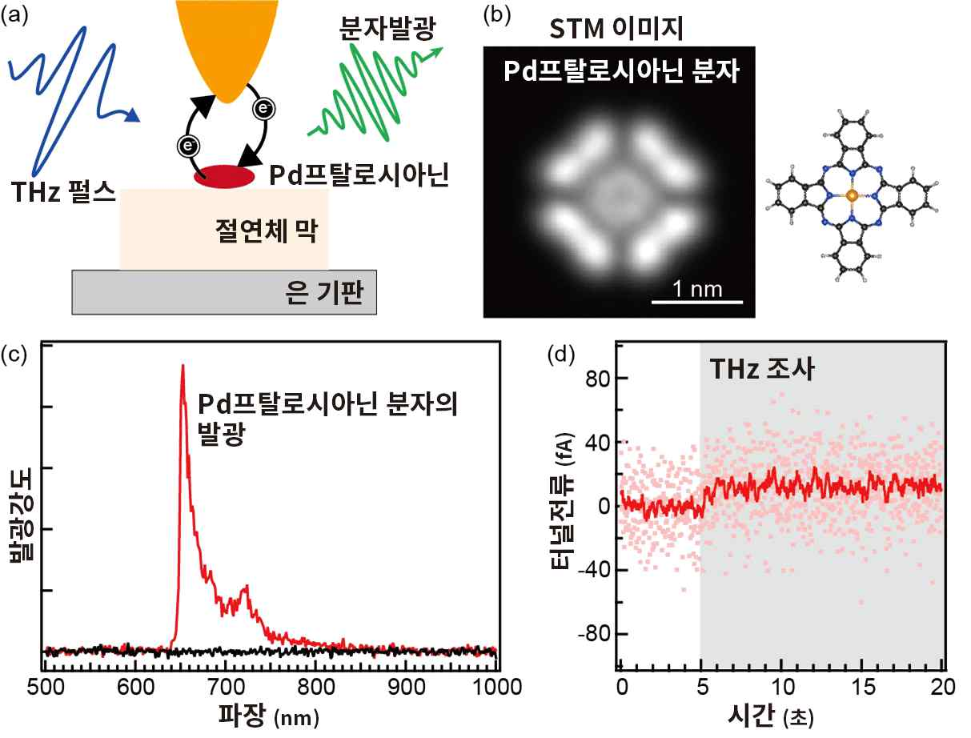

[Figure 1] Single-molecule luminescence measurement using THz-optical STM. (a) When a THz pulse (blue arrow) is irradiated to the STM, ultrafast charge transfer is induced between the STM probe and the molecule, forming an exciton within the molecule. The light (green arrow) emitted when the exciton annihilates is detected. (b) STM image of a Pd phthalocyanine molecule. On the right is a molecular model of Pd phthalocyanine, in which blue circles represent nitrogen, gray circles represent carbon, white circles represent hydrogen, and orange circles represent Pd atoms. (c) THz-optical STM spectrum of a Pd phthalocyanine molecule. The red line is the spectrum when the THz pulse is irradiated, and the black line is the spectrum when the THz pulse is not irradiated. A molecule-derived luminescence peak is observed near 660 nm. Since no luminescence peak is observed when the THz pulse is not irradiated, it is assumed that the THz pulse forms excitons and causes luminescence. (d) Time-dependent change of tunnel current during THz-optical STM spectrum measurement. In the figure, THz pulses are irradiated at 5-second intervals (gray border), but only a very small current of about 10 femtoamperes (fA, 1 fA is one trillionth of an ampere) flows.

Interestingly, when current was also measured while luminescence was measured, almost no current flowed [Figure 1d]. This indicates that charge was exchanged only between the STM probe and the molecule, and that there was almost no net current passing through the molecule [Figure 1a].

* frontier orbitals (HOMO and LUMO): Molecular orbitals are wave functions that describe the behavior of electrons in a molecule. Among them, the orbital with the highest energy among the molecular orbitals occupied by electrons is called the highest-energy orbital (HOMO), and the orbital with the lowest energy among the molecular orbitals not occupied by electrons is called the lowest-energy orbital (LUMO), and these are collectively called frontier orbitals.

Next, the research team investigated how the luminescence phenomenon changes when the waveform of the THz pulse is changed. Here, the waveform of the THz pulse can be expressed as a physical quantity called the carrier envelope phase*.

The research team developed a ‘THz phase shifter’, an optical device that can change the carrier envelope phase, and controlled the waveform of the THz pulse [Figure 2a]. As a result of measuring the luminescence intensity emitted from the molecule while changing the carrier envelope phase [Figure 2b], it was observed that the luminescence intensity changed as the waveform of the THz pulse changed. In particular, the luminescence intensity reached its maximum when the phase was near 210°.

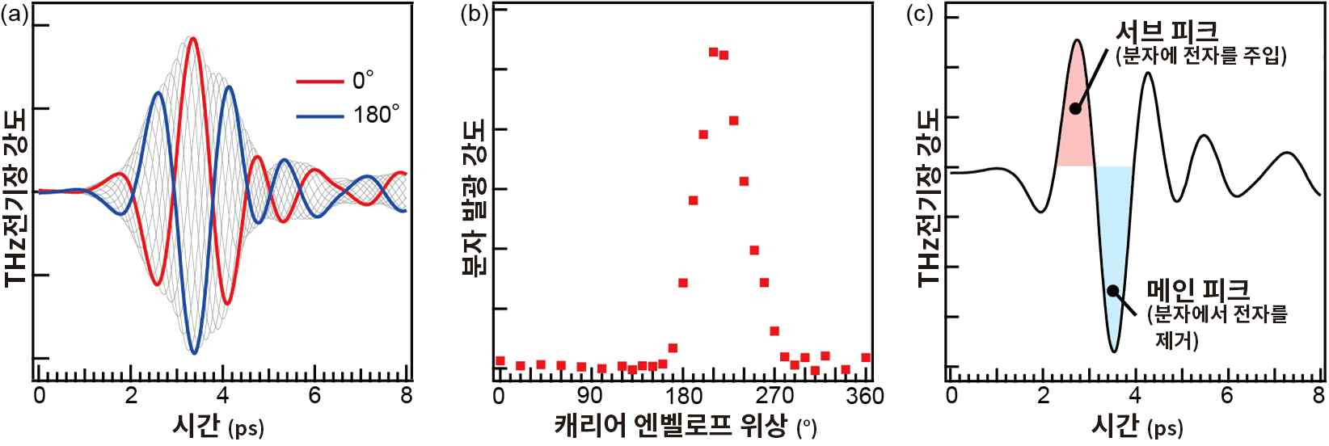

[Figure 2] Waveform control of THz pulse and clarification of exciton formation mechanism. (a) Waveform control of THz pulse by THz phase shifter. The carrier envelope phase is continuously changed from 0° to 360°. The red line represents the waveform of 0° (360°), and the main peak near 3.3 ps is caused by applying a positive electric field to the STM (in the direction from the silver substrate to the probe tip). The inverted blue line represents the waveform of 180°, and the main peak is caused by applying a negative electric field to the STM. (b) Carrier envelope phase dependence of molecular luminescence intensity. The luminescence from the molecule is measured while continuously changing the carrier envelope phase from 0° to 360°, and the intensity is plotted. The luminescence intensity from the molecule shows a maximum near 210°. (c) Schematic diagram of the exciton formation mechanism. The black line in the figure represents the THz pulse waveform with a carrier envelope phase of 210°. It is interpreted that electrons are injected into the LUMO of the molecule by the sub-peak (red) near 2.5 ps, and electrons are removed from the HOMO of the molecule by the main peak (blue) near 3.5 ps, forming excitons within the molecule.

As a result of analyzing this phenomenon, it is interpreted that electrons are injected into the lowest unoccupied orbital (LUMO) of the molecule at the sub-peak (red part) near 2.5 ps in the THz pulse waveform [Figure 2c], temporarily becoming negatively charged, and electrons are removed from the highest unoccupied orbital (HOMO) of the molecule at the main peak (blue part) near 3.5 ps, creating holes and forming excitons.

Based on these research results, the research team concluded that it is possible to control the state of molecules and form excitons through ultra-fast and continuous charge injection using THz pulses.

* carrier envelope phase: The phase of the optical electric field oscillation (carrier) relative to the envelope (envelope) of the optical pulse. In this study, the carrier envelope phase was continuously controlled from 0° to 360° using the THz phase shifter independently developed by co-author Hamamatsu Photonics (Figure 2a). For example, if the red line THz pulse in Figure 2a is defined as applying a positive electric field to the STM at the main peak, the blue line THz pulse with a 180° rotation in phase applies a negative electric field to the STM.

Professor Yousoo Kim said, “Through this study, we have established a method to measure and control the quantum state of molecules with extreme spatiotemporal resolution by combining THz pulses and optical STMs. This time, we were only able to detect the light emitted from the molecule, but if combined with other laser light sources, it will open the way to measuring various optical phenomena such as Raman scattering and photoluminescence with high temporal resolution.”

This international joint research led by Professors Yousoo Kim and Imada Hiroshi of the Department of Chemistry at GIST was supported by the Japan Society for the Promotion of Science (JSPS) Scientific Research Funding Project.

Meanwhile, Professor Hiroshi Imada was awarded the ‘7th Shimadzu Encouragement Award’ hosted by the Shimadzu Science and Technology Promotion Foundation in February in recognition of his achievements in developing an original measurement method that combines STM and nano-optical technology.



