"Ultra-precision measurements beyond the limits of existing physics are possible" GIST develops technology to implement ultra-high-resolution quantum spectrometer

- Professor Byoung S. Ham of the Department of Electrical Engineering and Computer Science proposes a method to implement a ‘quantum spectrometer’ that can be mounted on an existing spectrometer based on the independently developed ‘super-resolution quantum sensing’ theory... Innovative spectroscopy measurement technology presented

- Quantum-level sensitivity and resolution can be secured with a simple configuration, and applications are expected in various fields such as precision measurement, medical imaging, and remote sensing... Published in the international academic journal 《Scientific Reports》



▲ Professor Byoung S. Ham of the Department of Electrical Engineering and Computer Science

The Gwangju Institute of Science and Technology (GIST, President Kichul Lim) announced that Byoung S. Ham of the Department of Electrical Engineering and Computer Science has proposed a method to implement a ‘quantum spectrometer’ that can be mounted on an existing spectrometer based on the ‘super-resolution quantum sensing’* theory that he has independently developed.

A ‘quantum spectrometer’ overcomes the physical limitations (diffraction limit or standard quantum limit) of existing spectrometers, enabling ultra-precision measurements that could not be achieved with any existing classical physical laws or devices.

* Professor Byoung S. Ham presented a new concept of quantum sensing theory that is compatible with classical optics in the ‘super-resolution quantum sensing’ theory announced in 2024.

This study presents new possibilities for quantum sensor technology and heralds a paradigm shift in the field of optical measurement by securing phase sensitivity and resolution that will dramatically improve the performance of existing spectrometers.

A spectrometer is a device that quantitatively measures how a substance absorbs and emits light, and can accurately determine the wavelength of an unknown light by analyzing the difference in frequency from a known wavelength (helium-neon laser).

With this, the composition, concentration, and reaction dynamics of chemicals are analyzed, and it is widely used in various fields such as environmental monitoring, quality control, and biochemical research.

At this time, the resolution that accurately expresses the frequency difference is important, and the classical mechanical limit that determines the limit of this resolution is the ‘diffraction limit’* or ‘standard quantum limit’*.

* diffraction limit: The phenomenon in which waves that encounter a slit or obstacle during propagation spread out and propagate is called diffraction, and the diffraction limit refers to the limit of the resolution of an optical microscope due to the diffraction phenomenon of light.

* standard quantum limit (SQL): The precision limit of measurement derived from the uncertainty principle of quantum mechanics. When measuring any physical quantity (position, velocity, phase, frequency, etc.), the maximum precision that can be achieved is limited by the fundamental quantum noise regardless of the observation equipment and measurement method.

Conventional optical spectrometers had limited frequency resolution due to the diffraction limit. However, this study overcame this diffraction limit by utilizing phase control technology based on higher-order intensity correlation*.

This technology developed by Professor Ham has the characteristic that the phase sensitivity and frequency resolution are linearly improved in proportion to the order of the intensity product of light*.

* higher-order intensity correlations: A method for analyzing the statistical correlation between intensity signals of light in a high-dimensional manner in optics and quantum physics. All existing optical sensors are based on the first-order intensity correlation, but higher-order intensity correlation is a quantum measurement method that means the second-order intensity interference of light and is used to measure phase and photon interactions much more precisely.

* order of intensity product: A concept that analyzes higher-order correlations by multiplying the intensity of an optical signal multiple times, and plays an important role in the super-resolution technology that surpasses the diffraction limit and in improving phase sensitivity.

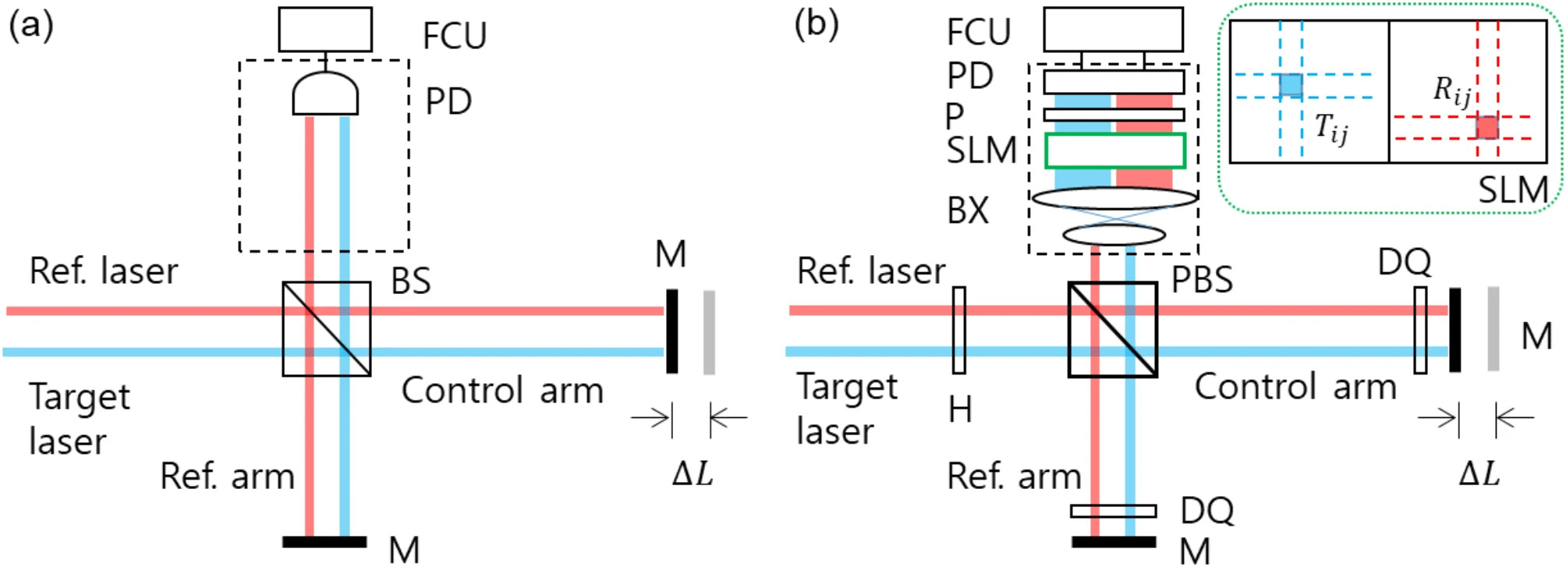

▲ Structure of a quantum spectrometer. (a) Conventional spectrometer. (b) Quantum spectrometer. SLM: spatial light modulator, FCU: frequency difference counter, P: polarizer, PD: photodetector, PBS: polarization light filter

In addition, existing quantum sensing had the problem of complexity that required the use of entangled photons and vulnerability to environmental noise.

Professor Ham secured both noise resistance and high stability by using the scanning mode of the interferometer* to accurately count the change in the interference pattern in a classical way.

* interferometer: A device that uses the interference phenomenon of light or electromagnetic waves to measure the characteristics of waves (phase, frequency, wavelength, etc.) with high precision. It is a high-sensitivity measuring device that can detect distance changes at almost the atomic level by using the principle that two or more lights meet each other and form an interference pattern.

The biggest achievement of this study is that instead of using a high-dimensional entangled photon pair based on a single photon, a general laser was used to create an innovative theory called ‘Phase-Controlled Intensity Product’. Through this, a method to implement a quantum spectrometer that satisfies the Heisenberg limit* was presented.

Phase-controlled intensity multiplication is a technology that precisely controls the phase information of light and maximizes resolution and measurement sensitivity by combining the higher-order correlation of light intensity. It synchronizes the phase and intensity of light (the process of precisely controlling and matching the relationship between the two) using an optical interferometer and a phase control device, and multiplies them to enable high-resolution measurements that surpass the existing diffraction limit.

* Heisenberg Limit: In quantum sensing theory, it is a relationship in which the measurement error is inversely proportional to the population size, and it represents the quantum gain corresponding to the square root of the population size compared to the standard quantum limit, which is the limit of classical sensing theory.

In this study, Professor Ham has dramatically overcome the current order limit of less than 20 in quantum sensing based on high-order entangled photons by utilizing the phase-controlled intensity product of the phase-controlled output field in the traditional sensor structure based on the Michelson interferometer*.

This method is highly practical in that the resolution can be increased by millions of times through the multi-pixel-based phase control system of the spatial light modulator*.

* Michelson interferometer: A device that uses the optical interference phenomenon to measure the phase difference and path difference of light with high precision. This interferometer, invented by Albert A. Michelson in 1887, has a resolution that surpasses the diffraction limit and a distance measurement capability at the nanometer level, and is used as an essential device in various scientific and technological fields such as optics, astronomy, and gravitational wave detection (LIGO).

* spatial light modulator (SLM): A device that displays or modulates images by controlling the spatial characteristics of light. It mainly uses electro-optical elements or liquid crystal display technology to control the intensity, phase, polarization, etc. of light. The resolution increases in proportion to the number of pixels, and the greater the number of pixels, the more detailed the light control becomes, enabling high-resolution image expression. In addition, it often shows stability against noise or interference from the external environment, so it maintains stable operation under various conditions.

Professor Ham verified the possibility of improving the frequency resolution by 10 times to up to 1 million times through numerical simulations and experiments. In particular, it showed a resolution that was improved by K times in proportion to the number of SLM pixels K, and it was confirmed that it had strong stability even in ambient noise.

This is significant in that it can secure quantum-level sensitivity and resolution with a relatively simple configuration without the complex equipment required by existing quantum optics-based technologies.

Professor Ham Byeong-seung said, “This research is expected to have immediate ripple effects in various cutting-edge fields such as optical sensors, spectral analysis, and quantum information processing as a core foundation for future quantum sensor technology. In particular, it will be widely used in precision measuring equipment that is strong against environmental changes, medical imaging technology, remote sensing systems, and radar/lidar. We plan to accelerate the development of practical quantum sensing equipment and commercialization research on quantum sensors in the future.”

This study was conducted with the support of the Ministry of Science and ICT's ITRC Quantum Internet Project, and the results were published online in the international academic journal 《Scientific Reports》 on February 22, 2025.



