GIST develops new drug candidate for urinary incontinence and chronic cough

- Research team of Professors Yong-Chul Kim, Chul-Seung Park, and Mi Sun Jin of the School of Life Science discovers a new compound that activates the BKCa channel (important for maintaining stable urination and airway functions) and verifies high efficacy without side effects in animal models

- Possibility of developing oral treatment also confirmed... Published in the international academic journal 《Journal of Medicinal Chemistry》



▲ (From left) GIST School of Life Science Professor Yong-Chul Kim, Professor Chul-Seung Park, Professor Mi Sun Jin, and PhD student Soo Bin Park

Urinary incontinence and chronic coughing greatly interfere with daily life and lower the quality of life. Existing treatments have been difficult to cure due to side effects or limited effectiveness, but domestic researchers have developed a new treatment substance that is highly effective while reducing side effects, drawing attention.

The Gwangju Institute of Science and Technology (GIST, President Kichul Lim) announced that the research team of Professors Yong-Chul Kim, Chul-Seung Park, and Mi Sun Jin of the School of Life Science succeeded in discovering a new drug treatment candidate that can alleviate urinary incontinence and cough symptoms.

The research team discovered a new compound that activates the BKCa channel (large-conductance calcium-activated potassium channel)*, which plays an important role in maintaining homeostasis of the urinary circuit and airway-related functions, opening up new possibilities for the development of treatments for urinary incontinence and cough.

* BKCa channel (large-conductance calcium-activated potassium channel): A potassium channel that maintains the electrical stability of cell membranes by regulating ion flow in nerve and muscle cells, and plays an important role in controlling bladder muscle contraction and airway protection mechanisms.

25-45% of the world's population experiences urinary incontinence symptoms, and the prevalence increases with age.

Antimuscarinic drugs currently used to treat urinary incontinence have various side effects, such as dry mouth, constipation, and cognitive impairment, and chronic cough treatments (such as codeine) also have central nervous system side effects and resistance issues, so it is necessary to develop treatments that can effectively relieve symptoms while reducing side effects.

The research team designed and synthesized an optimized compound based on the diphenyl ether core skeleton* and succeeded in increasing BKCa channel activity.

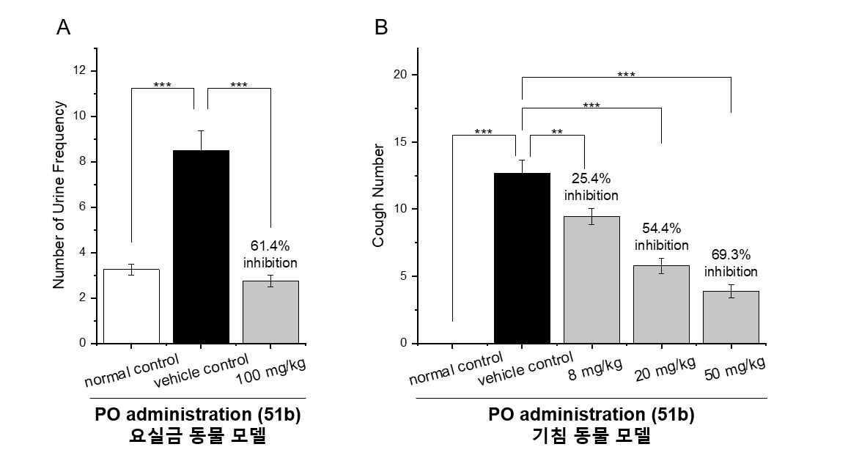

▲ Effect of BKCa channel activator confirmed in animal models of urinary incontinence and cough. Figure (A) shows the change in the number of urinations compared to the control group after oral administration of channel activator 51b to an animal model of urinary incontinence, and the efficacy of maintaining a normal level of urination interval after substance administration was confirmed. Figure (B) shows the change in the number of coughs compared to the control group after oral administration of 51b to an animal model of cough, and the decrease in the number of coughs due to substance administration was confirmed to be dose-dependent.

The developed BKCa channel activator ‘10b’ showed excellent activation effects even at a low concentration of 100 nanomolar, and the possibility of developing ‘51b’, which can be administered orally, as an oral treatment agent was confirmed to effectively alleviate urinary incontinence and cough symptoms when taken.

When BKCa channels expressed in bladder smooth muscle (smooth muscle: muscle that does not move by will) and airway epithelial cells are activated, excessive contraction of the bladder can be suppressed and cough reflex can be reduced.

* diphenyl ether core skeleton: The basic structure that serves as the basis for synthesis, and derivatives with various substituents can be designed based on this structure.

The research team applied the drug to an animal model of urinary incontinence (Spontaneously Hypertensive Rat, SHR) and an animal model of coughing (Citrate-induced cough guinea pig model), and confirmed the effects of reducing urination frequency and suppressing cough reflexes.

When 51b was orally administered to the urinary incontinence model at a dose of 100 mg/kg, urination frequency was reduced by 61.4%, and in the cough model, when administered at a dose of 20 mg/kg, the number of coughs was reduced by 54.4%. In addition, the interaction mechanism of 51b with the BKCa channel was elucidated at the molecular level through Cryo-EM* structural analysis.

* Cryo-EM (Cryo-Electron Microscopy): A cutting-edge structural biology technique that can observe the binding structure of proteins and drugs at the atomic level, and is used to elucidate the mechanism of action of drugs.

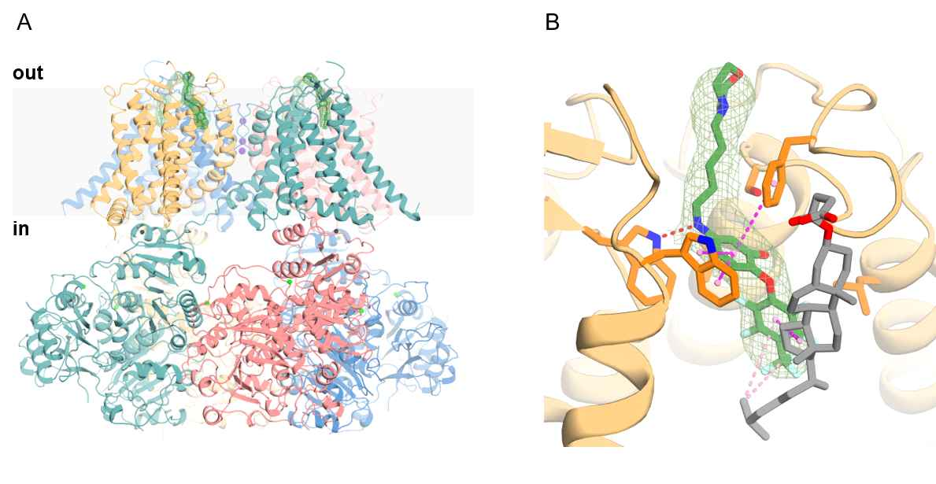

▲ Results of cryo-EM analysis. Figure (A) is a schematic diagram of the binding site of channel activator 51b to the BKCa channel for the entire protein, confirming that 51b binds to each monomer of the channel. Figure (B) analyzes the binding mode of 51b at each binding site, and schematically illustrates the detailed interactions with the protein by major substituents.

In particular, 51b did not show any side effects even when administered at high doses of 50-100 mg/kg to animal models. To find out the reason, the research team analyzed the in vivo pharmacokinetics using guinea pigs and concluded that 51b selectively reached the target tissue.

The research team also explained that this substance can be used not only to treat urinary incontinence, but also to treat respiratory diseases by supplying airway moisture and regulating smooth muscle sensitivity, which could be a new strategy for treating airway-related diseases such as chronic obstructive pulmonary disease (COPD), asthma, and cough.

Professor Yong-Chul Kim said, “Through this study, we have identified the binding mechanism between BKCa channels and drugs, developed new drug candidates targeting BKCa channels, and confirmed the possibility of treating urinary incontinence and cough. We expect that it will provide important clues for the development of various treatments with reduced side effects based on BKCa channel regulation in the future.”

This study was under the guidance of Professors Yong-Chul Kim, Chul-Seung Park, and Mi Sun Jin of the School of Life Sciences at GIST, and was conducted by Soo Bin Park and Saeng-i Jeong, and was supported by the Korea Drug Development Fund (KDDF) and the National Research Foundation of Korea’s Global Leading Research Center (IRC). The results of the study were published online on February 13 in the international academic 《Journal of Medicinal Chemistry》.



