"They say that if you get vision correction surgery, your eyes feel like they're being cut by glass" GIST suggests a new treatment possibility for neuropathic corneal pain

- Professor Euiheon Chung's research team in the Department of Biomedical Science and Engineering, clarifies the role of the 'Krt16 gene', a key mechanism that induces the progression of neuropathic corneal pain, and develops an animal model that precisely reproduces chronic eye pain caused by nerve damage

- Published in the international academic journal 《Investigative Ophthalmology & Visual Science》



▲ (From left) Professor Euiheon Chung of the Department of Biomedical Science and Engineering and Dr. Mohd. Afzal Khan

‘Neuropathic corneal pain’ is an intractable disease that occurs due to various causes such as nerve damage after refractive surgery, viral infection, diabetes, and autoimmune diseases. It is accompanied by symptoms such as chronic ocular discomfort, hypersensitivity to light, and burning sensation of unknown cause, and it occurs commonly worldwide. However, existing ophthalmic treatments are ineffective and often worsen, so the development of new treatments is urgent.

The Gwangju Institute of Science and Technology (GIST, President Kichul Lim) announced that the research team of Professor Euiheon Chung of the Department of Biomedical Science and Engineering has developed a new animal model that more accurately reflects the pathophysiology of neuropathic corneal pain (NCP)*.

Existing animal models have made it difficult to develop effective treatments due to the gap between clinical and clinical, but this study is expected to provide an important turning point in the development of treatments for neuropathic corneal pain.

Existing neuropathic corneal pain models were mainly designed through the transection of the ophthalmic nerve or ciliary nerve*, but they had limitations in not sufficiently reflecting the gradual neural changes and neuropathic pain mechanisms observed in clinical practice.

* ciliary nerve: A parasympathetic ganglion located in the posterior orbit, just behind the eye.

The research team developed a new animal model (Pulled Nerve (PN)) with partial damage to the long ciliary nerve*, designed to study the early-stage neural changes that occur in the chronic pain process leading to peripheral sensitization* and central sensitization*.

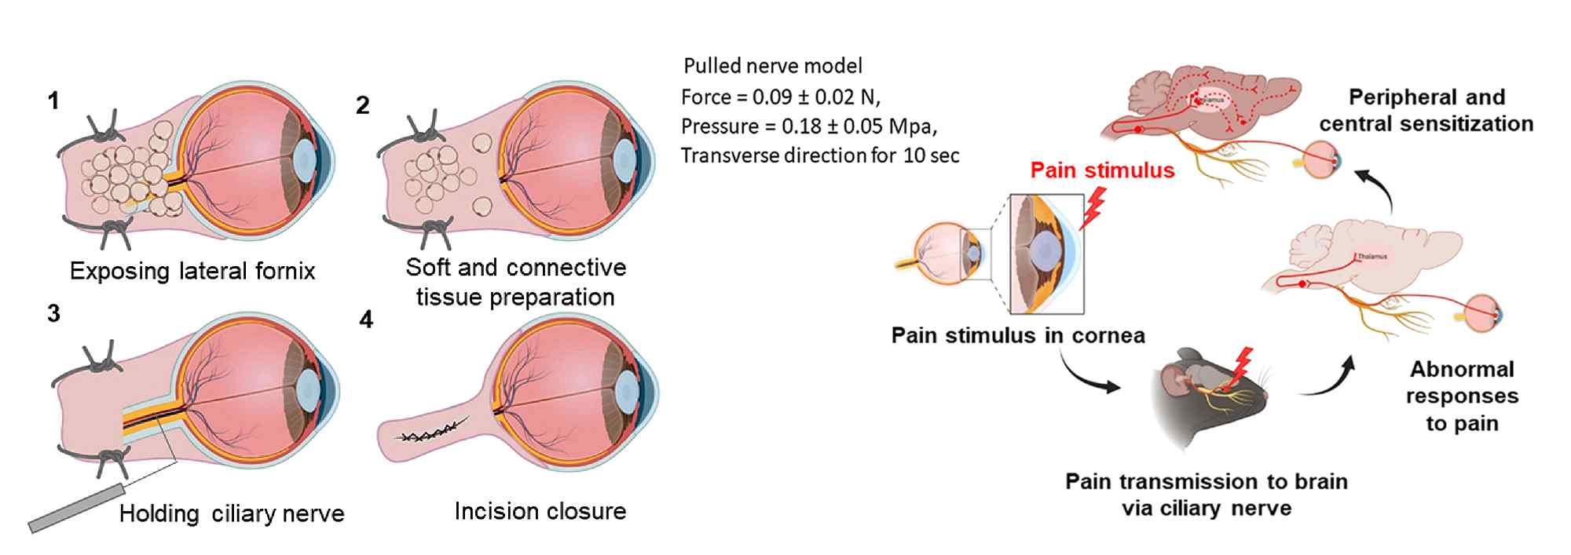

▲ Surgical procedure of the PN model: (1) Exposure of the lateral fornix: Induce ocular dislocation through lateral canthotomy. (2) Preparation of soft and connective tissue: Make an incision in the lateral fornix, but preserve the limbal conjunctiva. (3) Manipulation of the ciliary nerve: Apply light force to the ciliary nerve for 10 seconds. (4) Suture of the surgical site: Suture the surgical site using vicryl suture. The long ciliary nerve (LCN) was manipulated by applying the parameters designed in the pulled nerve (PN) model. In addition, the process by which external stimuli are transmitted from the cornea to the brain through the ciliary nerve is schematically illustrated. Abnormal pain responses (hyperalgesia or allodynia) are activated before transitioning to peripheral and central sensitization.

This ‘pulling nerve (PN)’ model can be utilized to conduct more sophisticated mechanistic studies on changes in nerve structure and function.

* long ciliary nerve (LCN): One of a pair of nerves that separates from the ciliary nerve, runs together with the short ciliary nerve, penetrates the sclera, and passes between the sclera and the choroid. It provides sensory fibers to the iris, cornea, and ciliary muscle, and sympathetic and general sensory motor fibers to the pupillary dilator.

* peripheral sensitization: This refers to the phenomenon in which pain receptors in peripheral tissues of the body (skin, muscles, joints, etc.) become hypersensitive. It occurs in inflammation, tissue damage, or pathological conditions, and makes pain more intense or makes people more sensitive to stimuli.

* central sensitization: A phenomenon in which the neural circuits of the spinal nervous system (spinal cord and brain) are overactivated and pain signal transmission is amplified. The initial peripheral sensitization continues to induce central sensitization, which leads to chronic pain.

Above all, this model can precisely reproduce chronic paresthesia and hypersensitivity, which are key features of neuropathic corneal pain. Using this, the research team elucidated the role of the ‘Krt16 gene’, which is important in regulating cell stress response and corneal epithelial homeostasis.

The Krt16 gene plays an important role in maintaining the structural and functional homeostasis of epithelial cells and responding to cell stress. The research team confirmed that dysregulation of this gene affects nerve signal transmission and may act as a key mechanism in inducing the progression of neuropathic pain.

The research team explained that this model can be used not only as an essential preclinical research tool to verify potential treatments, but also for research on pharmacological interventions (screening novel analgesics and neuroprotectors targeting corneal nerve dysfunction), gene-based therapies (studying the effects of modulating Krt16 expression on nerve responses and pain perception), and regenerative strategies (exploring approaches to restore and regenerate corneal nerves to improve clinical treatment outcomes).

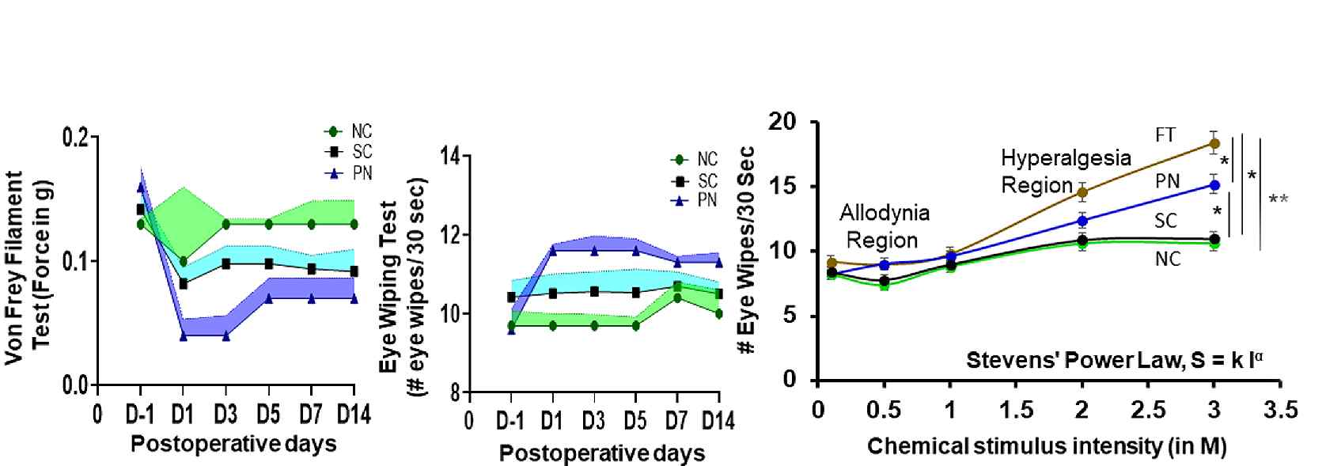

▲ Behavioral experiments to assess the propensity for neuropathic corneal pain (NCP) emphasize the importance of long-term behavioral assessment in understanding the progression of neuropathic pain in the cornea. As a result of quantitative assessment of neuropathic pain (n=5, each model group), the relationship between perceived pain level after surgery and chemical stimulus intensity was analyzed in normal control (NC), sham control (SC), pull nerve (PN), and complete transection (FT) models.

Professor Euiheon Chung said, “Through this study, we have established an important research foundation for more accurately understanding the pathogenesis of neuropathic corneal pain and developing customized treatments for patients. In particular, by overcoming the limitations of existing neuropathic pain treatments that have failed to address fundamental nerve dysfunction and have relied on opioids* and local analgesics, we expect to be able to present effective neuropathic pain treatment strategies in the future.”

* opioids: Narcotic analgesics, along with heroin and fentanyl, are considered representative prescription analgesics abused in the United States.

Professor Euiheon Chung of the Department of Biomedical Science and Engineering supervised and led the study. This study, conducted by Dr. Mohd. Afzal Khan, was supported by the HYPE Perceptual Neuroscience Research Group, a program of the National Science Challenge Convergence Research and Development (STEAM) Project of the Korean Academy of Science and Technology and the National Research Foundation of Korea, which aims to solve national challenges, and the Brain Science Leading Convergence Technology Development Project of the Ministry of Science and ICT and the National Research Foundation of Korea, and was published online in the international academic journal 《IOVS (Investigative Ophthalmology & Visual Science)》 on February 12, 2025.



