GIST develops transformer micro robot technology with light-emitting hydrogel that can be freely transformed, enabling precise movements for solving puzzles and catching objects

- Professor Yeongjae Choi's team from the School of Materials Science and Engineering develops an ultra-precision deformation mechanism that can provide various movements and shape changes to micro hydrogels... Published as a cover paper in 《Advanced Materials》

- A 'smart hydrogel' that can transform beyond structural and environmental constraints with only light and DNA cross-linking agents without a complex structure... Can be used for micro robots that need to move precisely in blood vessels

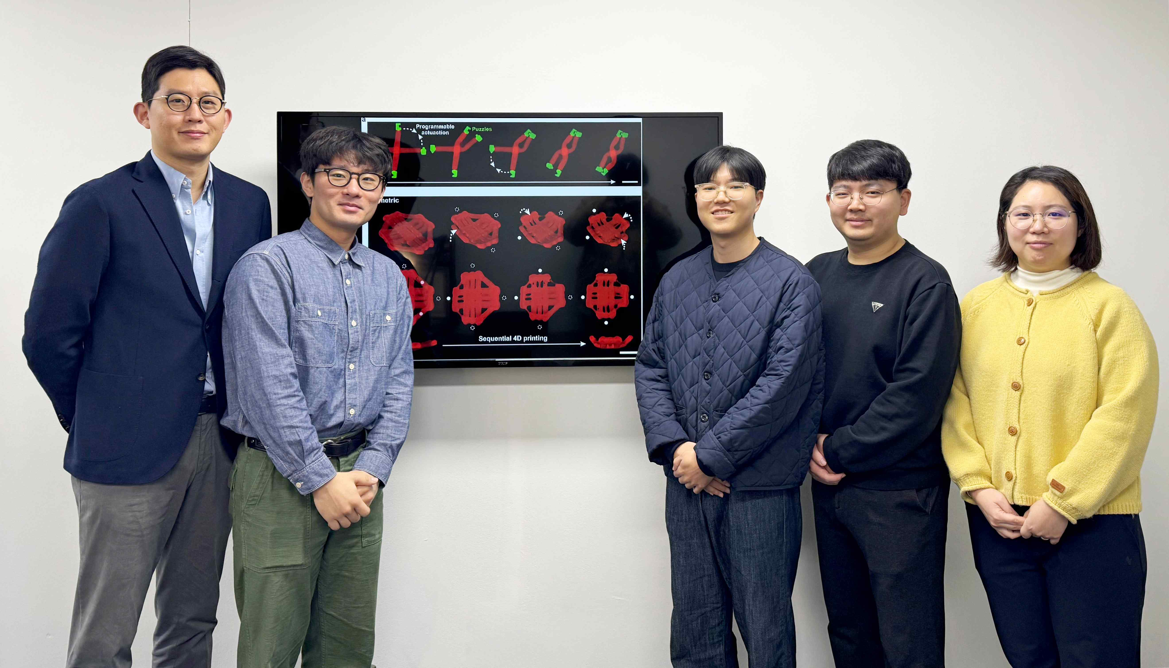

▲ (From left) Professor Yeongjae Choi of the School of Materials Science and Engineering, master's student Seongjun Park, master's student Junho Roh, master's student Hoeseong Kim, and Dr. Eunjin Choi

A hydrogel that can be freely transformed using light and DNA cross-linking agent* has been developed by domestic researchers. This hydrogel is expected to overcome the limitations of smart materials, especially since it can be used in microrobotics*.

* DNA cross-linking agent: Forms chemical or physical connections between DNA strands to provide structural stability or control the properties of materials, and is mainly used in biosensors, hydrogels, and drug delivery systems.

* microrobotics: A discipline that designs, manufactures, and controls very small robots, and is mainly used to provide precision work and innovative solutions in medical, biotechnology, and environmental monitoring.

The Gwangju Institute of Science and Technology (GIST, President Kichul Lim) announced that Professor Yeongjae Choi's research team in the School of Materials Science and Engineering has developed a micro hydrogel that can be transformed and repeatedly reconfigured into a desired shape using light (ultraviolet (UV) and visible light using LEDs).

A robotic arm made using this hydrogel can be used for precise tasks, such as moving and solving micro-sized puzzles and catching objects, by implementing micro-robot* movements.

* micro robots: Micro robots have ultra-fine structures close to the size of cells, and unlike large robots, they require special drive mechanisms, so they play a role in various fields such as medicine, environment, and manufacturing through precise movements and energy efficiency.

Hydrogels, which are polymer materials that interact with water and expand in volume, can control changes in shape, such as changes in volume, in response to external stimuli such as light, temperature, and hydrogen ion concentration (pH) and the environment.

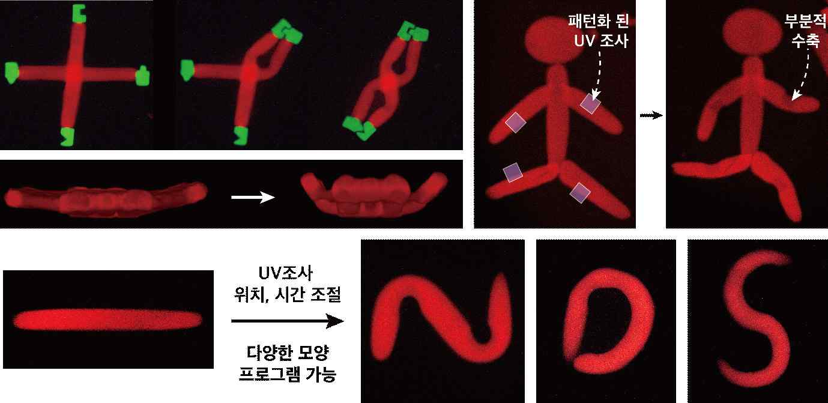

▲ Photo-responsive micro hydrogel robot. It can move and fit puzzles and fold into a 3D structure to act as a gripper. By controlling the patterned UV irradiation time and location, the degree and location of the hydrogel bending can be freely set, and this bending can be programmed to implement the robot's movements.

Existing shape-deformable hydrogels were manufactured by combining various materials with different reaction characteristics, but they have limitations in that they are fixed in a single shape in terms of location, direction, and degree, making it difficult to transform them in various ways.

In addition, when using a hydrogel that reacts to temperature or pH, energy must be continuously injected to maintain deformation and temperature, and a process of changing the pH by replacing the solution is necessary to return the shape to its original state.

In order to overcome these limitations and solve the problem, the development of a hydrogel that has a simple structure and can change variously with light alone without a solution replacement process is required.

The photoresponsive micro hydrogel developed by the research team can freely change its shape by controlling expansion and contraction in a desired area using patterned light.

In addition, the DNA cross-linking agent used in this study contains azobenzene, a photoresponsive isomer*, which can control the binding and separation of DNA depending on the wavelength of light. For example, when irradiated with visible light, azobenzene has a trans structure* and enables DNA binding.

On the other hand, when exposed to ultraviolet (UV) light, azobenzene has a Cis structure* and spatially disrupts hydrogen bonding between DNA base pairs, causing DNA separation. Therefore, under visible light, the length of the cross-linker increases through the chain bonding of DNA strands, causing the hydrogel to swell, and under UV, the bound DNA strands separate, the length of the cross-linker shortens, and the hydrogel shrinks.

* photoreactive isomers: Photoreactive isomers are special molecules that change their molecular structure when exposed to light. For example, when exposed to a specific light, the molecule changes from a straight (Trans) to a bent (Cis) shape, and when exposed to a different light, it returns to its original shape.

* trans structure, Cis structure: Azobenzene reacts to light to transform into two isomeric structures, trans and cis. The trans structure is linear and stable, and has strong intermolecular interactions, while the cis structure has the characteristic of reducing molecular density and weakening interactions in a bent shape.

By irradiating patterned light through a maskless lithography system*, the length of the photoreactive DNA cross-linker can be selectively controlled in a specific area.

When patterned UV is irradiated to a specific area of ​​a rod-shaped hydrogel, the area shrinks and the hydrogel bends due to the difference in expansion rate with the surrounding area. The research team succeeded in implementing precise movements of the robot by programming the bending by controlling the UV irradiation location and time.

* maskless lithography system: A technology used when manufacturing semiconductors or microstructures, it is a device that can directly draw a desired pattern with light without a traditional mask (a frame that creates a light pattern). In simple terms, it is a technology that directly engraves a pattern designed on a computer onto a surface with light, just like drawing a picture on paper with a printer.

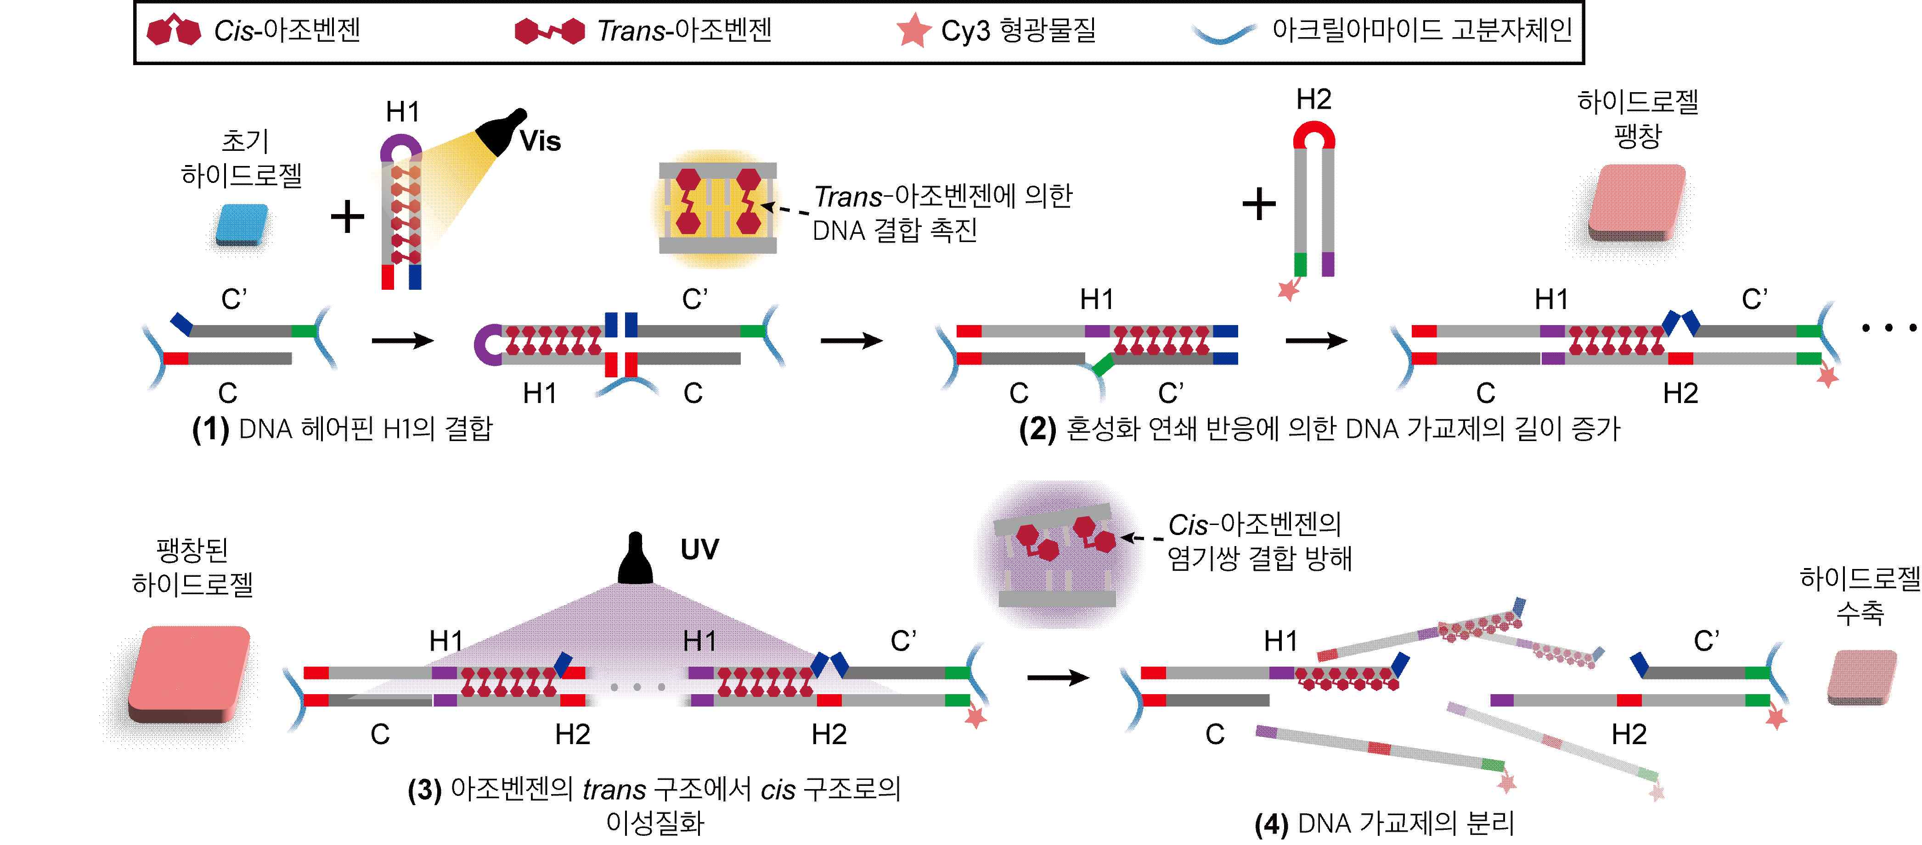

▲ Change in the length of the hydrogel cross-linker according to the wavelength of light. Under visible light, DNA is linked in a chain and the length of the cross-linker increases, causing the hydrogel to swell, and when irradiated with UV, the DNA strands separate, the length of the cross-linker shortens, and the hydrogel contracts.

Professor Yeongjae Choi said, “Through this research achievement, we have confirmed that hydrogel robots can be programmed with photoresponsive DNA cross-linkers and light without complex structures and additional stimulation. In the future, we expect that hydrogel robots that can operate like algorithms and exhibit advanced deformations through diversification of reaction mechanisms through DNA design will be developed.”

This research, supervised by Professor Yeongjae Choi and Dr. Eunjin Choi of the School of Materials Science and Engineering and conducted by master’s students Junho Roh and Seongjun Park, was supported by the Ministry of Science and ICT’s Excellent New Researcher Project and STEAM Research Project (Future Promising Convergence Technology Pioneer), and was published as a cover paper in the international academic journal 《Advanced Materials》 on February 5, 2025.

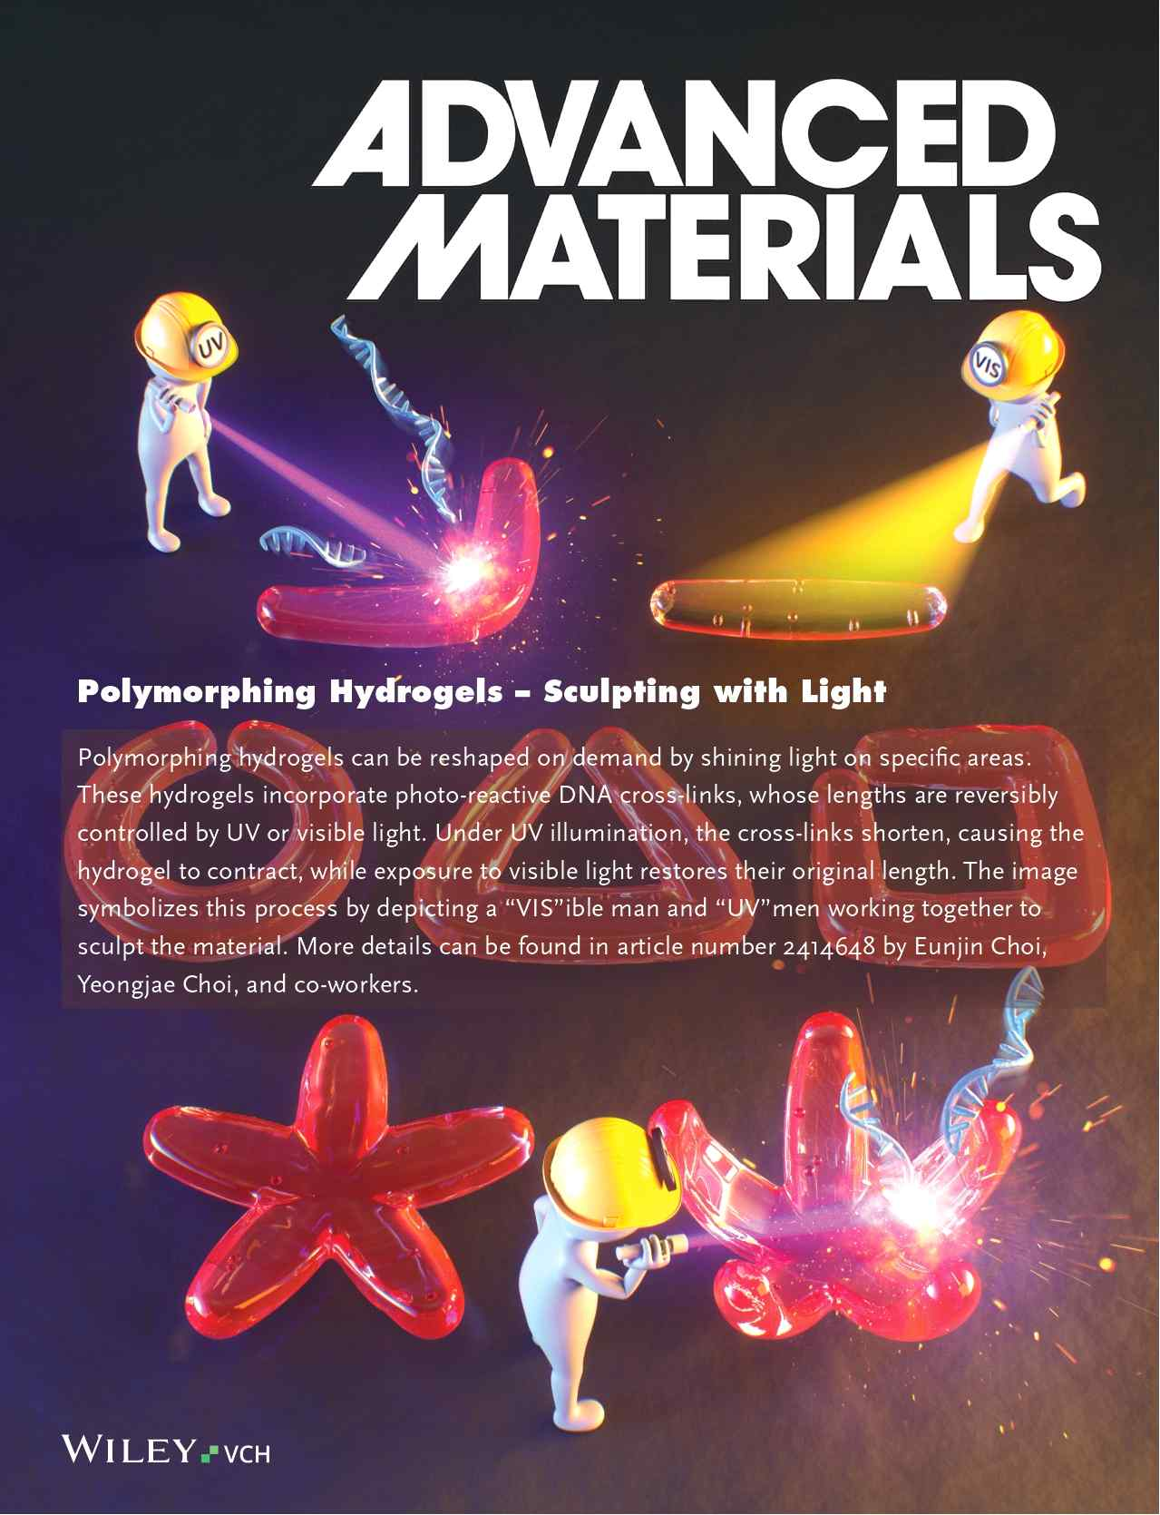

▲ Published on the cover of 《Advanced Materials》



