"Opening a new era of precision cancer treatment" GIST develops an AI-based compound anticancer drug prediction model

- Professor Hojung Nam's research team from the School of Electrical Engineering and Computer Science uses AI to suggest the optimal combination of anticancer drugs and their concentrations for each cancer cell... Customized anticancer treatment considering the characteristics of each patient is possible

- Compared to existing research and models, the accuracy of combination predictions is increased and the efficacy of combination anticancer drugs is improved, 2,556 promising combination anticancer drug pairs are presented... Published in the international academic journal 《Briefings in Bioinformatics》



▲ (From left) Doctoral student Songyeon Lee, Professor Hojung Nam, integrated master's and doctoral student Iljung Jin, and integrated master's and doctoral student Martin Schmuhalek

Combination therapy is a treatment method that uses two or more anticancer drugs in combination. It has the advantage of having a greater synergistic effect, lower toxicity, and overcoming drug resistance compared to single anticancer drug treatment. However, if the combination is wrong, it can cause strong toxicity or antagonism*, so it is important to accurately predict the optimal combination.

* antagonistic effect: This refers to the phenomenon in which when two or more drugs are prescribed together, the efficacy is lower than when each drug is prescribed alone due to drug interaction.

The Gwangju Institute of Science and Technology (GIST, President Kichul Lim) announced that the research team of Professor Hojung Nam of the School of Electrical Engineering and Computer Science developed an artificial intelligence (AI) combination anticancer drug prediction model that can precisely predict the combination and administration concentration of anticancer drugs for each cancer cell.

The results of this study are expected to enable precise anticancer treatment that considers the characteristics of each patient by analyzing the drug response that appears differently for each cancer cell using AI and suggesting the optimal combination and administration concentration of anticancer drugs.

The purpose of AI-based compound anticancer drug efficacy prediction research is to efficiently explore the optimal combination results for a large number of drugs. In previous studies, the synergistic effect of compound anticancer drugs was predicted by connecting cancer cell descriptors such as gene expression levels and drug characteristic data and using them as input data for deep neural networks.

However, this approach showed two limitations. First, it did not consider the direct correlation between single anticancer drugs and compound anticancer drugs. Second, it did not reflect the actual administered concentration of the drugs and only predicted the average synergistic effect, so even if an effective compound anticancer drug was found, it could not suggest a specific administration dose.

To solve these problems, the research team developed a compound anticancer drug efficacy prediction model (DD-PRiSM: A Deep Learning Framework for Decomposition and Prediction of Synergistic Drug Combinations) that can infer the efficacy and interaction of compound anticancer drugs with high accuracy for any cancer cell, drug, and drug concentration.

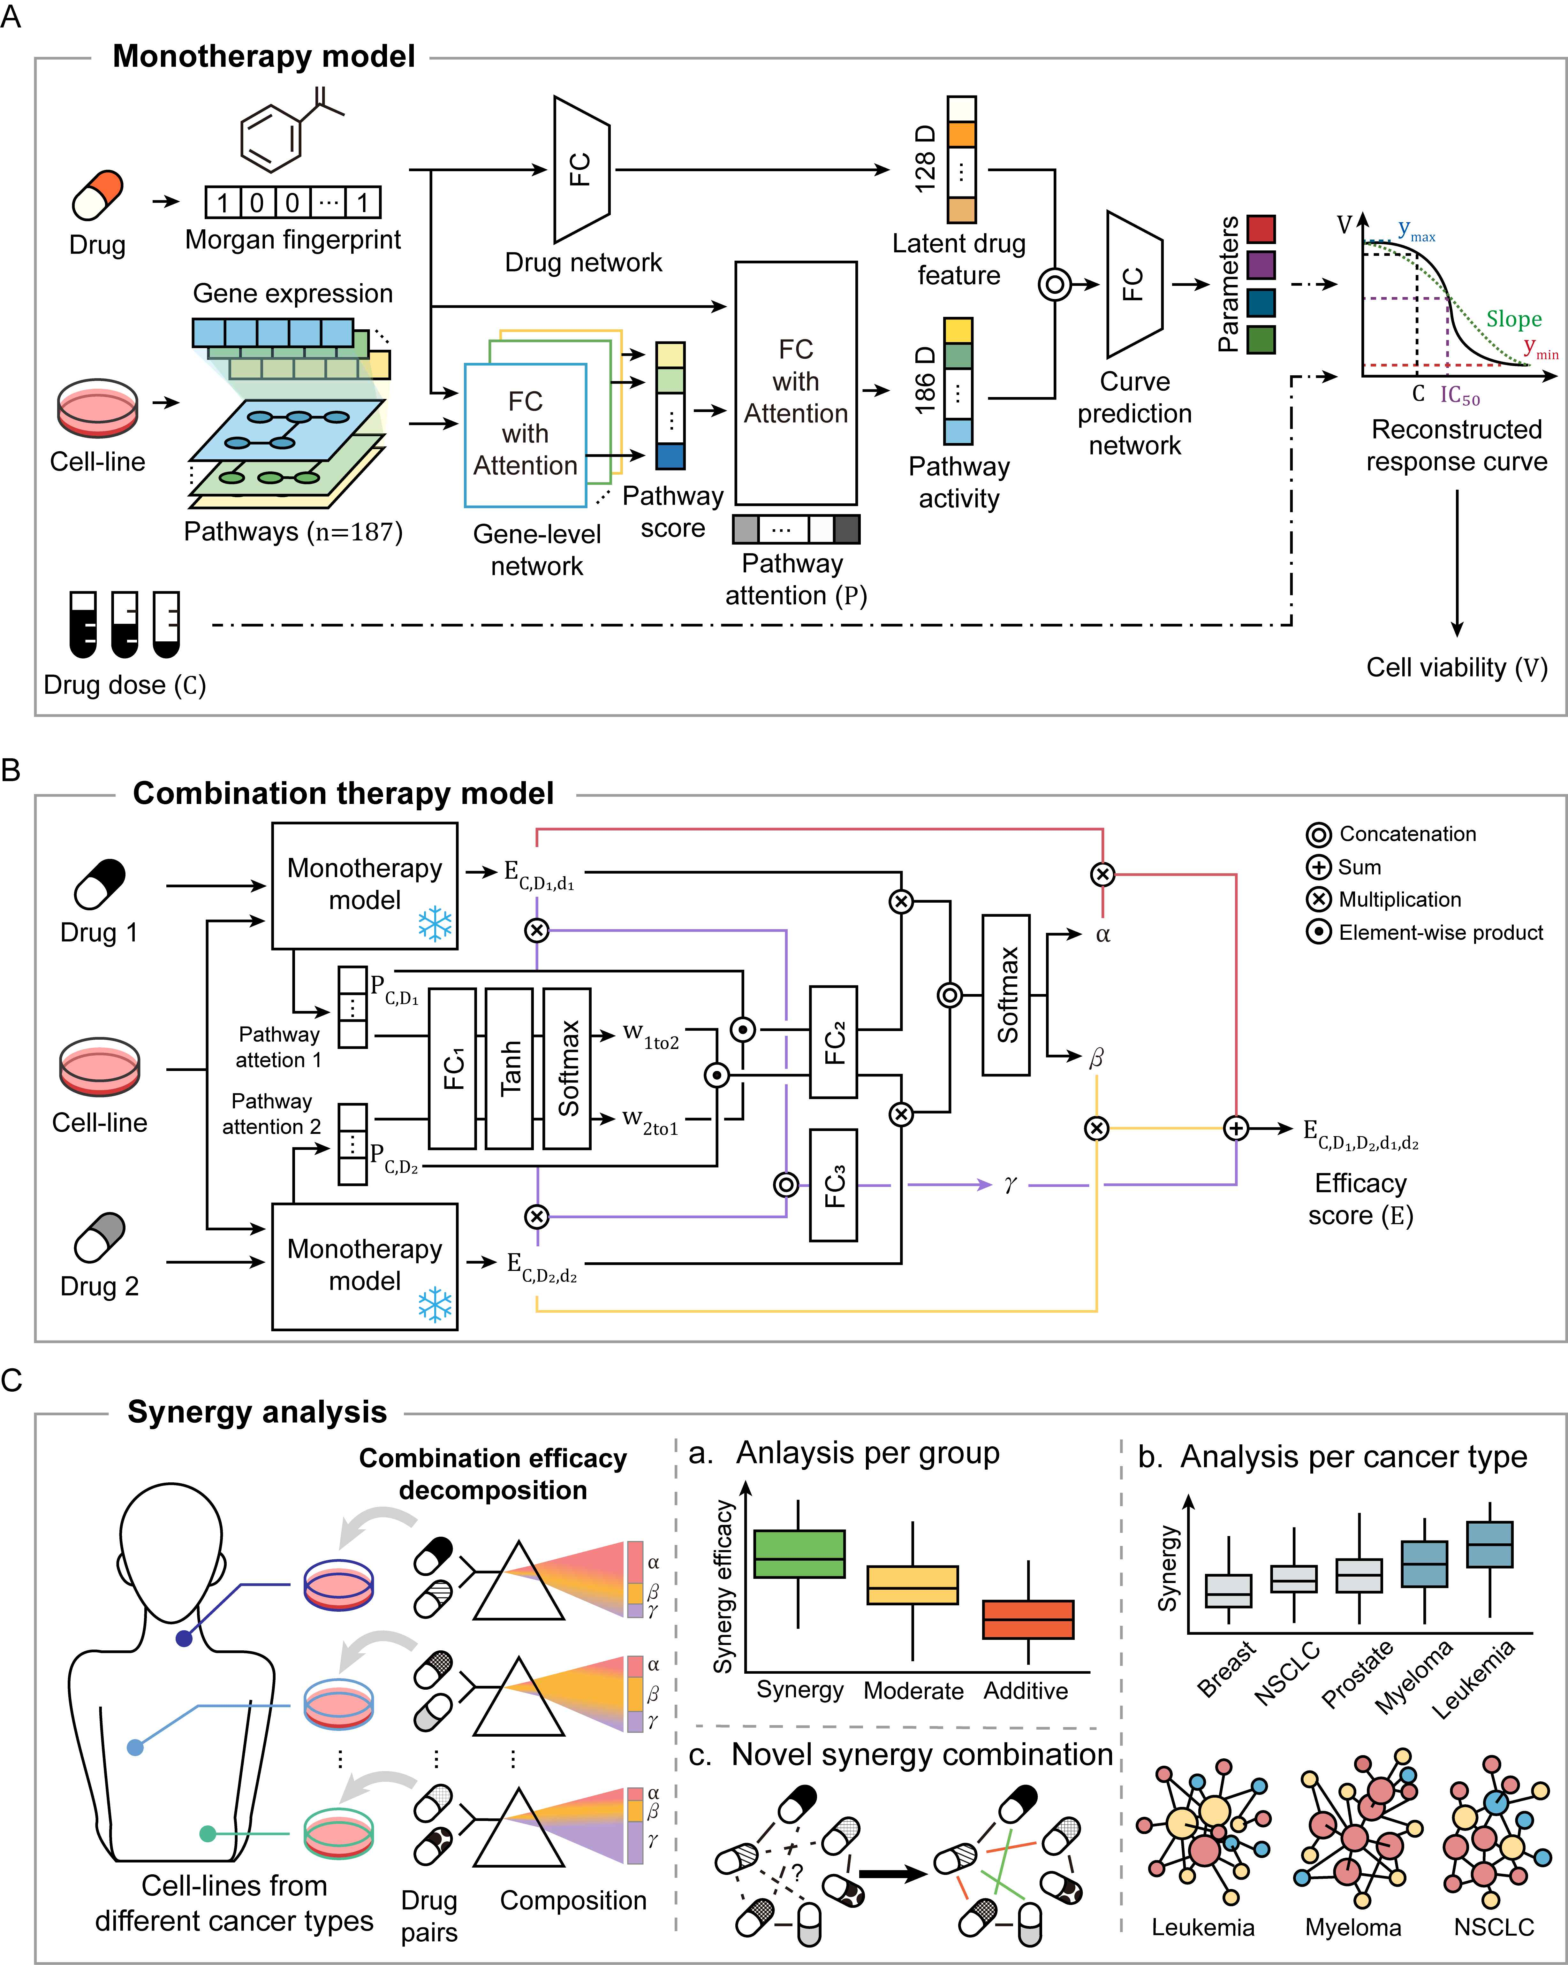

▲ DD-PRiSM research overview. It shows the two AI models that make up the research and the analysis method using them.

This model analyzes and predicts the drug mechanism and drug response curve between cancer cells and single anticancer drugs by utilizing the gene expression level of cancer cells and the structural information of single anticancer drugs, and then calculates the efficacy of the combined anticancer drug by predicting the synergistic effect of the combined anticancer drug that combines two single anticancer drugs and the influence of each single anticancer drug using the efficacy and drug mechanism of each single anticancer drug at a given concentration.

The advantage of this research result is that it can predict efficacy for any cell line, drug, and drug concentration.

The efficacy or synergistic effect of the combined anticancer drug on cancer cells varies depending on the concentration of each anticancer drug, but existing studies that predict the average value at all concentrations cannot predict the change in the synergistic effect according to the concentration.

In addition, it showed high performance of Pearson correlation coefficient* 0.9063 for cancer cell-composite anticancer drug combinations that were not covered in the learning process, and when compared with IDACombo*, another concentration-dependent compound anticancer drug efficacy prediction model under the same conditions, the root mean square error was improved by 8.37%.

* Pearson correlation coefficient: A method used in statistics to measure the degree of linear relationship between two variables, with a value between -1 and +1, where the closer the value is to +1, the more perfect the positive linear relationship, and the closer it is to -1, the more perfect the negative linear relationship. A value closer to 0 indicates that there is no linear relationship between the two variables.

* root mean squared error: An indicator that measures how much the estimated value differs from the actual value in statistics or machine learning, where a smaller value indicates a more accurate prediction.

* IDACombo: Based on the Independent Drug Action model, which is one of the models that explains the efficacy of combination anticancer drugs, the efficacy of combination anticancer drugs is calculated by assuming that the efficacy of the combination anticancer drug is the same as the efficacy of the two single anticancer drugs that make up the combination anticancer drug.

The research team also confirmed that combination anticancer drugs with strong synergy effects contain a higher proportion of targeted anticancer drugs* than combination anticancer drugs with weak synergy effects.

Based on the predicted synergy effects, each combination anticancer drug was classified into three groups (high/medium/low) based on the synergy effects, and as a result of the analysis, the ‘high’ group (56.58%) contained more targeted anticancer drugs than the other groups (medium: 40.52%, low: 35.96%).

* targeted anticancer drugs: Since they attack only specific markers possessed by cancer cells, they do not affect normal cells and are several times more effective at killing cancer cells than cytotoxic anticancer drugs.

The research team also confirmed that the degree of synergy effect occurs differently depending on the cancer type through the AI ​​model, and suggested a promising combination of anticancer drugs and concentrations for each cancer type.

As a result, it was confirmed that blood cancer was predicted to have a higher synergy effect than solid cancer. In particular, while a small number of anticancer drugs lead the synergy effect in blood cancer, a large number of anticancer drugs each showed a synergy effect with a small number of other anticancer drugs in solid cancer.

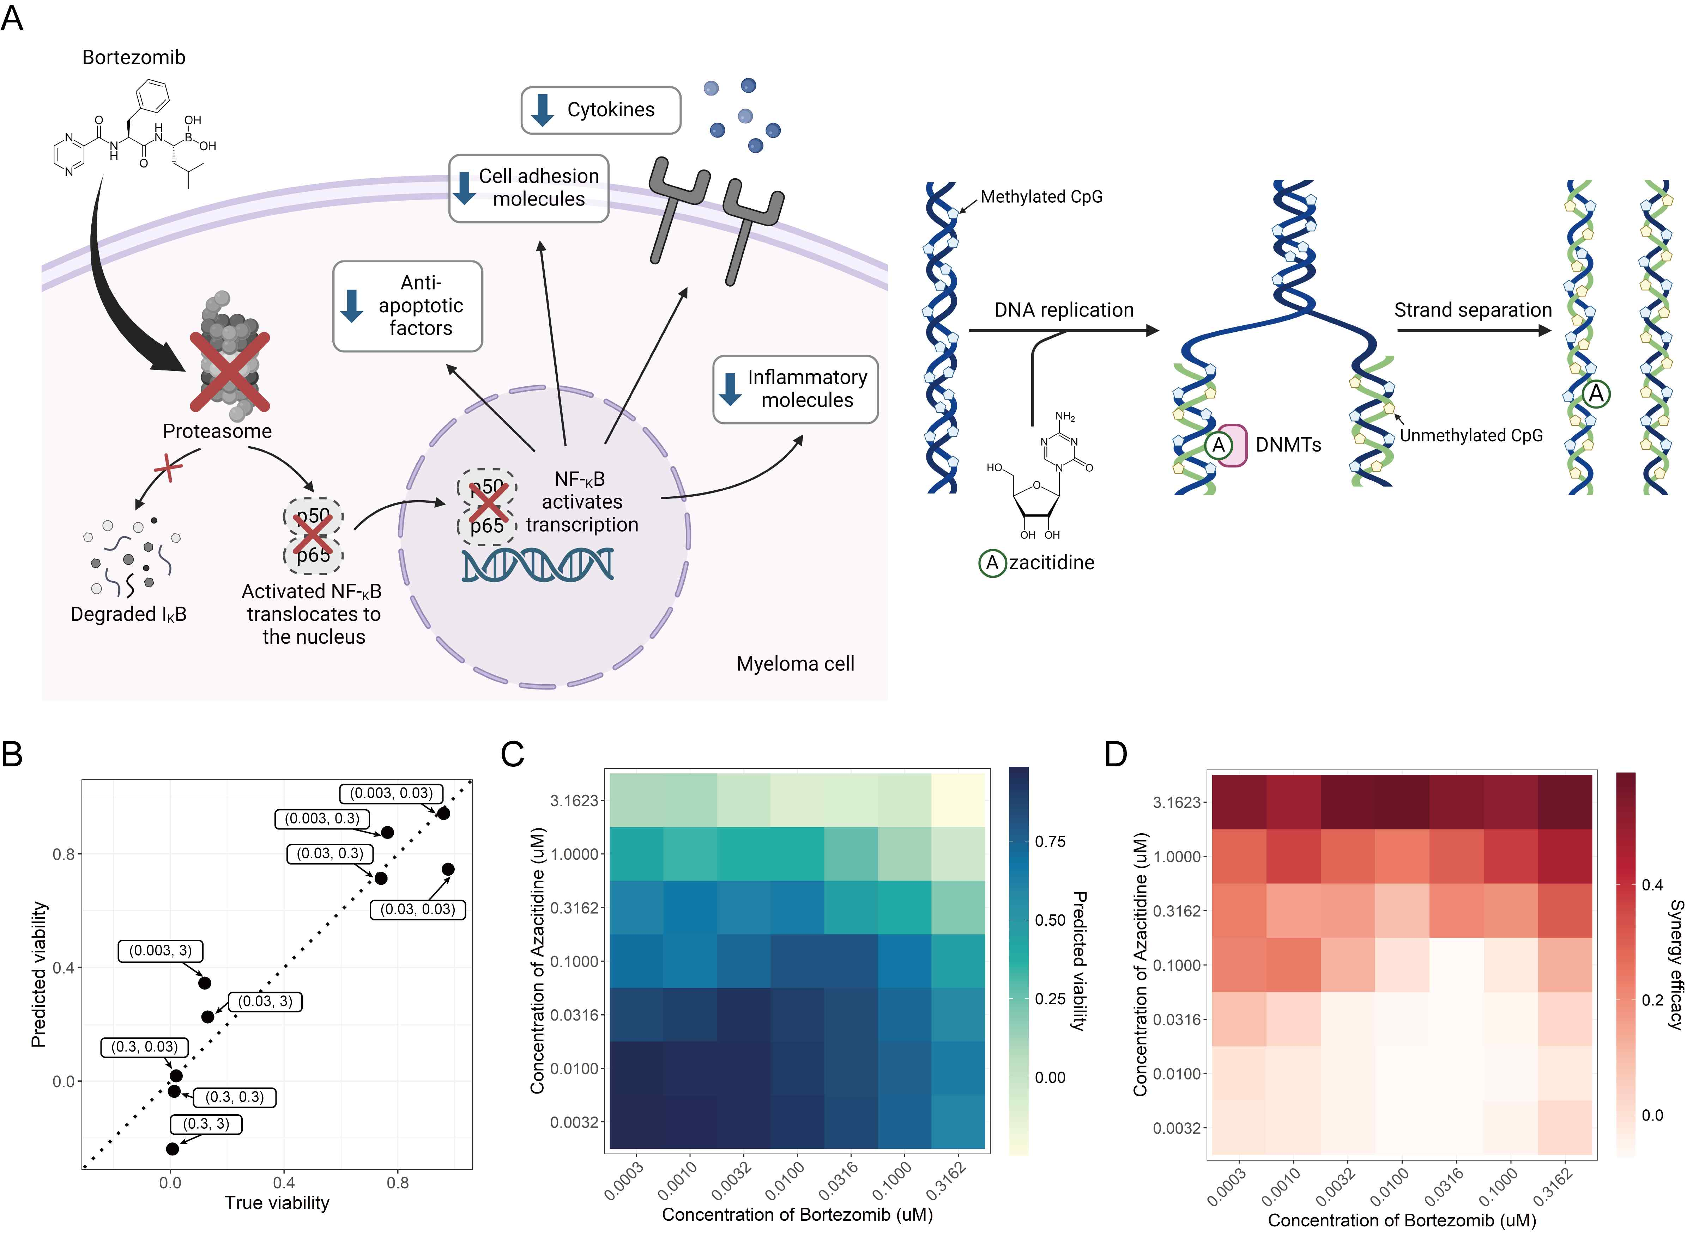

▲ Potential combination of anticancer drugs and concentrations predicted by DD-PRiSM. (A) Mechanism of action of the drugs (bortezomib, azacitidine) that make up the predicted combination anticancer drug. (B) Actual cell viability and cell viability predicted by DD-PRiSM when the combination anticancer drug was administered to multiple myeloma cell line RPMI-8226. (C) Cell viability by concentration of the combination anticancer drug predicted by DD-PRiSM. (D) Synergy effect of the corresponding combination anticancer drugs by concentration predicted by DD-PRiSM.

The research team suggested a total of 2,556 promising combination anticancer drugs, from as few as 41 pairs of combination anticancer drugs (prostate cancer) to as many as 417 pairs of combination anticancer drugs (myeloma), depending on the cancer type. In particular, the combination of bortezomib* and azacitidine* was found to have a high synergy effect and thus a high anticancer effect on RPMI-8226, a multiple myeloma cell line.

* bortezomib: It is a drug that is effective in treating multiple myeloma and some lymphomas and has recently attracted attention in the field of cancer treatment. This drug acts by inhibiting the proteasome, a protein-decomposing enzyme, thereby interfering with the survival and division of tumor cells.

* azacitidine: Recently, it has been attracting attention as an innovative drug that opens up new possibilities in cancer treatment. It is mainly used to treat blood cancers, especially acute myeloid leukemia (AML) and promyeloma, and plays a role in suppressing the growth and survival of cancer cells by regulating the DNA methylation status of cells.

Professor Hojung Nam explained the significance of this research result, saying, “It will greatly increase the accuracy of customized anticancer treatment. In particular, it is expected to have great clinical utility because it can precisely predict the administration concentration of complex anticancer drugs.”

This research, supervised by Professor Hojung Nam of the School of Electrical Engineering and Computer Science at GIST and conducted by Iljung Jin, a combined master’s and doctoral student, Songyeon Lee, a doctoral student, and Martin Schmuhalek, a combined master’s and doctoral student, was supported by the Ministry of Science and ICT and the National Research Foundation of Korea’s Advanced High-Performance Computing Utilization Project and the Korea Institute for Advancement of Technology’s Medium-Sized Enterprise DNA Convergence Industry-Academic Cooperation Project, and was published online in the international academic journal 《Briefings in Bioinformatics》 on January 12, 2025.



