"CO₂ as a high value-added petrochemical raw material" GIST develops eco-friendly catalyst technology, securing the world’s highest stability and efficiency

- Professor Sukwon Hong's team in the Department of Chemistry developed a catalyst that can synthesize highly absorbent materials (sodium acrylate) used for diapers and other sanitary products using carbon dioxide and ethylene... Reduced carbon emissions and increased efficiency

- Achieved the world's highest level of catalyst efficiency (TON 514→570) while significantly increasing production efficiency (yield 21%→82%) and confirmed the possibility of mass production... Published in the international academic journal 《Journal of CO₂ Utilization》



▲ (From left) Professor Sukwon Hong of GIST, Dr. Chang Hee Lee of LG Chemical, PhD student Changmuk Kang of GIST, and Dr. Seyong Kim of GIST

The Gwangju Institute of Science and Technology (GIST, President Kichul Lim) announced that the research team led by Professor Sukwon Hong of the Department of Chemistry has developed a catalyst that can synthesize sodium acrylate, a high value-added petrochemical raw material, using carbon dioxide (CO₂) and ethylene, with the world’s highest level of stability and efficiency.

This research achievement, which achieved an efficiency of TON* 570 and a production efficiency of yield* 82%, not only records the world’s highest level of turnover but also achieves an innovation that surpasses existing limits in terms of yield.

* turnover number (TON): A value indicating how much reactants can be converted into products by one catalyst, and is an important indicator for evaluating the performance of a catalyst. A high turnover number means that a large amount of products can be obtained with a small amount of catalyst. (Focus on catalyst efficiency)

* yield: A value indicating the amount of products actually obtained as a percentage compared to the amount of products theoretically obtained in a reaction. A high yield means that the products actually obtained were obtained efficiently without waste. (Focus on production efficiency)

Sodium acrylate, a key raw material for super absorbent polymer (SAP) materials used for sanitary products such as diapers, is steadily increasing in demand worldwide.

Sodium acrylate is mainly synthesized by reacting propylene with oxygen at high temperatures, but this process is evaluated as needing improvement in terms of energy efficiency and the environment.

Accordingly, a synthetic technology utilizing carbon dioxide and ethylene is gaining attention as an alternative that can achieve the two goals of reducing carbon emissions and producing high value-added chemicals.

However, this technology is very difficult to implement as it is considered a very challenging task in the field of catalysts, and the low conversion number and yield of existing catalysts make it difficult to use in actual processes, so research on this has been required.

The catalyst developed by the research team achieved the highest conversion number record (efficiency TON 570) while reaching 82% yield, and recorded 99% yield at conversion number 312. This innovative result that overcame the limitations of existing technologies opened up new possibilities for chemical processes utilizing carbon dioxide.

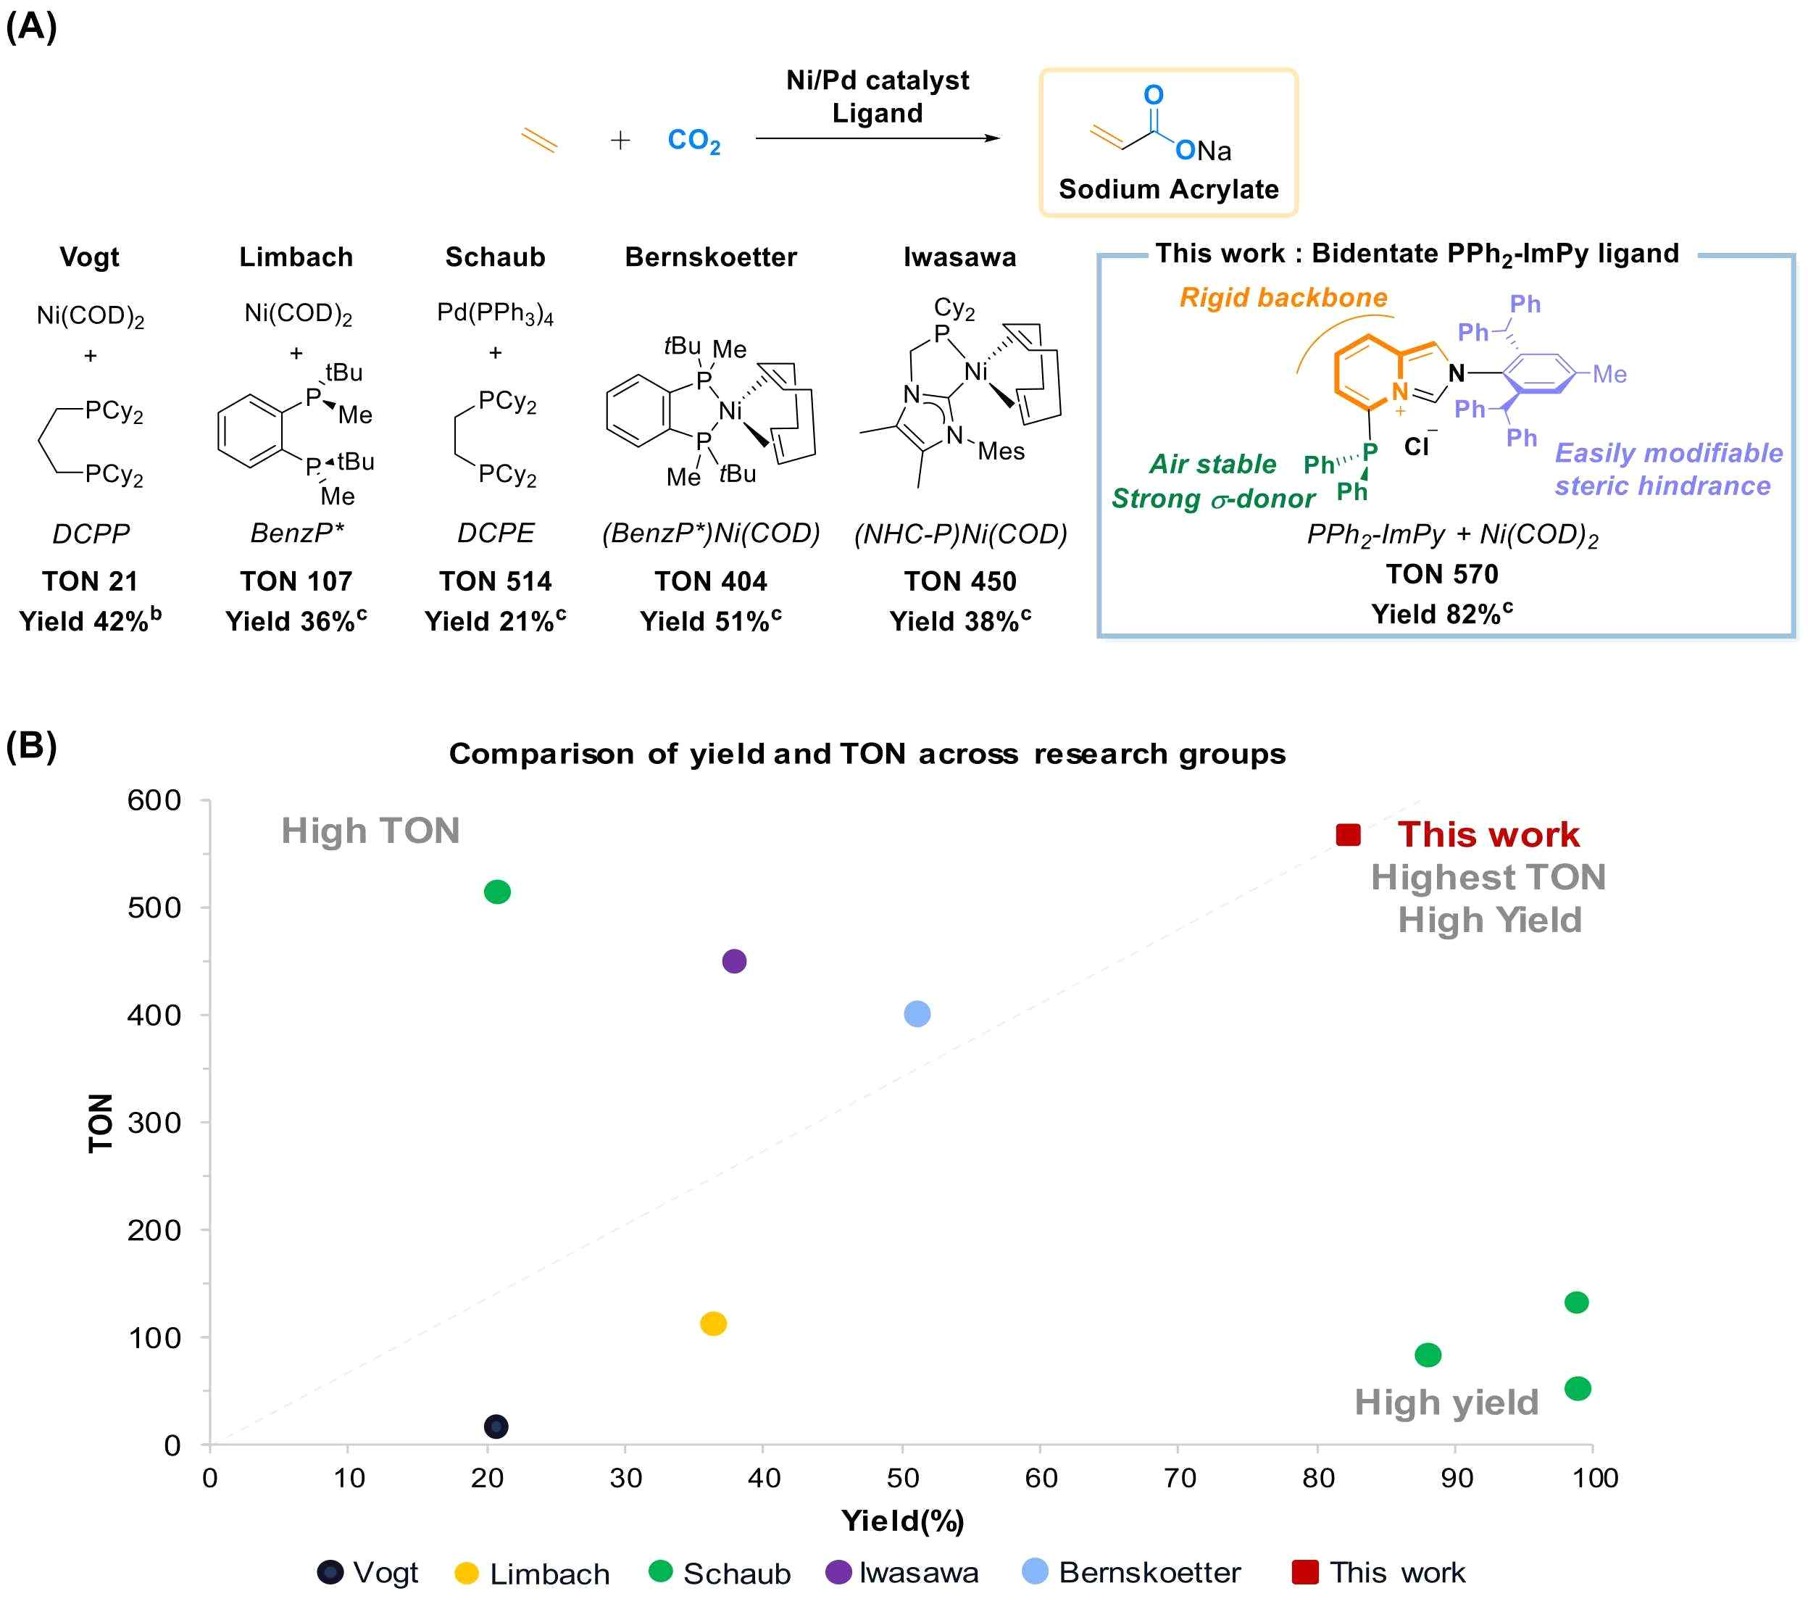

▲ (A) Structure and results of previously reported catalysts and the catalyst structure proposed in this study. (B) Comparison of yield and conversion number between research groups. In previous studies, the limitations were to tolerate low yields of 20-50% to achieve high conversion numbers in the range of 400-500, or to stay at a low conversion number of about 100 to achieve high yields of 90%. However, in this study, the highest conversion number of 570 was achieved with high yield (82%), and conversion number of 312 with 99% yield.

The previous world record was about conversion number of 514 (yield of 21%), but generally, as conversion number increases, yield decreases, and as yield increases, conversion number decreases.

The research team developed a nickel (0) compound catalyst with a solid and planar structure, securing excellent stability and efficiency compared to existing catalysts. These structural characteristics can maximize the reaction stability of the catalyst and minimize performance degradation.

In addition, the possibility of simplifying the process was also proven by separating sodium acrylate, which is produced through a simple water extraction method* in which the byproduct is insoluble in water and only the product, sodium acrylate, is soluble in water, with a high yield.

* Water extraction method: A method in which the raw material is crushed using a wet or dry method and then water is added to extract the oil.

Professor Sukwon Hong commented, “This study has created a new era in chemical processes using carbon dioxide, and its application and expansion to industrial scales are especially expected. It has overcome the limitations of existing processes and raised the feasibility of high-efficiency sodium acrylate synthesis technology using carbon dioxide and ethylene to the next level.”

He also said, “In the future, it will be able to substantially contribute to carbon reduction and production of high value-added materials in various chemical processes including acrylic acid synthesis.”

This study, supervised by Professor Sukwon Hong of GIST, with Dr. Chang Hee Lee of LG Chemical serving as co-corresponding author and doctoral student Changmuk Kang and Dr. Seyong Kim as co-first authors, was supported by the Nano and Materials Technology Development Program of LG Chemical, the Ministry of Science and ICT, and the National Research Foundation of Korea. The results of the study were published online in the international academic 《Journal of CO₂ Utilization》 on December 18, 2024.



