“There is a reason for the wildfires in LA and heavy snowfall in New York” GIST discovers mechanism for changing atmospheric circulation system “Climate change will cause amplification of atmospheric circulation in the Northern Hemisphere, which will lead to more frequent and severe abnormal weather phenomena”

- Korea-US international joint research team led by Professor Jin-Ho Yoon of the School of Environment and Energy Engineering, identifies the phenomenon of amplified atmospheric circulation in winter on a future warming Earth through climate model simulations

- Published in the international academic journal 《npj Climate and Atmospheric Science》



▲ (From left) School of Environment and Energy Engineering PhD student Jueun Lee and Professor Jin-Ho Yoon

As global warming accelerates, research results have been released that extreme weather phenomena such as droughts, heavy rains, and cold waves will occur more frequently in the northern hemisphere mid-latitudes in the future*, which will become hotter.

* According to the IPCC 6th report, the results for 2100 were discussed.

The Gwangju Institute of Science and Technology (GIST, President Kichul Lim) announced that Professor Jin-Ho Yoon's research team in the DepaSchool of Environment and Energy Engineering discovered the phenomenon and key mechanism of the large-scale atmospheric flow (planetary waves*) that directly affects the northern hemisphere's winter weather through a joint Korea-US international study, and clarified the impact of future climate change on the atmospheric circulation in winter.

By clarifying the fundamental causal relationship of why changes due to warming such as greenhouse gas emissions and deforestation cause extreme weather and climate phenomena more intensively in certain regions, they have laid the foundation for a more systematic understanding and forecast of future climate development patterns.

* planetary wave: A large-scale wind system, such as a belt-shaped wind commonly observed in the atmosphere of a planet. It is a long-wave wave-like westerly wind belt that mainly occurs in the upper troposphere in the mid-latitudes. Magnitude 5,000 kilometers or more

Using a global climate model experiment*, the research team predicted that rising sea surface temperatures and a decrease in sea ice (sea ice) in the Arctic would further strengthen the large-scale flow of the winter atmosphere, and pointed out the strengthening of the convection* system due to the warming of the equatorial western Pacific as the main cause of this phenomenon.

The research team discovered that the strengthening and northward expansion of mid-latitude westerly winds play a key role in the process of amplifying the large-scale flow of the winter atmosphere. The strengthened westerly winds act as a conduit for transmitting wave energy generated in the equatorial western Pacific to the northeast, and the decrease in sea ice in the Arctic adds a weak but complementary effect to amplify the overall northern hemisphere atmospheric circulation.

* The research team used the Global/Regional Integrated Model system (GRIMs) version 4.0 global climate model to simulate future climate. This was used as a reference model for the development of the physical process of the Korea Meteorological Administration's (KIM) numerical weather forecast model. It is widely used for various research purposes such as intra-seasonal/inter-seasonal forecasting and understanding climate change. The experiment was analyzed for the points at which the temperature increased by 1, 2, and 3 degrees compared to the past climate (1920-1949), and the point at which the temperature increased by 3 degrees corresponds to approximately 2080.

* convection: A method of heat transfer that occurs in a fluid such as a gas or liquid. Heat is transferred by the flow of the fluid caused by a temperature difference.

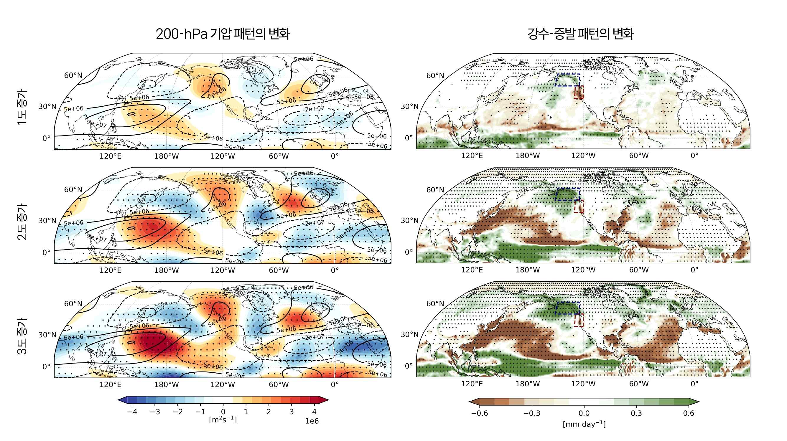

▲ Changes in the pattern of enhanced atmospheric circulation and surface precipitation patterns in the upper troposphere (200 hPa) during the northern hemisphere winter (December-January-February). Shown are changes in future warming climates of 1, 2, and 3 degrees Celsius using the GRIMs climate model simulation. (1) The degree of change (shading) compared to the control experiment (Contour) is shown, and the amplification pattern of planetary waves is observed at a fixed location compared to the climate value. (2) Looking at the change pattern of surface net moisture flux (precipitation minus evaporation), the phenomenon of enhanced divergence is observed in the equatorial western Pacific region.

This amplified atmospheric circulation was found to have a significant impact on winter weather, especially in North America. Specifically, it was confirmed that the development of high pressure in the western U.S. and low pressure trough in the eastern U.S. is closely related to the recent frequent occurrence of wildfires and droughts in the western U.S. and extreme snowfall and cold spells in the eastern U.S.

Professor Jin-Ho Yoon stated, “This study is significant in that it integrates the major mechanisms of atmospheric circulation changes suggested by previous researchers into one, and systematically explains the dynamic causal relationship with the recently observed atmospheric circulation amplification phenomenon. This phenomenon may become more extreme in the future, leading to serious climate risks, and we must hurry to thoroughly prepare for this.”

This study, supervised by Professor Jin-Ho Yoon of the School of Environment and Energy Engineering at GIST and participated by Ph.D. student Jueun Lee, was supported by the Ministry of Science and ICT and the National Research Foundation of Korea's Ocean and Polar Basic Technology Development Project and the Mid-level Research Project, and the Korea Environmental Industry & Technology Institute's New Climate System Environmental Technology Development Project. Professor Shih-Yu (Simon) Wang of Utah State University, Professor Seok-Woo Son and Professor Daehyun Kim of Seoul National University, Professor Jee-Hoon Jeong of Sejong University, and Professor Hyungjun Kim of KAIST participated.

The results of the study were published online on January 17, 2025, in the international academic journal 《npj Climate and Atmospheric Science》, a prominent international academic journal in the field of meteorology and a sister journal of Nature.



