“Securing clean water with eco-friendly future technology to solve water shortage” GIST, MIT, and international joint research team from the US, UK, Australia, and China, first to discover the unique water permeation phenomenon of graphene membranes

- Professor In S. Kim's visiting professor team from the School of Environment and Energy Engineering, along with international joint research teams from MIT, Northumberland University, and the University of New South Wales, Australia, have elucidated the principle of ultra-fast water molecule movement in a layered graphene oxide membrane.

- It is expected to lead to innovation in water treatment processes that require selective separation, such as advanced water treatment and seawater desalination, as it can significantly improve the material separation selectivity. Published in the international academic journal 《Chemical Engineering Journal》



▲ (From left) Professor In S. Kim of GIST and Dr. Chang-Min Kim (currently a research professor at Korea University)

Membrane-based technology*, which is widely used in recent water treatment and gas separation processes, is attracting attention as an eco-friendly future technology with high energy efficiency and low carbon emissions.

The membrane, which is the core component of this process, is mostly made of polymer materials, but when used for a long time, it shows limitations such as ▴ performance deterioration due to changes in material properties ▴ increased membrane resistance due to membrane fouling ▴ trade-offs between permeability and selectivity performance, so the development of new materials is necessary.

* membrane-based technology: Membranes not only have a general filtration function of particle separation by selectively passing specific components, but also have selective permeability that allows separation of dissolved substances or mixed gases in liquids. Membranes used in water treatment play a filtration role by allowing water to pass through but not allowing suspended solids to pass through, making separated water usable clean water.

The Gwangju Institute of Science and Technology (GIST, President Kichul Lim) announced that the research team of Professor In-Soo Kim of the Department of Environmental and Energy Engineering has successfully developed a layered oxide separation membrane using graphene as a material through international joint research and elucidated the principle of occurrence of the specific permeation phenomenon of water molecules in the layered graphene oxide membrane*.

In the case of conventional polymer membranes, pure water permeability* decreases significantly due to resistance as the thickness of the membrane increases, and there is a large difference depending on the material and structure of the membrane. On the other hand, in the case of layered graphene oxide membranes, the resistance is small even when the thickness increases, so the phenomenon of ultrafast and unblocked permeation has not been clearly identified until now.

* layered graphene oxide membrane: A membrane with a structure of graphene oxide in which two-dimensional materials, graphene oxide nanosheets (graphene oxide that forms a sheet with a size smaller than micro size), are stacked one after another and laminated by van der Waals forces.

* pure water permeability: The amount of ultrapure water that passes by applying a certain pressure to a unit area.

Selective membranes are the most important factor in determining membrane separation performance, so the development of a membrane that can maintain high permeability and selectivity at the same time and is also physically and chemically stable is most important in overcoming the limitations of existing polymer material membranes.

This research result is expected to significantly improve the material separation selectivity in the layered graphene oxide membrane, and to apply this mechanism in the synthesis of commercial membranes using other two-dimensional materials*, thereby creating a new concept of selective membrane.

* two-dimensional layered materials (2DLMs): Materials in which atoms form a crystal structure on a plane with a single atomic layer thickness.

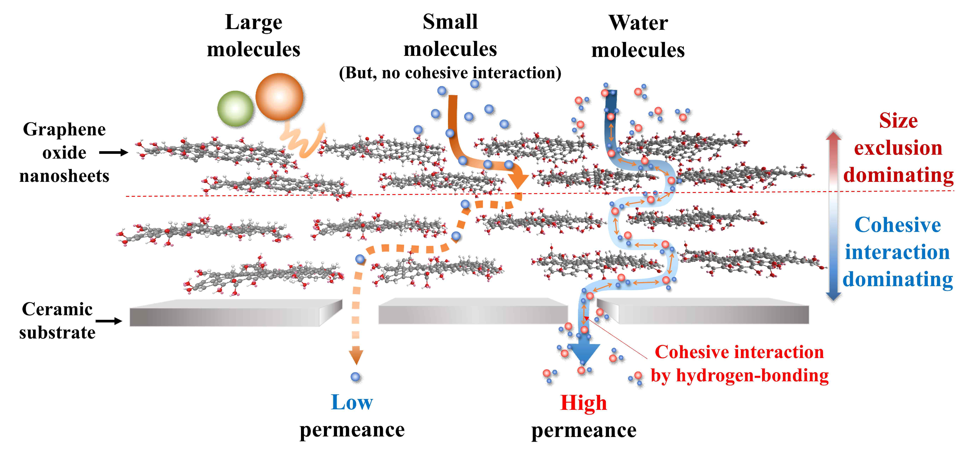

▲ Schematic diagram of the mass transport mechanism in a layered graphene oxide membrane. The fundamental mechanism of molecular permeation and the specific permeation mechanism of water molecules in a layered graphene oxide membrane were elucidated as the thickness changes.

Based on the advantages of graphene, which is called a dream material, such as atomic-level thickness, excellent mechanical strength, physicochemical stability, and chemical deformability, the research team synthesized an asymmetric separation membrane* using graphene oxide as an active layer* and porous ceramic as a support layer*.

Through previous research, the research team confirmed that the laminated graphene oxide film has high permeability and selectivity for small molecules (e.g., water, hydrogen molecules, etc.) in gas permeation, and in particular, in the case of water molecules, it was confirmed that permeation was possible at a rate of approximately 99% of the air diffusion rate* in the laminated graphene oxide film. * Active layer: A high-density thin film layer that determines the selectivity and separation of the membrane

* support layer: A thick layer that provides physical support to the active layer of the thin film

* asymmetric membrane: A membrane with an asymmetric cross-section where the active layer and support layer are combined

* diffusion: A phenomenon in which a specific substance naturally moves from a high concentration phase to a low concentration phase. In a membrane, when a concentration gradient of a specific substance is formed on both sides of the membrane, the phenomenon in which the substance selectively passes through the membrane from the high concentration phase to the low concentration phase

In addition to elucidating the phenomenon in which water molecules permeate ultrafast and unobstructed through the synthesized layered graphene oxide membrane, the research team also confirmed the specific permeation mechanism of water molecules.

As a result of observing the permeation phenomenon while changing the thickness of the laminated graphene oxide layer that constitutes the active layer, the general solvent molecules (methanol, ethanol, etc.) used in the experiment could hardly penetrate even the thin laminated graphene oxide film (140 nm), whereas in the case of water molecules, the permeation decreased by only about 40% even though the thickness of the graphene oxide active layer increased by about 1,500% (140 nm → 2000 nm).

In order to identify the specific water molecule permeation phenomenon, the research team changed each condition in a device that could control temperature, pressure, humidity, and weather conditions and confirmed the permeation characteristics.

As a result of comparing the permeation performance of finely permeable solvents and the permeation performance of water molecules, it was revealed that the size-resistance diffusion*, in which the size exclusion* effect and the diffusion effect simultaneously work, acts as a very important mechanism in the laminated graphene oxide film.

* size exclusion: Also called the molecular sieving effect, a phenomenon in which large substances cannot pass through and small substances pass through, a sieve effect occurs.

* hindered diffusion: Generally, when there are pores in a selective separation membrane, substances are permeated based on the size exclusion mechanism, and when there are no pores (non-porous membrane), substances are permeated based on the diffusion mechanism, but the size exclusion effect and diffusion effect work simultaneously to permeate substances.

Through thermodynamic analysis, the research team discovered that water molecules are transformed from gas to liquid-like fluid in a very limited space at the nanoscale, and it was confirmed that a complete change to liquid is impossible in a limited space, so a phase change* occurs, allowing a large amount of water molecules to move even in a short path.

Through this, it was proven that size-resistance diffusion is the mechanism for water molecules to show high permeability in contrast to other substances, and it was clarified that the interaction between individual water molecules and graphene oxide and the strong cohesion between water molecules are very important factors in the non-delayed permeation phenomenon in which the permeability decreases only slightly even when the thickness of the laminated graphene oxide layer increases greatly.

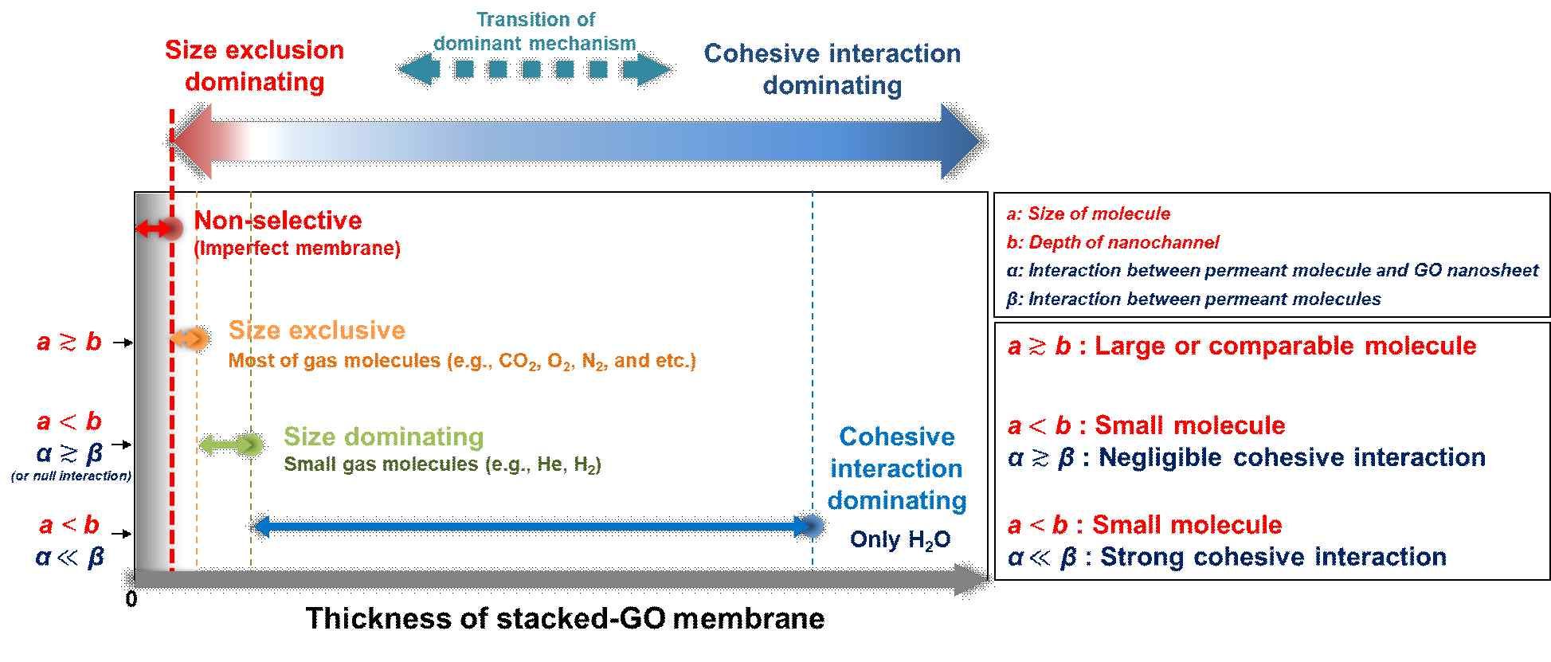

▲ The principle of mass transport regulation in laminated graphene oxide membranes being transferred to size exclusion and relative interaction. The reason why water molecules show a specific permeation phenomenon is affected by the small size of the molecule, but it was confirmed that the strong cohesion of water can maintain permeability even in thick laminated graphene oxide membranes.

At this time, the thinner the stacking thickness and the smaller the size of the penetrant in the laminated graphene oxide membrane, the better the penetration of the molecule, the ‘size-resistance diffusion’, which is the dominant mechanism for molecular penetration, was proven, while when the stacking thickness increases, the relative interaction force between the penetrant and the laminated graphene oxide membrane becomes a very important mechanism and changes or transitions.

* Quasi phase transition: An incomplete phase transition state in which molecules are arranged and combined in two dimensions because there is not enough space for molecules to align in three-dimensional space

Professor In S. Kim explained, “The greatest significance of this study is that it has elucidated the transition phenomenon of the water molecule movement mechanism that occurs in the laminated graphene oxide membrane. It is expected that in the future, not only will it be possible to synthesize commercial membranes using graphene, but also to elucidate the molecular movement mechanism in the laminated structure using two-dimensional materials, and thus present a new paradigm for the development of advanced water treatment, seawater desalination, and gas separation membranes.”

This study was conducted with the support of the National Research Foundation of Korea's Creative Challenge Research Project, the Ministry of Science and ICT's STEAM Research Project (Future Promising Convergence Technology Pioneer Science Challenge Type) Research Project, and the Regional Innovation Leading Research Center Research Project, and was published online on January 3, 2025 in the Chemical Engineering Journal, a top 3.1% international academic journal in the field of environmental engineering.

Meanwhile, Professor In S. Kim, who has been conducting research on membrane synthesis and membrane processes, has achieved various results in graphene-based membrane research. In 2021, he founded Innosep Co., Ltd., a hollow fiber membrane manufacturing company for hemodialysis, and is currently serving as the Chief Technology Officer (CTO). He is also a member of the Korean Academy of Science and Technology and the International Water Association (IWA).



