“If all the windows of Seoul’s buildings were solar cells” GIST develops semitransparent solar cells that blend in with the cityscape, realizing large areas, stability, and high efficiency

- Joint research team of Research Institute of Solar and Sustainable Energies Principal Researcher Hongkyu Kang and School of Materials Science and Engineering Professor Kwanghee Lee secures high efficiency and long-term stability with the world's highest level 206 cm² semitransparent organic solar cell module area

- "Applicable to various fields requiring transparency such as building windows, vehicle glass, and displays" - Published in international academic journal 《Chemical Engineering Journal》



▲ (From left) Principal Researcher Hongkyu Kang, Professor Kwanghee Lee, Research Fellow Hyeon-Seok Jeong (first author), PhD student Taeyoon Ki (first author), Research Fellow Dongha Lim (first author)

Solar cells that can convert solar energy into electrical energy are attracting attention as a clean energy source to respond to the climate crisis, but the currently commercialized silicon solar cells are bulky, heavy, have low efficiency, and are opaque, making it difficult to harmonize with urban buildings.

A Korean research team has successfully developed a large-area semitransparent organic solar cell module measuring 206 cm², the world’s largest, that has undergone a high-stability test of over 1,000 hours, thereby successfully catching ‘two birds with one stone’ of large-scale and durability, and is expected to enable commercialization that satisfies both high efficiency and aesthetics in the building-integrated photovoltaic (BIPV) market.

The Gwangju Institute of Science and Technology (GIST, President Kichul Lim) announced that a joint research team led by Hongkyu Kang, a senior researcher at the Next Generation Energy Research Institute, and Kwanghee Lee, a professor at the School of Materials Science and Engineering, has developed ‘next-generation semitransparent organic solar cell’ technology that can lead the urban-friendly solar power market. In particular, the research team succeeded in securing the world’s highest level of stability through this research achievement.

Semitransparent organic solar cells can be applied to various fields that require transparency, such as building windows, vehicle glass, and displays, and are gaining attention as an energy solution that is in harmony with the urban environment because they can produce electricity while maintaining aesthetics.

In particular, since they are expected to contribute to the expansion of urban eco-friendly energy infrastructure and the establishment of a future energy industry ecosystem, they can be manufactured on a large area, and long-term economic feasibility and eco-friendliness can also be expected through future process automation and production efficiency maximization.

However, existing semitransparent organic solar cell technology has problems such as long-term stability and difficulty in large-area implementation for building applications due to the vulnerability of organic materials and transparent electrodes.

In addition, organic solar cells have been mainly studied in opaque forms so far, and research on semitransparent organic solar cells has also been limited to small cell units or small-area modules, so there has been no research that has achieved both efficiency and stability at a commercially competitive level.
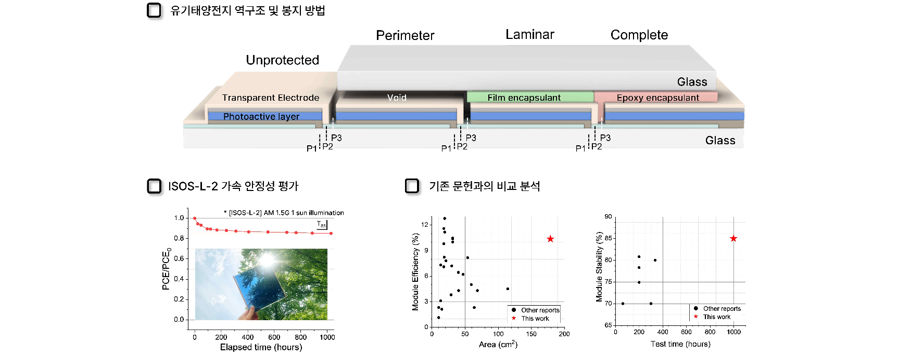
▲ (Top) Schematic diagram listing the cross-sectional structure and encapsulation methods of the semitransparent organic solar cell module produced by our research team, (bottom left) Efficiency change trend through long-term stability evaluation of large-area modules, and (bottom right) excellence index of this study compared to efficiency and stability reported in existing literature

In particular, organic solar cells are sensitive to the external environment (moisture, oxygen, ultraviolet rays, etc.), and have durability issues where efficiency rapidly decreases over time. The existing encapsulation method* not only fails to sufficiently block these stress factors, but also significantly reduces the transmittance when general encapsulation materials* are applied, which has acted as a major obstacle to the commercialization of semitransparent organic solar cells.

* encapsulation method: Sealing technology used to protect internal materials or devices from the external environment (moisture, oxygen, contaminants, etc.)

* encapsulation material: Sealing and protective material used to protect internal components from the external environment (moisture, oxygen, heat, UV, etc.). A material used as a core in the encapsulation method that maximizes the performance and lifespan of the target material or device

Therefore, the research team introduced the slot-die coating* process to implement module scalability, and secured efficiency uniformity by implementing a uniform coating thickness even in large-area modules. In addition, environmentally friendly non-halogen solvents were used instead of existing toxic solvents to simultaneously consider worker safety and environmental protection.

* slot-die coating: A coating method used for forming nano-thin films and mass production, a process technology that continuously applies liquid materials in a uniform and precise thickness.

The research team also introduced a new method to completely protect large-area module sizes based on glass-to-glass (G2G) encapsulation* technology. In particular, by utilizing a highly transparent solvent-free resin containing mercapto ester*, the polymer network formation by UV rays was induced, thereby delaying deterioration* caused by external factors and securing high durability of the module.

* Glass-to-glass (G2G) encapsulation: A technology that seals the inside by bonding two pieces of glass

* Mercapto ester: A compound containing a thiol group (-SH) and an ester group, and a substance used as a hardener for polymers and adhesives due to its excellent cross-linking ability

* Deterioration: A phenomenon in which the chemical and physical properties of an insulator deteriorate due to external or internal influences

Based on this, high stability (ISOS-L-2 test*) was secured under accelerated deterioration conditions of more than 1,000 hours in a large-area semitransparent organic solar cell module with a size of 206 cm², the world's best. Compared to the highest level reported in the existing literature of 4.5% photoelectric conversion efficiency in an area of 114.5 cm², this represents a 1.8-fold increase in area and a 2.3-fold increase in photoelectric conversion efficiency.
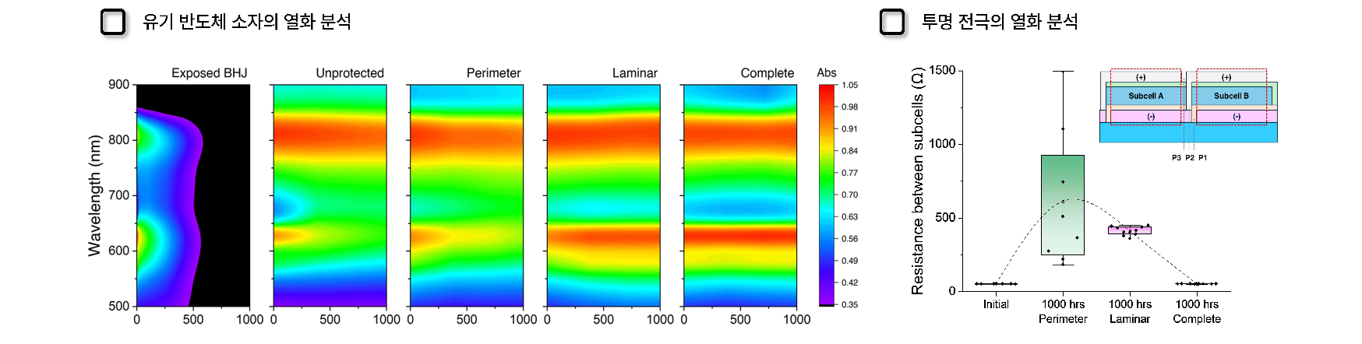

▲ (Left) Results of analyzing the change in absorbance of organic semiconductor materials over time to identify the degradation mechanism of semitransparent solar cell modules. The degradation process of the material due to photooxidation was confirmed, and it was proven that this could be effectively suppressed by applying a sealant. (Right) Changes in the internal resistance of the module confirmed that the sealant also successfully prevented photooxidation of the transparent electrode.

In addition, as a result of effectively suppressing photooxidation and electrode oxidation, which are the main degradation mechanisms of organic solar cells, the initial photoconversion efficiency decrease rate of 10.37% was maintained at 8.8% even after a 1,000-hour accelerated degradation condition test. In particular, while the reported literature showed an efficiency decrease of more than 20% within approximately 400 hours, this study demonstrated a groundbreaking improvement effect of only 15% decrease even after a long-term test of 1,000 hours.

* photo-oxidation: A phenomenon in which sunlight reacts with oxygen to change the chemical composition of organic semiconductor materials.

* ISOS-L-2 (International Summit on Organic PV Stability): A platform that presents international standards for evaluating and testing the stability of organic solar cells, and a standard that confirms how stably solar cells can operate in real environments through tests that reflect commercial outdoor conditions.

In addition, the research team received a test report from the Korea Glass Industry Co., Ltd. Technology Research Institute (now LX Glass Technology Research Institute), a certification agency, for optical and energy blocking performance that complies with the building glass standard (KS L 2514), thereby proving the possibility of replacing the currently used architectural glass with semitransparent organic solar cells.

In fact, based on the results of this research, Recell Co., Ltd., founded by Professor Kwanghee Lee of the School of Materials Science and Engineering in November 2022, is accelerating the establishment of a mass production system with the goal of commercializing building-integrated semitransparent organic solar cells.

Principal Researcher Hongkyu Kang explained, “The results of this research have solved the large-area expansion possibility and long-term stability issues of organic solar cells through the encapsulation process. It is expected to greatly contribute to the expansion of urban eco-friendly energy infrastructure by applying semitransparent solar cells to various areas of daily life such as vehicle windows and smart displays.”

This study, conducted by GIST Research Institute of Solar and Sustainable Energies Principal Researcher Hongkyu Kang and School of Materials Science and Engineering Professor Kwangjee Lee as corresponding authors, Research Institute of Solar and Sustainable Energies Hyeon-Seok Jeong, PhD candidate Taeyoon Ki, and Heeger Center for Advanced Materials Researcher Dongha Lim, was supported by the Climate Change Response Technology Development Project, Individual Basic Research, Startup Growth Technology Development, and GIST Research Institute of Solar and Sustainable Energies’s own institutional project supported by the National Research Foundation of Korea, the Ministry of Science and ICT, and the Ministry of SMEs and Startups, and was published in the prestigious international academic journal in the field of chemical engineering, 《Chemical Engineering Journal》, on January 1, 2025.



