"Proposed new principle for controlling the properties of battery materials using hydrogen ions" GIST, Kyung Hee University, and Georgia Institute of Technology develop new technology to improve the performance and lifespan of battery cathode materials

- GIST School of Materials Science and Engineering Professors KwangSup Eom and Joo-Hyoung Lee, Kyunghee University Professor Jung Tae Lee's joint research team, clarified the operating principle of metal oxide hydrogenation reaction and developed a new technology to control the material properties of metal oxides

- Hydrogenated molybdenum oxide cathode material realized high capacity (1.4~2 times↑), fast charging (approximately 20 minutes), and improved lifespan (maintains 76% of initial capacity even after 1,000 charge/discharge cycles) compared to existing commercial cathodes for lithium-ion secondary batteries

- Published in international academic journal 《Nature Communications》



▲ (From left) Professor KwangSup Eom (GIST), Professor Joo-Hyoung Lee (GIST), Professor Jung Tae Lee (Kyunghee University), Dr. JunHwa Kwon, and Dr. Soonsung So

Recently, research on improving energy storage performance such as batteries through material property modification using hydrogen ions in various fields such as energy has been attracting attention.

Until now, there has been a technical limitation in precisely controlling the degree of hydrogenation due to the lack of basic research on the operating principles of hydrogenation reactions, but Korean researchers have developed a technology that can control the material properties of metal oxides, and it is expected to be utilized in various material science fields such as energy storage and conversion systems.

The Gwangju Institute of Science and Technology (GIST, President Kichul Lim) announced that a joint research team of Professors KwangSup Eom and Joo-Hyoung Lee of the School of Materials Science and Engineering and Professor Jung Tae Lee of Kyunghee University has developed a metal oxide hydrogenation* technology that can modify the physicochemical properties of materials to properties suitable for energy storage using hydrogen ions.

* metal oxide hydrogenation: Refers to a reaction in which hydrogen ions and electrons are inserted (doped) into a metal oxide. A reduction reaction of a metal oxide occurs when electrons are supplied from a metal or metal ion with a relatively low standard reduction potential and hydrogen ions are supplied from an acidic electrolyte solution. (eg MO + xH+ + xe- → HxMO, MO: metal oxide)

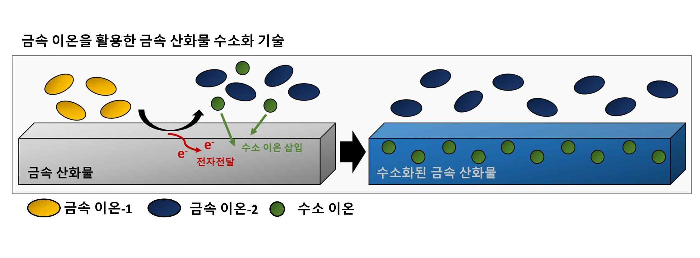

▲ Schematic diagram of oxide hydrogenation synthesis technology using metal ions: A galvanic corrosion reaction occurs at the interface between the metal oxide and metal ion-1. As the metal oxide is reduced (by receiving electrons), hydrogen ions present in the electrolyte are inserted into the metal oxide. At the same time, metal ion-1 is oxidized (by donating electrons) and exists in the electrolyte in the form of metal ion-2.

The synthesis method developed by the research team is a technology that can very precisely control the amount of hydrogen doped into the crystal structure of the metal oxide through the difference in the standard reduction potential* of the metal oxide and the metal ion dissolved in the acidic solution, as well as control and modify the crystal phase of the metal oxide.

The research team experimentally clarified that the operating principle of the metal oxide hydrogenation reaction is based on the electrochemical galvanic reaction*, which is a type of corrosion reaction.

* standard reduction potential: This refers to the potential measured in a cell made by combining a standard hydrogen electrode and a half-cell where reduction occurs. The standard reduction potential is the value of the potential measured when a reduction reaction occurs under standard conditions (25 degrees, 1 atm, 1 mole). Through this, the degree of oxidation-reduction of a specific electrochemical reaction under standard conditions can be determined.

* galvanic reaction: This is a phenomenon in which electrons and ions move due to the potential difference of the standard reduction potential when two metals with different standard reduction potentials (the value of the potential measured when a reduction reaction occurs under standard conditions -25 degrees, 1 atm, 1 mole) are in contact in an electrolyte. A metal with a large standard reduction potential is reduced, and a metal with a small standard reduction potential is oxidized.

Through basic material analysis, the research team noted that the structural and electrochemical properties of metal oxides are controlled when there are hydrogen ions inside the metal oxide. We have started designing a battery cathode material that can store high energy capacity by utilizing hydrogenated molybdenum* oxide as an actual lithium-ion battery cathode material.

Currently commercial lithium-ion battery cathode materials use cobalt, nickel, iron, manganese, etc., but their energy capacity is about 140~200 mA/g, which has already reached its limit.

Accordingly, molybdenum oxide (theoretical capacity: 279 mA/g) that can store high energy capacity is receiving a lot of attention, but it is difficult to commercialize due to durability issues caused by the collapse of the crystal structure that occurs during battery charging/discharging and slow charging/discharging speeds caused by low ion conductivity.

* molybdenum: It is a transition metal belonging to group 6 of the periodic table with atomic number 42. It is used in metallurgy, two-dimensional semiconductors, solar cells, batteries, and chemical catalysts.

The hydrogenated molybdenum oxide cathode material developed by the research team can store high energy of 280 mA/g, which is about 1.4 to 2 times that of commercial materials, and can quickly store and use 170 mA/g of energy within about 20 minutes.

In addition, the hydrogenated molybdenum oxide cathode material suppressed the structural collapse phenomenon, which was a chronic problem of existing molybdenum oxides, and its lifespan was improved to the point that it maintained about 76% of the initial capacity even after 1,000 charge/discharge cycles.

Through basic electrochemical and spectroscopy experiments, the research team confirmed that the doped hydrogen ions greatly improved the battery cycle stability by limiting the collapse reaction of the crystal structure that occurs during charge/discharge of molybdenum oxide.

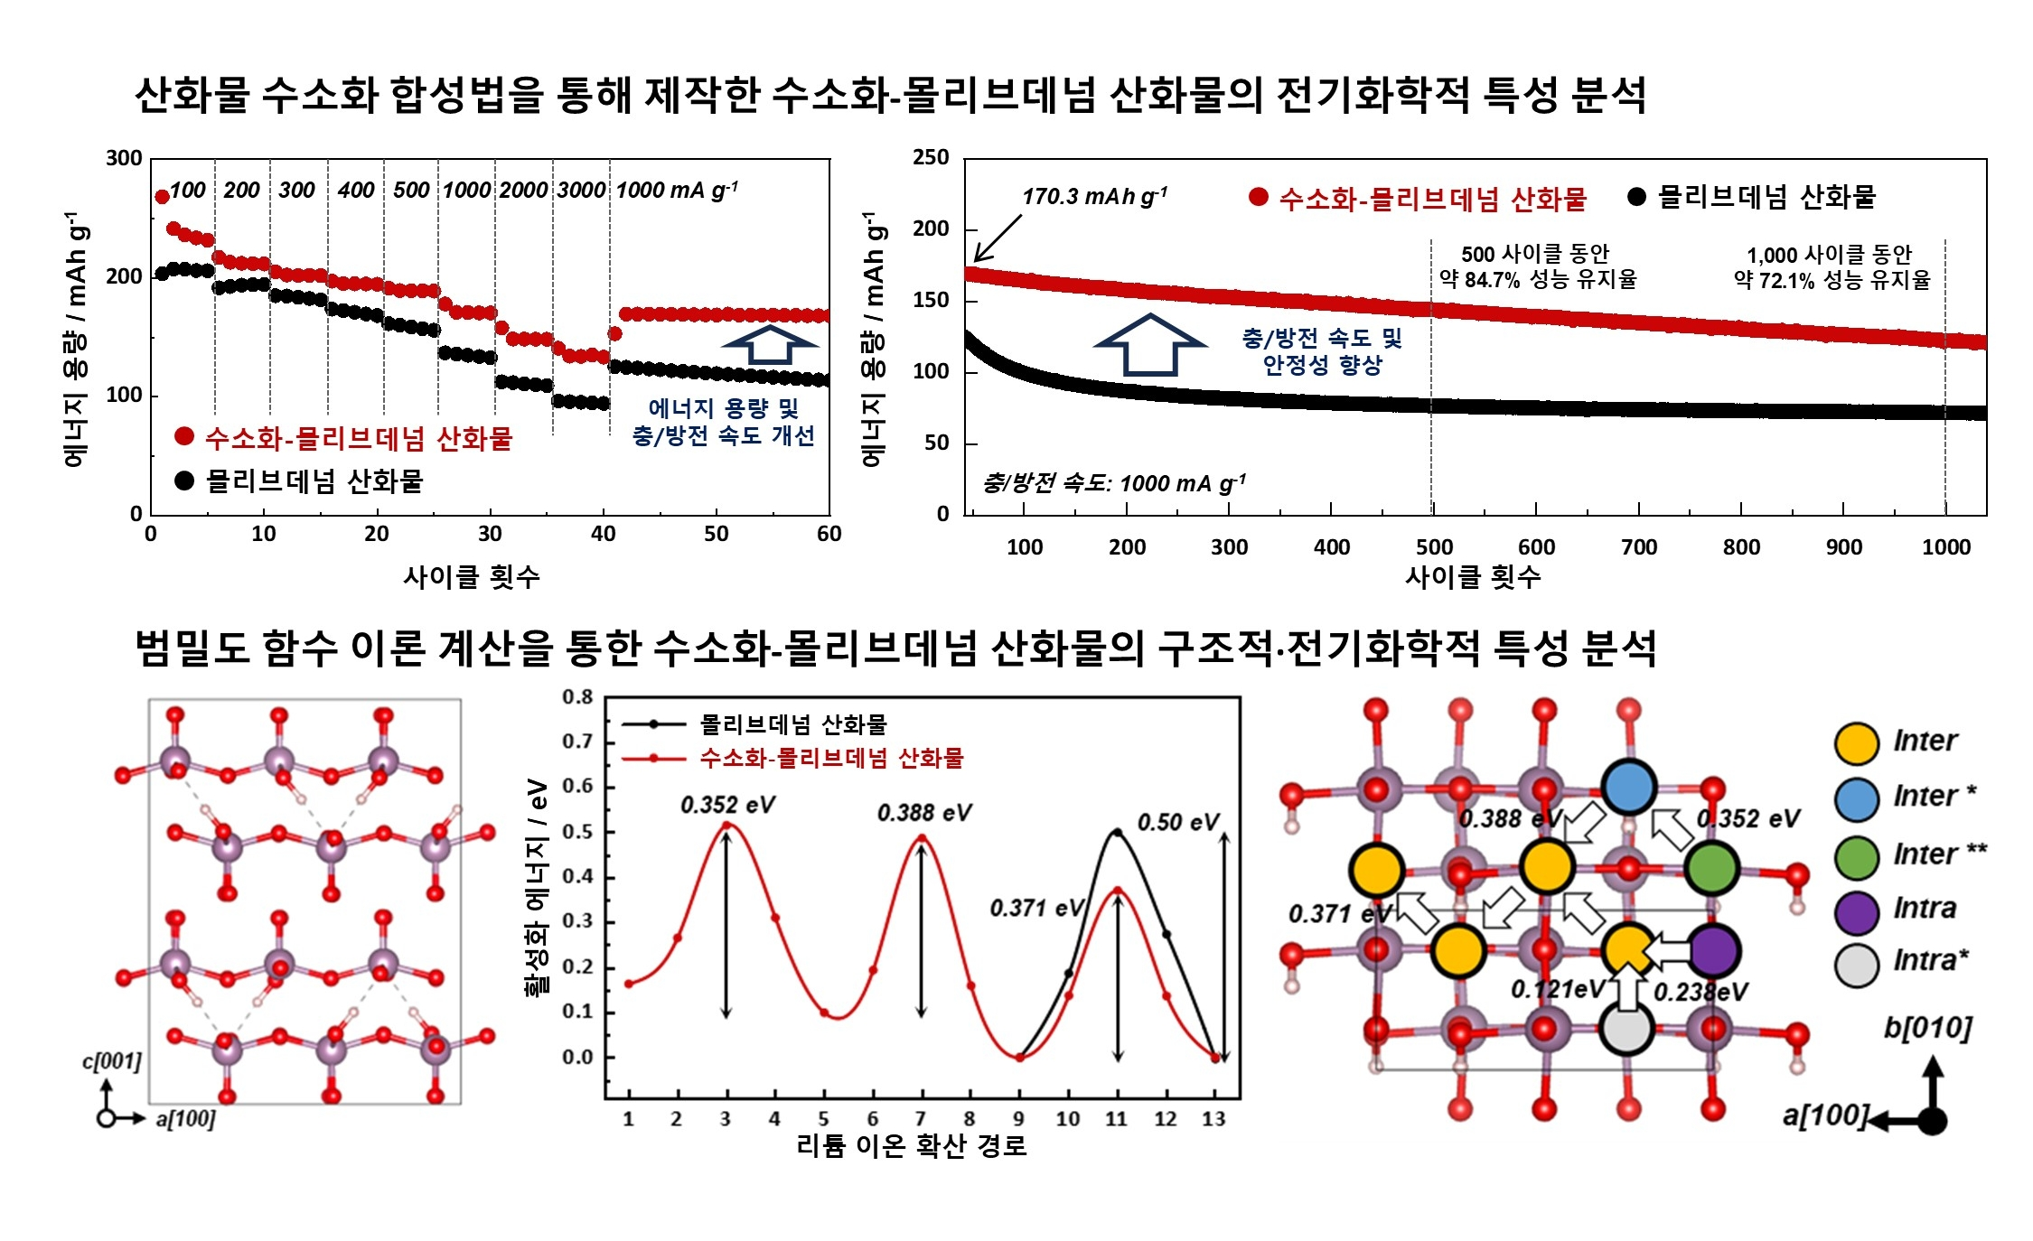

▲ (Top) Analysis of electrochemical properties of hydrogenated molybdenum oxide produced via oxide hydrogenation synthesis: When hydrogen ions are inserted into molybdenum oxide, the energy storage capacity and charge/discharge speed are improved, and the battery life is dramatically improved due to improved structural stability. (Bottom) Analysis of structural/electrochemical properties of hydrogenated molybdenum oxide through density functional theory calculations: When hydrogen ions exist inside molybdenum oxide, it is confirmed that the diffusion energy barrier of lithium ions inside the oxide is lowered. Through this, the cause of the improved charge/discharge speed of hydrogenated molybdenum oxide was identified.

In addition, through computational chemistry and electrochemical analysis, it was also identified that hydrogen ions distort the symmetrical crystal structure of molybdenum oxide, creating a path for lithium ions to diffuse smoothly within the crystal, thereby enabling fast charge/discharge.

Based on these results, the research team newly devised a methodology to insert hydrogen ions into metal oxides without external energy supply, and verified the possibility and effectiveness of industrial application of this research result by confirming that the material properties can be controlled by utilizing hydrogen ions.

Professor KwangSup Eom explained, “This study has academic significance in that it has elucidated the operating principle of metal oxide hydrogenation reaction. In particular, it is expected to open a new chapter in the development of energy materials in the future by very easily controlling the unique properties of materials by utilizing hydrogen ions.”

This study, conducted by Dr. JunHwa Kwon and Dr. Soonsung So under the joint supervision of Professors KwangSup Eom and Joo-Hyoung Lee of the School of Materials Science and Engineering at GIST and Professor Jung Tae Lee of Kyung Hee University, and supervised by Professor Tom Fuller of the Georgia Institute of Technology, was supported by the National Research Foundation of Korea's Mid-career Researcher Support Program, and the results were published online in the international academic journal 《Nature Communications》 on December 5, 2024.



