GIST-Chungnam National University Hospital-Korea University-HEM Pharma-Amore Pacific, discovered intestinal microorganism (3-phenyllactic acid (PLA)) effective in improving slow aging and geriatric diseases

- Research results of a joint research team of industry, academia, and research institutes led by Professor Dongryeol Ryu of the Department of Biomedical Science and Engineering at GIST... Healthy Aging Index (HAI) that can quantitatively evaluate changes in healthy life expectancy also developed

- Expected expansion and development of related technologies through the Korean ARPA-H project ‘Multimodal Sarcopenia Treatment Consortium’ (Director of Research Professor Dongryeol Ryu)... Published in the international academic journal 《Nature Communications》

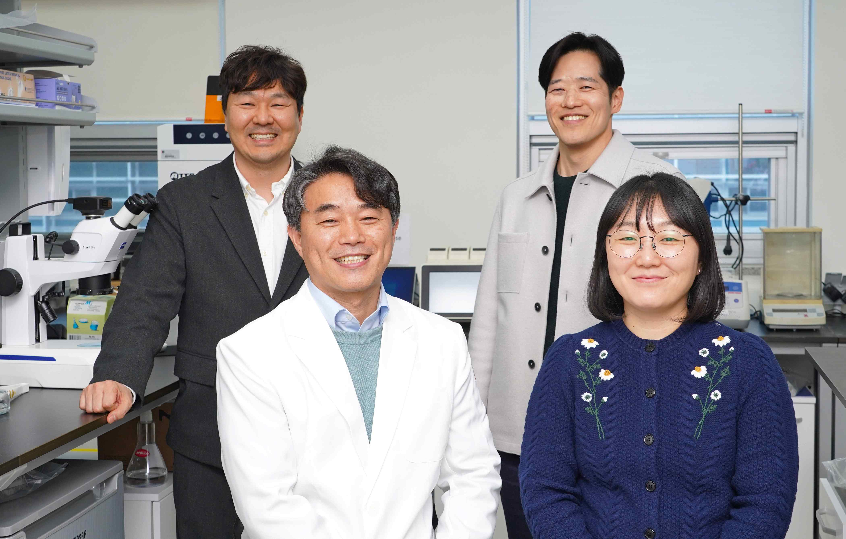

▲ (Counterclockwise from the left in the front row) Department of Biomedical Science and Engineering at GIST Professor Dongryeol Ryu, Dr. Yunju Jo, Dr. Joo-won Kim (currently a professor at Konkuk University College of Medicine), and Dr. Donghyun Cho (HEM Pharma)

Recently, interest in ‘slow aging’ and ‘anti-aging’ to delay aging and live young has been increasing.

Over the past 30 years, as research on longevity has been actively conducted, various studies have been conducted to induce life extension. As a result, it has been revealed that life extension does not necessarily mean extension of healthy life span, and that life can be extended even in a weakened state due to aging. This is why a method* that can quantitatively evaluate healthy life span is needed.

* Currently, various drugs targeting aging are being developed, but there are limitations in conducting preclinical and clinical trials due to the lack of indicators that can objectively quantify the anti-aging and reverse-aging effects. Accordingly, many research groups and companies at home and abroad are actively participating in the development of indicators that can evaluate the effects of anti-aging or reverse-aging drugs, such as 'aging clocks' or 'aging indices'. In addition, <MIT Technology Review> introduced the 'Aging Clock' in an article dated April 15, 2022, emphasizing that this technology can be used to measure biological age and evaluate the effects of anti-aging drugs, and mentioned the need for development.

The Gwangju Institute of Science and Technology (GIST, President Kichul Lim) announced that Professor Dongryeol Ryu’s research team from the Department of Biomedical Science and Engineering, Professor Hyon-Seung Yi’s research team from the Department of Endocrinology at Chungnam National University Hospital, Professor Dong Wook Choi’s research team from the Department of Biotechnology at Korea University, and researchers from H.E.M. Pharma and Amorepacific have discovered that intestinal microbes delay aging and have positive effects on health.

The research team focused on the metabolites produced by lactic acid bacteria and confirmed that 3-phenyllactic acid (PLA), a metabolite produced by intestinal commensal microbes, can play an important role in improving aging-related diseases such as sarcopenia by strengthening mitochondrial homeostasis.

In particular, the research team developed the ‘Healthy Aging Index (HAI)’ that can objectively evaluate healthy lifespan and systematically verified the effects of PLA through this.

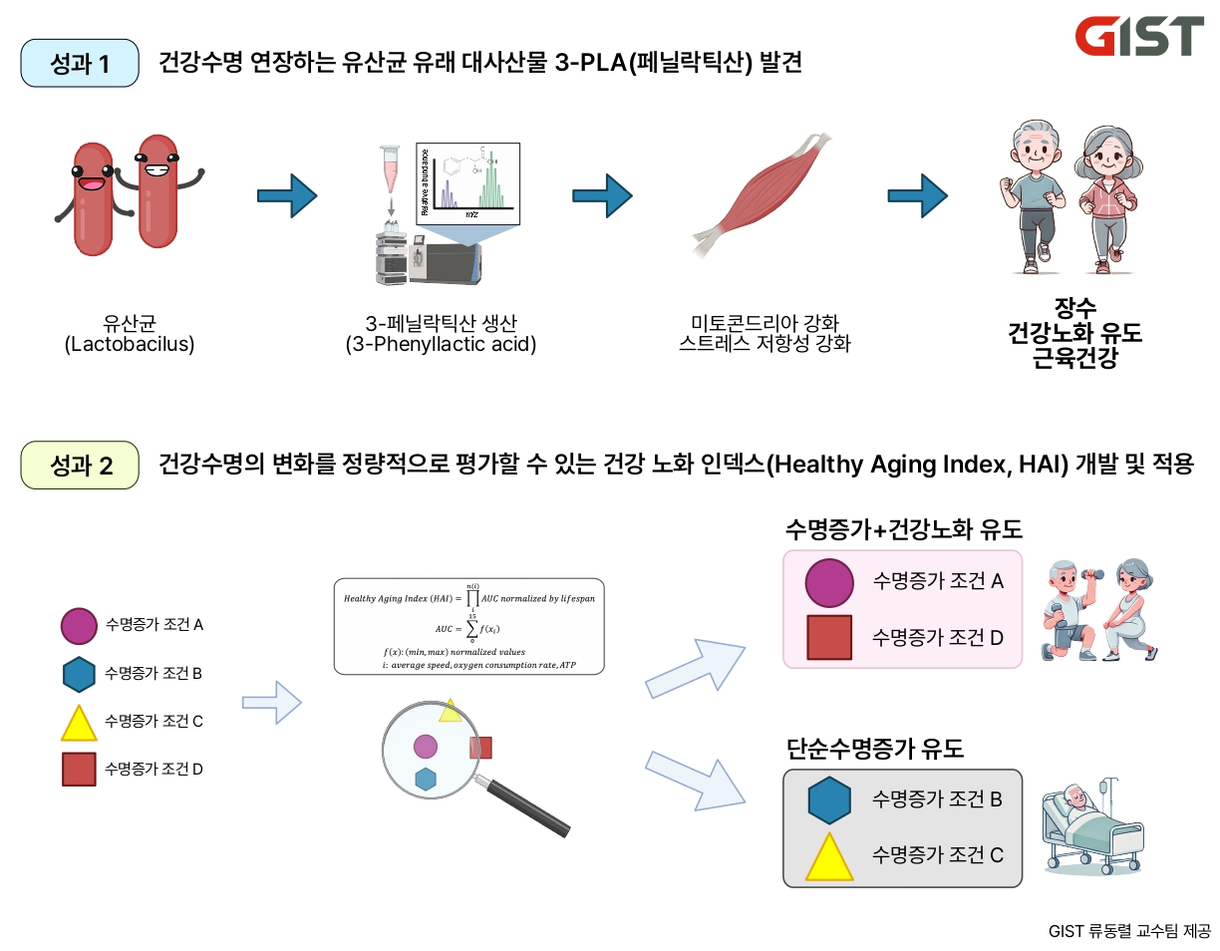

▲ Achievement 1. Discovery of 3-PLA (phenyllactic acid), a metabolite derived from lactic acid bacteria that extends healthy life span. It was discovered that 3-PLA, a metabolite produced by intestinal lactic acid bacteria (Lactobacillus), plays an important role in strengthening mitochondrial function, increasing stress resistance, and preventing muscle aging. This is expected to promote healthy aging. Achievement 2. Development and application of a healthy aging index that can quantitatively evaluate changes in healthy life span. The healthy aging index (HAI) is a new index that distinguishes between healthy life span and simple life extension. This can effectively distinguish between drugs and technologies that can help people live a long and healthy life span.

The healthy aging index is a new index that can objectively distinguish between ‘simple life extension’ and ‘healthy life extension’ by comprehensively evaluating vitality (voluntary movement), oxygen consumption (mitochondrial function), and ATP (adenosine triphosphate synthase, the energy source for all cellular activities) production.

The research team explained that this study showed that mitochondrial homeostasis, which decreases by 20-80% during the aging process, was restored to up to 80% of that of young individuals by dietary PLA supply, suggesting that this could play an important role in improving aging-related diseases such as sarcopenia.

The strengthening of mitochondrial homeostasis was proven by the figures showing that oxygen consumption and ATP production increased by 1.5 times and 1.8 times, respectively, in the PLA administration group compared to the control group. The research team expects that PLA will greatly contribute to the development of treatments for sarcopenia as well as the advancement of technology for healthy aging.

Mitochondria, which serve as a ‘power plant’ that produces and supplies bioenergy, can experience dysfunction as they age or are exposed to toxic substances. Most mitochondrial dysfunctions lead to diseases related to aging and are associated with various diseases such as neurodegenerative diseases, Lou Gehrig’s disease, cardiovascular diseases, mental illness, diabetes, and cancer.

Therefore, the process of creating new organelles such as mitochondria and destroying and reusing bad ones must be continuously performed. If this process is well managed, the aging rate of our body can be slowed down and healthy lifespan can be extended.

The research team also analyzed in detail the positive effects of PLA on muscles and energy metabolism.

As a result, it was confirmed that PLA plays an important role in extending healthy lifespan (approximately 150% increase based on HAI) and improving muscle aging symptoms by increasing mitochondrial activation (recovery to 70-80% of the level of young individuals), stress resistance (approximately 1.5-2 times increase compared to the unadministered control group), and lifespan (6.6% to 21.2% increase compared to the unadministered control group).

Professor Dongryeol Ryu said, “This study is the first to show that metabolites produced by gut symbiotic microorganisms can play an important role in improving age-related diseases, especially muscle aging such as sarcopenia. The Healthy Aging Index is expected to be used as an essential indicator for the development of drugs that help people live long and healthy lives by allowing the selection of drugs that simply prolong life without improving the quality of life.”

This study, supervised by Professor Dongryeol Ryu of the Department of Biomedical Science and Engineering at GIST and conducted by Dr. Joo-won Kim and Dr. Yunju Jo, was supported by the Ministry of Science and ICT’s Mid-career Research Support Project and was published in the international academic journal 《Nature Communications》 on December 30, 2024.

Meanwhile, Professor Dongryeol Ryu, who was selected as the ‘World’s Top 1% Researcher’ by Clarivate, an American academic information analysis company, in 2022, was also named as the ‘World’s Top 2% Scientist’ by Elsevier, a Dutch academic information analysis company, for three consecutive years from 2022 to 2024.

This study suggests the possibility of healthy aging and treatment of metabolic diseases such as sarcopenia, and the expansion and development of related technologies through the ‘Multimodal Sarcopenia Treatment Consortium’ of the Korean ARPA-H project, in which Professor Ryu was recently selected as the principal investigator, is expected.



