GIST discovers bacterial survival mechanism and expects development of new antibiotic mechanism

- Professor Jungwook Kim's team in the Department of Chemistry elucidates the chemical transformation and molecular operating principles of enzymes involved in the cell membrane synthesis process, which is the core of bacterial life phenomena... Reveals protein-lipid interactions and cell membrane binding mechanisms

- "Provides new understanding of the structure and function of PssA, an important bacterial phospholipid synthesis enzyme"

- Published in the international academic journal 《Science Advances》



▲ (From left) Professor Jungwook Kim of the Department of Chemistry and PhD student Eunju Lee

The emergence of super bacteria that are immune to all types of antibiotics poses a serious threat to humanity. The cell membrane* plays an essential role in maintaining the life of cells, and the same is true for bacteria.

Up until now, nothing has been known about the high-resolution structure of the ‘PssA protein’ that contributes to maintaining the stability of the bacterial cell membrane and the phospholipid* complex, which is one of the membrane components. However, domestic researchers are expected to contribute to the development of antibiotics with new mechanisms by identifying the co-crystal* structure of the complex.

* cell membrane: A membrane that surrounds all cells, which controls the entry and exit of substances by distinguishing between the internal and external environments of the cell.

* phospholipid: A major component of the cell membrane, composed of molecules with a hydrophilic head that likes water and a hydrophobic tail that hates water.

* enzyme: A protein that promotes chemical reactions in living organisms, helping to accelerate specific reactions.

* co-crystal structure: A structure in which two or more molecules are combined in a specific ratio to form a regular crystal form. In biochemistry, it is mainly used to analyze the binding ecology of proteins and substrate molecules.

The Gwangju Institute of Science and Technology (GIST, President Kichul Lim) announced that Professor Jungwook Kim's research team in the Department of Chemistry has elucidated the chemical modification and molecular mechanism of an enzyme involved in the cell membrane synthesis process, which is the core of bacterial life.

The research team used x-ray crystallography* to accurately identify the substrate binding site of the high-resolution co-crystal structure of the enzyme (PssA*) and phospholipid (CDP-DG) and elucidated the activation mechanism of the enzyme.

* PssA (Phosphatidylserine synthase): An enzyme that synthesizes phosphatidylserine, an important phospholipid that constitutes cell membranes, and plays an essential role in cell survival and signal transmission.

* x-ray crystallography: An experimental technique that elucidates the three-dimensional structure of molecules such as proteins at the atomic level. The sample is passed through x-rays after crystallography and the diffraction pattern is analyzed.

In the field of biochemistry, x-ray crystallography is used as a powerful tool to elucidate the three-dimensional structure of proteins, but it has limitations in that it is difficult to produce high-purity protein crystals and ensure stability. In particular, membrane proteins are more difficult to analyze structurally due to the complex characteristics of the hydrophilic and hydrophobic regions.

Therefore, among the total protein structures registered in the database (Protein Databank, PDB) where biomolecule structures are registered, membrane protein structures account for only about 2-3%, and among these, the structures of extrinsic membrane proteins* are even more limited.

* extrinsic membrane proteins: Proteins that indirectly connect to the membrane through interactions with membrane phospholipids or intrinsic membrane proteins, and can be separated without destroying the membrane.

The mechanism of action of PssA, an extrinsic membrane protein, is limited in understanding at the atomic level due to the absence of a complex structure with the substrate. To this end, the research team successfully determined the structure of the complex with phospholipids by introducing a ‘point mutation’* that stops or lowers the enzyme’s active function.

As a result, it was confirmed that phospholipids interact at the active site of the enzyme, and that the hydrophobic and hydrophilic regions of phospholipids bind to specific amino acid residues.

* point mutation: This refers to a mutation that occurs mainly during DNA replication, and is caused by a change (substitution), addition (insertion), or disappearance (deletion) of a base pair in the base sequence of DNA and RNA.

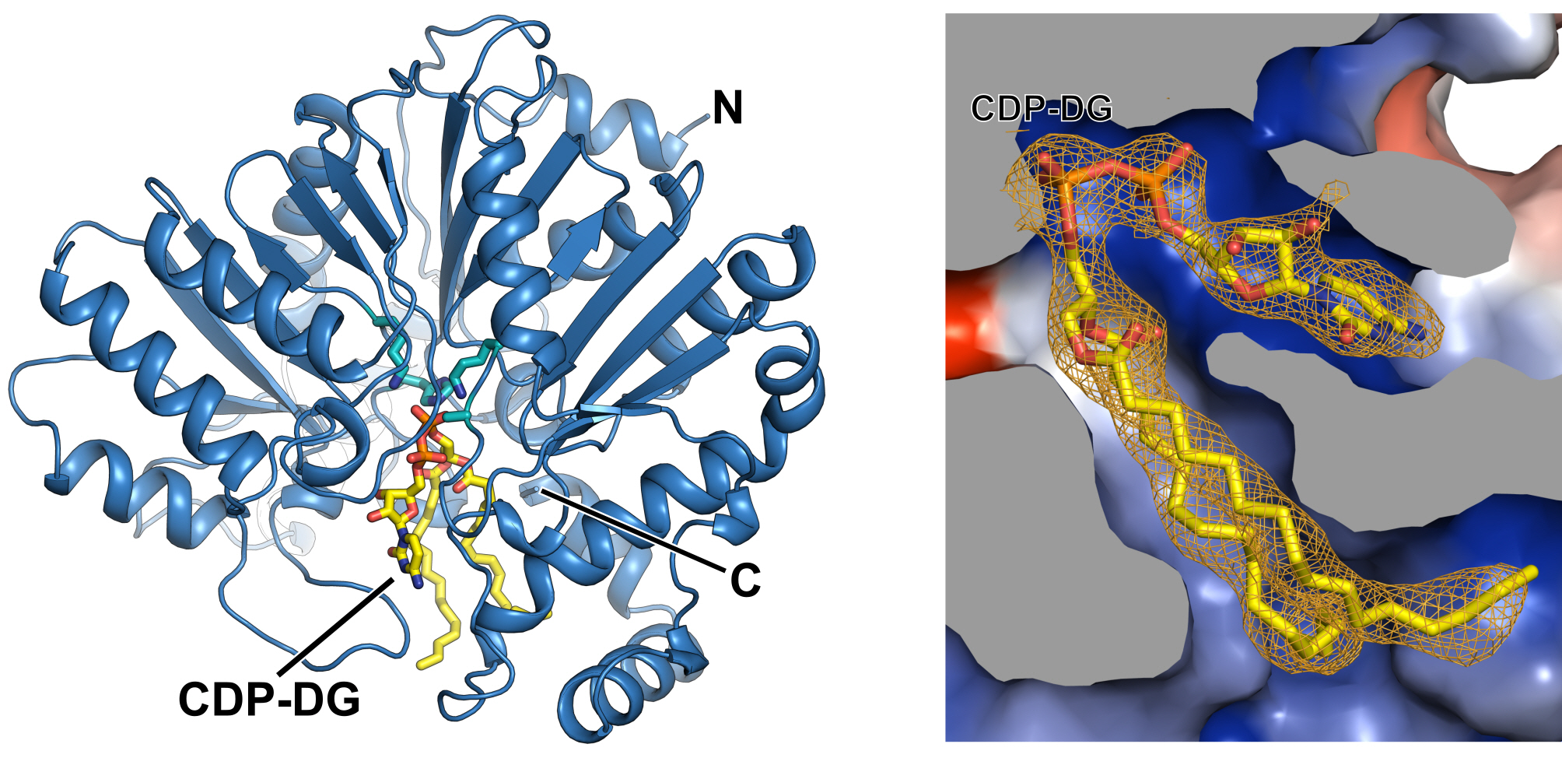

▲ Structure of enzyme PssA and substrate CDP-DG complex discovered by the research team. The left figure shows the overall appearance of the PssA enzyme. The enzyme's reaction center is shown in the form of a light blue stick. The PssA substrate CDP-DG is color-coded by carbon (C, yellow), oxygen (O, red), nitrogen (N, blue), and phosphorus (P, orange). The right figure shows the surface of the enzyme, with the negatively charged substrate CDP-DG bound to the positively charged (blue) enzyme surface. This indicates protein-lipid interaction at the active site of the enzyme.

The research team also discovered that PssA exists in monomer and dimer forms. In particular, they demonstrated that specific hydrophobic amino acids on the protein surface play an important role in dimer formation, and that modifying this site causes the protein to exist only as a monomer.

* monomer/dimer: The structural unit of a protein. A monomer exists as a single unit, and a dimer is a structure in which two units are combined.

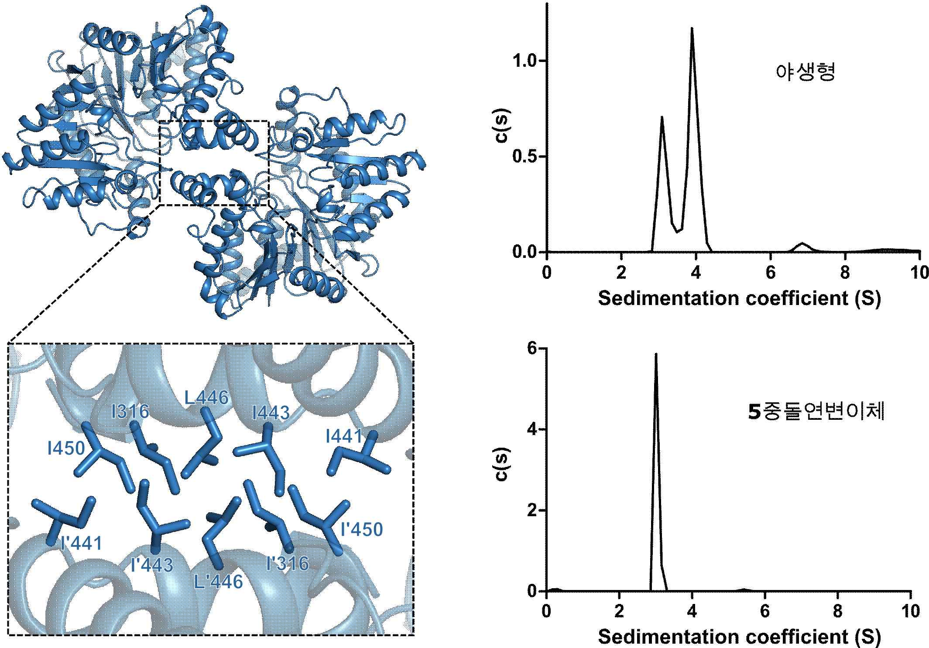

▲ Prediction and verification of the dimer binding site of an enzyme in the cytoplasm. The left figure is the E. coli PssA dimer model predicted by AlphaFold, and the residues existing at the dimer interface are represented in stick form and labeled. The right diagram shows the binding site verification through sedimentation velocity experiments after mutation and substitution of five residues at the dimer interface.

Furthermore, through molecular dynamics simulation* and mutation experiments*, it was confirmed that specific positively charged residues of PssA bind to the negatively charged cell membrane (positively charged PssA residues bind to negatively charged cell membrane). Through this, the mechanism of protein-cell membrane interaction was understood more deeply, and the preference for specific lipids was revealed.

* molecular dynamics simulation: A method that computationally simulates the interactions and movements between molecules, and is used to predict molecular structures and mechanisms.

* mutation experiment: An experiment that changes specific amino acids that make up a protein, and studies how the function or structure of the protein changes through this.

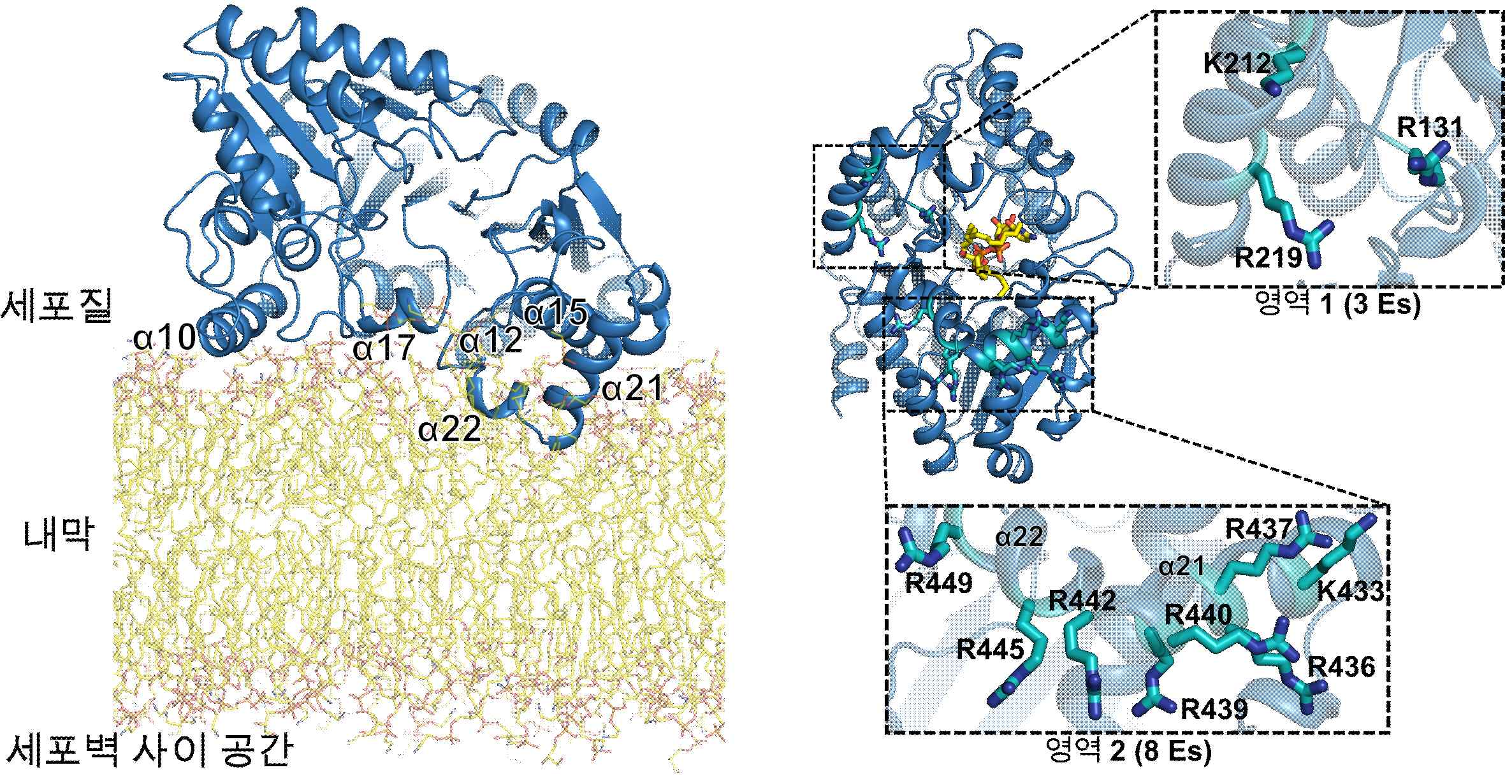

▲ enzyme-cell membrane binding interaction site. The left figure is a molecular dynamics prediction of what happens when the enzyme (blue) binds to the cell membrane (yellow, orange), and the right figure shows which residues directly interact with the cell membrane based on the predicted structure. A total of 11 residues in two regions interact with the cell membrane.

The research team explained that PssA binds to the membrane when in the active state and synthesizes phospholipids, and when in the latent state, it detaches from the membrane and stays in the cytoplasm, delaying synthesis, and this contributes to understanding the complex biochemical processes related to lipid regulation within cells.

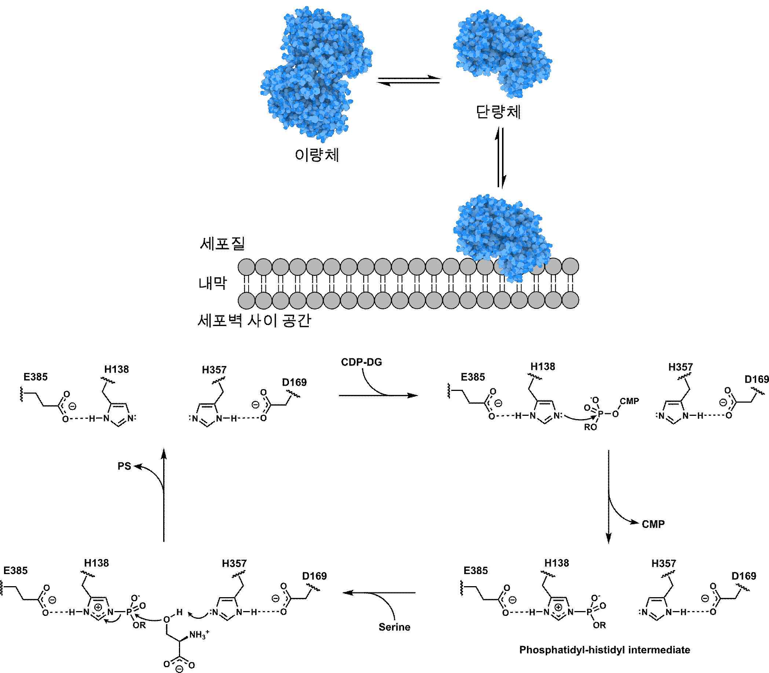

▲ Molecular mechanism and chemical mechanism of intracellular E. coli PssA. The figure above shows the molecular mechanism of PssA, which exists in an equilibrium state of dimer and monomer in the cytoplasm, but only the monomer form can bind to the cell membrane. The chemical mechanism model below proposes a mechanism in which the substrate CDP-DG releases the product phosphatidylserine through an intermediate based on the experimental results obtained in this study.

Professor Jungwook Kim said, "This study is significant in that it provides new insight into the structure and function of PssA, an important bacterial phospholipid synthesis enzyme, and elucidates the protein-lipid interaction and cell membrane binding mechanism. It will be able to suggest new research directions for the regulation of bacterial phospholipid balance as well as antibiotic development."

This study, supervised by Professor Jungwook Kim Kim of the Department of Chemistry at GIST and conducted by PhD student Eunju Lee, was supported by the Ministry of Science and ICT's Global Leading Research Center (IRC) support project and the Advanced Bio Large-Scale Equipment Joint Utilization System Establishment Project, and was published online in the international academic journal 《Science Advances》 on December 18, 2024.



