GIST develops a high-performance hydrogen production photoelectrode that is bendable and durable

- Professor Sanghan Lee (School of Materials Science and Engineering) and Professor Jong Hoon Joo (School of Environment and Energy Engineering) joint research team develops flexible photoelectrode using flexible yet durable zirconia material (3YSZ)

- Stable hydrogen production for long periods of time (9 hours → 24 hours) even after repeated bending (3,000 times → 10,000 times)

- “Confirmation of the possibility of practical use of solar energy-based hydrogen production” Published in 《Journal of Materials Chemistry A》



▲ (From left) Professor Sanghan Lee of the School of Materials Science and Engineering, Professor Jong Hoon Joo of the School of Environment and Energy Engineering, Ph.D. student Jun Beom Hwang of the School of Materials Science and Engineering, and master's student Jeongsu Lee

‘Photoelectrochemical water splitting’, which uses solar energy to produce eco-friendly hydrogen from water, is gaining attention as a next-generation clean energy technology. In order to implement this technology, a photoelectrode* that maintains performance for a long time under various operating conditions is required, and a domestic research team has succeeded in developing a photoelectrode with excellent performance and high durability even in harsh environments.

* photoelectrode: A material that absorbs light to generate electrons and holes and transfers them to cause a chemical reaction.

The Gwangju Institute of Science and Technology (GIST, President Lim Ki-chul) announced that a joint research team of Professor Sanghan Lee of the School of Materials Science and Engineering Jong Hoon Joo of the School of Environment and Energy Engineering developed a photoelectrode that can stably produce hydrogen for a long time even under repeated bending using a flexible and durable zirconia material (3YSZ).

Flexible photoelectrodes can be attached or applied to irregular structures, making them easier to install than rigid substrates. They also have the advantage of maximizing the sunlight collection area and being able to be effectively applied to various application environments.

The research team precisely controlled the concentration of yttria addition to produce a 3YSZ material that is differentiated from the existing yttria-stabilized zirconia (8YSZ). In the process, the structure of the zirconia was optimized by maintaining up to 95% of the entire crystal structure in a stable form and suppressing the unstable phase of the crystal to less than 5%, thereby providing flexibility that can be bent.

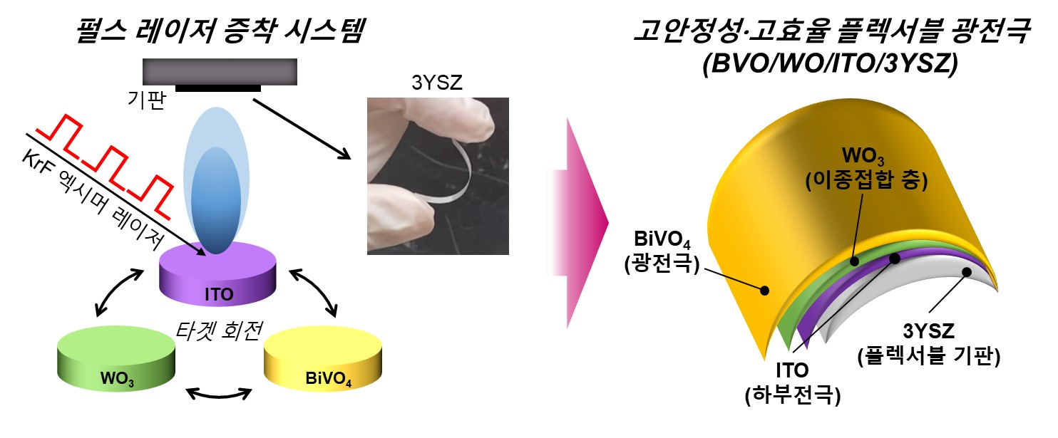

▲ Schematic diagram of a high-stability, high-efficiency flexible photoelectrode fabricated using pulsed laser deposition. The research team fabricated a high-quality heterojunction photoelectrode on a flexible 3YSZ substrate using pulsed laser deposition.

The research team explained that the 3YSZ substrate developed this time exhibited the highest elastic modulus* (192 GPa, 2.7 times higher than the existing one) and yield strength* (856 MPa, 14.3 times higher than the existing one) among the flexible substrates reported to date. This means that 3YSZ has excellent resistance to deformation such as bending while maintaining excellent mechanical properties.

* yttria-stabilized zirconia 3YSZ: Yttria-stabilized zirconia is a ceramic material that is made stable even at room temperature by adding yttria to zirconia. 3YSZ is made by adding about 3 mol% of yttria (Y2O3) to zirconia (ZrO2), and has high thermal stability, chemical resistance, and mechanical strength compared to 8YSZ, which is doped with 8 mol% of yttria in the zirconia crystal, and maintains the structural stability of the material even in high temperatures and harsh environments. Here, ‘3 mol%’ means that yttria is included at a ratio of about 3% of the total material.

* elastic modulus: A standard that determines the extent to which a material stretches or bends when subjected to an external force. The higher the value, the less easily the material deforms.

* yield strength: The limit at which a material begins to permanently deform due to an external force. The higher the value, the more it maintains its shape and is less easily deformed even under a greater force.

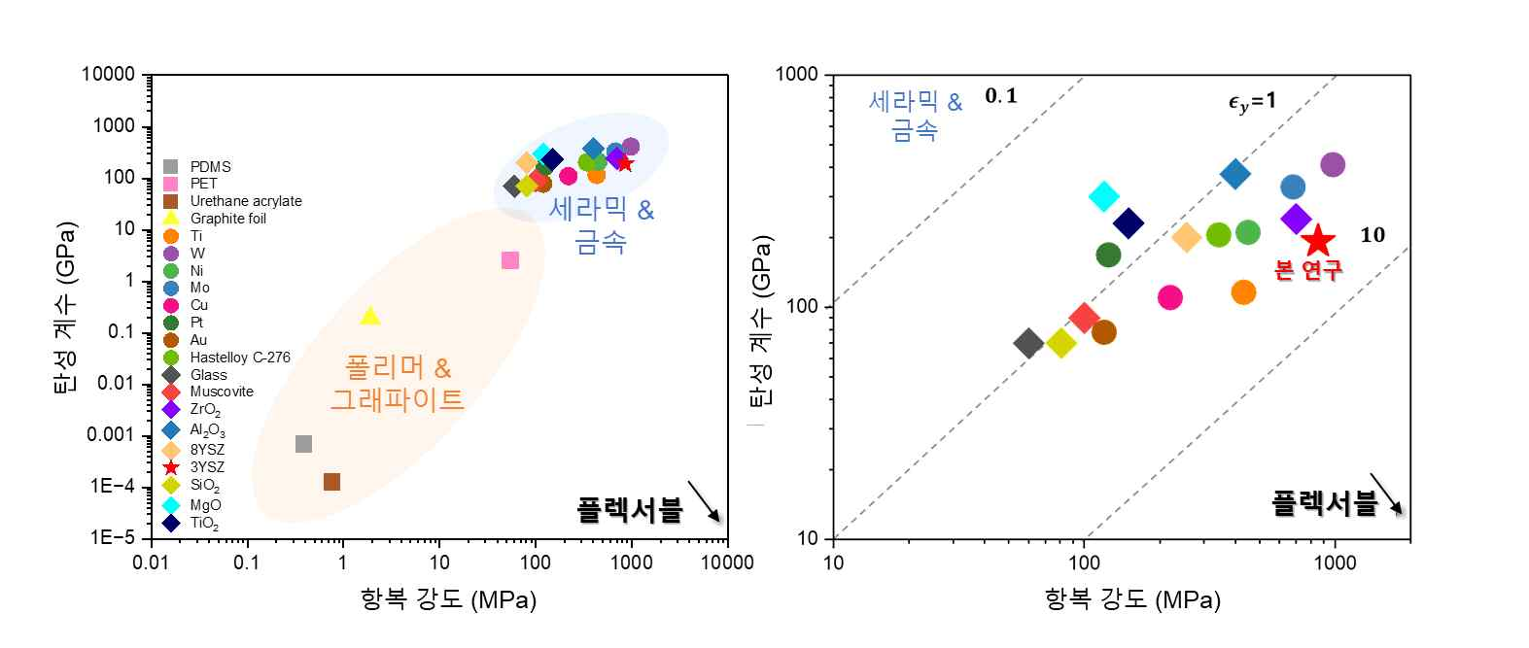

▲ Comparison of yield strength and elastic modulus of flexible materials. Ceramics and metals are positioned in positions with high strength and elastic modulus, and 3YSZ (red star) used in this study is a material that satisfies both excellent mechanical properties and flexible properties.

The research team also succeeded in fabricating a high-quality bismuth vanadate*/tungsten oxide* heterojunction structure (BiVO₄/WO₃) on the 3YSZ substrate fabricated in this way using pulsed laser deposition (PLD)*.

Through the formation of the heterojunction structure, the recombination of photogenerated electrons was suppressed and charge separation and mobility were improved, resulting in an increase in photocurrent density of approximately 2.3 times (0.78→1.78 mA/cm²) compared to the conventional structure. In addition, it maintained 99.8% of the initial performance even after 10,000 bending tests, and it operated stably for 24 hours in a bent state, demonstrating excellent durability and long-term stability.

This is the result of combining the mechanical stability of the 3YSZ substrate and the excellent performance of the BiVO₄/WO₃ heterojunction structure, suggesting the possibility of commercializing a flexible solar energy conversion system that can be sustainable even in harsh environments.

* pulsed laser deposition (PLD): PLD is a technology that uses a high-energy laser to vaporize a target material and then form a high-quality thin film on a substrate. In particular, it can precisely deposit ceramic materials such as 3YSZ without a separate buffer layer in a short period of time, so that complex structures and compositions can be maintained.

* bismuth vanadate (BiVO₄, BVO): BVO, which has excellent light absorption and charge transfer characteristics, is attracting attention as an oxide photoelectrode material and is evaluated as a very promising material for hydrogen production through water decomposition reaction.

* tungsten Oxide (WO₃, WO): An oxide semiconductor with excellent electrical conductivity and chemical stability, when combined with BVO to form a heterojunction structure, it can suppress charge recombination and greatly improve electron separation and transfer characteristics.

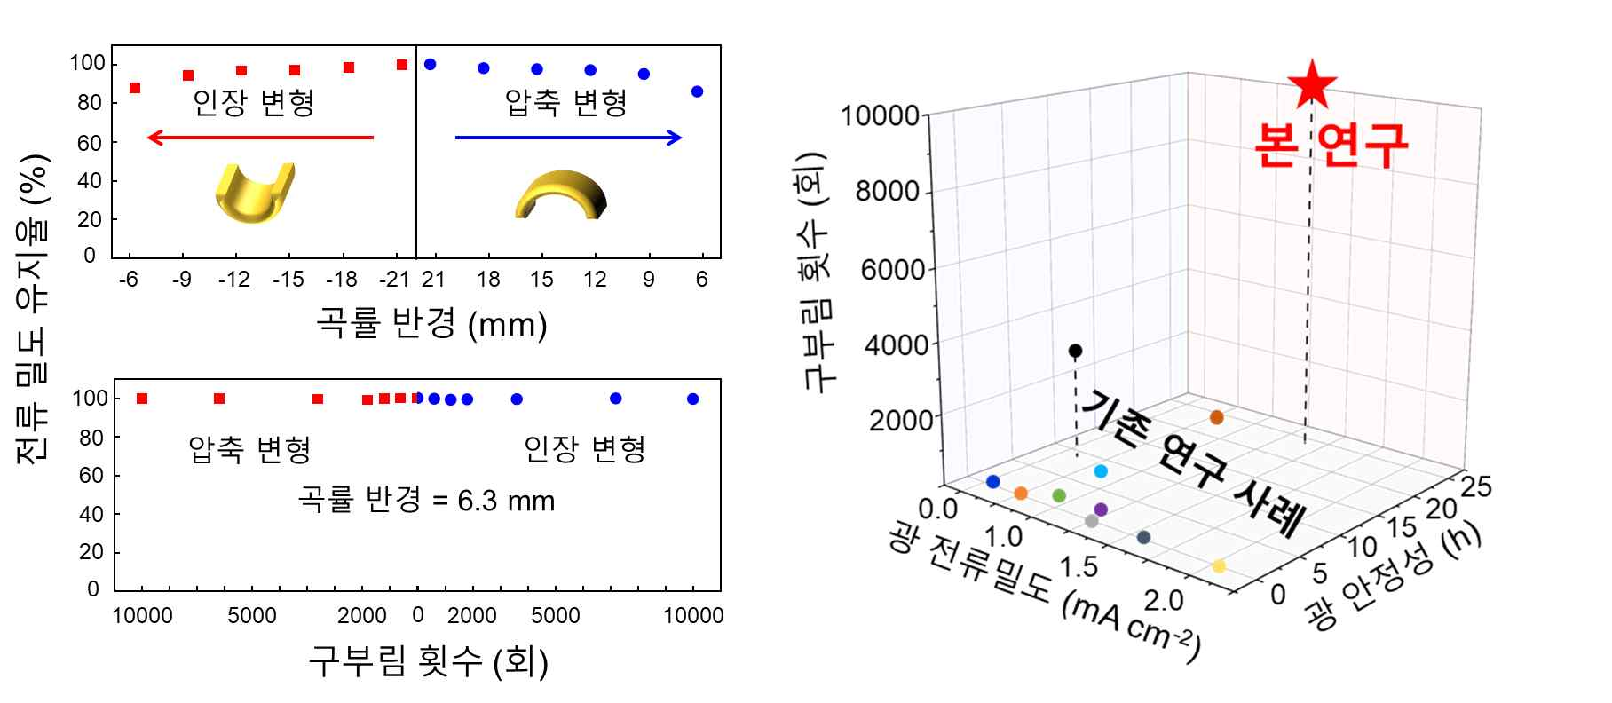

▲ Current density retention rate according to curvature radius and number of repeated bending cycles, and comparison with previous research cases. The results of this joint research (red star) show the best performance compared to the research cases reported so far, achieving high photocurrent density, long stability retention time, and excellent durability without performance degradation even after 10,000 repeated bending cycles.

Professor Sanghan Lee said, "This research achievement overcomes the structural and performance limitations of existing flexible photoelectrodes and confirms the practical feasibility of solar energy-based hydrogen production. In addition, it is expected that the 3YSZ material provided by Professor Jong Hoon Joo's research team will be utilized in various fields and become a new approach for developing next-generation energy systems."

This study, supervised by Professor Sanghan Lee of the School of Materials Science and Engineering of Materials Science and Engineering at GIST and Professor Joo Jong-hoon of the School of Environment and Energy Engineering, and conducted by doctoral student Hwang Jun-beom and master's student Lee Jeong-su of the Department of Materials Science and Engineering, was supported by the Urban Waste Gasification Material Innovative Conversion Leading Research Center Project and the Future Hydrogen Source Technology Development Project supported by the National Research Foundation of Korea, and was published in the international academic journal 《Journal of Materials Chemistry A》Volume 48 on December 28, 2024.



