“Even on a getaway vehicle, even inside a fire scene~” GIST develops a launcher that sticks to a long-distance target. As soon as it is launched, it rotates and spreads out like pizza dough, and sticks to the target surface.

- Professor Jongho Lee's team from the School of Mechanical and Robotics Engineering develops 'rotational unfolding attachment technology' that can be stably attached to difficult-to-access places

- GPS and cameras can be installed on launch attachment projectiles, allowing for a wide range of applications, including security and disaster safety sites

- Published in the international academic journal 'Advanced Functional Materials'

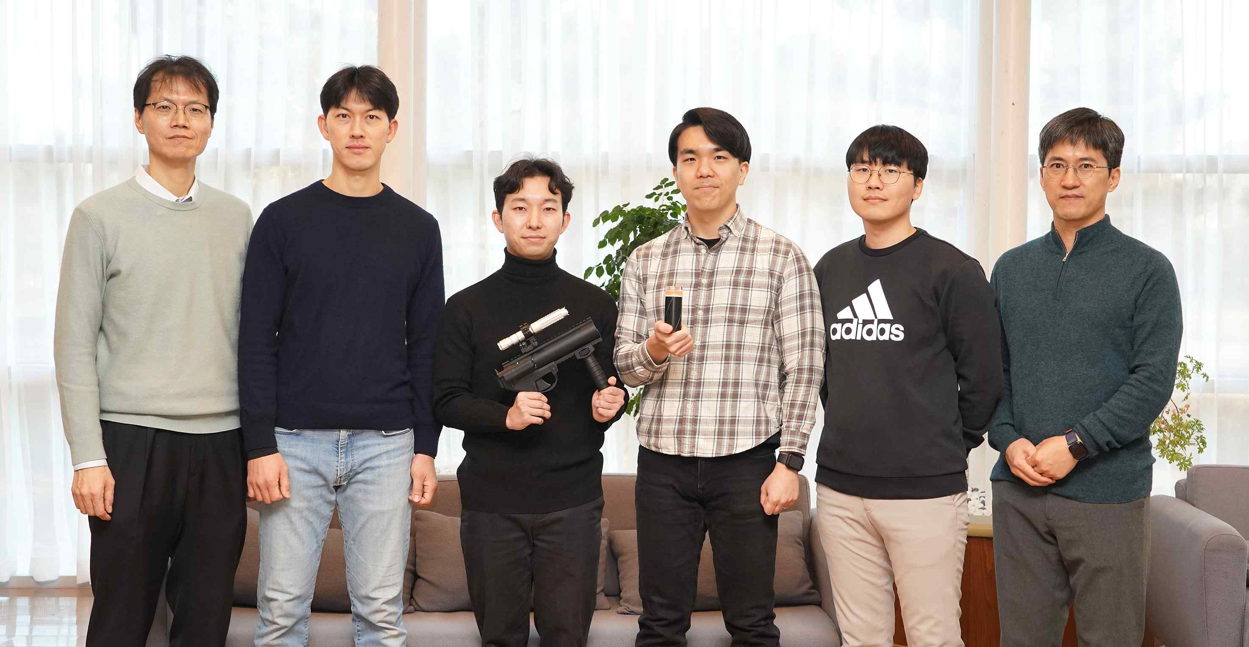

▲ (From left) Professor Jaewook Lee, Dr. Sungbum Cho, student Yonghwa Ji, student Changeui Hong, student Hyungwook Yoo, and Professor Jongho Lee.

A technology that can track the location of hit-and-run vehicles or vehicles fleeing after committing crimes without risking a chase has been developed by Korean researchers.

When an adhesive projectile with adhesive technology that spreads widely and sticks to a vehicle at the same time as it is launched is fired toward a vehicle at a distance, the location of the vehicle can be identified in real time through a location tracker mounted on the ‘launched attachment projectile.’

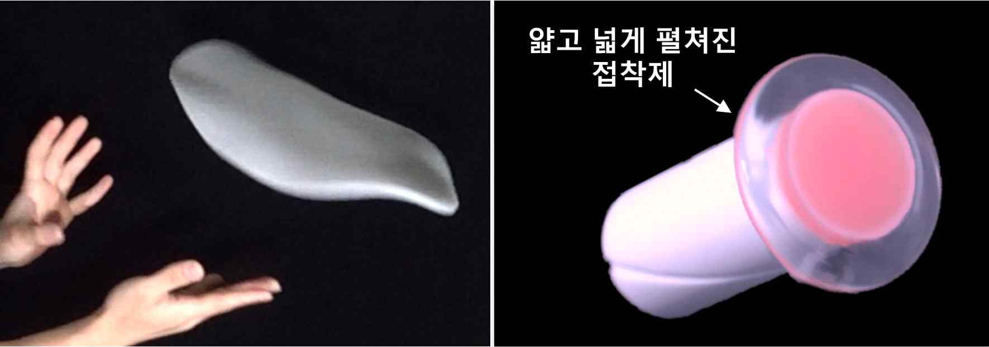

▲ An adhesive that spreads out thinly and widely by rotation, like rolling out pizza dough. (Left) A photo of a pizza dough replica material being rotated. (Right) An adhesive that spreads out by rotation.

The Gwangju Institute of Science and Technology (GIST, President Kichul Lim) announced that a research team led by Professor Jongho Lee of the School of Mechanical and Robotics Engineering has developed a rotational unfolding attachment technology that launches a functional electronic device* using a thin and widely spreadable elastic adhesive* and stably attaches and maintains it on a target.

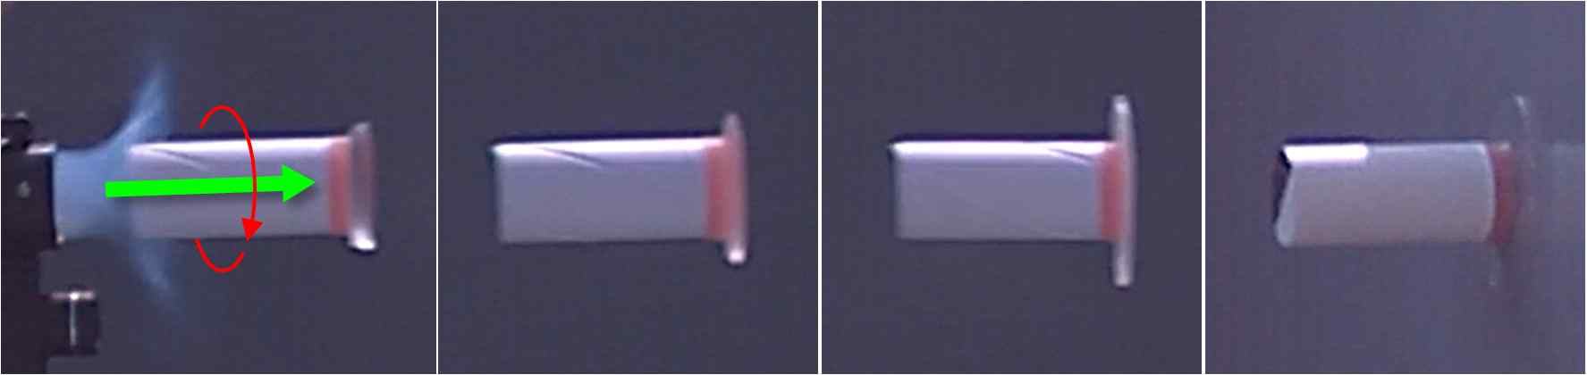

▲ A launcher that rotates and spreads out to attach to a distant surface. The launcher's adhesive material is spread thinly and widely by centrifugal force, and the bullet stably attaches to the target surface, and its straightness is maintained by angular momentum during flight.

The results of this study are expected to be widely used in emergency situations such as location tracking, wireless monitoring, and rescue activities by launching and attaching electronic devices up to 10m away in physically difficult to access places or moving vehicles.

* elastomeric adhesive: An adhesive based on elastomer with elasticity like rubber, which flexibly responds to external deformation or impact and maintains adhesive strength.

* functional electronics: Electronic devices designed to perform specific functions or purposes.

In cases where a driver who has committed a crime such as drunk driving, drug driving, or hit-and-run and flees without responding to a police order, there is a risk that not only the pursuer and the fugitive, but also ordinary citizens may be seriously injured due to the imminent chase.

In addition, if wireless cameras can be installed on the spot at disaster sites such as fires to monitor indoor situations, the possibility of identifying survivors and rescuing them without causing casualties can be increased.

In order to track the location of escaped vehicles and monitor indoor situations at disaster sites, GPS or cameras must be remotely attached to vehicles or places that cannot be directly touched by hands while in motion.

Therefore, it is necessary to develop a long-distance launching and attachment technology that can not only adhere adhesive materials to various surfaces but also maintain the attachment state for a long time.

Thin and wide adhesive materials are easy to attach stably, but they have the disadvantage of being difficult to carry around or handle on their own. To solve this problem, the research team succeeded in developing a long-distance rotational unfolding attachment technology that can spread the adhesive material thinly and widely only when launched, like rolling pizza dough.

This long-distance rotational spreading attachment technology improves the bonding strength and holding power of the adhesive material, while also making it possible to adhere the adhesive material to narrow and uneven surfaces such as columns, steel grids, inclined surfaces, and protruding surfaces. The surface area of ​​the adhesive material is expanded through rotation, which is advantageous for attachment, while the rotational inertia* ensures straightness.

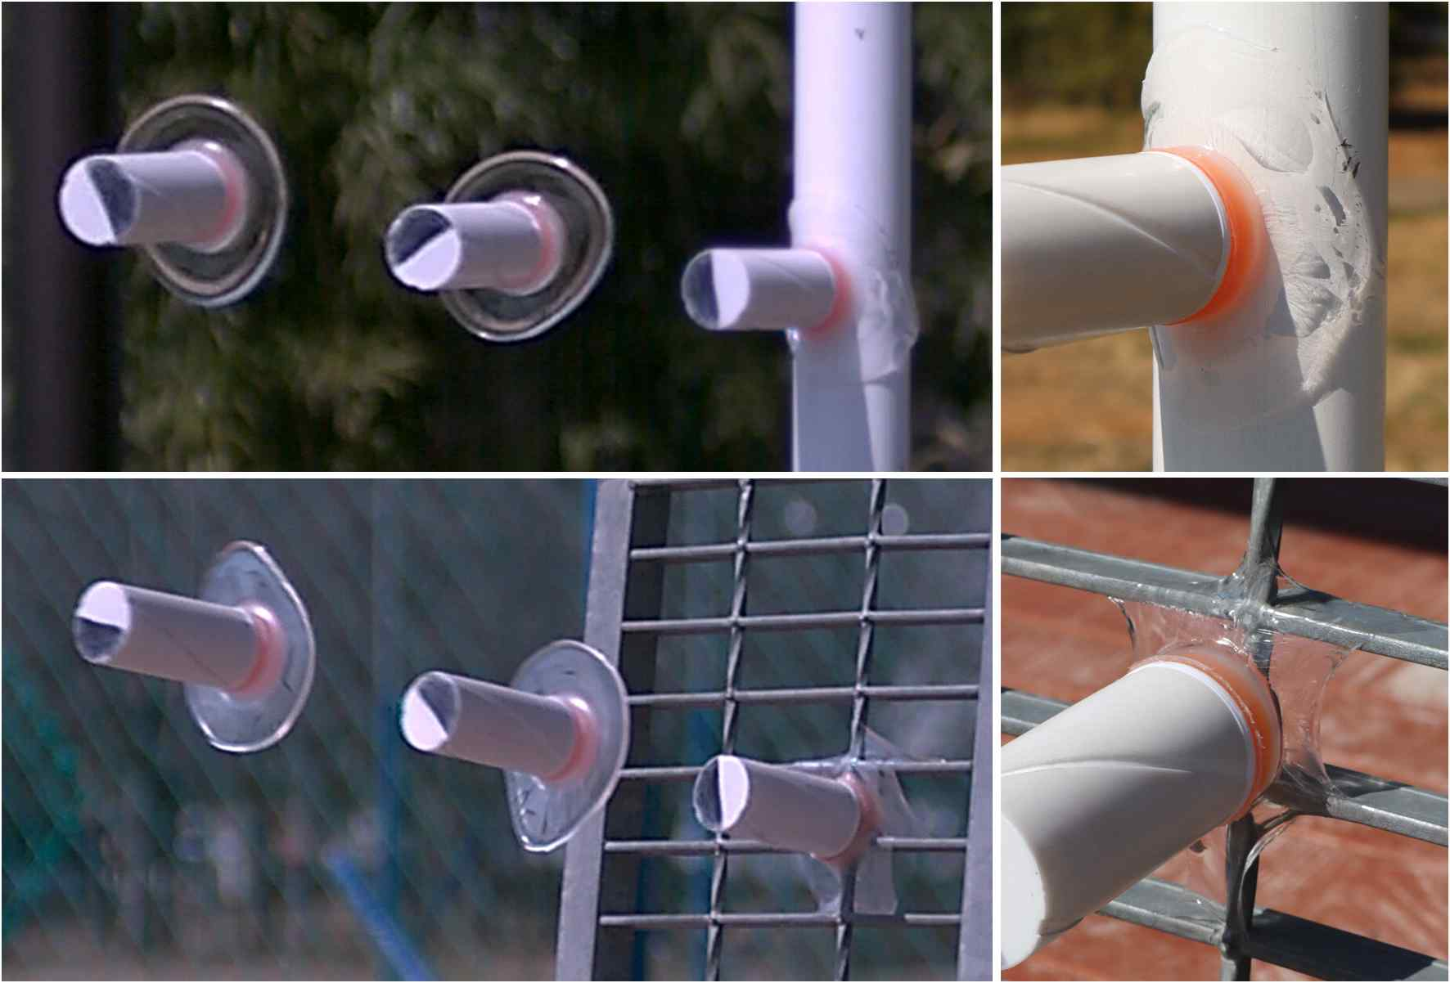

▲ A projectile attached to a composite surface. (Above) A projectile attached to a cylinder and (below) a steel grid while wrapping around it.

The thin and widely spread projectiles attached to the glass surface showed superior adhesion performance compared to the unspread ones, and it was confirmed that they remained attached for a much longer period of time when hanging or pulling heavy objects such as automobile sheet metal, glass, emblems, wipers, bumpers, tires, wheels, and interior and exterior walls of buildings.

* rotational inertia: The property of a rotating object to continue to rotate steadily around the same axis.

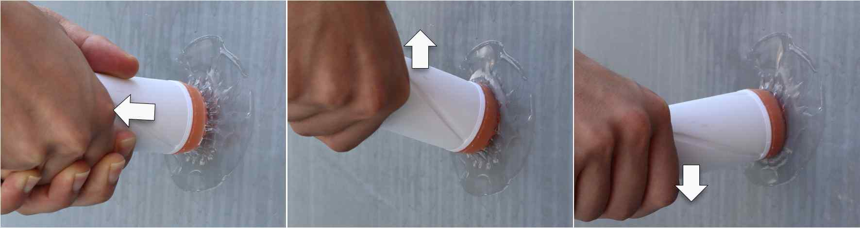

▲ A projectile attached by rotating and unfolding. (Left) It remains attached even when pulled, (Middle) raised, and (Right) pressed down.

The research team also proved the possibility of using it for location tracking, wireless monitoring, and rescue activities at emergency sites based on its excellent adhesive performance through experiments.

The research team launched and attached a launcher-mounted projectile equipped with a location tracking device to the rear of a vehicle traveling at 60 km/h, tracked real-time location information, and confirmed that the attachment status of the launcher-mounted grenade was maintained in various driving environments such as in the city, on highways, and on curved roads.

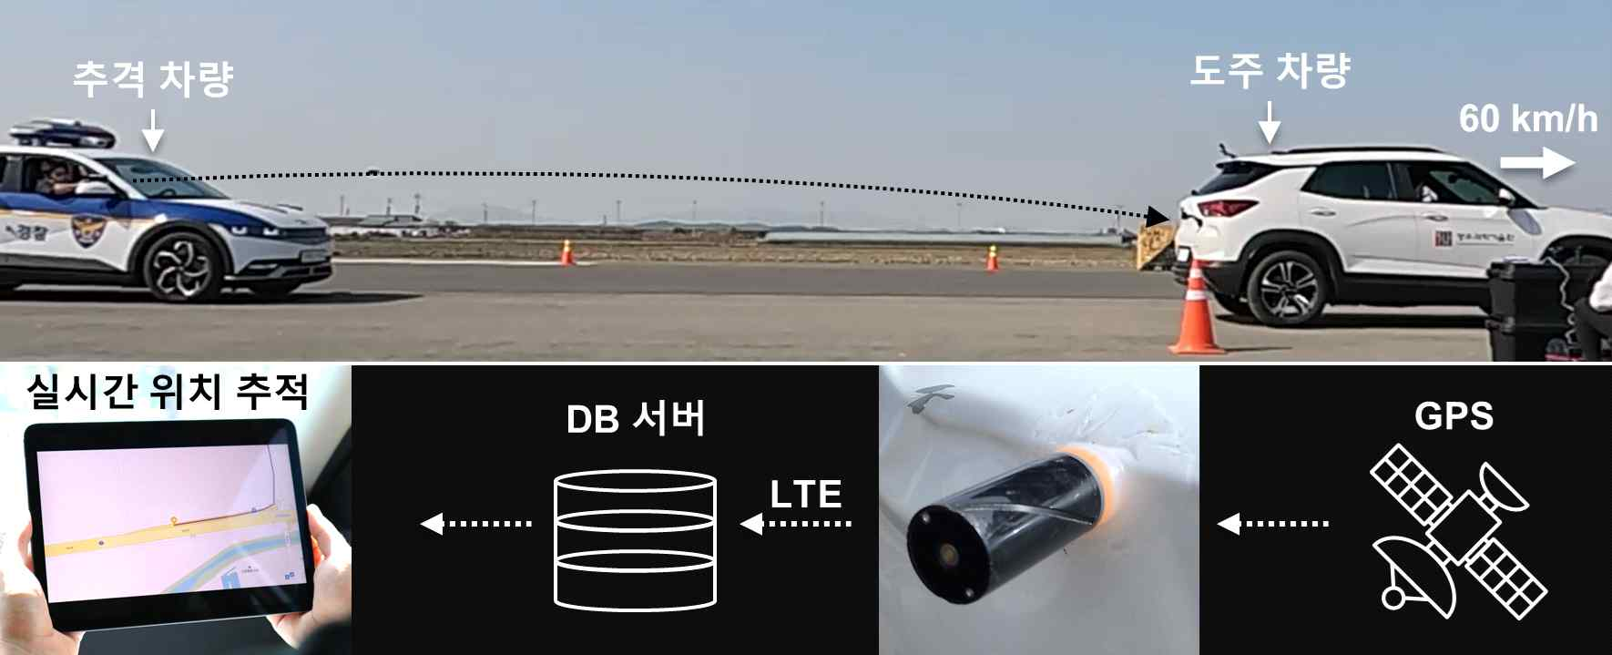

▲ Location tracking using rotational unfolding attachment technology. (Top) Attaching a launcher-mounted grenade equipped with a location tracking device to the rear of a vehicle traveling at 60 km/h. (Bottom) Real-time location tracking system of the attached location tracking device.

In addition, in the event of an emergency such as a fire, a launcher-mounted projectile equipped with a wireless camera was stably launched and attached to the interior walls and ceiling of a building to wirelessly monitor the interior of the building.

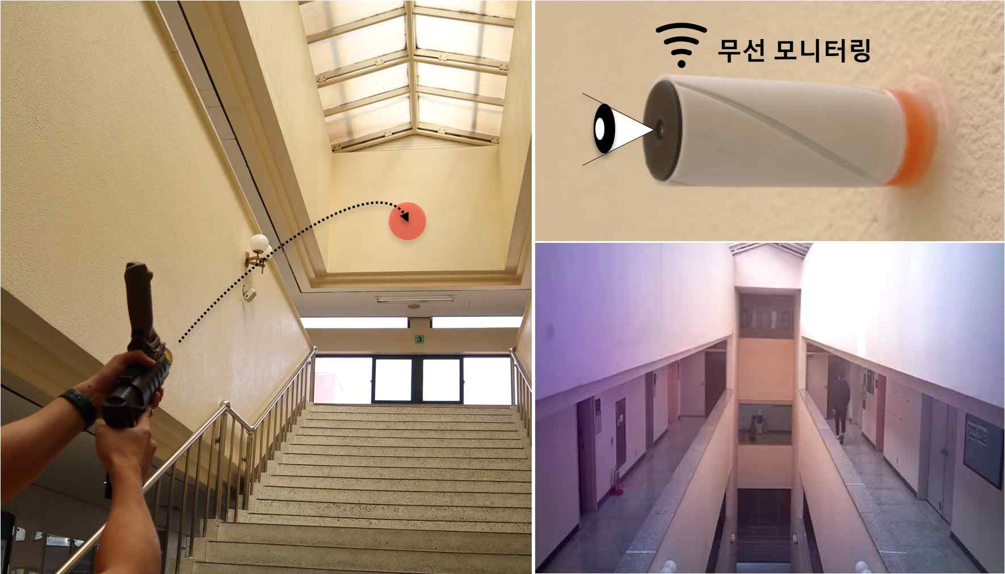

▲ Wireless monitoring using a wireless camera. Attach a launcher equipped with a wireless camera to the upper wall inside the building to check the inside view of the building.

Furthermore, it was made possible to attach a string to the launcher like Spiderman shooting a spider web, and this can be used to deliver relief supplies or rescue people in emergency situations, the research team explained.

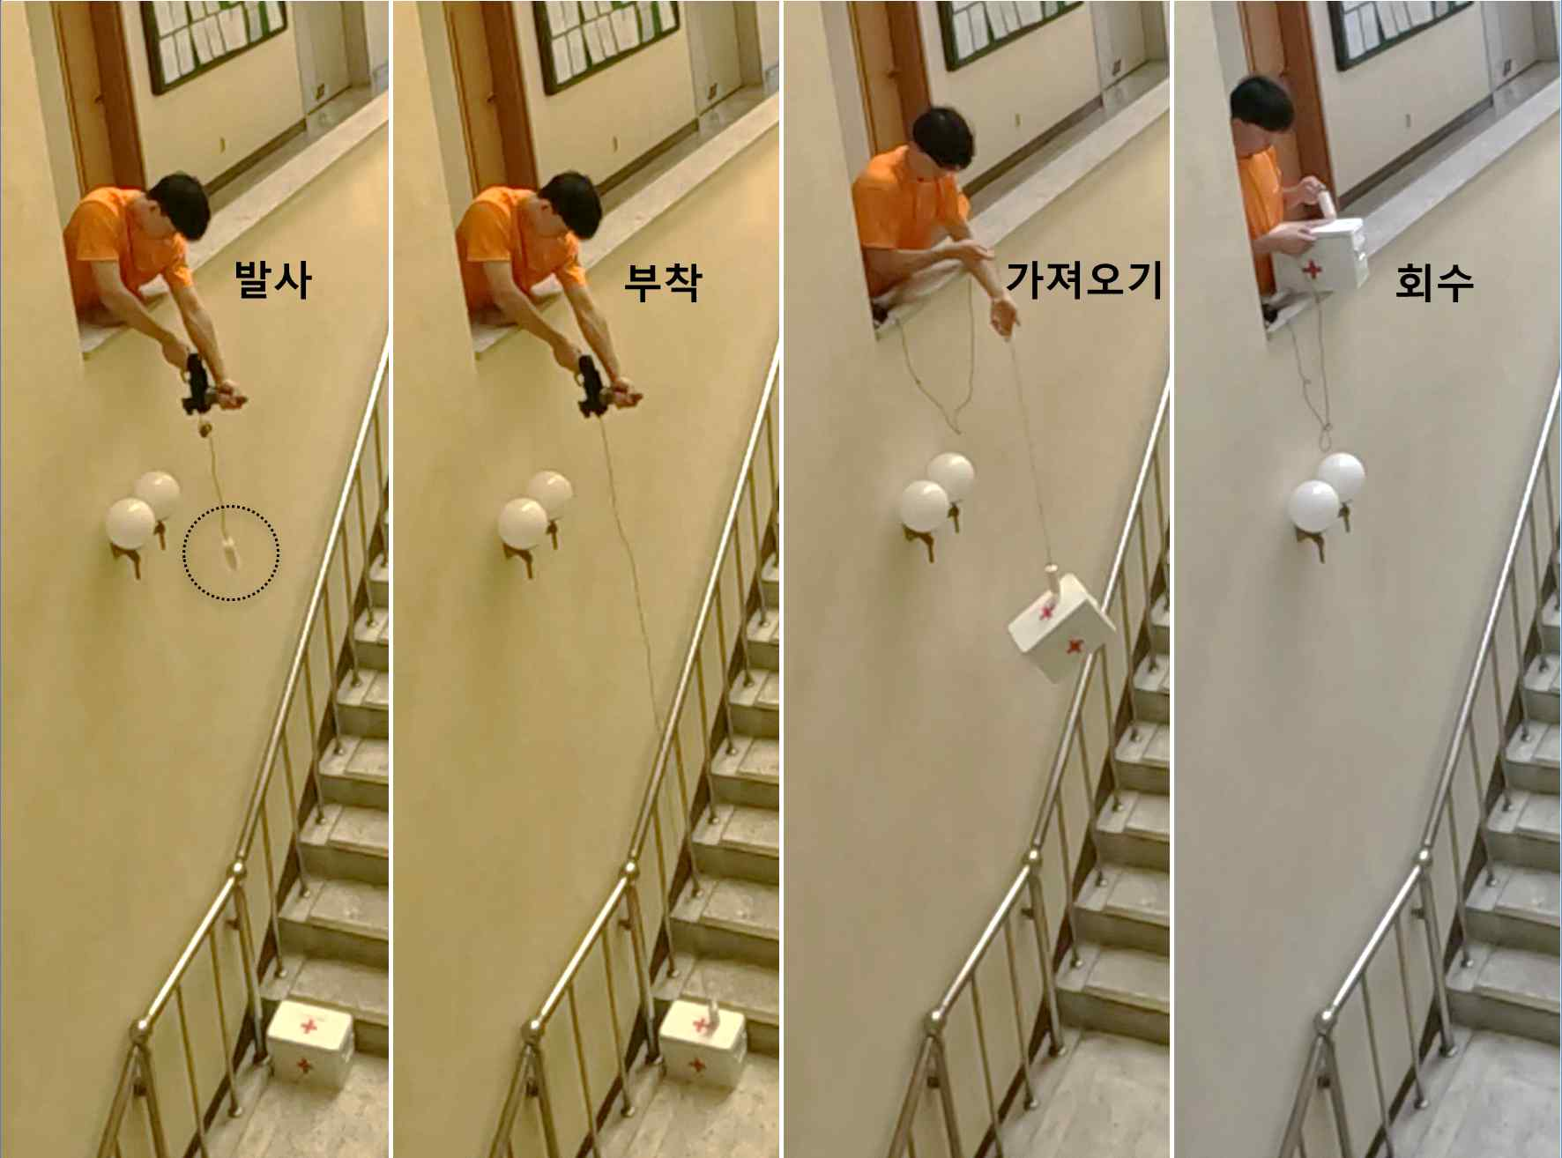

▲ Securing relief supplies using a projectile attachment attached to a string. Relief supplies in difficult-to-access places can be secured by firing, attaching, lifting, and retrieving a projectile attachment attached to a string in that order.

Dr. Sungbum Cho and Changeui Hong, a doctoral student (joint first authors) said, "It took a lot of trial and error and effort to develop a bonding technology that can securely attach regardless of the shape of the surface to which it is to be attached, while minimizing damage to the surface to which it is to be attached. We hope that this long-distance bonding technology will be widely used in various fields such as national defense, public safety, and disaster sites in the future."

Professor Jongho Lee said, "The newly developed launcher can be equipped with various electronic devices (GPS, communication, cameras, sensors, etc.), so it is expected to be widely used in the future in public security, disaster safety, national defense, and various civilian fields."

This study, supervised by Professor Jongho Lee of the School of Mechanical and Robotics Engineering at GIST and conducted in collaboration with Dr. Sungbum Cho, doctoral student Changeui Hong (joint first authors), and Professor Jaewook Lee’s research team, was supported by the Ministry of Science and ICT and the National Police Agency’s Customized Research and Development Project for Security Fields (Police Lab 2.0), and partially supported by the GIST-MIT Research Collaboration Project and the Mid-career Researcher Project of the National Research Foundation of Korea. The results of the study were published online in the international journal 《Advanced Functional Materials》 on December 20, 2024.



