"Collagen's Betrayal - Helps Cancer Metastasis" Professor Jeong-Seok Nam's research team unravels the tumor malignancy mechanism of cancer metastasis protein (dysadherin)

- Professor Jeong-Seok Nam's team from the School of Life Sciences, who discovered the fact that dysadherin induces cancer malignancy and metastasis in a previous study and discovered a peptide anticancer agent, just discovered that dysadherin plays an important role in collagen remodeling... Published in the international academic journal 《Nature Communications》

- "It will contribute to establishing a new cancer treatment strategy for controlling tumor malignancy and metastasis" Peptide that inhibits cancer cell proliferation by suppressing dysadherin function also completed US patent registration



▲ (From left) Professor Jeong-Seok Nam and Dr. Choong-Jae Lee of the School of Life Sciences

Cancer is a disease that is difficult to treat due to recurrence and metastasis, and it is known that most deaths due to cancer are not caused by primary cancer (first occurring in a specific organ), but by metastasis that damages the function of essential organs.

In order to overcome cancer metastasis, it is necessary to identify the malignancy and metastasis mechanism of cancer and establish a new treatment strategy that can control it.

The Gwangju Institute of Science and Technology (GIST, President Kichul Lim) announced that the research team of Professor Jeong-Seok Nam of the School of Life Sciences has discovered that the cancer metastasis protein ‘dysadherin’ promotes cancer malignancy and metastasis through the decomposition and rearrangement of collagen.

‘Dysadherin’ is a protein that is expressed only in cancer, and it has been found that the expression level is particularly high in cancers with strong invasiveness and metastasis, and it is classified as a cancer metastasis protein in the disease genome database of the National Human Genome Research Institute (NHGRI) in the United States.

In a previous study conducted in 2022*, the research team discovered that dysadherin induces cancer malignancy and metastasis through cell signaling, and discovered a peptide anticancer agent that suppresses it.

Based on the previous study, through single-cell public data analysis and clinical tissue analysis of colon cancer patients, it was revealed that dysadherin plays an important role in the remodeling of collagen, a representative component of the extracellular matrix (ECM) in the tumor microenvironment*, and that this phenomenon occurs more actively as the cancer malignancy increases.

* previous research: Published online on May 21, 2022, in the top 6.07% international academic journal in the medical field, Theranostics, and applied for a patent for a novel peptide and an anticancer composition containing it.

* tumor microenvironment: Composed of surrounding cells such as vascular epithelial cells, immune cells, and fibroblasts, and extracellular matrix, it constantly interacts with cancer cells and plays an important role in promoting growth, malignancy, and metastasis. Accordingly, research on the tumor microenvironment has recently been attracting attention.

* collagen remodeling: Structural changes including collagen decomposition and rearrangement

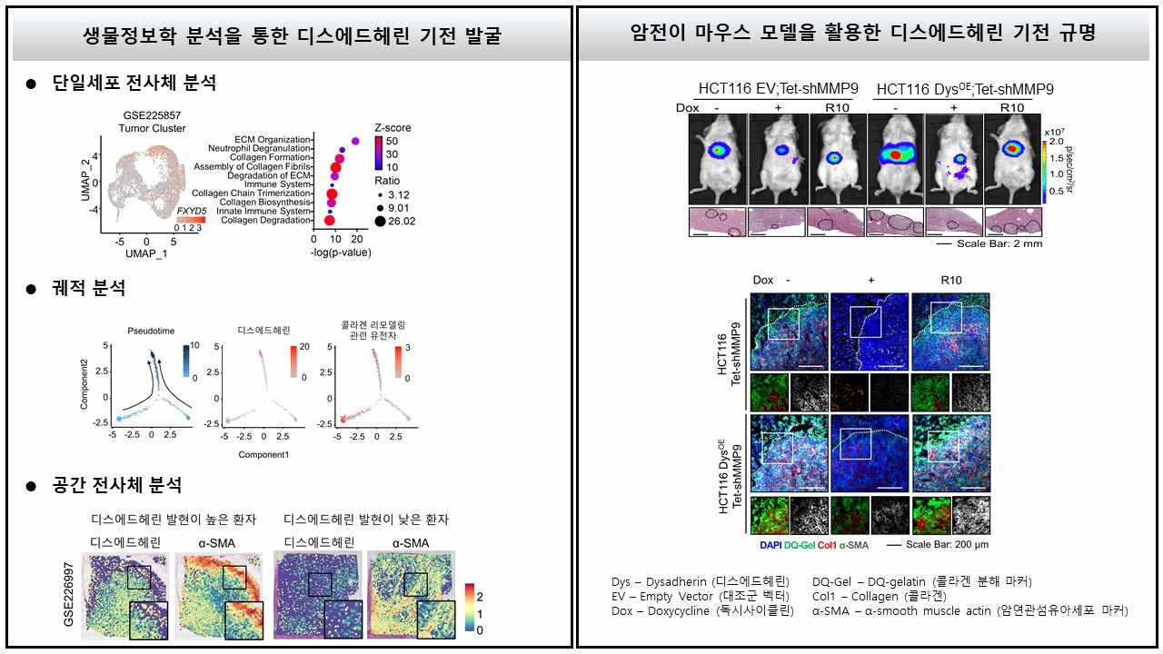

▲ Clarification of the collagen remodeling mechanism by dysedherin. Using various bioinformatics analyses (left) and a cancer metastasis mouse model (right), the collagen remodeling mechanism of dysadherin was clarified.

The research team revealed that dysadherin increases the expression of matrix metalloproteinase-9 (MMP9)* through a specific mechanism, which promotes collagen degradation and collagen rearrangement through the activation of cancer-associated fibroblasts (CAF), thereby inducing cancer malignancy and metastasis.

* matrix metalloprotease-9 (MMP9): A type of matrix metalloproteinase, a protein that plays a role in decomposing and reconstructing various extracellular matrices, such as collagen, that exist outside of cells. Generally, it contributes to the regeneration and healing process of tissues, but abnormal activity causes diseases such as inflammation and cancer metastasis.

Furthermore, the research team created humanized mice* and confirmed that collagen remodeling mediated by dysadherin/MMP9 signaling promotes immunosuppression and angiogenesis, contributing to the formation of a cancer cell-friendly tumor microenvironment.

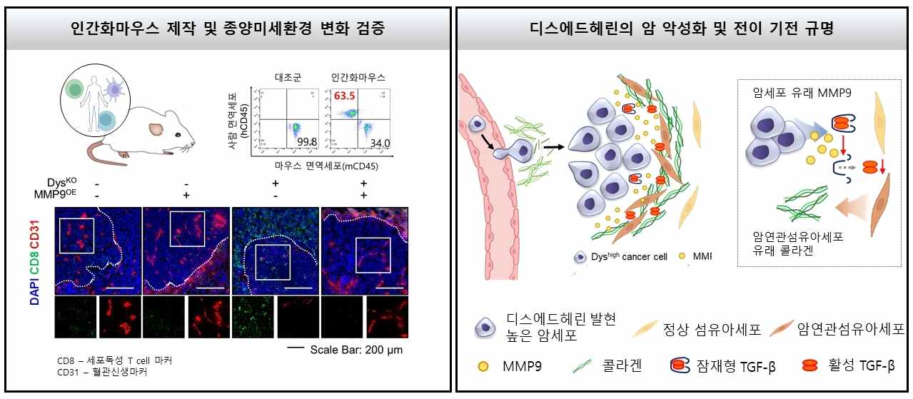

▲ Identification of the cancer malignancy mechanism of dysadherin. (Left) Using humanized mice, the effect of dysadherin-mediated collagen remodeling on the tumor microenvironment was identified. (Right) Schematic diagram of the novel cancer malignancy and metastasis mechanism of dysadherin.

In addition, the inhibitory effect of the peptide discovered in the previous study on the integrin (a molecule involved in cell-to-cell adhesion) signaling mediated by dysadherin was further verified and a US patent was registered (registration number US 12,024,546 B2).

* humanized mouse: A model created by transplanting human cells or tissues into mice to have the same immune system as humans, and has the characteristic of having both mouse and human genes.

Professor Jeong-Seok Nam said, "This study is significant in that it has identified a novel mechanism that promotes cancer malignancy and metastasis through changes in the tumor microenvironment caused by the cancer metastasis protein dysadherin. It is expected to contribute to laying the foundation for a new treatment strategy that can control tumor malignancy and metastasis in the future."

This study, supervised by Professor Jeong-Seok Nam of the School of Life Sciences at GIST and conducted by Dr. Choong-Jae Lee (Postdoctoral Researcher at the National Cancer Center), was supported by the National Research Foundation of Korea’s Mid-career Researcher Support Project, Biomedical Technology Development Project, IRC Leading Research Center Support Project, and GIST GRI Project, and was published in the international academic journal 《Nature Communications》 on November 30, 2024.



